

Capstone Project Final Report

**CAPSTONE PROJECT MANAGEMENT**

|  |  |
| --- | --- |
|  | **FUCPM Team** |
|  |  |
|  | Đỗ Đình Đức – SE04936 |
|  | Bùi Trung Kiên – SE05182 |
| **Group Members** | Nguyễn Ngọc Khánh - SE05045 |
|  |
|  | Nguyễn Đức Long – SE05906 |
|  | Nguyễn Minh Khang – SE05904 |
| **Supervisor** | Lecturer: Nghiêm Thị Lan Phương |
|  |  |
| **Capstone Project code** | CPM |
|  |  |

**Hanoi, Sep 1st, 2020**

**Table of contents**

**ACKNOWLEDGEMENTS****4**

**DEFINITIONS AND ACRONYMS****5**

**CHAPTER 1 : INTRODUCTION****7**

1.1 PURPOSE 7

1.2 PROJECT INFORMATION 7

1.3 THE PEOPLE 7



1.4 BACKGROUND 7

1.5 THE EXISTING SYSTEM 8

1.6 THE PROPOSAL OF SYSTEM 9



**CHAPTER 2 : PROJECT PLAN****12**

2.1 PURPOSE 12



2.2 PROJECT MANAGEMENT PLAN 14



**CHAPTER 3 : SOFTWARE REQUIREMENT SPECIFICATION****18**

3.1 PURPOSE 18

3.2 FUNCTIONAL REQUIREMENTS 18



3.3 NON-FUNCTIONAL REQUIREMENT 65



3.4 DATABASE DOCUMENT DIAGRAM 67

**CHAPTER 4 : SOFTWARE DESIGN****70**

4.1 PURPOSE 70

4.2 ARCHITECTURE OVERVIEW 70



4.3 DESIGN OF ASC SYSTEM 73





**CHAPTER 5 : SOFTWARE TESTING DOCUMENTATION****192**

5.1 PURPOSE 192



5.2 TEST PLAN 193



5.3 TEST CASE 200



5.4 TEST REPORT 206



**CHAPTER 6 : USER MANUAL****220**

6.1 DEPLOYMENT GUIDELINES 220



6.2 USER GUIDELINES 223



**Acknowledgements**

*We wish to express our deepest gratitude to our supervisor Mrs. Nghiem Thi Lan Phuong for his continuously sharing and motivating throughout the project. Under the instructions of Mrs. Phuong, the project team has always felt comfortable and confident. Apart from all the technologies and methodologies, Mrs. Phuong shared with us the philosophy of keeping the right attitude towards problems. We believe that was the most important factor that led to the success of this project.*

*We would also like to thank the instructors at FPT University for all the classes. We hope you will find this project as a reflection of the knowledge and experiences you have given us during this period of four years.*

*Finally, we truly appreciate the random fellows on the internet who has discussed with us.*

*Without them, it would have likely been a real struggle to solve every tiny problem.*

|  |  |
| --- | --- |
|  | **Definitions and Acronyms** |
| **Terminologies** |  |
|  |  |
| **Terminology** | **Definition** |
| **Chatbot (also Bots)** | Software that is used to interact between a computer and a human in |
|  | natural language. |
| **Broadcast** | A message proactively to users. |
|  |  |
| **Nodes** | A node is where different points of a dialog or workflow intersect |
|  |  |
| **Utterance** | Anything someone using chatbot says to it. |
|  |  |
| **Intent** | The few essential words that describe what the user wants the chatbot to |
|  | do. |
| **Entity** | Entities are the fields, data, or words the developer designates are |
|  | necessary for a chatbot to complete the user’s request. An entity could be |
|  | a date, a time, a location, a description or any number of things. |
| **Chat logs** | Histories of all recorded human-to-bot interactions. |
|  |  |
| **Acronyms** |  |
|  |  |
| **Acronym** | **Definition** |
| **API** | Application Programming Interface |
|  |  |
| **BDD** | Behavior-Driven Development |
|  |  |
| **CPU** | Central Processing Unit |
|  |  |
| **NLP** | Natural Language Processing |
|  |  |
| **NLU** | Natural Language Understanding |
|  |  |
| **NER** | Named Entity Recognition |
|  |  |
| **BoW** | Bag-of-Words |
|  |  |
| **SVM** | Support Vector Machine |
|  |  |
| **TF-IDF** | Term Frequency- Inverse Document Frequency |
|  |  |
| **DBMS** | Database Management System |
|  |  |
| **DOM** | Document Object Model |
|  |  |
| **GUI** | Graphical User Interface |
|  |  |
| **HDD** | Hard Disk Drive |
|  |  |
| **HTTP** | Hypertext Transfer Protocol |
|  |  |
| **HTTPS** | Hypertext Transfer Protocol Secure |
|  |  |
| **IDE** | Integrated Development Environment |
|  |  |
| **UML** | Unified Modeling Language |
|  |  |
| **N/A** | Not Available |
|  |  |
| **OS** | Operating System |
|  |  |
| **PM** | Project manager |
|  |  |
| **REST** | Representational State Transfer |
|  |  |
| **SRS** | Software Requirement Specification |
|  |  |
| **TDD** | Test-Driven Development |
|  |  |

|  |  |
| --- | --- |
| **UC** | Use Case |
|  |  |
| **UI** | User Interface |
|  |  |
| **UX** | User Experience |
|  |  |
| **URL** | Uniform Resource Locator |
|  |  |
| **FAQ** | Frequently Asked Questions |
|  |  |
| **PSID** | Page-Scoped ID |
|  |  |
| **Fb** | Facebook |
|  |  |
| **FU** | FPT University |
|  |  |
| **JWT** | JSON Web Token |
|  |  |
| **ASC** | Admission Supporting Chatbot |
|  |  |

**Chapter 1 : Introduction**

**1.1 Purpose**

This chapter provides an overview of the project including background information, a literature review of the existing system and raising a proposal for ideas of improvement.

**1.2 Project Information**

* Project name: Capstone Project Management
* Project code: **CPM**
* Project group name: **FUCPM**
* Product type: **Web Application**
* Timeline: **Sep 1st** **2020 -**

**1.3** **The people**

**Supervisor**



|  |  |  |  |  |  |  |  |  |  |  |  |  |  |  |  |  |  |
| --- | --- | --- | --- | --- | --- | --- | --- | --- | --- | --- | --- | --- | --- | --- | --- | --- | --- |
|  |  |  | **Full name** | |  | **Phone** | |  |  | **E-Mail** | | | |  | **Title** | | |
|  |  |  |  |  |  |  |  |  |  |  |  | |  |  |  |  |  |
|  | Supervisor | | Nghiêm Thị Lan Phương | |  |  | |  |  | phuongntl@fe.edu.vn | | | |  | Lecturer | | |
|  |  |  |  |  |  |  |  | |  |  |  |  |  |  |  |  |  |
|  |  |  |  | *Table 1-1: Supervisor's information* | | | | | | | | | | |  |  |  |
|  |  | **Team members** | |  |  |  |  |  |  |  |  |  |  |  |  |  |  |
|  |  |  |  |  |  |  |  |  |  |  |  |  |  |  |  |  |  |
|  |  | **Full name** |  | **Student** | **Phone** | |  | **E-mail** | | | | | | |  |  | **Role in** |
|  |  |  | **code** |  |  |  | **Group** |
|  |  |  |  |  |  |  |  |  |  |  |  |  |  |  |  |
|  |  |  | |  |  | |  |  | | | | |  | |  |  |  |
|  | 1 | Đỗ Đình Đức | | SE04936 | 0968480997 | |  | [ducdse04936@fpt.edu.vn](mailto:ducdse04936@fpt.edu.vn) | | |  | | | |  |  | Leader |
|  | 2 | Bùi Trung Kiên | | SE05182 | 0983268048 | |  | [kienbtse05182@fpt.edu.vn](mailto:kienbtse05182@fpt.edu.vn) | | | | |  | | | | Member |
|  | 4 | Nguyễn Ngọc Khánh | | SE05045 | 0914092466 | |  | [khanhnnse05045@fpt.edu.vn](mailto:khanhnnse05045@fpt.edu.vn) | | | | |  | | | | Member |
|  | 4 | Nguyễn Đức Long | | SE05906 | 0978299648 | |  | [longndse05906@fpt.edu.vn](mailto:longndse05906@fpt.edu.vn) | | | | |  | |  |  | Member |
|  | 5 | Nguyễn Minh Khang | | SE05904 | 0971091547 | |  | [khangnmse05904@fpt.edu.vn](mailto:khangnmse05904@fpt.edu.vn) | | | | | | |  |  | Member |
|  |  |  |  | *Table 1-2: Team member's information* | | | | | | | | | | |  |  |  |



**1.4** **Background**

Each student studying at FPT University has a 4-year path to complete subjects according to the school's schedule. Each student must complete a graduation thesis to complete the final test of student time. This makes us think of a project to create a software that performs functions for students to register, discuss, complete deadlines, exchange with teachers ... It would be useful to reduce costs and time.



*Figure 1-1: FPT University*

**1.5** **The Existing System**

While there are already chatbots that allow users to communicate, they all have certain problems. Below, we will go over a few chatbots application and their problems.

|  |  |  |
| --- | --- | --- |
| **Features** | **Ana1** | **Harafunel2** |
| Support Vietnamese chatting. |  | ✓ |
|  |  |  |
| Serve in specific admission domain. | ✓ |  |
|  |  |  |
| Throw random greeting responses. |  |  |
|  |  |  |
| The accuracy of a domain specific bot can further improve. |  |  |
|  |  |  |
| Having the flow of conversations and context. |  |  |
|  |  |  |
| Allow the end user to leave personal information. | ✓ | ✓ |
|  |  |  |
| Allow the end user to rate and review. |  | ✓ |
|  |  |  |

|  |  |  |
| --- | --- | --- |
| Having dashboard administration. | ✓ | ✓ |
|  |  |  |
| Allow the admin to view statistics. |  | ✓ |
|  |  |  |
| Allow the admin to manage chat logs. | ✓ | ✓ |
|  |  |  |
| Allow the admin to send messages to all end users at time. |  | ✓ |
|  |  |  |
| Allow admin to categorize end users into different groups. |  | ✓ |
|  |  |  |
| *Table 1-3: The existing system information* | |  |

**1.6** **The Proposal of system**

**System functions**



Allow the student.

Allow the student to project registration.

Allow the student to login by FPT email account.

Allow the student to view information of mentor supply.

Allow the student to rename the title project.

Allow the student to report the process of working in group.

Allow the student to statistics process of working in group.

Allow the student to view report and feedback.

Allow the mentor.

Allow the mentor to view the list of register.

Allow the mentor to pick team project to guide.

Allow the mentor to accept / reject the project.

Allow the mentor to statistics process of working in group.

Allow the mentor to view report and feedback.

Allow the mentor to assessment the process of project.

Allow the Academic Affairs Department.

Allow the academic affairs department to mentor view the project to approve or not.

Allow the academic affairs department to announce to student to change project.

Allow the academic affairs department to announce the date of project defense.

Allow the examination council.

Allow the examination council to Assessment result.

**Out of scope functions**



Because of the time limitation, we will not implement these following functions in the CPM initial version 1.0.0 release of the project but not permanently excluded, and will be developed in future version 2.0.0, although we are aware that they so also important:

* CPM adds function for affairs department.
* CPM adds function for examination council.
* CPM complete function assessment the process of project

Finally, we use some new approaches to solve the stated problems. Having awareness of the importance of new technologies, we aim at applying them to our project.

**Special approaches**



1. Using Java Spring boot for business development for application.
2. Using Spring data jpa.
3. Using SQL server to store data.
   1. Using HTML, CSS, Bootstrap create fontend.

**Chapter 2 : Project Plan**

**2.1 Purpose**

This chapter provides an overview of the project plan including project organization and project management plan.

**Software Process Model**

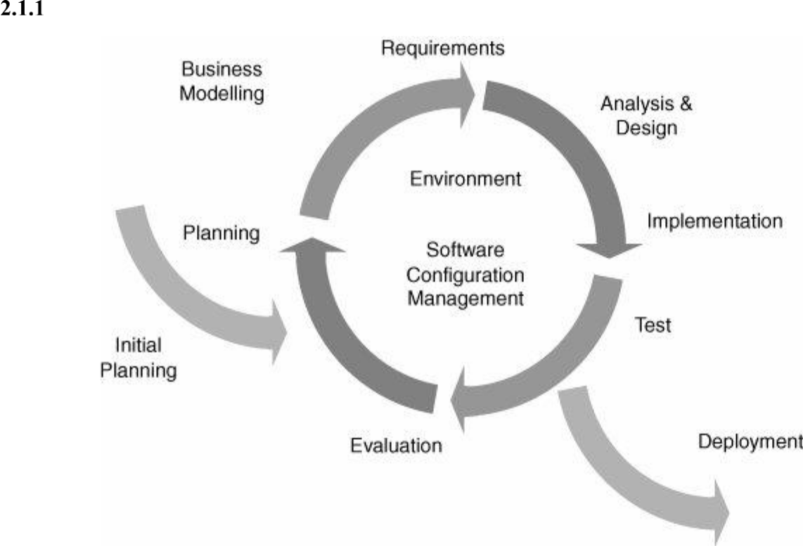

*Figure 2-1: Iterative and Incremental Software Process Model*

ASC project uses the Iterative and Incremental Software Process Model.

The Iterative and Incremental Software Process Model is mostly used when the scope of the project is big, the major requirements are defined clearly, some more details will be added later in software development. By using this software process model, we break down the developing system task into series of smaller tasks which will be completed separately, allowing us to take advantage of what was learned during development of earlier parts of the system. In addition, the iterative model is easier than other models when the issues are discovered. They are fed back to the team, and solutions will be found while the project is still in development.

|  |  |  |  |  |
| --- | --- | --- | --- | --- |
| **Roles and Responsibilities** | | | |  |
| **2.1.2.1** | **Organization Structure** | | |  |
|  |  |  |  |  |
|  | **Role** |  |  | **Responsibility** |
|  |  |  |  |  |
| Project Manager | | Planning, | | developing schedules, coordinating communication, |
| generally responsible for keeping the team’s focus on the main goal. | | |
|  |  |
|  |  |  |  | |
|  |  | Responsible for choosing and deciding what technologies should be | | |
| Technical Leader | | used, as well as for overseeing the work being done by other | | |
|  |  | developers. | | |
|  |  |  |  | |
| Quality | Assurance | Ensuring the product meets the certain standards of quality from | | |
| Manager | | requirements. | | |
|  |  |  |  | |
|  |  | Responsible for test execution, including test set-up and test run, | | |
| Test Leader | | evaluation of test run and error recovery, defect logging and test | | |
|  |  | results recording. | | |
|  | |  |  | |
| Developer | | Involve to code the product and review code of other developers. | | |
|  | |  |  | |
| Designer | | Involve to design product’s user interface. | | |
|  |  |  |  | |
| Tester |  | Involve to test the product. | | |
|  |  |  |  |  |
| Business Analyst | | Analyzes | | an organization or business domain and documents its |
| business or processes or systems. | | |
|  |  |
|  |  |  |  | |
|  |  |  | *Table 2-1: Project Structure* | |
| **2.1.2.2 Project Team Member** | | | |  |
|  | |  |  |  |
| **Team Member** | |  |  | **Role** |
|  |  |  |  | |
| DuNV |  |  | Project Manager, Developer, Business Analyst, Designer. | |
|  | |  |  | |
| QuynhDTT | |  | Developer, Quality Assurance Manager, Business Analyst, Test | |
|  |  |  | Leader. | |
|  | |  |  | |
| AnhDV | |  | Technical Leader, Developer, Tester. | |
|  | |  |  | |
| TuanDM | |  | Developer, Tester. | |
|  |  |  |  | |
|  |  |  | *Table 2-2: Project Team Member* | |

**

**Tools and Techniques**



|  |  |
| --- | --- |
| **Programming languages** | NodeJS, JavaScript |
|  |  |
| **Framework** | ExpressJS, Socket.IO, Elasticsearch |
|  |  |
| **API** | Wit.ai |
|  |  |
| **DBMS** | MongoDB |
|  |  |
| **IDEs/Editors** | Visual Studio Code, Atom |
|  |  |
| **UML tools** | Visual Paradigm, Hackolade, Microsoft Visio, Astah |
|  |  |
| **Version Control** | Gitlab |
|  |  |
| **Deployment server** | Microsoft Azure, Linux Virtual Machines |
|  |  |
| **Project management tool** | Microsoft Project, Trello, Backlog |
|  |  |
| **Process model** | Iterative and Incremental Software Process Model |
|  |  |
| **Development process** | Test-driven development, Behavior Driven Development |
|  |  |
|  | *Table 2-3: Project Team Member* |

**2.2 Project Management Plan**

**Tasks**



Refers to “ASC_ProjectManagement.mpp” file.

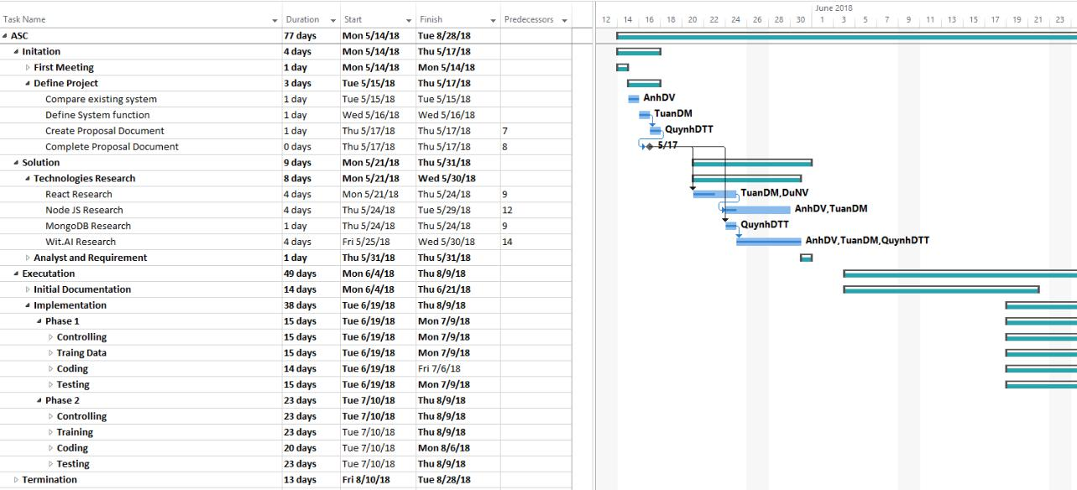

*Figure 2-2: ASC Project Management file*

**Meeting Minutes**



All meeting minutes will be written following this template:

|  |  |  |  |  |  |  |
| --- | --- | --- | --- | --- | --- | --- |
| ***Meeting/Project*** |  | *ASC* |  |  |  |  |
| ***Name:*** |  |  |  |  |  |  |
| ***Date of Meeting:*** | *18/05/2018* | |  | ***Time: (Type)*** | *1 hours (Face-to-face)* | |
| ***Meeting Called by:*** |  | *DuNV* |  | ***Location:*** | *FPT University – P205* | |
| ***Note Taker:*** |  | *QuynhDTT* |  | ***Time Keeper:*** | *DuNV* |  |
| 1. Meeting Objective |  |  |  |  |  |  |
|  |  |  |  |  |  |  |
| 1. Assign new task for member | | |  |  |  |  |
| 2. Do report No.2 |  |  |  |  |  |  |
|  |  |  |  |  |  |  |
| 2. Attendance |  |  |  |  |  |  |
|  |  |  |  |  |  |  |
| ***Name*** |  | ***Roles*** |  | ***E-mail*** |  | ***Phone*** |
| Nguyen Van Du |  | Project Manager |  | dunvse04312@fpt.edu.vn | | 0904423162 |
|  |  |  |  |  | |  |
| Do Thi Thu Quynh |  | Developer, Tester Leader |  | quynhdttse04133@fpt.edu.vn | | 0966343635 |
|  |  |  |  |  | |  |
| Duong Viet Anh |  | Developer, Tester |  | anhdvse04154@fpt.edu.vn | | 01645500597 |
|  |  |  |  |  |  |  |
| Dao Manh Tuan |  | Developer, Tester |  | tuandmse04002@fpt.edu.vn | | 0974481558 |
|  |  |  |
|  |  |  |  |  |  |  |



1. Done task
   1. Build project structure
   2. Configure git repository with security
   3. Do report No.1
2. New task
   1. Backend
      1. Training Data with Wit.ai
      2. Setup Environment
      3. Code Modules Integration
   2. Frontend
      1. Setup environment
      2. Code Dashboard Homepage
      3. Code Login page
   3. Do report No.2
3. Risk & Difficulty



N/A

*Table 2-4: Meeting Minutes Template*

**Coding Conventions**



We strictly follow Eslint JavaScript Style Guide.

Please refer to **JavaScript Style Guide - Eslint.pdf** file or the official website at <https://www.npmjs.com/package/eslint>

**Risk Management Plan**



|  |  |  |  |  |  |  |  |  |  |
| --- | --- | --- | --- | --- | --- | --- | --- | --- | --- |
| **No** |  | **Description** | |  |  | **Avoidance plan** |  | **Contingency plan** | **Status** |
|  |  |  |  |  |  |  |  |  |  |
| **R1** |  | Data loss |  | - | | Use GitLab for version control. | - | Restore backed up | Closed |
|  |  |  |  |  | - Teach members how to use Git | |  | data from GitLab. |  |
|  |  |  |  |  |  | and resolve conflicts. |  |  |  |
|  |  |  |  |  | - Always have important backups. | |  |  |  |
| **R2** |  | Illness | or | - | | Provide schedules in advance. | - | Assign the tasks of | Closed |
|  |  | absence | of | - | | For long periods of absence, |  | absent member to |  |
|  |  | team |  |  |  | members should notify the group |  | other members. |  |
|  |  | members |  |  |  |  |  |
|  |  |  |  |  | in advance. | - | Work overtime if |  |
|  |  |  |  |  |  |  |
|  |  |  |  |  |  |  |  | necessary. |  |
|  |  |  | |  | |  |  |  |  |
| **R3** |  | Misunderstan | | - | | Discuss requirements carefully | - | Make sure idea’s | Closed |
|  |  | ding | of |  |  | with the customer. |  | business logic is |  |
|  |  | requirements | |  | - Always ask for clarification if | |  | carefully analyzed. |  |
|  |  |  |  |  |  |  |
|  |  |  |  |  |  | requirement is unclear. |  |  |  |
|  |  |  |  |  | - Comment need to meet reality and | |  |  |  |
|  |  |  |  |  |  | possibility. |  |  |  |
|  |  |  | |  | |  |  |  |  |
| **R4** |  | Requirement | | - | | Every new update of requirement | - | If requirement has | Closed |
|  |  | changed |  |  |  | has to be reviewed by all team |  | new update, all |  |
|  |  |  |  |  |  | members and supervisor. |  | members have to |  |
|  |  |  |  |  | - Team member has to analyze | |  | join the meeting to |  |
|  |  |  |  |  |  | requirement carefully before raise |  | aware and make |  |
|  |  |  |  |  |  | up to team. |  | decision. |  |
|  |  |  |  |  | |  |  |  |  |
| **R5** |  | Conflict |  | - | | Everything must be documented. | - | Make sure any | Closed |
|  |  | between team | | - | | Every team member has to express |  | miscommunication |  |
|  |  | members |  |  |  | clearly and carefully. |  | has to be resolved. |  |
|  |  |  |  |  |  |  |  |
| **R6** |  | Failure | to | - | | Plan and develop schedule | - | Find the root cause | Closed |
|  |  | meet deadline | | - | | carefully | - | of the problem |  |
|  |  |  |  | Assign tasks carefully | Reassign tasks |  |
|  |  |  |  |  | - Define punishment for team | | - | Focus on important |  |
|  |  |  |  |  |  | members who neglect work |  | functions first |  |
|  |  |  |  |  |  |  |  |  |  |

*Table 2-5: Risk Management*

**Communication Plan**



*Weekly meeting schedule:* We use Iterative and Incremental Process Model, then we dividethe system into two sub-systems (ASC Backend and ASC Frontend), each sub-system is divided into a series of small tasks. Each task is logged to TRELLO then estimated depending on difficulty and the amount of work by the whole team, after that the task will be assigned to team members by the Team Leader and depending on difficulty the Technical Leader will assign deadlines for each task. We will have a meeting every Sunday to inform to all team about what each member finished last week, the status (fast, on time or slow), the issues met and how to solve them. If any member raises any issue, the whole team will help to find out a solution together. After that, the team will define detailed stories for next week tasks.

*Daily meeting schedule*: Each sub-system has one development team with different schedule.When starting work-day, each team will have a stand-up meeting to inform to others: “What did I do yesterday?”, “What will I do today?” and “Is there any difficulty?”. By focusing on what each person accomplished yesterday and will accomplish today, the team gains an excellent understanding of what has been done and what remains.

*Unscheduled meeting*: If someone has an important problem that he wants to solveimmediately, we will have a meeting for discussion, usually via some online channel: Slack, Facebook or Phone.

*Communication channel*: Our main communication channel is Slack. On the other hand, weuse face-to-face meeting, Facebook group and comment on TRELLO issues. However, we sometimes make a phone call or instant message if someone has a problem.

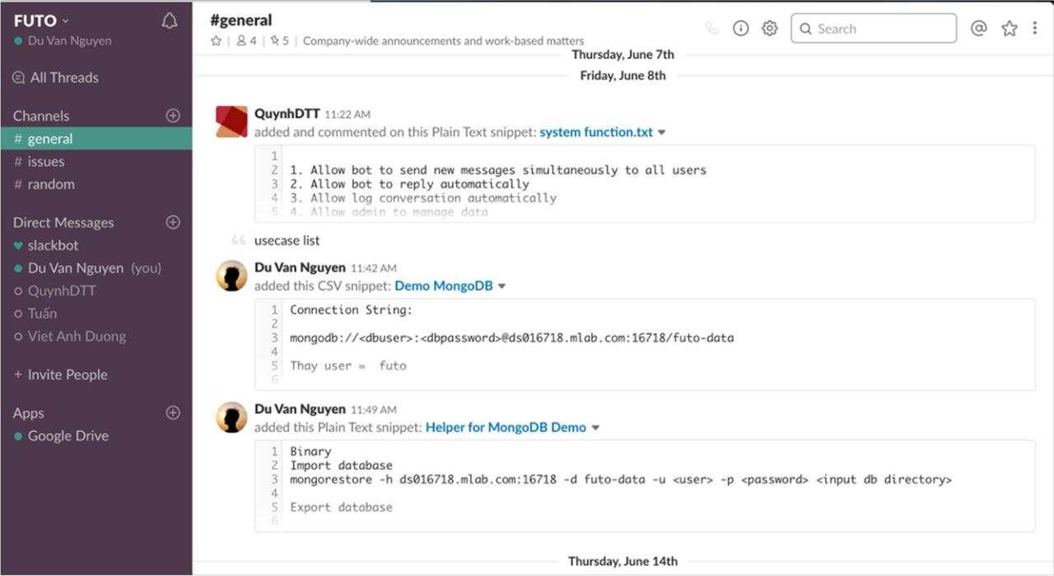

*Figure 2-3: Communication via Slack*

**Chapter 3 : Software Requirement Specification**

**3.1 Purpose**

This chapter outlines functional and non-functional requirements of our website. It also provides some format constraints in common requirements and project success criteria. All members will work based on the information provided in this chapter.

**3.2** **Functional Requirements**

**Use Case Diagram**

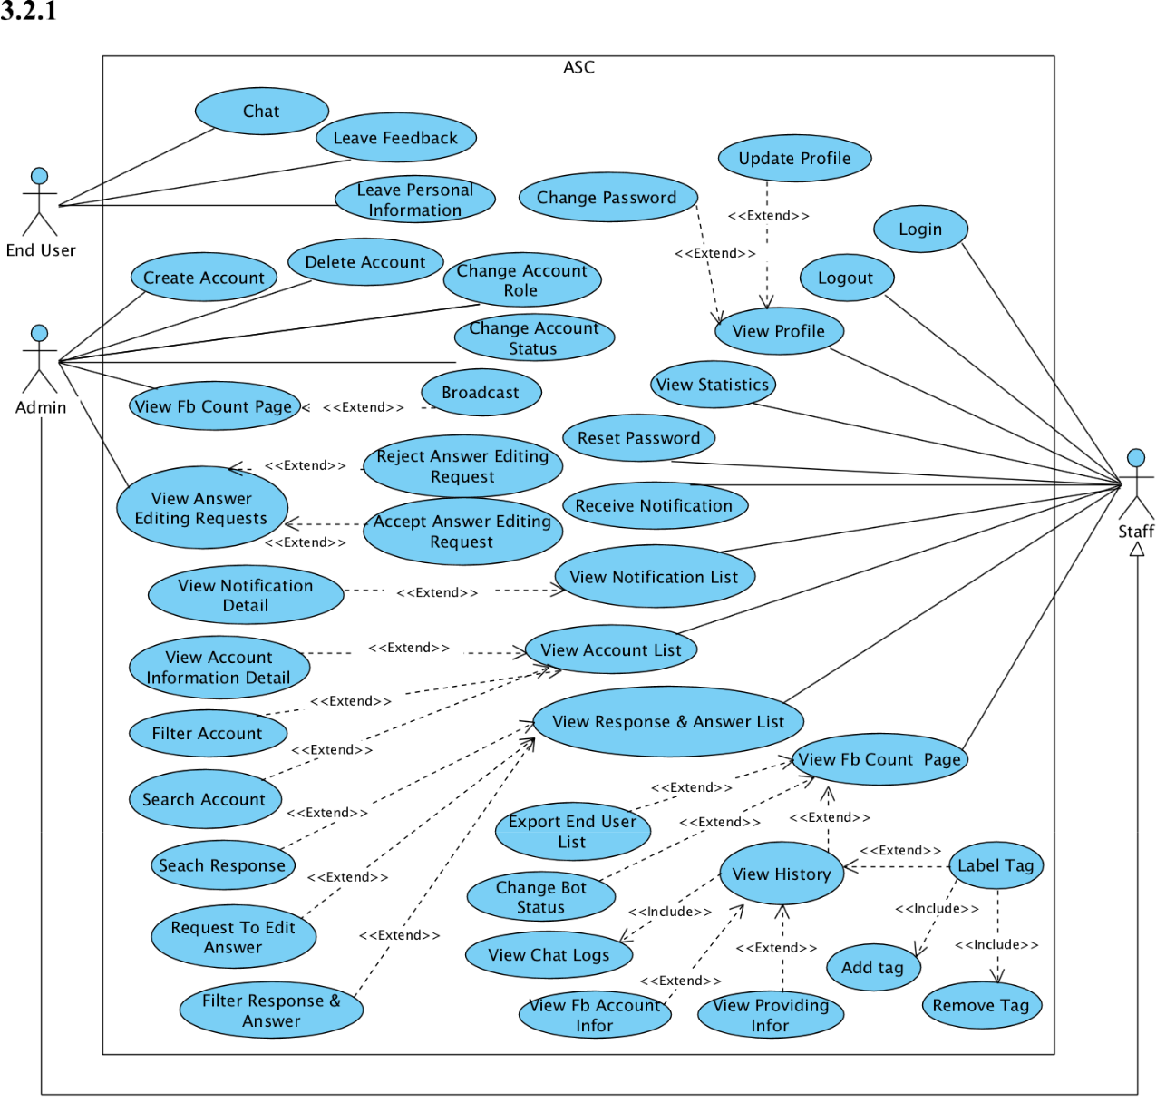

*Figure 3-1:Use case diagram of ASC system*

**Business Rules**

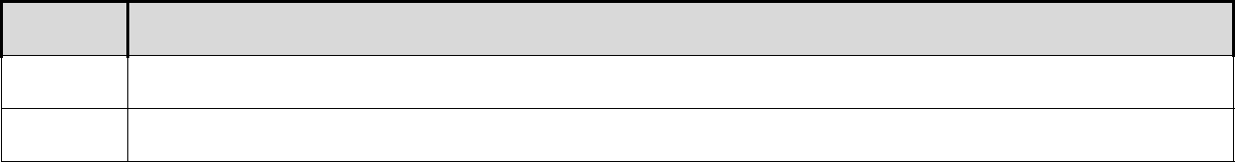

**No** **Description**

**B1** Username must not be empty.

**B2** Username must be unique.

|  |  |
| --- | --- |
| **B3** | User’s full name must not be empty. |
|  |  |
| **B4** | User’s address must not be empty. |
|  |  |
| **B5** | The email must not be empty. |
|  |  |
| **B6** | Email address must be valid. |
|  |  |
| **B7** | Each email address may be used for only one account. |
|  |  |
| **B8** | Re-enter password must match with password. |
|  |  |
| **B9** | Password must not be empty. |
|  |  |
| **B10** | Password reset token expires after 24 hours. |
|  |  |
| **B11** | The password length must not be less than 6. |
|  |  |
| **B12** | Deactivation must note reasons. |
|  |  |
| **B13** | Change deactivated status to active status must delete note and deactivated time. |
|  |  |
| **B14** | Phone number must be valid. |
|  |  |
| **B15** | Phone number must be numeric string only. |
|  |  |
| **B16** | Exported files must be Microsoft Excel files with valid format. |
|  |  |
| **B17** | The admin must fill out username and email field. |
|  |  |
| **B18** | Every user accessing dashboard has a role: staff or admin. |
|  |  |
| **B19** | The administrator is able to: active/ deactivate account, change account role, change |
| request state. |
|  |
|  |  |
| **B20** | Staff can request to edit chatbot answer. |
|  |  |
| **B21** | An answer editing request has 3 states: “PENDING”, “REJECTED”, “ACCEPTED” |
|  |  |
| **B22** | Answer editing request form must have: old answer, new answer, created date, creator. |
|  |  |
| **B23** | Only “PENDING” editing answer can be accepted by the admin, after that editing |
| answer’s state is “ACCEPTED”. |
|  |
|  |  |
| **B24** | Only “PENDING” editing answer can be rejected by the admin, after that editing |
| answer’s state is “REJECTED”. |
|  |
|  |  |
| **B25** | Answer editing request status only can be changed from “PENDING” to |
| “ACCEPTED” or “REJECTED”. |
|  |
|  |  |
| **B26** | To review an answer request, the staff must have at least an editing answer. |
|  |  |
| **B27** | The chatbot always has a state: “ON” or “OFF”. |
|  |  |
| **B28** | The chatbot will not automatically reply in “OFF” state. |
|  |  |
| **B29** | The chatbot will automatically reply in “ON” state. |
|  |  |
| **B30** | When admin deactivates account. System logs that account out of ASC system. |
|  |  |
| **B31** | Rating must be 1 in 5 states: “EXCELLENT”, “VERY GOOD”, “GOOD”, “BAD”, |
| “VERY BAD”. |
|  |
|  |  |
| **B32** | When no reply after 10 minutes, the chatbot auto finishes the conversation. |
|  |  |

*Table 3-1: Business rules*

**Use Cases**



|  |  |
| --- | --- |
| **Actor** | **Description** |
|  |  |
| End User | Someone who uses the application to engage in a conversation. |
|  |  |
| Staff | Everyone who has a ASC Account such as FU staffs. |
|  |  |
| Admin | Administrator is a staff, has the highest permission level and is responsible for |
|  | managing administrative tasks. |
|  |  |
|  | *Table 3-2: Actor description* |

|  |  |  |  |  |  |  |  |
| --- | --- | --- | --- | --- | --- | --- | --- |
| **ID** | **Actor** | **Name** | **Description** | |  |  |  |
|  |  |  |  | | | |  |
| UC-1.0 | End User | Chat | End User asks a question and | | | | |
|  |  |  | chatbot replies automatically. | | | | |
|  |  |  |  | | | | |
| UC-2.0 | End User | Leave Feedback | End User is able to leave | | | | |
|  |  |  | feedback, which is comprised | | | | |
|  |  |  | of a text message and a rating. | | | | |
|  |  |  |  | | |  | |
| UC-3.0 | End User | Leave Personal Information | End User leaves | | | personal | |
|  |  |  | information. | |  |  |  |
|  |  |  |  |  | |  | |
| UC-4.0 | Staff, Admin | Reset Password | Reset | a forgotten | | password | |
|  |  |  | using email. | |  |  |  |
|  |  |  |  | | | | |
| UC-5.0 | Staff, Admin | Login | Login to dashboard in ASC | | | | |
|  |  |  | account. | |  |  |  |
|  |  |  |  |  | | |  |
| UC-6.0 | Staff, Admin | View Statistics | View | feedbacks, number | | | of |
|  |  |  | end user and related admission | | | | |
|  |  |  | information statistics. | | | |  |
|  |  |  |  | | | |  |
| UC-7.0 | Staff, Admin | View Profile | View personal profile. | | | |  |
|  |  |  |  | | | |  |
| UC-8.0 | Staff, Admin | Update Profile | Update personal profile. | | | |  |
|  |  |  |  | | | | |
| UC-9.0 | Staff, Admin | Change Password | Change password of account. | | | | |
|  |  |  |  | | | | |
| UC-10.0 | Staff, Admin | View Account List | View a list of accounts in the | | | | |
|  |  |  | system. | |  |  |  |
|  |  |  |  |  |  | | |
| UC-11.0 | Staff, Admin | View Account Information | View | detailed | information | | |
|  |  | Detail | regarding specific account. | | | | |
|  |  |  |  |  |  | |  |
| UC-12.0 | Staff, Admin | Search Account | Search | for | account | | by |
|  |  |  | username or full name. | | | |  |
|  |  |  |  | | | | |
| UC-13.0 | Staff, Admin | Filter Account | Filter account by role or status. | | | | |
|  |  |  |  |  | |  | |
| UC-14.0 | Staff, Admin | View Response & Answer List | View | chatbot | | responses | |
|  |  |  | regarding answers. | | |  |  |
|  |  |  |  |  |  | |  |
| UC-15.0 | Staff, Admin | Filter Response & Answer | Filter | chatbot | response | | and |
|  |  |  | answer by intent. | | |  |  |
|  |  |  |  | | | | |
| UC-16.0 | Staff, Admin | Search Response | Search for chatbot response. | | | | |
|  |  |  |  |  |  |  |  |

|  |  |  |  |  |  |  |  |  |  |
| --- | --- | --- | --- | --- | --- | --- | --- | --- | --- |
| UC-17.0 | Staff, Admin | Request to Edit Answer | |  | Request to edit a chatbot | | | | |
|  |  |  |  |  | answer. | |  |  |  |
|  |  |  | |  |  | |  | |  |
| UC-18.0 | Staff, Admin | Receive Notification | |  | Notification | | of changes | | to |
|  |  |  |  |  | events | automatically | | sent | by |
|  |  |  |  |  | the system as a result of an | | | | |
|  |  |  |  |  | edit. |  |  |  |  |
|  |  |  | |  |  | | | |  |
| UC-19.0 | Staff, Admin | View Notification List | |  | View a list of notifications. | | | |  |
|  |  |  | | |  | | | | |
| UC-20.0 | Staff, Admin | View Notification Detail | | | View some details of the | | | | |
|  |  |  |  |  | notification. | |  |  |  |
|  |  |  | |  |  | | | | |
| UC-21.0 | Staff, Admin | View Fb Count Page | |  | View all End User interacting | | | | |
|  |  |  |  |  | with the chatbot. | | |  |  |
|  |  |  | |  |  | | |  | |
| UC-22.0 | Staff, Admin | View Chat Logs | |  | View a conversation | | | history | |
|  |  |  |  |  | between End User and the | | | | |
|  |  |  |  |  | chatbot. | |  |  |  |
|  |  |  | |  |  |  | |  |  |
| UC-23.0 | Staff, Admin | View Fb Account Infor | |  | View | information | | of | Fb |
|  |  |  |  |  | Account | | and | his/her | |
|  |  |  |  |  | satisfaction | | ratings | and | |
|  |  |  |  |  | reviews. | |  |  |  |
|  |  |  | |  |  |  | | | |
| UC-24.0 | Staff, Admin | View Providing Infor | |  | View | providing information | | | |
|  |  |  |  |  | of End User. | |  |  |  |
|  |  |  |  |  |  | | | | |
| UC-25.0 | Staff, Admin | Add Tag |  |  | Add a tag to categorize and | | | | |
|  |  |  |  |  | filter End User. | | |  |  |
|  |  |  | |  |  | | | | |
| UC-26.0 | Staff, Admin | Remove Tag | |  | Remove a tag from End User. | | | | |
|  |  |  | |  |  | | | | |
| UC-27.0 | Staff, Admin | Export End User List | |  | Export a list of End Users into | | | | |
|  |  |  |  |  | Excel file. | |  |  |  |
|  |  |  | |  |  | | | |  |
| UC-28.0 | Staff, Admin | Change Bot Status | |  | Turn chatbot on or off. | | | |  |
|  |  |  |  |  |  | | | | |
| UC-29.0 | Staff, Admin | Logout |  |  | Log out of the ASC | | | | |
|  |  |  |  |  | dashboard. | |  |  |  |
|  |  |  | | |  | | | | |
| UC-30.0 | Admin | View Answer Editing Requests | | | View a list of answers edited | | | | |
|  |  |  |  |  | by staff. | |  |  |  |
|  |  |  |  |  |  |  |  |  | |
| UC-31.0 | Admin | Accept | Answer | Editing | Accept | an | answer | editing | |
|  |  | Request |  |  | request with status Pending. | | | | |
|  |  |  | | |  |  |  |  | |
| UC-32.0 | Admin | Reject Answer Editing Request | | | Reject | an | answer | editing | |
|  |  |  |  |  | request with status Pending. | | | | |
|  |  |  | |  |  | | | |  |
| UC-33.0 | Admin | Create Account | |  | Create a new ASC account. | | | |  |
|  |  |  | |  |  | | | |  |
| UC-34.0 | Admin | Delete Account | |  | Delete an existing account. | | | |  |
|  |  |  | |  |  | | | |  |
| UC-35.0 | Admin | Change Account Role | |  | Change role of account: | | | |  |
|  |  |  |  |  | Admin or Staff. | | |  |  |
|  |  |  | |  |  | | | | |
| UC-36.0 | Admin | Change Account Status | |  | Change status to be a | | | | |
|  |  |  |  |  | deactivated account or active | | | | |
|  |  |  |  |  | account. | |  |  |  |
|  |  |  |  |  |  |  |  |  |  |

|  |  |  |  |
| --- | --- | --- | --- |
| UC-37.0 | Admin | Broadcast | Send a single message to all of |
|  |  |  | the chatbot end users. |
|  |  |  |  |

*Table 3-3: Use Case list*

**3.2.3.1 End User**

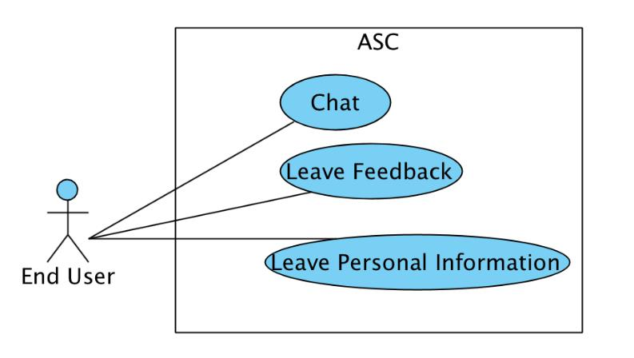

*Figure 3-2:Use case diagram of End User actor*

***3.2.3.1.1*** ***Chat***

***3.2.3.1.1.1 Training the Chatbot***

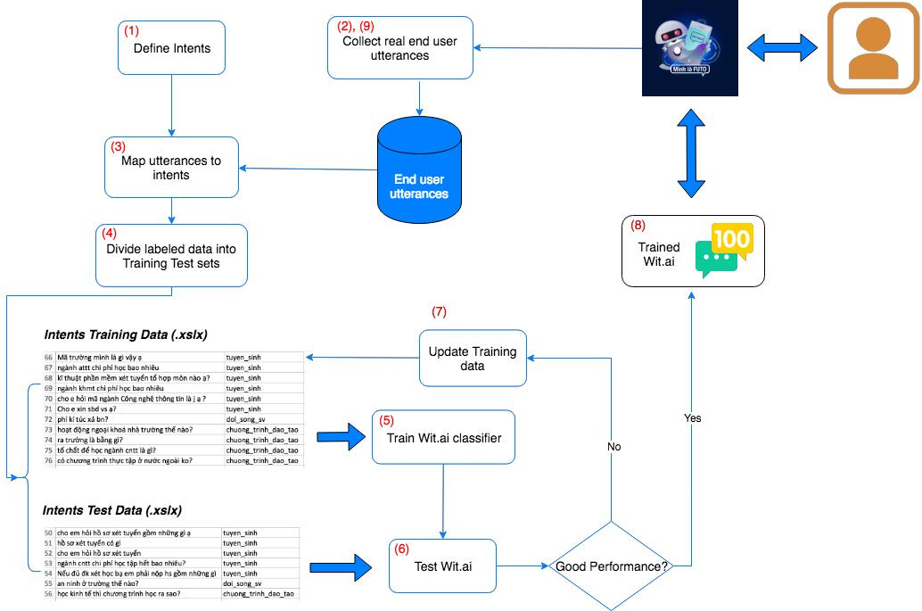

*Figure 3-3: Training the Chatbot activity diagram*

**Explanation:**

(1): Define the intents chatbot to extract from natural language utterances.

(2): Collect real end user utterances that the chatbot to map to intents.

(3): Assign the utterances collected to the different intents.

(4): Randomly divide the utterances into two sets, a training set and a test set. A 70% training and 30% test is a typical split.

(5): Train the chatbot using the training set.

(6): Once training is complete, run the test set against the trained classifier and collect performance metrics such as accuracy, precision, and recall.

(7): Perform Error Analysis: review the results in previous step to understand why the classifier missed certain utterances. Update training data accordingly and go back to step (5)

(8): If satisfied with the results produced by the trained system, the system is now ready to be released.

(9): When the chatbot is in use, continue to collect end user utterances. Then map results collected to new training/test data. Go back to step (4) and iterate.

**Detail Specification:**

1. Define intent

An intent represents the purpose of an end user’s input.

To define intent , we go to my customer FPT Admission Office to see what they think are the top reasons end users are contacting them. The typical support material that the reps use we will get closer to understanding the end user intent is website of FU1. It is largely divided into “Question” and “Answer”. Data named “Answer” are normal article data from the website with section, title, body attributes. Data named “Question” are the end user’s comments.

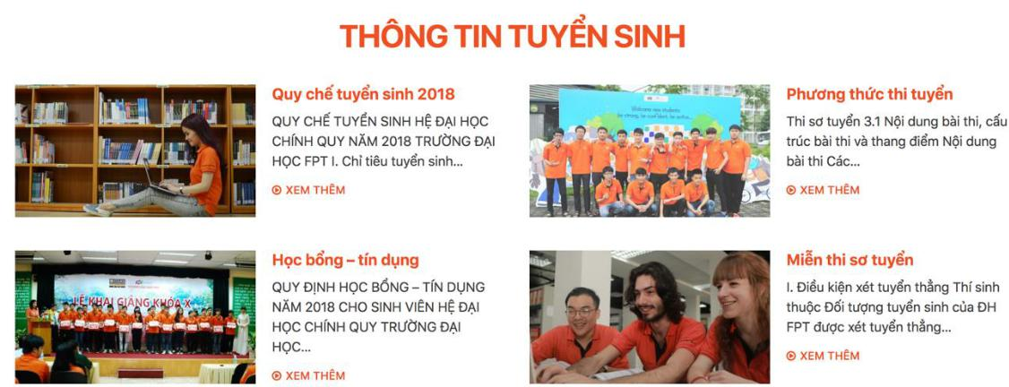

*Figure 3-4: Answer data*

1. FU website: <http://daihoc.fpt.edu.vn/>

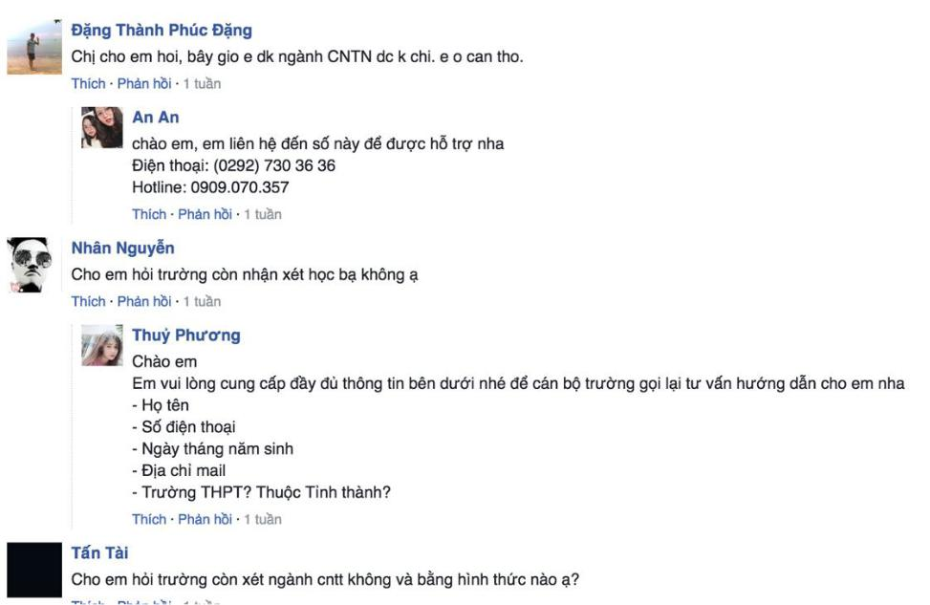

*Figure 3-5: Question Data*

Since the raw data had too many topics such as admission procedures, tuition fees, scholarships, and other classes making the end user is interested in so much, we grouped them into larger classes, also called intents.

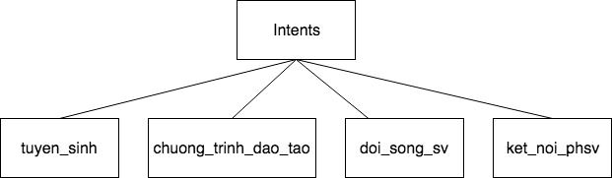

Besides the intent, we create a lot of entities. An entity represents a term or object in the end user’s input that provides clarification or specific context for a particular intent.

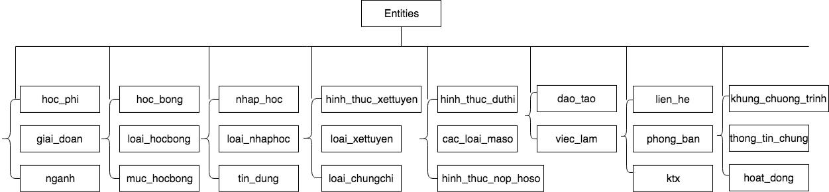

1. Collect training data

To get all real comments of potential end user from the “dai.hoc.fpt.edu.vn” website for training , we must create a crawler tool to accquire data.



Input: “http:daihoc.fpt.edu.vn/tuyen-sinh/”

Output: data.json

A sample of raw data is provided below:

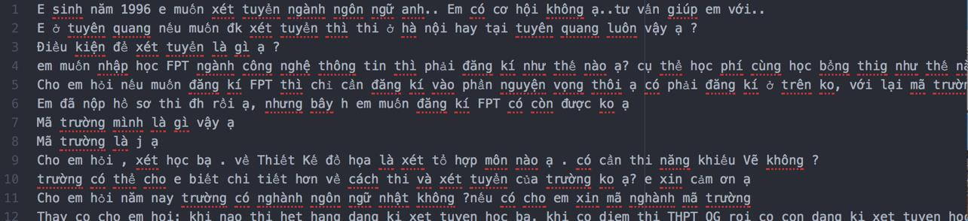

1. Clean and assign data collected to the different intent.

To get high quality labeled training data, we must clean the misunderstanding and ambigious utterances. Only keeping the utterance having an intent and relating our model domain.

To label training data, we attach each of utterance into diffrent intent and entity.

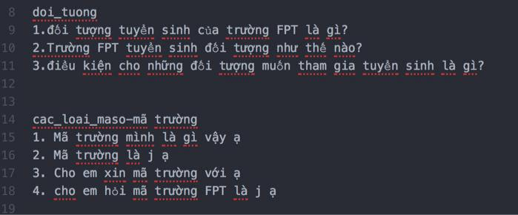

***3.2.3.1.1.2 Chat process***

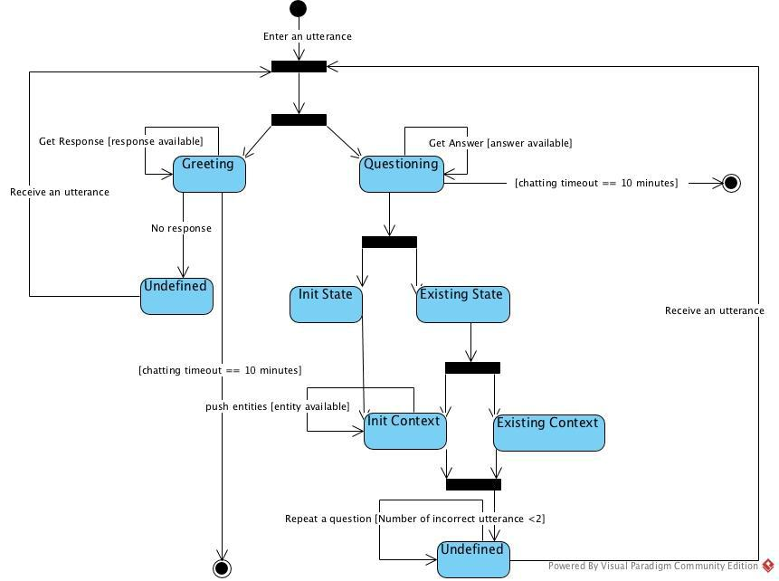

*Figure 3-6: Chat state machine diagram*

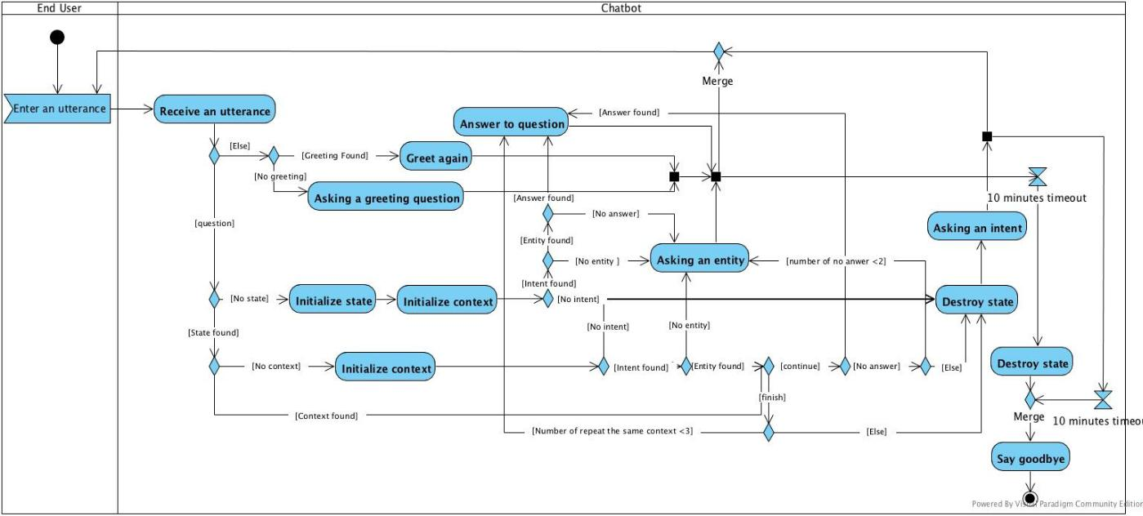

*Figure 3-7: Chat activity diagram*

*Use Case Specification*

|  |  |  |  |  |
| --- | --- | --- | --- | --- |
| UC ID and Name: | **UC-1.0 Chat** | |  |  |
|  |  | |  |  |
| Created by: | **QuynhDTT** | | Date Created: | **24/05/2018** |
|  |  | |  |  |
| Primary Actor: | **End User** | | Secondary Actors: |  |
|  |  |  |  |  |
| Trigger: | N/A |  |  |  |
|  |  | | | |
| Description: | Allow End User to send a question and receive the answer to their question | | | |
|  | immediately. | |  |  |
|  |  | | | |
| Preconditions: | **PRE-1.1.** The end user starts the Facebook Messenger application. | | | |
|  |  | | | |
| Post conditions: | **POST-1.1.** The answer to the end user’s question is sent. | | | |
|  |  | |  |  |
| Normal Flow: | **1.0 Chat** | |  |  |
|  | 1. | End User enters a question then clicks on the send button. | | |
|  | 2. | System generates an answer displayed in the chat window to reply | | |
|  |  | his/her question. |  |  |
|  |  | | | |
| Alternative Flows: | **1.0 End User violates some business rule in step 1** | | | |
|  | 1. | System sends a goodbye message to finish the conversation. | | |
|  |  | | |  |
| Exceptions: | **1.0-E1 – Cannot communicate with server.** | | |  |
|  | 1. | ASC displays error message. | |  |
|  |  |  |  |  |
| Priority: | High |  |  |  |
|  |  |  |  |  |

|  |  |
| --- | --- |
| Frequency of Use: | High |
|  |  |
| Business Rules: | **B32** |
|  |  |
| Other Information: | N/A |
|  |  |
| Assumptions: | N/A |
|  |  |

***3.2.3.1.2*** ***Leave Feedback***

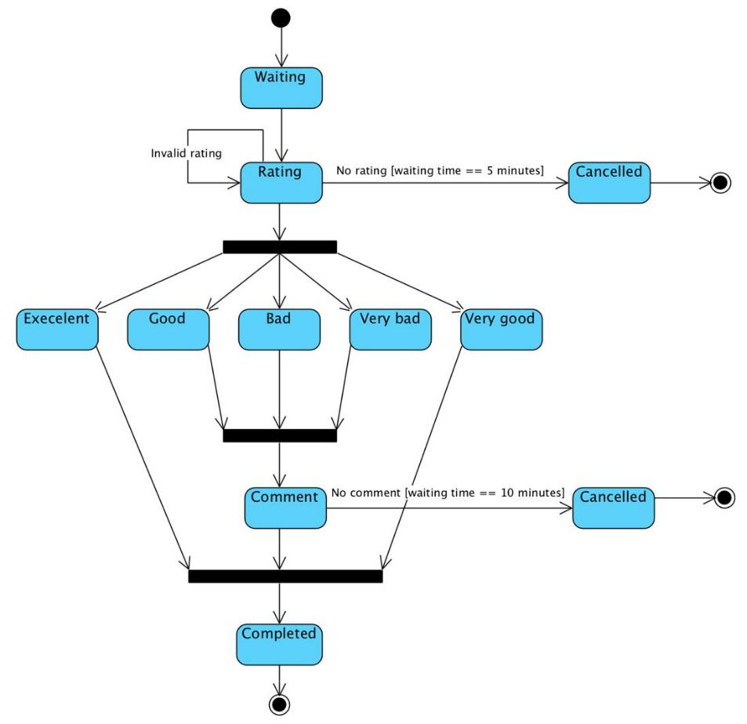

*Figure 3-8: Feedback state machine diagram*

*Use Case Specification*

|  |  |  |  |
| --- | --- | --- | --- |
| UC ID and Name: | **UC-2.0 Leave Feedback** | |  |
|  |  |  |  |
| Created by: | **QuynhDTT** | Date Created: | **24/05/2018** |
|  |  |  |  |
| Primary Actor: | **End User** | Secondary Actors: |  |
|  |  |  |  |
| Trigger: | N/A |  |  |
|  |  | | |
| Description: | Allow End User to rate and review for chatbot in the end of conversation. | | |
|  |  |  |  |

|  |  |  |
| --- | --- | --- |
| Preconditions: | **PRE-2.1.** End User has already chat. | |
|  | **PRE-2.2.** End User has not sent any message for 10 minutes. | |
|  |  | |
| Post conditions: | **POST-2.1.** System saves new feedback to database. | |
|  |  | |
| Normal Flow: | **2.0 Leave Feedback** | |
|  | 1. | After 10 minutes finishing conversation, system sends a message |
|  |  | with 5 rating quick replies. |
|  | 2. | End User chooses one of them. |
|  | 3. | System asks for reasons that they chose it. |
|  | 4. | End User gives their review for chatbot. |
|  | 5. | System saves his/her feedback to database. |
|  |  | |
| Alternative Flows: | **2.0 End User violates some business rule in step 2** | |
|  | 1. | System sends the help message” (Fb frirst name) vui lòng chọn 1 |
|  |  | trong số các lựa chọn bên dưới giúp Futo.” |
|  | **2.0 End User violates some business rule in step 4** | |
|  | 2. | System sends a goodbye message to finish the conversation. |
|  |  |  |
| Exceptions: | **2.0-E1** | **– Cannot communicate with server.** |
|  | 1. | ASC displays error message. |
|  |  |  |
| Priority: | High |  |
|  |  | |
| Frequency of Use: | Medium | |
|  |  | |
| Business Rules: | **B31, B32** | |
|  |  |  |
| Other Information: | N/A |  |
|  |  |  |
| Assumptions: | N/A |  |
|  |  |  |

***3.2.3.1.3*** ***Leave Personal Information***

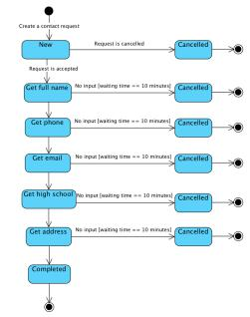

*Figure 3-9: Leave Personal Information state machine diagram*

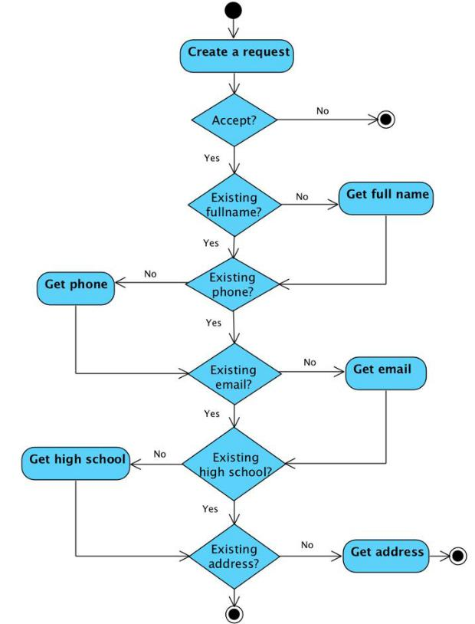

*Figure 3-10: Leave Personal Information activity diagram*

*Use Case Specification*

|  |  |  |  |  |
| --- | --- | --- | --- | --- |
| UC ID and Name: | **UC-3.0 Leave Personal Information** | | |  |
|  |  | |  |  |
| Created by: | **QuynhDTT** | | Date Created: | **24/05/2018** |
|  |  | |  |  |
| Primary Actor: | **End User** | | Secondary Actors: |  |
|  |  |  |  |  |
| Trigger: | N/A |  |  |  |
|  |  | | | |
| Description: | Allow End User to leave personal information to contact. | | | |
|  |  | | | |
| Preconditions: | **PRE-3.1.** End User sends a message to want to talk to some real person. | | | |
|  |  | | | |
| Post conditions: | **POST-3.1.** System savesend user’s personal informationto database. | | | |
|  |  | | |  |
| Normal Flow: | **3.0 Leave Personal Information** | | |  |
|  | 1. | System asks some questions about getting end user’s personal | | |
|  |  | information. |  |  |
|  | 2. | End User replies to each of them. | |  |
|  | 3. | System saves information that end user provides. | | |
|  |  | | | |
| Alternative Flows: | **3.0 End User violates some business rule in step 2** | | | |
|  | 1. | System sends a goodbye message to finish the conversation. | | |
|  |  | | |  |
| Exceptions: | **3.0-E1 – Cannot communicate with server.** | | |  |
|  | 1. | ASC displays error message. | |  |
|  |  |  |  |  |
| Priority: | High |  |  |  |
|  |  | |  |  |
| Frequency of Use: | Medium | |  |  |
|  |  |  |  |  |
| Business Rules: | **B32** |  |  |  |
|  |  |  |  |  |
| Other Information: | N/A |  |  |  |
|  |  |  |  |  |
| Assumptions: | N/A |  |  |  |
|  |  |  |  |  |

**3.2.3.2 Staff**

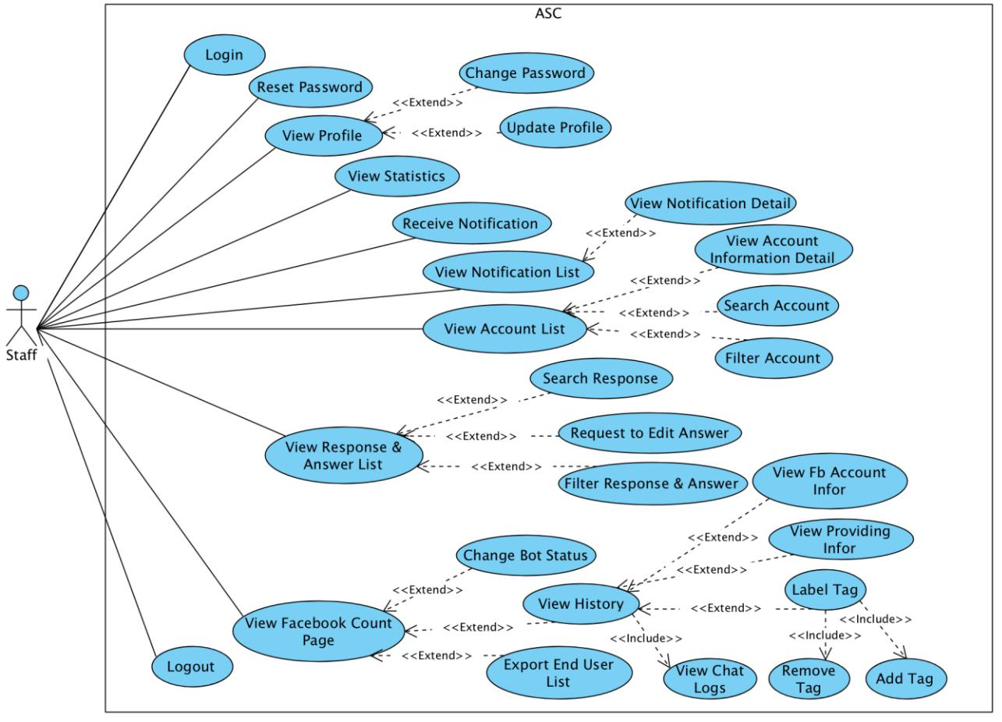

*Figure 3-11: Use case diagram of Staff actor*

***3.2.3.2.1 Reset password***

*Use Case Specification*

|  |  |  |  |  |
| --- | --- | --- | --- | --- |
| UC ID and Name: | **UC-4.0 Reset password** | |  |  |
|  |  |  |  |  |
| Created by: | **AnhDV** |  | Date Created: | **24/05/2018** |
|  |  |  |  |  |
| Primary Actor: | **Staff** |  | Secondary Actors: |  |
|  |  |  |  |  |
| Trigger: | N/A | |  |  |
|  |  | | |  |
| Description: | Allow Staff to reset a forgotten password. | | |  |
|  |  | | | |
| Preconditions: | **PRE-4.1**. Staff account has been set up and username and password has | | | |
|  | been generated. | |  |  |
|  |  | | | |
| Post conditions: | **POST-4.1**. New password is reset and sent to staff via his/her email. | | | |
|  |  |  |  |  |

|  |  |  |
| --- | --- | --- |
| Normal Flow: | **4.0 Reset password** | |
|  | 1. | Staff visits the dashboard page. |
|  | 2. | System displays Login page. |
|  | 3. | Staff clicks “Quên mật khẩu”. |
|  | 4. | System displays Forgot Password page. |
|  | 5. | Staff enters his/her email, then clicks “Xin cấp lại mật khẩu”. |
|  | 6. | System displays a message that asks the staff to check email and |
|  |  | follow instruction. |
|  | 7. | Staff clicks on the link in email. |
|  | 8. | System displays Reset Password page. |
|  | 9. | Staff is required to input password twice, then clicks “Xác nhận”. |
|  | 10. | System displays message “Thay đổi mật khẩu thành công”. |
|  | 11. | System displays Login page. |

|  |  |  |
| --- | --- | --- |
| Alternative Flows: | **4.0 User violates some business rule in step 5** | |
|  | 1. | System displays help message popup. |
|  | 2. | Staff enters email address complying the business rules then clicks |
|  |  | “Xin cấp lại mật khẩu”. |
|  | 3. | Go to step 6 in normal flow. |

**4.0 User violates some business rule in step 9**

1. System displays help message popup.

2. Staff enters password complying the business rules then clicks “Xác nhận”.

3. Go to step 10 in normal flow.

|  |  |
| --- | --- |
| Exceptions: | **4.0-E1 – Cannot communicate with server.** |
|  | 1. ASC displays error message. |
|  |  |
| Priority: | High |
|  |  |
| Frequency of Use: | Low |
|  |  |
| Business Rules: | **B5, B6, B8, B10, B11** |
|  |  |
| Other Information: | N/A |
|  |  |
| Assumptions: | N/A |

***3.2.3.2.2 Login***

*Use Case Specification*

|  |  |
| --- | --- |
| UC ID and Name: | **UC-5.0 Login** |
|  |  |

|  |  |  |  |
| --- | --- | --- | --- |
| Created by: | **TuanDM** | Date Created: | **24/05/2018** |
|  |  |  |  |
| Primary Actor: | **Staff** | Secondary Actors: |  |
|  |  |  |  |
| Trigger: | N/A |  |  |
|  |  |  |  |
| Description: | Allow Staff who has ASC account to login. | |  |
|  |  |  |  |
| Preconditions: | **PRE-5.1**. Staff account has been set up and username and password has | | |
|  | been generated. |  |  |
|  |  |  |  |
| Post conditions: | **POST-5.1**. The staff is logged into ASC successfully. | | |
|  | **POST-5.2**. System displays Dashboard Home Page. | | |
|  |  |  |  |
| Normal Flow: | **5.0 Login** |  |  |
|  | 1. Staff visits the website. | |  |
|  | 2. Staff fills valid username and password then clicks “Đăng nhập”. | | |
|  | 3. System displays Dashboard Home page. | | |
|  |  |  |  |
| Alternative Flows: | **5.0 Staff violates some business rule in step 2** | | |
|  | 1. System displays help message popup. | |  |
|  | 2. Staff enters username and password complying the business rules | | |
|  | then clicks “Đăng nhập”. | |  |
|  | 3. Go to step 3 in normal flow. | |  |
|  |  |  |  |
| Exceptions: | **5.0-E1 – Cannot communicate with server.** | |  |
|  | 1. ASC displays error message. | |  |
|  |  |  |  |
| Priority: | High |  |  |
|  |  |  |  |
| Frequency of Use: | High |  |  |
|  |  |  |  |
| Business Rules: | **B1, B9** |  |  |
|  |  |  |  |
| Other Information: | N/A |  |  |
|  |  |  |  |
| Assumptions: | N/A |  |  |
|  |  |  |  |
| ***3.2.3.2.3 View Statistics*** | |  |  |
| *Use Case Specification* | |  |  |
|  |  |  |  |
| UC ID and Name: | **UC-6.0 View Statistics** |  |  |
|  |  |  |  |
| Created by: | **AnhDV** | Date Created: | **24/05/2018** |
|  |  |  |  |
| Primary Actor: | **Staff** | Secondary Actors: |  |
|  |  |  |  |

|  |  |  |
| --- | --- | --- |
| Trigger: | N/A |  |
|  |  | |
| Description: | Allow Staff to view statistics about majors, feedbacks, number of end | |
|  | users. |  |
|  |  | |
| Preconditions: | **PRE-6.1.** Staff can access the system. | |
|  | **PRE-6.2.** Staff logins successfully. | |
|  |  | |
| Post conditions: | **POST-6.1.** System displays statistics. | |
|  |  | |
| Normal Flow: | **6.0 View Statistics** | |
|  | 1. | From index page, system displays statistics using 4 cards and 2 |
|  |  | charts: |
|  | 2. | Card about the number of all end users asking. |
|  | 3. | The number of new end users asking today. |
|  | 4. | The number of old end users asking today. |
|  | 5. | The number of end users proving personal information. |
|  | 6. | Pie chart about FU academic majors. |
|  | 7. | Bar chart about the number of end user’s feedback. |
|  |  |  |
| Alternative Flows: | N/A |  |
|  |  |  |
| Exceptions: | **6.0-E1** | **– Cannot communicate with server.** |
|  | 1. | ASC displays error message. |
|  |  |  |
| Priority: | High |  |
|  |  | |
| Frequency of Use: | Medium | |
|  |  |  |
| Business Rules: | **N/A** |  |
|  |  |  |
| Other Information: | N/A |  |
|  |  |  |
| Assumptions: | N/A |  |
|  |  |  |

***3.2.3.2.4 View Profile***

*Use Case Specification*

|  |  |  |  |
| --- | --- | --- | --- |
| UC ID and Name: | **UC-7.0 View Profile** |  |  |
|  |  |  |  |
| Created by: | **DuNV** | Date Created: | **24/05/2018** |
|  |  |  |  |
| Primary Actor: | **Staff** | Secondary Actors: |  |
|  |  |  |  |
| Trigger: | N/A |  |  |
|  |  |  |  |

|  |  |  |  |  |  |  |
| --- | --- | --- | --- | --- | --- | --- |
| Description: | Allow all staffs to view his/her personal profile. | | | | | |
|  |  | | |  | |  |
| Preconditions: | **PRE-7.1.** Staff can access the system. | | | | |  |
|  | **PRE-7.2.** Staff logins successfully. | | | | |  |
|  |  | | |  | |  |
| Post conditions: | **POST-7.1.** System displays the staff profile page. | | | | | |
|  |  | | |  |  |  |
| Normal Flow: | **7.0 View Profile** | | | |  |  |
|  | 1. | From the website header, staff clicks on avatar icon in the top right | | | | |
|  |  | corner. | | |  |  |
|  | 2. | Staff clicks “Trang cá nhân”. | | | |  |
|  | 3. | System displays the staff profile page with following tab: | | | | |
|  |  | o Thông tin tài khoản | | | |  |
|  |  | o | Tên tài khoản | |  |  |
|  |  | o | Vai trò | |  |  |
|  |  | o Thông tin liên hệ | | | |  |
|  |  | o | Họ và tên | |  |  |
|  |  | o | Email | |  |  |
|  |  | o | Số điện thoại | |  |  |
|  |  | o | Địa chỉ | |  |  |
|  |  |  |  |  |  |  |
| Alternative Flows: | N/A |  |  |  |  |  |
|  |  |  | |  | |  |
| Exceptions: | **7.0-E1** | **– Cannot communicate with server.** | | | |  |
|  | 1. | ASC displays error message. | | | |  |
|  |  | |  |  |  |  |
| Priority: | Medium | |  |  |  |  |
|  |  | |  |  |  |  |
| Frequency of Use: | Medium | |  |  |  |  |
|  |  |  |  |  |  |  |
| Business Rules: | **N/A** |  |  |  |  |  |
|  |  |  |  |  |  |  |
| Other Information: | N/A |  |  |  |  |  |
|  |  |  |  |  |  |  |
| Assumptions: | N/A |  |  |  |  |  |
|  |  |  |  |  |  |  |
| ***3.2.3.2.5 Update Profile*** | |  |  |  |  |  |
| *Use Case Specification* | |  |  |  |  |  |
|  |  | | |  |  |  |
| UC ID and Name: | **UC-8.0 Update Profile** | | | |  |  |
|  |  | | |  |  |  |
| Created by: | **QuynhDTT** | | |  | Date Created: | **26/05/2018** |
|  |  |  |  |  |  |  |
| Primary Actor: | **Staff** |  |  |  | Secondary Actors: |  |
|  |  |  |  |  |  |  |
| Trigger: | N/A |  |  |  |  |  |
|  |  |  |  |  |  |  |

|  |  |  |
| --- | --- | --- |
| Description: | Allow Staff to update his/her basic information after signing in. | |
|  |  | |
| Preconditions: | **PRE-8.1.** Staff can access the system. | |
|  | **PRE-8.2.** Staff logins successfully. | |
|  |  | |
| Post conditions: | **POST-8.1.** New staff profile is saved into database. | |
|  | **POST-8.2.** New updated profile is displayed in profile page. | |
|  |  | |
| Normal Flow: | **8.0 Update Profile** | |
|  | 1. | From the website header, staff clicks on avatar icon in the top right |
|  |  | corner. |
|  | 2. | Staff clicks “Trang cá nhân”. |
|  | 3. | System displays the Staff profile. |
|  | 4. | Staff can edit information about fullname, address, phone, email. |
|  | 5. | Staff clicks “Lưu thông tin cá nhân” to save the changed |
|  |  | inforamtion. |
|  | 6. | System saves changed into database then displays updated profile |
|  |  | information. |
|  |  | |
| Alternative Flows: | **8.0 Staff violates some business rule in step 4** | |
|  | 1. | System displays help message under each input area. |
|  | 2. | Staff enters fullname, email, phone and address complying the |
|  |  | business rules then clicks “Lưu thông tin cá nhân”. |
|  | 3. | Go to step 6 in normal flow. |
|  |  |  |
| Exceptions: | **8.0-E1** | **– Cannot communicate with server.** |
|  | 1. | ASC displays error message. |
|  |  | |
| Priority: | Medium | |
|  |  |  |
| Frequency of Use: | Low |  |
|  |  | |
| Business Rules: | **B3, B4, B5, B6, B7, B14, B15** | |
|  |  |  |
| Other Information: | N/A |  |
|  |  |  |
| Assumptions: | N/A |  |
|  |  |  |

***3.2.3.2.6*** ***Change Password***

*Use Case Specification*

UC ID and Name: **UC-9.0 Change password**

|  |  |  |  |
| --- | --- | --- | --- |
| Created by: | **AnhDV** | Date Created: | **26/05/2018** |
|  |  |  |  |

|  |  |  |  |
| --- | --- | --- | --- |
| Primary Actor: | **Staff** | Secondary Actors: |  |
|  |  |  |  |
| Trigger: | N/A |  |  |
|  |  |  |  |
| Description: | Allow Staff to change his/her account password. | | |
|  |  |  |  |
| Preconditions: | **PRE-9.1.** Staff can access the system. | |  |
|  | **PRE-9.2.** Staff logins successfully. | |  |
|  |  |  |  |
| Post conditions: | **POST-9.1.** New password is saved into database. | | |
|  | **POST-9.2.** Staff logins successfully with new password. | | |
|  |  |  |  |
| Normal Flow: | **9.0 Change Password** |  |  |
|  | 1. From the website header, staff clicks on avatar icon in the top right | | |
|  | corner. |  |  |
|  | 2. Staff clicks “Thay đổi mật khẩu” | |  |
|  | 3. System displays the Change Password page. | | |
|  | 4. Staff enters current password, new password and re-enter password | | |
|  | in the corresponding text boxes. | |  |
|  | 5. Staff clicks “Đổi mật khẩu”. | |  |
|  | **6.** System saves new data into database. | |  |
|  |  |  |  |
| Alternative Flows: | N/A |  |  |
|  |  |  |  |
| Exceptions: | **9.0-E1 – Cannot communicate with server.** | |  |
|  | 1. ASC displays error message. | |  |
|  |  |  |  |
| Priority: | High |  |  |
|  |  |  |  |
| Frequency of Use: | Low |  |  |
|  |  |  |  |
| Business Rules: | **B8, B9, B11** |  |  |
|  |  |  |  |
| Other Information: | N/A |  |  |
|  |  |  |  |
| Assumptions: | N/A |  |  |
|  |  |  |  |
| ***3.2.3.2.7 View Account List*** | |  |  |
| *Use Case Specification* | |  |  |
|  |  |  |  |
| UC ID and Name: | **UC-10.0 View Account List** | |  |
|  |  |  |  |
| Created by: | **AnhDV** | Date Created: | **26/05/2018** |
|  |  |  |  |
| Primary Actor: | **Staff** | Secondary Actors: |  |
|  |  |  |  |
| Trigger: | N/A |  |  |
|  |  |  |  |

|  |  |  |  |  |  |
| --- | --- | --- | --- | --- | --- |
| Description: | Allow Staff to view the list of accounts in the system. | | | | |
|  |  |  | |  |  |
| Preconditions: | **PRE-10.1.** Staff can access the system. | | | |  |
|  | **PRE-10.2.** Staff logins successfully. | | | |  |
|  | **PRE-10.3.** Account data has been added to the system by the admin. | | | | |
|  |  |  | |  | |
| Post conditions: | System displays the account list screen with necessary elements. | | | | |
|  |  |  |  |  |  |
| Normal Flow: | **10.0 View Account List** | |  |  |  |
|  | 1. Staff clicks on “Tất cả tài khoản” on menu in the left side bar of the | | | | |
|  | screen. | |  |  |  |
|  | 2. System displays list of all accounts. | | | |  |
|  |  |  |  |  |  |
| Alternative Flows: | N/A | |  |  |  |
|  |  |  | |  |  |
| Exceptions: | **10.0-E1 – Cannot communicate with server.** | | | |  |
|  | 1. ASC displays error message. | | | |  |
|  |  |  |  |  |  |
| Priority: | Medium | |  |  |  |
|  |  |  |  |  |  |
| Frequency of Use: | Medium | |  |  |  |
|  |  |  |  |  |  |
| Business Rules: | **N/A** | |  |  |  |
|  |  |  |  |  |  |
| Other Information: | N/A | |  |  |  |
|  |  |  |  |  |  |
| Assumptions: | N/A | |  |  |  |
|  |  |  |  |  |  |
| ***3.2.3.2.8 View Account Information Detail*** | | |  |  |  |
| *Use Case Specification* | | |  |  |  |
|  |  |  | |  |  |
| UC ID and Name: | **UC-11.0 View Account Information Detail** | | | |  |
|  |  |  |  |  |  |
| Created by: | **AnhDV** |  | Date Created: |  | **26/05/2018** |
|  |  |  |  |  |  |
| Primary Actor: | **Staff** |  | Secondary Actors: |  |  |
|  |  |  |  |  |  |
| Trigger: | N/A | |  |  |  |
|  |  | | | | |
| Description: | Allow Staff to view detail information of an account. | | | | |
|  |  | | | |  |
| Preconditions: | **PRE-11.1.** Staff can access the system. | | | |  |
|  | **PRE-11.2.** Staff logins successfully. | | | |  |
|  | **PRE-11.3.** Account data has been added to the system by the admin. | | | | |
|  |  | | | | |
| Post conditions: | System displays a model with chosen account information. | | | | |
|  |  |  |  |  |  |

|  |  |  |
| --- | --- | --- |
| Normal Flow: | **11.0 View Account Information** | |
|  | 1. | Staff clicks on “Tất cả tài khoản” on the left side of the screen. |
|  | 2. | System displays list of all accounts. |
|  | 3. | Staff clicks “Xem” button on each row in table. |
|  | 4. | System displays account information. |
|  |  |  |
| Alternative Flows: | N/A |  |
|  |  | |
| Exceptions: | **11.0-E1 – Cannot communicate with server.** | |
|  | 1. | ASC displays error message. |
|  |  | |
| Priority: | Medium | |
|  |  |  |
| Frequency of Use: | Low |  |
|  |  |  |
| Business Rules: | **N/A** |  |
|  |  |  |
| Other Information: | N/A |  |
|  |  |  |
| Assumptions: | N/A |  |
|  |  |  |

***3.2.3.2.9*** ***Search Account***

Use Case Specification

***3.2.3.2.9.1 Search Account by Username***

|  |  |  |  |  |
| --- | --- | --- | --- | --- |
| UC ID and Name: | **UC-12.0 Search Account by Username** | | |  |
|  |  | |  |  |
| Created by: | **TuanDM** | | Date Created: | **26/05/2018** |
|  |  |  |  |  |
| Primary Actor: | **Staff** |  | Secondary Actors: |  |
|  |  |  |  |  |
| Trigger: | N/A |  |  |  |
|  |  | | | |
| Description: | Allow Staff to search account(s) belong to username. | | | |
|  |  | | |  |
| Preconditions: | **PRE-12.1.** Staff can access the system. | | |  |
|  | **PRE-12.2.** Staff logins successfully. | | |  |
|  | **PRE-12.3.** Account data has been added to the system by the admin. | | | |
|  |  |  |  |  |
| Post conditions: | N/A |  |  |  |
|  |  | | |  |
| Normal Flow: | **12.0 Search Account by Username** | | |  |
|  | 1. | Staff clicks on “Tất cả tài khoản” on the left side of the screen. | | |
|  | 2. | System displays table of all accounts. | |  |
|  | 3. | In the “Tài khoản” text box, staff enters text. | | |
|  |  |  |  |  |

1. System displays account(s) that related to search keyword.

Alternative Flows:N/A

|  |  |
| --- | --- |
| Exceptions: | **12.0-E1 – Cannot communicate with server.** |
|  | 1. ASC displays error message. |
|  |  |
| Priority: | Medium |
|  |  |
| Frequency of Use: | Medium |

|  |  |
| --- | --- |
| Business Rules: | **N/A** |
|  |  |
| Other Information: | N/A |
|  |  |
| Assumptions: | N/A |

***3.2.3.2.9.2 Search Account by Fullname***

|  |  |  |  |  |
| --- | --- | --- | --- | --- |
| UC ID and Name: | **UC-12.0 Search Account by Fullname** | | |  |
|  |  | |  |  |
| Created by: | **TuanDM** | | Date Created: | **26/05/2018** |
|  |  |  |  |  |
| Primary Actor: | **Staff** |  | Secondary Actors: |  |
|  |  |  |  |  |
| Trigger: | N/A |  |  |  |
|  |  | | |  |
| Description: | Allow Staff to search account by fullname. | | |  |
|  |  | | |  |
| Preconditions: | **PRE-12.1.** Staff can access the system. | | |  |
|  | **PRE-12.2.** Staff logins successfully. | | |  |
|  | **PRE-12.3.** Account data has been added to the system by the admin. | | | |
|  |  |  |  |  |
| Post conditions: | N/A |  |  |  |
|  |  | | |  |
| Normal Flow: | **12.0 Search Account by Fullname** | | |  |
|  | 1. | Staff clicks on “Tất cả tài khoản” on the left side of the screen. | | |
|  | 2. | System displays account list. | |  |
|  | 3. | In the “Họ và tên” text box, staff enters text. | | |
|  | 4. | System displays account list that related to search keyword. | | |
|  |  |  |  |  |
| Alternative Flows: | N/A |  |  |  |

Exceptions: **12.0-E1 – Cannot communicate with server.**

1. ASC displays error message.

Priority:Medium

|  |  |
| --- | --- |
| Frequency of Use: | Medium |

|  |  |
| --- | --- |
| Business Rules: | **N/A** |

Other Information: N/A

Assumptions: N/A

***3.2.3.2.10 Filter Account***

Use Case Specification

***3.2.3.2.10.1 Filter Account by Role***

|  |  |  |  |  |
| --- | --- | --- | --- | --- |
| UC ID and Name: | **UC-13.0 Filter Account by Role** | | |  |
|  |  |  |  |  |
| Created by: | **TuanDM** | Date Created: |  | **26/05/2018** |
|  |  |  |  |  |
| Primary Actor: | **Staff** | Secondary Actors: |  |  |
|  |  |  |  |  |
| Trigger: | N/A |  |  |  |
|  |  | | |  |
| Description: | Allow Staff to filter accounts by role. | | |  |
|  |  | | |  |
| Preconditions: | **PRE-13.1.** Staff can access the system. | | |  |
|  | **PRE-13.2.** Staff logins successfully. | | |  |
|  | **PRE-13.3.** Account data has been added to the system by the admin. | | | |
|  |  |  |  |  |
| Post conditions: | N/A |  |  |  |
|  |  | | |  |
| Normal Flow: | **13.0 Filter Account by Role** | | |  |
|  | 1. Staff clicks role dropdown button | | |  |
|  | 2. System displays role list in dropdown list. | | | |
|  | 3. Staff selects a specific role. | | |  |
|  | 4. System hided role list and displays selected role and accounts list | | | |
|  | related to selected role. | | |  |
|  |  |  |  |  |
| Alternative Flows: | N/A |  |  |  |
|  |  | | |  |
| Exceptions: | **13.0-E1 – Cannot communicate with server.** | | |  |
|  | 1. ASC displays error message. | | |  |
|  |  |  |  |  |
| Priority: | Medium |  |  |  |
|  |  |  |  |  |
| Frequency of Use: | Medium |  |  |  |
|  |  |  |  |  |
| Business Rules: | **N/A** |  |  |  |
|  |  |  |  |  |
| Other Information: | N/A |  |  |  |
|  |  |  |  |  |
| Assumptions: | N/A |  |  |  |
|  |  |  |  |  |

***3.2.3.2.10.2 Filter Account by Status***

|  |  |  |  |  |
| --- | --- | --- | --- | --- |
| UC ID and Name: | **UC-13.0 Filter Account by Status** | | |  |
|  |  |  |  |  |
| Created by: | **TuanDM** | Date Created: |  | **26/05/2018** |
|  |  |  |  |  |
| Primary Actor: | **Staff** | Secondary Actors: |  |  |
|  |  |  |  |  |
| Trigger: | N/A |  |  |  |
|  |  |  |  |  |
| Description: | Allow Staff to filter account by status. | | |  |
|  |  |  |  |  |
| Preconditions: | **PRE-13.1.** Staff can access the system. | | |  |
|  | **PRE-13.2.** Staff logins successfully. | | |  |
|  | **PRE-13.3.** Account data has been added to the system by the admin. | | | |
|  |  |  |  |  |
| Post conditions: | N/A |  |  |  |
|  |  |  |  |  |
| Normal Flow: | **13.0 Filter Account by Status** | | |  |
|  | 1. Staff clicks on status dropdown button. | | |  |
|  | 2. System displays status list in dropdown list. | | | |
|  | 3. Staff selects a specific status. | | |  |
|  | 4. System hided status list and displays selected state and accounts list | | | |
|  | related to selected status. | | |  |
|  |  |  |  |  |
| Alternative Flows: | N/A |  |  |  |
|  |  |  |  |  |
| Exceptions: | **13.0-E1 – Cannot communicate with server.** | | |  |
|  | 1. ASC displays error message. | | |  |
|  |  |  |  |  |
| Priority: | Medium |  |  |  |
|  |  |  |  |  |
| Frequency of Use: | Medium |  |  |  |
|  |  |  |  |  |
| Business Rules: | **N/A** |  |  |  |
|  |  |  |  |  |
| Other Information: | N/A |  |  |  |
|  |  |  |  |  |
| Assumptions: | N/A |  |  |  |
|  |  |  |  |  |
| ***3.2.3.2.11 View Response & Answer List*** | |  |  |  |
| *Use Case Specification* | |  |  |  |
|  |  |  |  |  |
| UC ID and Name: | **UC-14.0 View Response & Answer List** | | |  |
|  |  |  |  |  |
| Created by: | **AnhDV** | Date Created: |  | **26/05/2018** |
|  |  |  |  |  |
| Primary Actor: | **Staff** | Secondary Actors: |  |  |
|  |  |  |  |  |

|  |  |
| --- | --- |
| Trigger: | N/A |
|  |  |
| Description: | Allow Staff to view list of responses regarding answers. |
|  |  |
| Preconditions: | **PRE-14.1.** Staff can access the system. |
|  | **PRE-14.2.** Staff logins successfully. |
|  |  |
| Post conditions: | System displays response and answer. |
|  |  |
| Normal Flow: | **14.0 View Response & Answer List** |
|  | 1. Staff clicks on “Quản lí dữ liệu của Chatbot” on the left side of the |
|  | screen. |
|  | 2. System displays list of responses regarding answers. |
|  |  |
| Alternative Flows: | N/A |
|  |  |
| Exceptions: | **14.0-E1 – Cannot communicate with server.** |
|  | 1. ASC displays error message. |
|  |  |
| Priority: | Medium |
|  |  |
| Frequency of Use: | Low |
|  |  |
| Business Rules: | **N/A** |
|  |  |
| Other Information: | N/A |
|  |  |
| Assumptions: | N/A |
|  |  |

***3.2.3.2.12 Filter Response & Answer***

*Use Case Specification*

|  |  |  |  |
| --- | --- | --- | --- |
| UC ID and Name: | **UC-15.0 Filter Response & Answer** | |  |
|  |  |  |  |
| Created by: | **QuynhDTT** | Date Created: | **26/05/2018** |
|  |  |  |  |
| Primary Actor: | **Staff** | Secondary Actors: |  |
|  |  |  |  |
| Trigger: | N/A |  |  |
|  |  | |  |
| Description: | Allow Staff to filter response and answer. | |  |
|  |  | |  |
| Preconditions: | **PRE-15.1.** Staff can access the system. | |  |
|  | **PRE-15.2.** Staff logins successfully. | |  |
|  | **PRE-15.3.** Response and Answer data has been added to the system by the | | |
|  | admin. |  |  |
|  |  | | |
| Post conditions: | **POST-15.1.** System displays filtered response and answer. | | |
|  |  |  |  |

|  |  |  |  |  |
| --- | --- | --- | --- | --- |
| Normal Flow: | **15.0 Filter Response & Answer.** | | |  |
|  | 1. Staff clicks on intent dropdown butoon. | | |  |
|  | 2. System displays intent list in dropdown list. | | | |
|  | 3. Staff selects a specific intent. | | |  |
|  | 4. System hided intent list and displays selected intent and responses | | | |
|  | regarding answers list related to selected intent. | | | |
|  |  |  |  |  |
| Alternative Flows: | N/A |  |  |  |
|  |  |  |  |  |
| Exceptions: | **15.0-E1 – Cannot communicate with server.** | | |  |
|  | 1. ASC displays error message. | | |  |
|  |  |  |  |  |
| Priority: | Medium |  |  |  |
|  |  |  |  |  |
| Frequency of Use: | Low |  |  |  |
|  |  |  |  |  |
| Business Rules: | **N/A** |  |  |  |
|  |  |  |  |  |
| Other Information: | N/A |  |  |  |
|  |  |  |  |  |
| Assumptions: | N/A |  |  |  |
|  |  |  |  |  |
| ***3.2.3.2.13 Search Response*** | |  |  |  |
| *Use Case Specification* | |  |  |  |
|  |  |  |  |  |
| UC ID and Name: | **UC-16.0 Search Response** | | |  |
|  |  |  |  |  |
| Created by: | **QuynhDTT** | Date Created: |  | **26/05/2018** |
|  |  |  |  |  |
| Primary Actor: | **Staff** | Secondary Actors: |  |  |
|  |  |  |  |  |
| Trigger: | N/A |  |  |  |
|  |  | | |  |
| Description: | Allow Staff to search chatbot response(s). | | |  |
|  |  | | |  |
| Preconditions: | **PRE-16.1.** Staff can access the system. | | |  |
|  | **PRE-16.2.** Staff logins successfully. | | |  |
|  | **PRE-16.3.** Response data has been added to the system by the admin. | | | |
|  |  | | | |
| Post conditions: | **POST-16.1.** System displays searched responses regarding answers. | | | |
|  |  |  |  |  |
| Normal Flow: | **16.0 Search Response** |  |  |  |

1. Staff clicks on “Quản lí dữ liệu của Chatbot” on the left side of the screen.
2. System displays responses regarding answers list.
3. In the response textbox, Staff enters text.

|  |  |
| --- | --- |
|  | 4. System displays response regarding answers list related to search |
|  | keyword. |
|  |  |
| Alternative Flows: | N/A |
|  |  |
| Exceptions: | **12.0-E1 – Cannot communicate with server.** |

1. ASC displays error message.

Priority:Medium

|  |  |
| --- | --- |
| Frequency of Use: | Low |
|  |  |
| Business Rules: | **N/A** |
|  |  |
| Other Information: | N/A |
|  |  |
| Assumptions: | N/A |

***3.2.3.2.14 Request to Edit Answer***

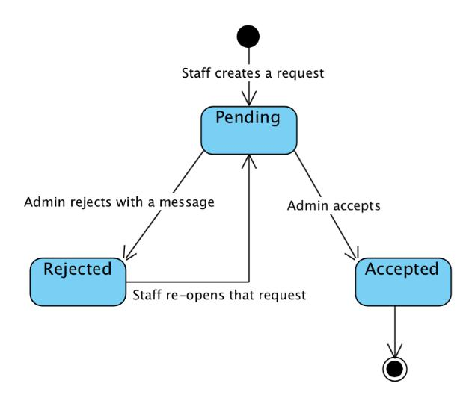

*Figure 3-12: Answer Editing Request state machine diagram*

*Use Case Specification*

|  |  |  |  |
| --- | --- | --- | --- |
| UC ID and Name: | **UC-17.0 Request to Edit Answer** | |  |
|  |  |  |  |
| Created by: | **QuynhDTT** | Date Created: | **26/05/2018** |
|  |  |  |  |
| Primary Actor: | **Staff** | Secondary Actors: |  |
|  |  |  |  |
| Trigger: | N/A |  |  |
|  |  | | |
| Description: | Allow Staff to request to edit an answer of chatbot. | | |
|  |  | |  |
| Preconditions: | **PRE-17.1.** Staff can access the system. | |  |
|  | **PRE-17.2.** Staff logins successfully. | |  |
|  |  |  |  |

|  |  |  |
| --- | --- | --- |
|  | **PRE-17.3.** Answer data has been added to the system by the admin. | |
|  |  | |
| Post conditions: | **POST-17.1.** An answer editing request is successfully submitted and | |
|  | noticed to admin. | |
|  |  | |
| Normal Flow: | **17.0 Edit Answer** | |
|  | 1. | Staff clicks “Quản lí dữ liệu của Chatbot” on the left side of the |
|  |  | screen. |
|  | 2. | System displays response regarding answers list. |
|  | 3. | In each row of answer, Staff clicks on edit button. |
|  | 4. | Staff enters new answer. |
|  | 5. | Staff clicks “Lưu”. |
|  | 6. | System saves new answer editing request into database with |
|  |  | pending status. |
|  |  |  |
| Alternative Flows: | N/A |  |
|  |  | |
| Exceptions: | **17.0-E1 – Cannot communicate with server** | |
|  | 1. | ASC displays error message. |
|  |  | |
| Priority: | Medium | |
|  |  |  |
| Frequency of Use: | Low |  |
|  |  | |
| Business Rules: | **B20, B21, B22** | |
|  |  |  |
| Other Information: | N/A |  |
|  |  |  |
| Assumptions: | N/A |  |
|  |  |  |

***3.2.3.2.15 Receive notification***

*Use Case Specification*

|  |  |  |  |
| --- | --- | --- | --- |
| UC ID and Name: | **UC-18.0 Receive notification** | |  |
|  |  |  |  |
| Created by: | **TuanDM** | Date Created: | **08/06/2018** |
|  |  |  |  |
| Primary Actor: | **Staff** | Secondary Actors: |  |
|  |  |  |  |
| Trigger: | An chatbot editing answer, end user’s request or changing account detail | | |
|  | from admin, which is related to Staff, is created. | | |
|  |  | |  |
| Description: | Allow Staff to receive notification. | |  |
|  |  | |  |
| Preconditions: | **PRE-18.1.** Staff can access the system. | |  |
|  | **PRE-18.2.** Staff logins successfully. | |  |
|  |  |  |  |

|  |  |  |
| --- | --- | --- |
|  | **PRE-18.3.** Admin deactivates account successfully. | |
|  | **PRE-18.4.** Admin changes role of account. | |
|  | **PRE-18.5.** Staff request to edit chatbot answer. | |
|  | **PRE-18.6.** Admin rejects answer editing request. | |
|  | **PRE-18.7.** Admin accepts answer editing request. | |
|  | **PRE-18.7.** End User requests to contact. | |
|  |  | |
| Post conditions: | **POST-18.1.** Staff receives notification. | |
|  |  | |
| Normal Flow: | **18.0 Account is deactivated.** | |
|  | 1. | Admin deactivates staff’s account. |
|  | 2. | Staff receives notification. |
|  | **18.1 Role of account is changed.** | |
|  | 1. | Admin changes staff’s role. |
|  | 2. | Staff receives notification. |
|  | **18.2 Staff request to edit Answer.** | |
|  | 1. | Staff submits a request for editing answers. |
|  | 2. | Admin receives notification. |
|  | **18.3 Answer is rejected.** | |
|  | 1. | Admin rejects answer editing request. |
|  | 2. | Staff receives notification that your request has been rejected. |
|  | **18.4 Answer is accepted.** | |
|  | 1. | Admin accepts answer editing request. |
|  | 2. | Staff receives notification that your request has been accepted. |
|  | **18.5 End User requests to contact.** | |
|  | 1. | End User send a call back or chatting request with staff . |
|  | 2. | Admin receives notifications. |
|  |  |  |
| Alternative Flows: | N/A |  |
|  |  | |
| Exceptions: | **18.0-E1 – Cannot communicate with server.** | |
|  | 1. | ASC displays error message. |
|  |  |  |
| Priority: | High |  |
|  |  |  |
| Frequency of Use: | High |  |
|  |  |  |
| Business Rules: | **N/A** |  |
|  |  |  |
| Other Information: | N/A |  |
|  |  |  |

Assumptions: N/A

***3.2.3.2.16 View notification list***

*Use Case Specification*

|  |  |  |  |  |
| --- | --- | --- | --- | --- |
| UC ID and Name: | **UC-19.0 View notification list** | | |  |
|  |  |  |  |  |
| Created by: | **TuanDM** | Date Created: |  | **08/06/2018** |
|  |  |  |  |  |
| Primary Actor: | **Staff** | Secondary Actors: |  |  |
|  |  |  |  |  |
| Trigger: | N/A |  |  |  |
|  |  | | | |
| Description: | Allow Staff to view notifications about account status, answer editing | | | |
|  | request status, end user’s contact request. | | |  |
|  |  | | |  |
| Preconditions: | **PRE-19.1.** Staff can access the system. | | |  |
|  | **PRE-19.2.** Staff logins successfully. | | |  |
|  | **PRE-19.3.** Staff has an action history. | | |  |
|  |  | | | |
| Post conditions: | **POST-19.1.** System resets notification count to zero. | | | |
|  |  | | |  |
| Normal Flow: | **19.0 View notification list** | | |  |
|  | 1. On top right of navigation bar, Staff clicks on the notification icon. | | | |
|  | 2. System displays dropdown menu to show all notifications. | | | |
|  | 3. Staff scrolls down to view more notifications. | | | |
|  | 4. System changes status of all notifications to read. | | | |
|  |  |  |  |  |
| Alternative Flows: | N/A |  |  |  |
|  |  | | |  |
| Exceptions: | **19.0-E1 – Cannot communicate with server.** | | |  |
|  | 1. ASC displays error message. | | |  |
|  |  |  |  |  |
| Priority: | High |  |  |  |
|  |  |  |  |  |
| Frequency of Use: | Medium |  |  |  |
|  |  |  |  |  |
| Business Rules: | **N/A** |  |  |  |
|  |  |  |  |  |
| Other Information: | N/A |  |  |  |
|  |  |  |  |  |
| Assumptions: | N/A |  |  |  |
|  |  |  |  |  |

***3.2.3.2.17 View notification detail***

*Use Case Specification*

|  |  |  |  |  |
| --- | --- | --- | --- | --- |
| UC ID and Name: | **UC-20.0 View notification detail** | | |  |
|  |  |  |  |  |
| Created by: | **TuanDM** | Date Created: |  | **08/06/2018** |
|  |  |  |  |  |
| Primary Actor: | **Staff** | Secondary Actors: |  |  |
|  |  |  |  |  |
| Trigger: | Mark selected notification as read. | | |  |
|  |  |  |  | |
| Description: | Allow Staff to view specific content to the notification. | | | |
|  |  |  |  |  |
| Preconditions: | **PRE-20.1.** Staff can access the system. | | |  |
|  | **PRE-20.2.** Staff logins successfully. | | |  |
|  | **PRE-20.3.** Staff has notification(s). | | |  |
|  |  |  |  | |
| Post conditions: | **POST-20.1.** Redirect to specific content correspond to each notification. | | | |
|  |  |  |  |  |
| Normal Flow: | **20.0 View notification detail** | | |  |
|  | 1. Staff clicks on the notification icon on top right of navigation bar. | | | |
|  | 2. Staff clicks on a notification in notification list. | | | |
|  |  |  |  |  |
| Alternative Flows: | N/A |  |  |  |
|  |  |  |  |  |
| Exceptions: | **20.0-E1 – Cannot communicate with server.** | | |  |
|  | 1. ASC displays error message. | | |  |
|  |  |  |  |  |
| Priority: | High |  |  |  |
|  |  |  |  |  |
| Frequency of Use: | Medium |  |  |  |
|  |  |  |  |  |
| Business Rules: | **N/A** |  |  |  |
|  |  |  |  |  |
| Other Information: | N/A |  |  |  |
|  |  |  |  |  |
| Assumptions: | N/A |  |  |  |
|  |  |  |  |  |
| ***3.2.3.2.18 View Facebook Count Page*** | |  |  |  |
| *Use Case Specification* | |  |  |  |
|  |  |  |  |  |
| UC ID and Name: | **UC-21.0 View Facebook Count Page** | | |  |
|  |  |  |  |  |
| Created by: | **AnhDV** | Date Created: |  | **26/05/2018** |
|  |  |  |  |  |
| Primary Actor: | **Staff** | Secondary Actors: |  |  |
|  |  |  |  |  |
| Trigger: | N/A |  |  |  |
|  |  | | | |
| Description: | Allow Staff to view list of end user’s information. | | | |
|  |  | | |  |
| Preconditions: | **PRE-21.1.** Staff can access the system. | | |  |
|  |  |  |  |  |

|  |  |  |  |  |  |  |
| --- | --- | --- | --- | --- | --- | --- |
|  | **PRE-21.2.** Staff logins successfully. | | | |  |  |
|  |  | |  | | |  |
| Post conditions: | System displays all end users interacting with the chatbot. | | | | | |
|  |  | |  | |  |  |
| Normal Flow: | **21.0 View Facebook Count Page** | | | |  |  |
|  | 1. Staff clicks “Quản lí dữ liệu từ Facebook” on the left side of the | | | | | |
|  |  | screen. | |  |  |  |
|  | 2. System displays | | | a table of all | Facebook accounts having a | |
|  |  | conversation with the chatbot. Some information is displayed with | | | | |
|  |  | each of account: | |  |  |  |
|  | 3. | Fb name | |  |  |  |
|  | 4. Count of his/her messages | | | |  |  |
|  | 5. | Current Bot status | | |  |  |
|  | 6. | Labeling tag | |  |  |  |
|  |  |  |  |  |  |  |
| Alternative Flows: | N/A |  |  |  |  |  |
|  |  | |  | | |  |
| Exceptions: | **21.0-E1 – Cannot communicate with server.** | | | | | |
|  | 1. ASC displays error message. | | | |  |  |
|  |  | |  |  |  |  |
| Priority: | Medium | | |  |  |  |
|  |  |  |  |  |  |  |
| Frequency of Use: | Low |  |  |  |  |  |
|  |  |  |  |  |  |  |
| Business Rules: | **N/A** |  |  |  |  |  |
|  |  |  |  |  |  |  |
| Other Information: | N/A |  |  |  |  |  |
|  |  |  |  |  |  |  |
| Assumptions: | N/A |  |  |  |  |  |
|  |  |  |  |  |  |  |
| ***3.2.3.2.19 View Chat Logs*** | |  |  |  |  |  |
| *Use Case Specification* | |  |  |  |  |  |
|  |  | |  | |  |  |
| UC ID and Name: | **UC-22.0 View Chat Logs** | | | |  |  |
|  |  | |  |  |  |  |
| Created by: | **AnhDV** | |  | Date Created: |  | **26/05/2018** |
|  |  |  |  |  | |  |
| Primary Actor: | **Staff** |  |  | Secondary Actors: | |  |
|  |  |  |  |  |  |  |
| Trigger: | N/A |  |  |  |  |  |
|  |  | | | | | |
| Description: | Allow Staff to view conversation history between specific end user and the | | | | | |
|  | chatbot. | | |  |  |  |
|  |  | | | |  |  |
| Preconditions: | **PRE-22.1.** Staff can access the system. | | | |  |  |
|  | **PRE-22.2.** Staff logged in. | | | |  |  |
|  |  | | | |  |  |
| Post conditions: | System displays conversation history. | | | |  |  |
|  |  |  |  |  |  |  |

|  |  |  |  |  |
| --- | --- | --- | --- | --- |
| Normal Flow: | **22.0 View Chat Logs** |  |  |  |
|  | 1. Staff clicks “Lịch sử hội thoại” on each row of facebook account | | | |
|  | table. |  |  |  |
|  | 2. System displays the history of all messages from end user. | | | |
|  | 3. Staff clicks “Xem thêm” to view more messages. | | | |
|  |  |  |  |  |
| Alternative Flows: | N/A |  |  |  |
|  |  |  |  |  |
| Exceptions: | **22.0-E1 – Cannot communicate with server.** | | |  |
|  | 1. ASC displays error message. | | |  |
|  |  |  |  |  |
| Priority: | Low |  |  |  |
|  |  |  |  |  |
| Frequency of Use: | Medium |  |  |  |
|  |  |  |  |  |
| Business Rules: | **N/A** |  |  |  |
|  |  |  |  |  |
| Other Information: | N/A |  |  |  |
|  |  |  |  |  |
| Assumptions: | N/A |  |  |  |
|  |  |  |  |  |
| ***3.2.3.2.20 View Fb Account Infor*** | |  |  |  |
| *Use Case Specification* | |  |  |  |
|  |  |  |  |  |
| UC ID and Name: | **UC-23.0 View Fb Account Infor** | | |  |
|  |  |  |  |  |
| Created by: | **AnhDV** | Date Created: |  | **26/05/2018** |
|  |  |  |  |  |
| Primary Actor: | **Staff** | Secondary Actors: |  |  |
|  |  |  |  |  |
| Trigger: | N/A |  |  |  |
|  |  | | | |
| Description: | Allow Staff to view a specific facebook account information detail | | | |
|  | corresponding with his/her feedback(s). | | |  |
|  |  | | |  |
| Preconditions: | **PRE-23.1.** Staff can access the system. | | |  |
|  | **PRE-23.2.** Staff logged in. | | |  |
|  |  | | | |
| Post conditions: | System displays information about facebook account. | | | |
|  |  | | |  |
| Normal Flow: | **23.0 View Fb Account Infor** | | |  |
|  | 1. Staff clicks “Lịch sử hội thoại” on each row of facebook account | | | |
|  | table. |  |  |  |
|  | 2. System displays some tabs. | | |  |
|  | 3. Clicks “Thông tin Facebook” tab | | |  |
|  | 4. System displays facebook name, gender and his/her feedbacks. | | | |
|  |  |  |  |  |

|  |  |  |  |  |
| --- | --- | --- | --- | --- |
| Alternative Flows: | N/A |  |  |  |
|  |  |  |  |  |
| Exceptions: | **23.0-E1 – Cannot communicate with server.** | | |  |
|  | 1. ASC displays error message. | | |  |
|  |  |  |  |  |
| Priority: | Low |  |  |  |
|  |  |  |  |  |
| Frequency of Use: | Medium |  |  |  |
|  |  |  |  |  |
| Business Rules: | **N/A** |  |  |  |
|  |  |  |  |  |
| Other Information: | N/A |  |  |  |
|  |  |  |  |  |
| Assumptions: | N/A |  |  |  |
|  |  |  |  |  |
| ***3.2.3.2.21 View Providing Infor*** | |  |  |  |
| *Use Case Specification* | |  |  |  |
|  |  |  |  |  |
| UC ID and Name: | **UC-24.0 View Providing Infor** | | |  |
|  |  |  |  |  |
| Created by: | **AnhDV** | Date Created: |  | **26/05/2018** |
|  |  |  |  |  |
| Primary Actor: | **Staff** | Secondary Actors: |  |  |
|  |  |  |  |  |
| Trigger: | N/A |  |  |  |
|  |  | | | |
| Description: | Allow Staff to view providing personal information of end user. | | | |
|  |  | | |  |
| Preconditions: | **PRE-24.1.** Staff can access the system. | | |  |
|  | **PRE-24.2.** Staff logged in. | | |  |
|  |  | | | |
| Post conditions: | System displays the providing information of end user. | | | |
|  |  | | |  |
| Normal Flow: | **24.0 View Providing Infor** | | |  |
|  | 1. Staff clicks “Lịch sử hội thoại” on each row of facebook account | | | |
|  | table. |  |  |  |
|  | 2. System displays some tabs. | | |  |
|  | 3. Staff clicks “Thông tin đã cung cấp” tab. | | | |
|  | 4. System displays end user’s providing information. | | | |
|  |  |  |  |  |
| Alternative Flows: | N/A |  |  |  |
|  |  | | |  |
| Exceptions: | **24.0-E1 – Cannot communicate with server.** | | |  |
|  | 1. ASC displays error message. | | |  |
|  |  |  |  |  |
| Priority: | High |  |  |  |
|  |  |  |  |  |
| Frequency of Use: | High |  |  |  |
|  |  |  |  |  |

|  |  |
| --- | --- |
| Business Rules: | **N/A** |

Other Information: N/A

Assumptions: N/A

***3.2.3.2.22 Add Tag***

*Use Case Specification*

|  |  |  |  |  |  |
| --- | --- | --- | --- | --- | --- |
| UC ID and Name: | **UC-25.0 Add Tag** | |  |  |  |
|  |  | |  |  |  |
| Created by: | **QuynhDTT** | | Date Created: |  | **01/06/2018** |
|  |  |  |  |  |  |
| Primary Actor: | **Staff** |  | Secondary Actors: |  |  |
|  |  |  |  |  |  |
| Trigger: | N/A |  |  |  |  |
|  |  | | | |  |
| Description: | Allow Staff to add item tags to end user. | | | |  |
|  |  | | | |  |
| Preconditions: | **PRE-25.1.** Staff can access the system. | | | |  |
|  | **PRE-25.2.** Staff logged in. | | | |  |
|  |  | | | | |
| Post conditions: | **POST-25.1.** End User is tagged with some label. | | | | |
|  |  | |  |  |  |
| Normal Flow: | **25.0 Add Tag** | |  |  |  |
|  | 1. | Staff clicks “Lịch sử hội thoại” on each row of facebook account | | | |
|  |  | table. |  |  |  |
|  | 2. | System displays some tabs. | | |  |
|  | 3. | Staff clicks “Gãn nhãn phân loại”. | | |  |
|  | 4. | System displays all labelling tag with the end user. | | | |
|  | 5. | Staff clicks inside add tags field and choose an existing tag from | | | |
|  |  | the dropdown list or type a new tag then choose recently generated | | | |
|  |  | tag from the dropdown list. | | |  |
|  | 6. | Staff clicks “Lưu” button. | | |  |
|  | 7. | System saves changed data into database. | | | |
|  |  |  |  |  |  |
| Alternative Flows: | N/A |  |  |  |  |
|  |  | | | |  |
| Exceptions: | **25.0-E1 – Cannot communicate with server.** | | | |  |
|  | 1. | ASC displays error message. | | |  |
|  |  | |  |  |  |
| Priority: | Medium | |  |  |  |
|  |  | |  |  |  |
| Frequency of Use: | Medium | |  |  |  |
|  |  |  |  |  |  |
| Business Rules: | **N/A** |  |  |  |  |
|  |  |  |  |  |  |

Other Information: N/A

Assumptions: N/A

***3.2.3.2.23 Remove Tag***

*Use Case Specification*

|  |  |  |  |  |  |
| --- | --- | --- | --- | --- | --- |
| UC ID and Name: | **UC-26.0 Remove Tag** | |  |  |  |
|  |  | |  |  |  |
| Created by: | **QuynhDTT** | | Date Created: |  | **01/06/2018** |
|  |  |  |  |  |  |
| Primary Actor: | **Staff** |  | Secondary Actors: |  |  |
|  |  |  |  |  |  |
| Trigger: | N/A |  |  |  |  |
|  |  | | | |  |
| Description: | Allow Staff to remove a tag from the end user. | | | |  |
|  |  | | | |  |
| Preconditions: | **PRE-26.1.** Staff can access the system. | | | |  |
|  | **PRE-26.2.** Staff logged in. | | | |  |
|  |  | | | |  |
| Post conditions: | **POST-26.1.** Tag is removed successfully. | | | |  |
|  |  | |  |  |  |
| Normal Flow: | **26.0 Remove Tag** | |  |  |  |
|  | 1. | Staff clicks “Lịch sử hội thoại” on each row of facebook account | | | |
|  |  | table. |  |  |  |
|  | 2. | System displays some tabs. | | |  |
|  | 3. | Staff clicks “Gán nhãn phân loại” tab. | | |  |
|  | 4. | System displays all tags labeling with the end user. | | | |
|  | 5. | Staff selects a tag, then clicks “x”. | | |  |
|  | 6. | Staff clicks “Lưu” button. | | |  |
|  | 7. | System saves changed to database. | | |  |
|  |  |  |  |  |  |
| Alternative Flows: | N/A |  |  |  |  |
|  |  | | | |  |
| Exceptions: | **26.0-E1 – Cannot communicate with server.** | | | |  |
|  | 1. | ASC displays error message. | | |  |
|  |  | |  |  |  |
| Priority: | Medium | |  |  |  |
|  |  | |  |  |  |
| Frequency of Use: | Medium | |  |  |  |
|  |  |  |  |  |  |
| Business Rules: | **N/A** |  |  |  |  |
|  |  |  |  |  |  |
| Other Information: | N/A |  |  |  |  |
|  |  |  |  |  |  |
| Assumptions: | N/A |  |  |  |  |
|  |  |  |  |  |  |

***3.2.3.2.24 Export End User List***

*Use Case Specification*

|  |  |  |  |  |
| --- | --- | --- | --- | --- |
| UC ID and Name: | **UC-27.0 Export End User List** | | |  |
|  |  |  |  |  |
| Created by: | **QuynhDTT** | Date Created: |  | **01/06/2018** |
|  |  |  |  |  |
| Primary Actor: | **Staff** | Secondary Actors: |  |  |
|  |  |  |  |  |
| Trigger: | N/A |  |  |  |
|  |  | | | |
| Description: | Allow Staff to export list of all End Users in the system. | | | |
|  |  | | |  |
| Preconditions: | **PRE-27.1.** Staff can access the system. | | |  |
|  | **PRE-27.2.** Staff logged in. | | |  |
|  |  | | |  |
| Post conditions: | **POST-27.1.** Excel file is generated. | | |  |
|  |  | | |  |
| Normal Flow: | **27.0 Export End User List** | | |  |
|  | 1. Staff clicks “Quản lí dữ liệu từ Facebook” on the left side of the | | | |
|  | screen. |  |  |  |
|  | 2. Staff clicks “Tải xuống dữ liệu” button on top right of the screen. | | | |
|  | 3. System auto generates end user’s information list into excel file. | | | |
|  |  |  |  |  |
| Alternative Flows: | N/A |  |  |  |
|  |  | | |  |
| Exceptions: | **27.0-E1 – Cannot communicate with server.** | | |  |
|  | 1. ASC displays error message. | | |  |
|  |  |  |  |  |
| Priority: | High |  |  |  |
|  |  |  |  |  |
| Frequency of Use: | Medium |  |  |  |
|  |  |  |  |  |
| Business Rules: | **B16** |  |  |  |
|  |  |  |  |  |
| Other Information: | N/A |  |  |  |
|  |  |  |  |  |
| Assumptions: | N/A |  |  |  |
|  |  |  |  |  |

***3.2.3.2.25 Change Bot Status***

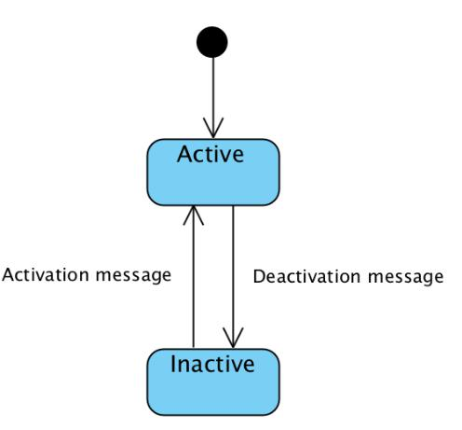

*Figure 3-13: Bot state machine diagram*

*Use Case Specification*

|  |  |  |  |  |  |
| --- | --- | --- | --- | --- | --- |
| UC ID and Name: | **UC-28.0 Change Bot Status** | | | |  |
|  |  | |  |  |  |
| Created by: | **AnhDV** | | Date Created: |  | **01/06/2018** |
|  |  |  |  |  |  |
| Primary Actor: | **Staff** |  | Secondary Actors: |  |  |
|  |  |  |  |  |  |
| Trigger: | N/A |  |  |  |  |
|  |  | | | |  |
| Description: | Allow Staff to turn on/off chatbot. | | | |  |
|  |  | | | |  |
| Preconditions: | **PRE-28.1.** Staff can access the system. | | | |  |
|  | **PRE-28.1.** Staff logged in. | | | |  |
|  |  | | | | |
| Post conditions: | **POST-28.1.** System turns chatbot on/off corresponding with staff request. | | | | |
|  |  | |  |  |  |
| Normal Flow: | **28.0 Turn on chatbot** | |  |  |  |
|  | 1. | Staff chooses a specific end user in facebook account table, then | | | |
|  |  | clicks “ON” toggle button. | | |  |
|  | 2. | Whenever the end user asking, chatbot will automatically reply. | | | |
|  | **28.0 Turn off chatbot** | |  |  |  |
|  | 1. | Staff chooses a specific end user in facebook account table, then | | | |
|  |  | clicks “OFF” toggle button. | | |  |
|  | 2. | Whenever the end user asking, chatbot will not automatically reply. | | | |
|  |  |  |  |  |  |
| Alternative Flows: | N/A |  |  |  |  |
|  |  | | | |  |
| Exceptions: | **28.0-E1 – Cannot communicate with server.** | | | |  |
|  | 1. | ASC displays error message. | | |  |
|  |  |  |  |  |  |
| Priority: | High |  |  |  |  |
|  |  |  |  |  |  |

|  |  |
| --- | --- |
| Frequency of Use: | Medium |
|  |  |
| Business Rules: | **B27, B28, B29** |
|  |  |
| Other Information: | N/A |
|  |  |
| Assumptions: | N/A |
|  |  |

***3.2.3.2.26 Logout***

*Use Case Specification*

|  |  |  |  |  |  |
| --- | --- | --- | --- | --- | --- |
| UC ID and Name: | **UC-29.0 Logout** |  |  |  |  |
|  |  |  |  |  |  |
| Created by: | **AnhDV** |  | Date Created: |  | **01/06/2018** |
|  |  |  |  |  |  |
| Primary Actor: | **Staff** |  | Secondary Actors: |  |  |
|  |  |  |  |  |  |
| Trigger: | N/A |  |  |  |  |
|  |  | | | |  |
| Description: | Allow Staff to log out of ASC system. | | | |  |
|  |  | | | |  |
| Preconditions: | **PRE-29.1.** Staf can access the system. | | | |  |
|  | **PRE-29.1.** Staff logged in. | | | |  |
|  |  | | | |  |
| Post conditions: | **POST-29.1.** Staff logs out of system. | | | |  |
|  |  |  |  |  |  |
| Normal Flow: | **29.0 Logout** |  |  |  |  |
|  | 1. On Navigation Bar, Staff clicks on profile avatar. | | | | |
|  | 2. Staff clicks | “Đăng xuất”. | | |  |
|  | 3. System logs Staff out of system and redirects to Login page. | | | | |
|  |  |  |  |  |  |
| Alternative Flows: | N/A |  |  |  |  |
|  |  | | | |  |
| Exceptions: | **29.0-E1 – Cannot communicate with server.** | | | |  |
|  | 1. ASC displays error message. | | | |  |
|  |  |  |  |  |  |
| Priority: | High |  |  |  |  |
|  |  |  |  |  |  |
| Frequency of Use: | Medium |  |  |  |  |
|  |  |  |  |  |  |
| Business Rules: | **N/A** |  |  |  |  |
|  |  |  |  |  |  |
| Other Information: | N/A |  |  |  |  |
|  |  |  |  |  |  |
| Assumptions: | N/A |  |  |  |  |
|  |  |  |  |  |  |

***3.2.3.3 Admin***

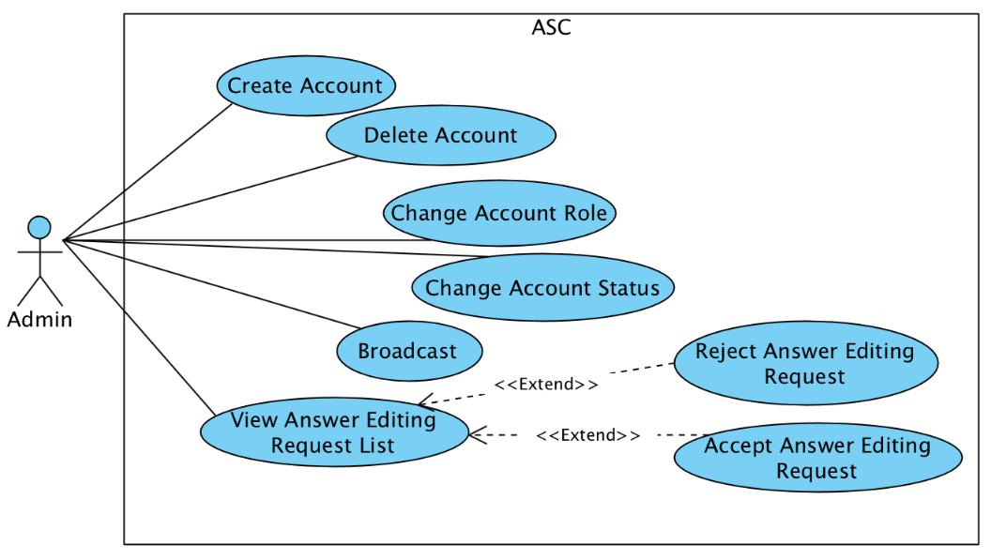

*Figure 3-14: Use case diagram of Admin actor*

***3.2.3.3.1 View Answer Editing Requests***

*Use Case Specification*

|  |  |  |  |  |
| --- | --- | --- | --- | --- |
| UC ID and Name: | **UC-30.0 View Answer Editing Requests** | | |  |
|  |  |  |  |  |
| Created by: | **QuynhDTT** | Date Created: |  | **30/05/2018** |
|  |  |  |  |  |
| Primary Actor: | Admin | Secondary Actors: |  |  |
|  |  |  |  |  |
| Trigger: | N/A |  |  |  |
|  |  | | | |
| Description: | Admin views a list of all chatbot answer editing requests. | | | |
|  |  | | | |
| Preconditions: | **PRE-30.1**. Admin logins into ASC administration successfully. | | | |
|  |  | | |  |
| Post conditions: | **POST-30.1**. System displays a list of requests. | | |  |
|  |  | | |  |
| Normal Flow: | **30.0 View Answer Editing Request List** | | |  |
|  | 1. Admin clicks “Kiểm duyệt dữ liệu Chatbot” tab on the left side in | | | |
|  | the window screen. | | |  |
|  | 2. System displays all requests as table. | | |  |
|  |  |  |  |  |
| Alternative Flows: | N/A |  |  |  |
|  |  | | |  |
| Exceptions: | **30.0-E1 – Cannot communicate with server.** | | |  |
|  | 1. ASC displays error message. | | |  |
|  |  |  |  |  |
| Priority: | Medium |  |  |  |
|  |  |  |  |  |
| Frequency of Use: | Medium |  |  |  |
|  |  |  |  |  |

|  |  |
| --- | --- |
| Business Rules: | **B19, B26** |

Other Information: N/A

Assumptions: N/A

***3.2.3.3.2 Accept Answer Editing Request***

*Use Case Specification*

|  |  |  |  |  |  |
| --- | --- | --- | --- | --- | --- |
| UC ID and Name: | **UC-31.0 Accept Answer Editing Request** | | | |  |
|  |  | |  |  |  |
| Created by: | **QuynhDTT** | | Date Created: |  | **30/05/2018** |
|  |  |  |  |  |  |
| Primary Actor: | Admin |  | Secondary Actors: |  |  |
|  |  |  |  |  |  |
| Trigger: | N/A |  |  |  |  |
|  |  | | | |  |
| Description: | Admin accepts an answer editing request. | | | |  |
|  |  | | | | |
| Preconditions: | **PRE-31.1**. Admin logins into ASC administration successfully. | | | | |
|  | **PRE-31.2**. Answer editing request status is pending. | | | | |
|  |  | | | | |
| Post conditions: | **POST-31.1**. Answer editing request status is changed to accepted. | | | | |
|  | **POST-31.2**. System pushes new status to Websocket server to notify staff. | | | | |
|  |  | | | |  |
| Normal Flow: | **31.0 Accept an answer opening request** | | | |  |
|  | 1. | Admin navigates to Request Management. | | | |
|  | 2. | System displays a list of answer editing request. | | | |
|  | 3. | Admin chooses an answer editing request from list. | | | |
|  | 4. | Admin chooses option “Chấp nhận”. | | |  |
|  | 5. | System changes chosen answer editing request to accepted. | | | |
|  | 6. | System sends a notification about his/her answer editing request has | | | |
|  |  | been accepted. |  |  |  |
|  |  |  |  |  |  |
| Alternative Flows: | N/A |  |  |  |  |
|  |  | | | |  |
| Exceptions: | **31.0-E1 – Cannot communicate with server.** | | | |  |
|  | 1. | ASC displays error message. | | |  |
|  |  | |  |  |  |
| Priority: | Medium | |  |  |  |
|  |  |  |  |  |  |
| Frequency of Use: | Low |  |  |  |  |
|  |  | |  |  |  |
| Business Rules: | **B23, B25, B26** | |  |  |  |
|  |  |  |  |  |  |
| Other Information: | N/A |  |  |  |  |
|  |  |  |  |  |  |

|  |  |  |  |  |  |
| --- | --- | --- | --- | --- | --- |
| Assumptions: | N/A |  |  |  |  |
|  |  | |  |  |  |
| ***3.2.3.3.3 Reject Answer Editing Request*** | | |  |  |  |
|  |  | |  |  |  |
| UC ID and Name: | **UC-31.0 Reject Answer Editing Request** | | | |  |
|  |  | |  |  |  |
| Created by: | **QuynhDTT** | | Date Created: |  | **30/05/2018** |
|  |  |  |  |  |  |
| Primary Actor: | Admin |  | Secondary Actors: |  |  |
|  |  |  |  |  |  |
| Trigger: | N/A |  |  |  |  |
|  |  | | | |  |
| Description: | Admin rejects an answer editing request. | | | |  |
|  |  | | | | |
| Preconditions: | **PRE-31.1**. Admin logins into ASC administration successfully. | | | | |
|  | **PRE-31.2**. Answer editing request status is pending. | | | | |
|  |  | | | | |
| Post conditions: | **POST-31.1**. Answer editing request status is changed to rejected. | | | | |
|  | **POST-31.2**. System pushes new status to Websocket server to notify staff. | | | | |
|  |  | | | |  |
| Normal Flow: | **31.0 Reject answer editing request** | | | |  |
|  | 1. | Admin navigates to Request Management. | | | |
|  | 2. | System displays a list of answer editing request. | | | |
|  | 3. | Admin chooses an answer editing request from list. | | | |
|  | 4. | Admin chooses option “Từ chối”. | | |  |
|  | 5. | System displays admin message textbox. | | | |
|  | 6. | Admin fills in message. | | |  |
|  | 7. | Admin clicks “Gửi phản hồi”. | | |  |
|  | 8. | System changes chosen answer editing request to rejected. | | | |
|  | 9. | System sends a notification about his/her answer editing request has | | | |
|  |  | been rejected. |  |  |  |
|  |  |  |  |  |  |
| Alternative Flows: | N/A |  |  |  |  |
|  |  | | | |  |
| Exceptions: | **31.0-E1 – Cannot communicate with server.** | | | |  |
|  | 1. | ASC displays error message. | | |  |
|  |  | |  |  |  |
| Priority: | Medium | |  |  |  |
|  |  |  |  |  |  |
| Frequency of Use: | Low |  |  |  |  |
|  |  | |  |  |  |
| Business Rules: | **B24, B25, B26** | |  |  |  |
|  |  |  |  |  |  |
| Other Information: | N/A |  |  |  |  |
|  |  |  |  |  |  |

|  |  |  |  |  |  |  |
| --- | --- | --- | --- | --- | --- | --- |
| Assumptions: | N/A |  |  |  |  |  |
|  |  |  |  |  |  |  |
| ***3.2.3.3.4 Create Account*** | |  |  |  |  |  |
| *Use Case Specification* | |  |  |  |  |  |
|  |  | |  | |  |  |
| UC ID and Name: | **UC-32.0 Create Account** | | | | |  |
|  |  | |  |  |  |  |
| Created by: | **QuynhDTT** | |  | Date Created: |  | **30/05/2018** |
|  |  |  |  |  |  |  |
| Primary Actor: | Admin |  |  | Secondary Actors: |  |  |
|  |  |  |  |  |  |  |
| Trigger: | N/A |  |  |  |  |  |
|  |  | | | | |  |
| Description: | Admin creates a new account. | | | | |  |
|  |  | | | | | |
| Preconditions: | **PRE-32.1**. Admin logins into ASC administration successfully | | | | | |
|  |  | | | | | |
| Post conditions: | **POST-32.1**. System displays Add Account page. | | | | | |
|  | **POST-32.2**. A new account is created. | | | | |  |
|  |  | | |  |  |  |
| Normal Flow: | **32.0 Create Account** | | |  |  |  |
|  | 1. | Admin clicks “Thêm mới tài khoản” tab on the left side in the | | | | |
|  |  | window screen. | |  |  |  |
|  | 2. | Add Account page is displayed. | | | |  |
|  | 3. | Admin enters username, email, fullname and role, then clicks “Tạo | | | | |
|  |  | tài khoản”. | |  |  |  |
|  | 4. | System saves the new account with his/her information into | | | | |
|  |  | database and sends password to his/her email. | | | | |
|  |  | | | | | |
| Alternative Flows: | **32.0 Admin violates some business rule in step 3** | | | | | |
|  | 1. | System displays help message under each input area. | | | | |
|  | 2. | Admin enters usename, email and fullname complying business | | | | |
|  |  | rules, then clicks “Tạo tài khoản”. | | | |  |
|  | 3. | Go to step 4 in normal flow. | | | |  |
|  |  | | | | |  |
| Exceptions: | **32.0-E1 – Cannot communicate with server.** | | | | |  |
|  | 1. | ASC displays error message. | | | |  |
|  |  | | |  |  |  |
| Priority: | Medium | | |  |  |  |
|  |  | | |  |  |  |
| Frequency of Use: | Medium | | |  |  |  |
|  |  | | |  |  |  |
| Business Rules: | **B1, B2, B5, B6, B7, B17** | | |  |  |  |
|  |  |  |  |  |  |  |
| Other Information: | N/A |  |  |  |  |  |
|  |  |  |  |  |  |  |

Assumptions: N/A

***3.2.3.3.5 Delete Account***

*Use Case Specification*

|  |  |  |  |  |  |
| --- | --- | --- | --- | --- | --- |
| UC ID and Name: | **UC-33.0 Delete Account** | | | |  |
|  |  | |  |  |  |
| Created by: | **QuynhDTT** | | Date Created: |  | **30/05/2018** |
|  |  | |  |  |  |
| Primary Actor: | Admin | | Secondary Actors: |  |  |
|  |  |  |  |  |  |
| Trigger: | N/A |  |  |  |  |
|  |  | | | |  |
| Description: | Account is deleted from the system. | | | |  |
|  |  | | | | |
| Preconditions: | **PRE-33.1**. Admin logins into ASC administration successfully. | | | | |
|  |  | | | |  |
| Post conditions: | **POST-33.1**. Selecting account is deleted. | | | |  |
|  |  | |  |  |  |
| Normal Flow: | **33.0 Delete Account** | |  |  |  |
|  | 1. | Admin clicks “Tất cả tài khoản” tab on the left side in the window | | | |
|  |  | screen. |  |  |  |
|  | 2. | Accounts is displayed as table. | | |  |
|  | 3. | Admin clicks on “Xoá” button on each row. | | | |
|  | 4. | System deletes the selected account from system. | | | |
|  |  |  |  |  |  |
| Alternative Flows: | N/A |  |  |  |  |
|  |  | | | |  |
| Exceptions: | **33.0-E1 – Cannot communicate with server.** | | | |  |
|  | 1. | ASC displays error message. | | |  |
|  |  | |  |  |  |
| Priority: | Medium | |  |  |  |
|  |  | |  |  |  |
| Frequency of Use: | Medium | |  |  |  |
|  |  |  |  |  |  |
| Business Rules: | **N/A** |  |  |  |  |
|  |  |  |  |  |  |
| Other Information: | N/A |  |  |  |  |
|  |  |  |  |  |  |
| Assumptions: | N/A |  |  |  |  |
|  |  |  |  |  |  |

***3.2.3.3.6 Change Account Role***

*Use Case Specification*

UC ID and Name: **UC-34.0 Change Account Role**

|  |  |  |  |
| --- | --- | --- | --- |
| Created by: | **QuynhDTT** | Date Created: | **30/05/2018** |
|  |  |  |  |

|  |  |  |  |  |
| --- | --- | --- | --- | --- |
| Primary Actor: | Admin | Secondary Actors: |  |  |
|  |  |  |  |  |
| Trigger: | N/A |  |  |  |
|  |  |  |  |  |
| Description: | Admin changes role of account. | | |  |
|  |  |  |  | |
| Preconditions: | **PRE-34.1**. Admin logins into ASC administration successfully. | | | |
|  |  |  |  | |
| Post conditions: | **POST-34.1**. Role of his/her account is changed. | | | |
|  |  |  |  |  |
| Normal Flow: | **34.0 Change Account Role** | | |  |
|  | 1. Admin clicks “Tất cả tài khoản” tab on the left side in the window | | | |
|  | screen. |  |  |  |
|  | 2. Accounts is displayed as table. | | |  |
|  | 3. Admin changes specific role from role dropdown list. | | | |
|  | 4. System saves the new updated role. | | |  |
|  |  |  |  |  |
| Alternative Flows: | N/A |  |  |  |
|  |  |  |  |  |
| Exceptions: | **34.0-E1 – Cannot communicate with server.** | | |  |
|  | 1. ASC displays error message. | | |  |
|  |  |  |  |  |
| Priority: | Medium |  |  |  |
|  |  |  |  |  |
| Frequency of Use: | Medium |  |  |  |
|  |  |  |  |  |
| Business Rules: | **B18, B19** |  |  |  |
|  |  |  |  |  |
| Other Information: | N/A |  |  |  |
|  |  |  |  |  |
| Assumptions: | N/A |  |  |  |
|  |  |  |  |  |
| ***3.2.3.3.7 Change Account Status*** | |  |  |  |
| *Use Case Specification* | |  |  |  |
|  |  |  |  |  |
| UC ID and Name: | **UC-35.0 Change Account Status** | | |  |
|  |  |  |  |  |
| Created by: | **QuynhDTT** | Date Created: |  | **30/05/2018** |
|  |  |  |  |  |
| Primary Actor: | Admin | Secondary Actors: |  |  |
|  |  |  |  |  |
| Trigger: | N/A |  |  |  |
|  |  | | |  |
| Description: | Admin changes status of account. | | |  |
|  |  | | | |
| Preconditions: | **PRE-35.1**. Admin logins into ASC administration successfully | | | |
|  |  | | |  |
| Post conditions: | **POST-35.1**. Account status is changed | | |  |
|  |  |  |  |  |

|  |  |  |
| --- | --- | --- |
| Normal Flow: | **35.0 Change Account Status** | |
|  | 1. | Admin clicks “Tất cả tài khoản” tab on the left side in the window |
|  |  | screen. |
|  | 2. | Accounts is displayed as table. |
|  | 3. | Admin select a specific user click “Hoạt động” | “Ngừng” depends |
|  |  | on account current status. |
|  | 4. | Admin fill reason that causes admin action. |
|  | 5. | Status of account is updated. |
|  |  |  |
| Alternative Flows: | N/A |  |
|  |  | |
| Exceptions: | **35.0-E1 – Cannot communicate with server.** | |
|  | 1. | ASC displays error message. |
|  |  |  |
| Priority: | Low |  |
|  |  |  |
| Frequency of Use: | Low |  |
|  |  | |
| Business Rules: | **B12, B13, B19, B30** | |
|  |  |  |
| Other Information: | N/A |  |
|  |  |  |
| Assumptions: | N/A |  |
|  |  |  |

***3.2.3.3.8*** ***Broadcast***

*Use Case Specification*

|  |  |  |  |  |
| --- | --- | --- | --- | --- |
| UC ID and Name: | **UC-36.0 Broadcast** | |  |  |
|  |  | |  |  |
| Created by: | **QuynhDTT** | | Date Created: | **30/05/2018** |
|  |  |  |  |  |
| Primary Actor: | Admin |  | Secondary Actors: |  |
|  |  |  |  |  |
| Trigger: | N/A |  |  |  |
|  |  | | | |
| Description: | Admin sends information to all end user in the system. | | | |
|  |  | | | |
| Preconditions: | **PRE-36.1**. Admin logins into ASC administration successfully. | | | |
|  |  | | | |
| Post conditions: | **POST-36.1**. A single message is sent to all end users in the system. | | | |
|  |  | |  |  |
| Normal Flow: | **36.0 Broadcast** | |  |  |
|  | 1. | Admin navigates to Facebook Data Management. | | |
|  | 2. | System displays broadcast form. | |  |
|  | 3. | Admin inputs broadcast content, selects appreciate label, then | | |
|  |  | clicks “Gửi”. |  |  |
|  |  |  |  |  |

1. System sends a single message to all chosen end users.

Alternative Flows:N/A

|  |  |
| --- | --- |
| Exceptions: | **36.0-E1 – Cannot communicate with server.** |
|  | 1. ASC displays error message. |
|  |  |
| Priority: | High |
|  |  |
| Frequency of Use: | High |

|  |  |
| --- | --- |
| Business Rules: | **N/A** |
|  |  |
| Other Information: | N/A |
|  |  |
| Assumptions: | N/A |

***3.3*** **Non-functional Requirement**

**Security**



* Token-Based Authentication, relies on a signed token that is sent to the server on each request.
* Apply SSL encryption to restrict user access and prevent man-in-the-middle attacking.
* All passwords are encrypted by MD5 algorithm.
* The security matrix is as the following table:

|  |  |  |  |
| --- | --- | --- | --- |
| **Function** | **End User** | **Staff** | **Admin** |
|  |  |  |  |
| Chat | ✓ |  |  |
|  |  |  |  |
| Leave Feedback | ✓ |  |  |
|  |  |  |  |
| Leave Personal Information | ✓ |  |  |
|  |  |  |  |
| Reset Password |  | ✓ | ✓ |
|  |  |  |  |
| Login |  | ✓ | ✓ |
|  |  |  |  |
| View Statistics |  | ✓ | ✓ |
|  |  |  |  |
| View Profile |  | ✓ | ✓ |
|  |  |  |  |
| Update Profile |  | ✓ | ✓ |
|  |  |  |  |
| Change Password |  | ✓ | ✓ |
|  |  |  |  |
| View Account List |  | ✓ | ✓ |
|  |  |  |  |
| Search Account |  | ✓ | ✓ |
|  |  |  |  |
| View Account Information Detail |  | ✓ | ✓ |
|  |  |  |  |

|  |  |  |  |  |
| --- | --- | --- | --- | --- |
| Filter Account |  |  | ✓ | ✓ |
|  |  |  |  |  |
| View Response & Answer List |  |  | ✓ | ✓ |
|  |  |  |  |  |
| Filter Response & Answer |  |  | ✓ | ✓ |
|  |  |  |  |  |
| Search Response |  |  | ✓ | ✓ |
|  |  |  |  |  |
| Request to Edit Answer |  |  | ✓ | ✓ |
|  |  |  |  |  |
| Receive Notification |  |  | ✓ | ✓ |
|  |  |  |  |  |
| View Notification List |  |  | ✓ | ✓ |
|  |  |  |  |  |
| View Notification Detail |  |  | ✓ | ✓ |
|  |  |  |  |  |
| View Facebook Count Page |  |  | ✓ | ✓ |
|  |  |  |  |  |
| View Chat Logs |  |  | ✓ | ✓ |
|  |  |  |  |  |
| View Fb Account Infor |  |  | ✓ | ✓ |
|  |  |  |  |  |
| View Providing Infor |  |  | ✓ | ✓ |
|  |  |  |  |  |
| Add Tag |  |  | ✓ | ✓ |
|  |  |  |  |  |
| Remove Tag |  |  | ✓ | ✓ |
|  |  |  |  |  |
| Export End User List |  |  | ✓ | ✓ |
|  |  |  |  |  |
| Change Bot Status |  |  | ✓ | ✓ |
|  |  |  |  |  |
| Logout |  |  | ✓ | ✓ |
|  |  |  |  |  |
| View Answer Editing Requests |  |  |  | ✓ |
|  |  |  |  |  |
| Reject Answer Editing Request |  |  |  | ✓ |
|  |  |  |  |  |
| Accept Answer Editing Request |  |  |  | ✓ |
|  |  |  |  |  |
| Create Account |  |  |  | ✓ |
|  |  |  |  |  |
| Delete Account |  |  |  | ✓ |
|  |  |  |  |  |
| Change Account Role |  |  |  | ✓ |
|  |  |  |  |  |
| Change Account Status |  |  |  | ✓ |
|  |  |  |  |  |
| Broadcast |  |  |  | ✓ |
|  |  |  |  |  |
|  | *Table 3-4: Security matrix* | | |  |
| **Accuracy** |  |  |  |  |



* The overall accuracy is calculated by diving total number of correct answers by the number of questions asked.

**Maintainability & Extensibility**



* Follow the coding convention of Airbnb JavaScript Style Guide to help improve readability of source code and make the website more maintainable.
* Client-side web application uses Redux architecture. It complements React's compostable view components by utilizing a unidirectional data flow.

**Availability and Scalability**



* Using Azure Load Balancer for high availability.
* Using Microsoft Azure Virtual Machines for automatic horizontal scalability.
* Using Azure Monitor to monitor all services and alert when something wrong happened.

**Performance**



* Using HTTP/2, which uses a single, multiplexed connection to allow multiple requests to be sent on the same connection instead of establishing new connection for each request, increase speed of request-response.
* Web frontend uses React which uses several clever techniques to minimize the number of costly DOM operations required to update the UI.
* Web frontend is a Single Page Application with the goal of providing a more fluid user experience.
* Node.js brings event-driven programming to web servers, enables development of fast web servers in JavaScript.
* Using Microsoft Azure, Linux Virtual Machine for storage, hosting and deployment.

**Usability**



* The dashboard interface should be elegant, simple: links and buttons look like they are clickable, and are easily clickable, search box is wide enough for users to see what they have typed, interface does not break at various zoom levels.
* Chatbot avatar design is distinct, colorful and sets of words chatbot using are simple, friendly to create a friendly feel for the conversation and give the chatbot a bit of a persona.
* Having human in the loop to resolve ambiguity and provide response supervision.
* Having response buttons, rating buttons and clickable menus to help guide end users to their answer when needed.
* Using typing indicators allow the chatbot to interact with an end user in a more natural conversation.

**3.4** **Database document diagram**

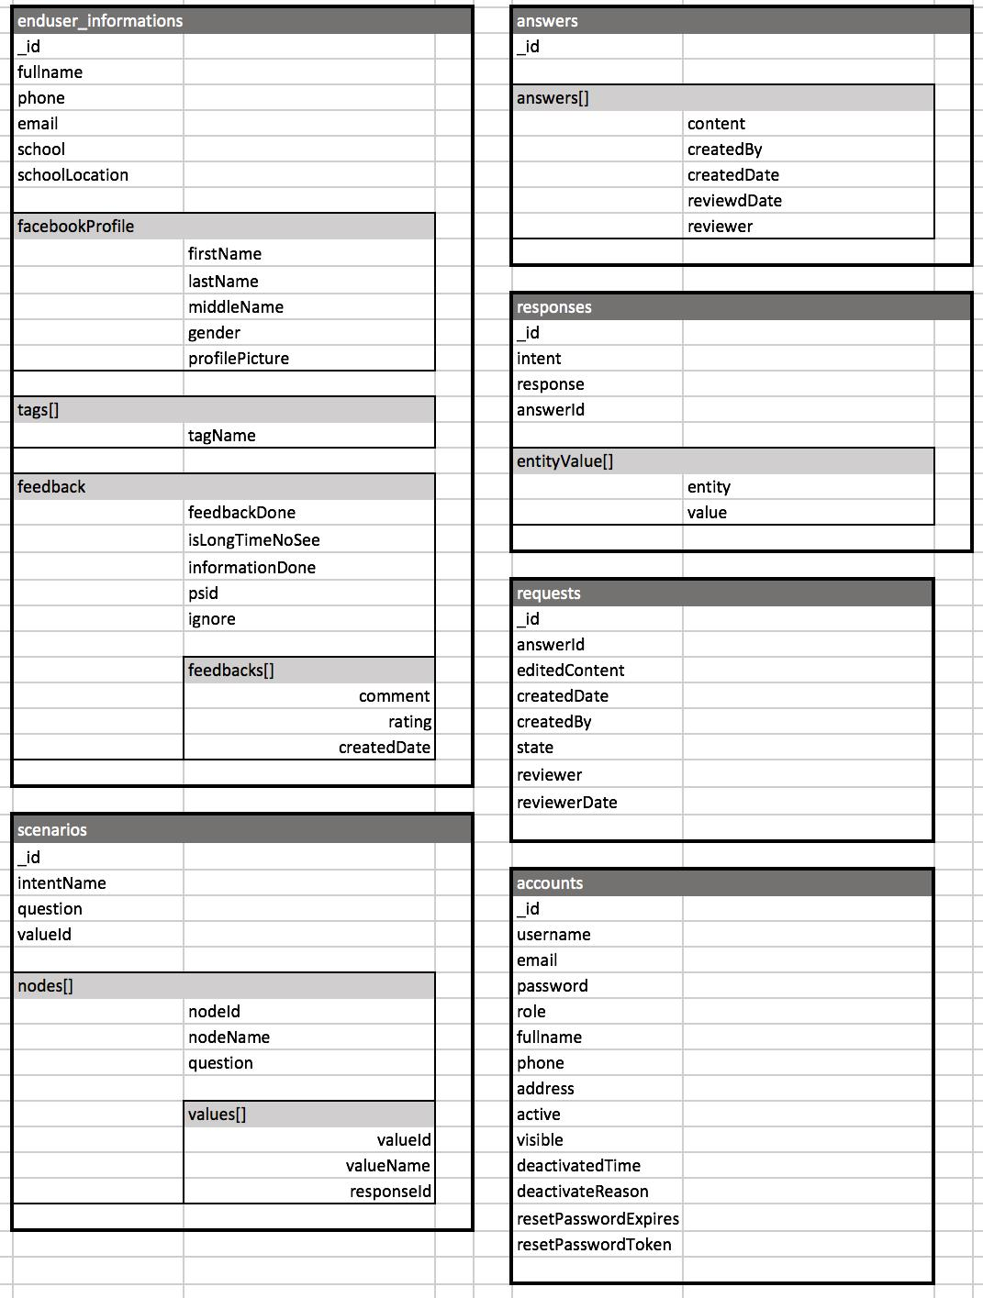

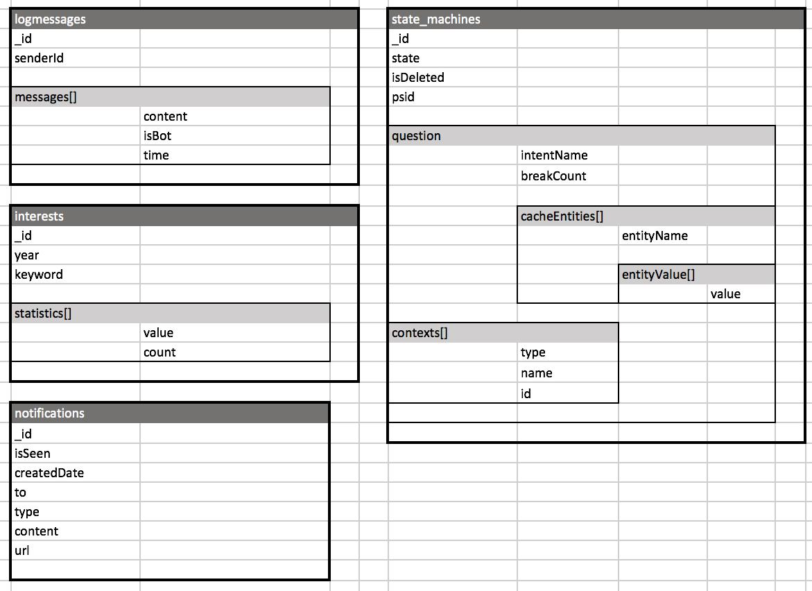

*Figure 3-15: ASC database document diagram*

**Chapter 4 : Software Design**

**4.1 Purpose**

This chapter is to give the developer team the overview and detailed design of what the system’s architecture is, and how they should be implemented. This chapter consists of:

* Architecture overview
* Component diagram
* Detailed design
* Detailed description of components
* Database design

**4.2** **Architecture Overview**

**System Architecture**



**4.2.1.1 Diagram**

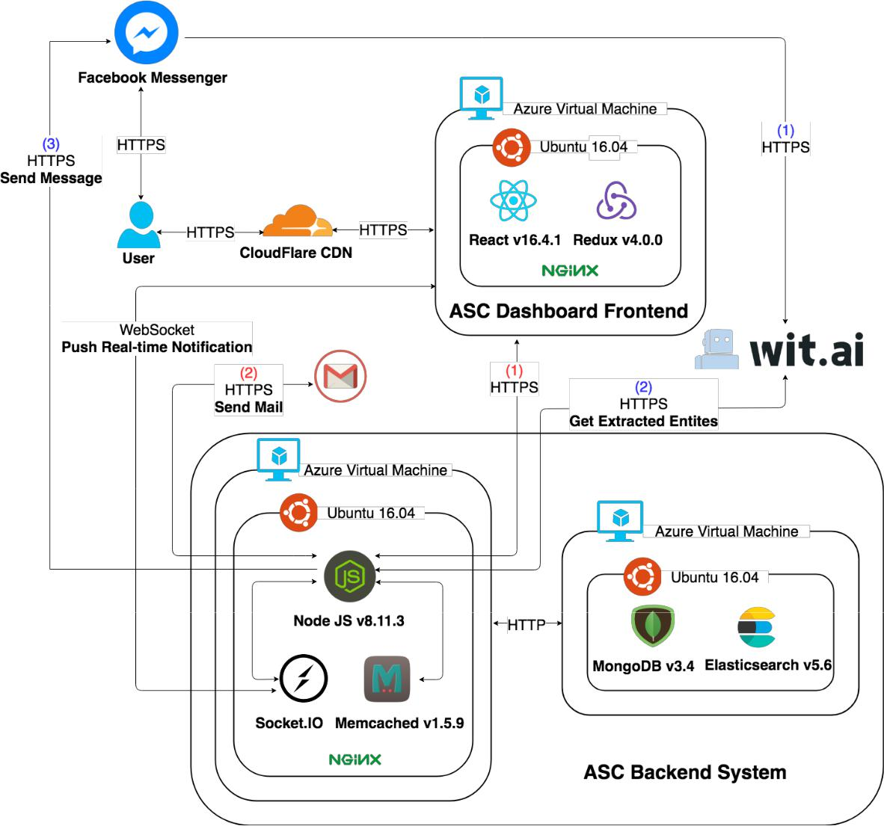

*Figure 4-1: ASC System Architecture*

**4.2.1.2 Explanation**

1. ASC Frontend sends a request to ASC Backend.

**Implementation**



Request URL: <https://futo-dashboard.luzotech.com/data/facebook>

Request Method: GET

Status Code: 200

1. ASC Backend requests to send mail using library.
2. Messenger’s built-in NLP automatically detects meaning and intent in every text message.
3. ASC Backend requests to Wit.AI API to get all entities detected in the message.
4. ASC Backend sends messages using Facebook Webhook.

**Implementation**



Request URL: https://graph.facebook.com/v3.0/me/messages?access_token=

Request Method: POST

**System Architecture Explanation**



The entire project will be deployed on Microsoft Azure. We aim at delivering a secured, responsive, and highly available system. In the following section, we will explain the function and mechanism of each unit in the system architecture design.

**4.2.2.1 CloudFlare CDN**



*Figure 4-2: CloudFlare*

**CloudFlare** provides a content delivery network and distributed domain name server (DNS)services, sitting between the visitor and the CloudFlare user’s hosting provider, acting as a reverse proxy for websites**. We use it to provide addition layer of protection for ASC** **via Cloud Flare’s**

**SSL and resolve domain name to IP address point to server.**

**4.2.2.2 Nginx**



*Figure 4-3: Nginx*

**Nginx** is a web server. It can act as a reverse proxy server for HTTP, HTTPS, SMTP, POP3,and IMAP protocols, as well as a load balancer and an HTTP cache. **We use Nginx as a web server**

**to serve static assets of ASC Frontend System.**

**4.2.2.3** **React**



*Figure 4-4: React*

**React** is an open-source JavaScript library for building user interfaces, allows developers tocreate large web applications that use data which can change over time, without reloading the page.

**We use it to build entire website view instead of plain HTML/JavaScript.**

**4.2.2.4** **Redux**



*Figure 4-5: Redux*

**Redux** is a predictable state container for JavaScript apps. **Redux** evolves the ideas of **Flux** what isthe application architecture that Facebook uses for building client-side web applications. It complements **React** view components by utilizing a unidirectional data flow. **We use Redux to take** **advantages of better separation of concerns, less time debugging.**

**4.2.2.5 MongoDB**



*Figure 4-6: MongoDB*

**MongoDB** is a free and open-source cross-platform document-oriented database program. **We use it to manage ASC operational data.**

**4.2.2.6 Elasticsearch**



*Figure 4-7: Elasticsearch*

**Elasticsearch** is a search engine that provides a distributed, multitenant-capable full-textsearch engine with an HTTP web interface and schema-free JSON documents. **We use it to**

**implement full-text search for end user’s name and name of school.**

**4.2.2.7** **Node.js**



*Figure 4-8: Node.js*

**Node.js** is an open-source, cross-platform JavaScript run-time environment for executingJavaScript code server-side.

**4.2.2.8 Socket.IO**



*Figure 4-9: Socket.IO*

**Socket.IO** is a JavaScript library for real-time web applications. It enables real-time, bi-directional communication between web clients and servers. It has two parts: a client-side library that runs in the browser, and a server-side library for node.js**. We use Socket.IO to push real-time** **updates to our Web application when there are changes of answer information, when dashboard user’s status is updated, etc....**

**4.3** **Design of ASC System**

**Architecture Layers Design**



**4.3.1.1** **ASC– API Layer Design**

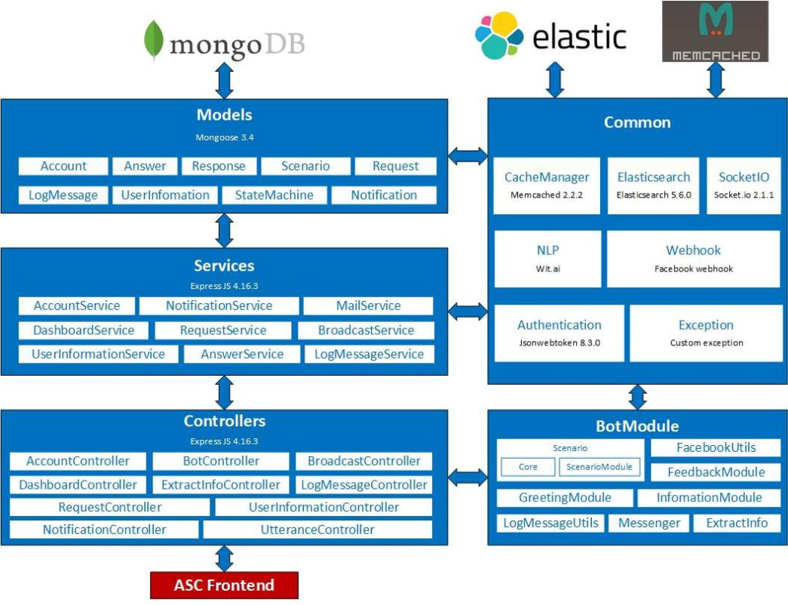

*Figure 4-10: ASC - API Layer Design*

|  |  |  |  |  |  |  |  |
| --- | --- | --- | --- | --- | --- | --- | --- |
| **No** |  |  | **Directory/File** |  | **Description** |  | **Convention** |
|  |  |  |  |  |  |  |  |
| 1 |  |  | app.js |  | Entry point for the application. Everything in the app |  | N/A |
|  |  |  | gets triggered through this file. |  |
|  |  |  |  |  |  |  |
|  |  |  |  |  |  |  |  |

|  |  |  |  |  |  |  |
| --- | --- | --- | --- | --- | --- | --- |
|  | 2 | config/ | This folder contains additional configuration files. | | | XXXConfig.js |
|  |  |  |  |  |  |  |
|  | 3 | controllers/ | Contain | Authentication, | Account,Request, | XXXController.js |
|  | LogMessage, UserInformation, Utterance, Bot. | | |
|  |  |  |  |
|  |  |  |  | |  |  |
|  | 4 | constans/ | Contain the constants. | |  | N/A |
|  |  |  |  | | |  |
|  | 5 | bot_modules/ | Contain modules related to bot. | | | N/A |
|  |  |  |  | | |  |
|  | 6 | doc/ | Contains documentation that uses the API. | | | N/A |
|  |  |  |  | | |  |
|  | 7 | models/ | Contain all Mongoose models. | | | N/A |
|  |  |  |  | | |  |
|  | 8 | services/ | Contains files that directly interact with database | | | XXXService.js |
|  | like AccountService.js, RequestService.js. | | |
|  |  |  |  |
|  |  |  |  | |  |  |
|  | 9 | views/ | Contain all ejs files. | |  | N/A |
|  |  |  |  | | |  |
|  | 10 | routes/ | Contain all route logic for RESTful API endpoint. | | | N/A |
|  |  |  |  | |  |  |
|  | 11 | templates/ | Contain all template. | |  | N/A |
|  |  |  |  | |  |  |
|  | 12 | utilities/ | Contain helper files. | |  | N/A |
|  |  |  |  |  | |  |
|  | 13 | test/ | Contain | unit tests, integration tests, fixtures, and | | N/A |
|  | others test apparatus. | |  |
|  |  |  |  |  |
|  |  |  |  |  |  |  |
|  | 14 | package.json | Contain | meta data about | application: the list of | N/A |
|  | dependencies, npm run script. | | |
|  |  |  |  |
|  |  |  |  | | |  |
|  | 15 | .eslintrc.json | Contain rules for ESLint, which a set of rules to keep | | | N/A |
|  | our project’s code clean and well conventional. | | |
|  |  |  |  |
|  |  |  |  | | |  |
|  |  |  | *Table 4-1: ASC-API Layer Detail* | | |  |
| **4.3.1.2 ASC – Frontend Design** | | | |  |  |  |

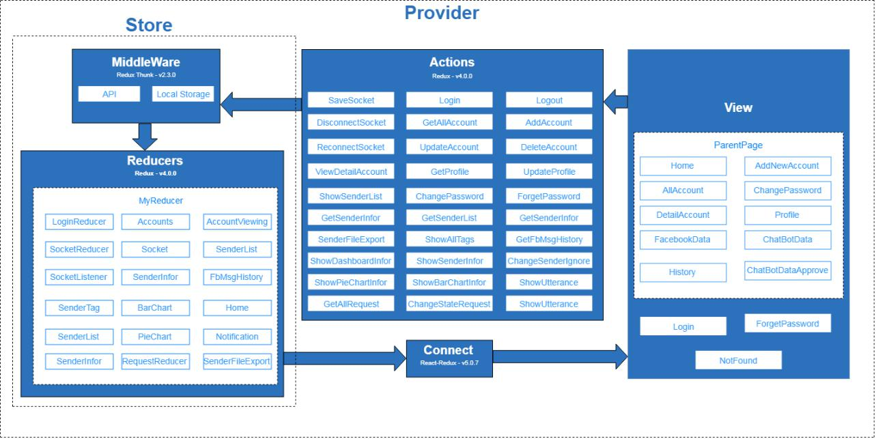

*Figure 4-11: ASC – Frontend Design*

|  |  |  |  |  |  |  |  |  |  |  |  |  |
| --- | --- | --- | --- | --- | --- | --- | --- | --- | --- | --- | --- | --- |
| **No** |  |  | **Directory/File** |  | **Description** | |  |  |  |  |  | **Convention** |
|  |  |  |  |  |  |  |  |  |  |  |  |  |
| 1 |  |  | node_modules/ |  | This folder contains all library of node | | | | | |  | N/A |
|  |  |  | modules | |  |  |  |  |  |
|  |  |  |  |  |  |  |  |  |  |  |
|  |  |  |  |  |  |  |  |  | | |  |  |
| 2 |  |  | public/ |  | This | folder | contains | resource about | | |  | N/A |
|  |  |  | html, css, javascript | | |  |  |  |  |
|  |  |  |  |  |  |  |  |  |  |
|  |  |  |  |  |  | | | | | |  |  |
| 3 |  |  | src/ |  | This folder contains all source code of | | | | | |  | N/A |
|  |  |  | project | |  |  |  |  |  |
|  |  |  |  |  |  |  |  |  |  |  |
|  |  |  |  |  |  | | | | | |  |  |
| 4 |  |  | src/actions/ |  | This folder contains all Redux actions | | | | | |  | N/A |
|  |  |  | which components dispath | | | |  |  |  |
|  |  |  |  |  |  |  |  |  |
|  |  |  |  |  |  | | | | | |  |  |
| 5 |  |  | src/components/ |  | This folder contains some components | | | | | |  | N/A |
|  |  |  | which is common UI for whole app | | | | |  |  |
|  |  |  |  |  |  |  |  |
|  |  |  |  |  |  |  |  |  |  | |  |  |
| 6 |  |  | src/constants/ |  | This | folder | contains | all | constants | |  | N/A |
|  |  |  | variable of project | | |  |  |  |  |
|  |  |  |  |  |  |  |  |  |  |
|  |  |  |  |  |  | | | | |  |  |  |
| 7 |  |  | src/img/ |  | This folder contains some image | | | | |  |  | N/A |
|  |  |  |  |  |  |  |  |  |  |  |  |  |
| 8 |  |  | src/pages/ |  | This | folder | contains | all | pages | of |  | N/A |
|  |  |  | application, each page map with a route | | | | | |  |
|  |  |  |  |  |  |  |
|  |  |  |  |  |  | | | | | |  |  |
| 9 |  |  | src/reducers/ |  | This folder contains all Redux Reducer | | | | | |  | N/A |
|  |  |  | of projects | |  |  |  |  |  |
|  |  |  |  |  |  |  |  |  |  |  |
|  |  |  |  |  |  |  |  |  | |  |  |  |
| 10 |  |  | src/utils/ |  | This | folder | contains | some file | | to |  | N/A |
|  |  |  | connect with api | | |  |  |  |  |
|  |  |  |  |  |  |  |  |  |  |
|  |  |  |  |  |  |  |  |  |  |  |  |  |

|  |  |  |  |  |  |  |  |  |
| --- | --- | --- | --- | --- | --- | --- | --- | --- |
|  | 11 |  | src/App.css | The file | contains some css | | of App | N/A |
|  |  | component | |  |  |
|  |  |  |  |  |  |  |
|  |  |  |  |  | | | |  |
|  |  |  |  | This root component of application. All | | | |  |
|  | 12 |  | src/App.js | others components are show through | | | | N/A |
|  |  |  |  | this component | |  |  |  |
|  |  |  |  |  | | | |  |
|  |  |  |  | Entry point for the application. | | | |  |
|  | 13 |  | src/index.js | Everything in the app gets triggered | | | | N/A |
|  |  |  |  | through this file. | |  |  |  |
|  |  |  |  |  | | | |  |
|  | 14 |  | src/ | This file to register service with opera | | | | N/A |
|  |  | registerServiceWorker.js | system to help app always run. | | | |
|  |  |  |  |
|  |  |  |  |  |  |  |  |  |
|  | 15 |  | src/routes.js | This file | contains | route | matching | N/A |
|  |  | configurations. | |  |  |
|  |  |  |  |  |  |  |
|  |  |  |  |  |  | | |  |
|  | 16 |  | .gitignore | Specifies | intentionally untracked files | | | N/A |
|  |  | to ignore. |  |  |  |
|  |  |  |  |  |  |  |  |
|  |  |  |  |  | | | |  |
|  |  |  |  | This file contains information of project | | | |  |
|  | 17 |  | package.json | and all library with it is version of node | | | | N/A |
|  |  |  |  | modules |  |  |  |  |
|  |  |  |  |  |  |  | |  |
|  | 18 |  | package-lock.json | The file | describes | the exacted node | | N/A |
|  |  | modules tree that was generated | | | |
|  |  |  |  |  |
|  |  |  |  |  | | |  |  |
|  |  |  | *Table 4-2: ASC- Frontend Layer Detail* | | | |  |  |
|  |  | **Database Design** | |  |  |  |  |  |
| **4.3.2.1 Explanation of database decision** | | | | |  |  |  |  |
|  |  | As our system have following characteristic: | | | |  |  |  |



1. Users manage data frequently on dashboard. o Flexible data model.

o System may need to scale.

o Provide real-time experience for statistics.

So, we chose MongoDB because:

1. MongoDB stores data in flexible, JSON-like documents, meaning fields can vary from document to document and data structure can be changed over time.
2. MongoDB is free and open-source.
3. MongoDB enables scaling by shards (partitions data by key ranges and distributes the data among two or more database instances).
4. MongoDB allows stores sub-document inside document avoiding join multiple tables, therefore providing faster write and read time.

**4.3.2.2 Database Diagram**

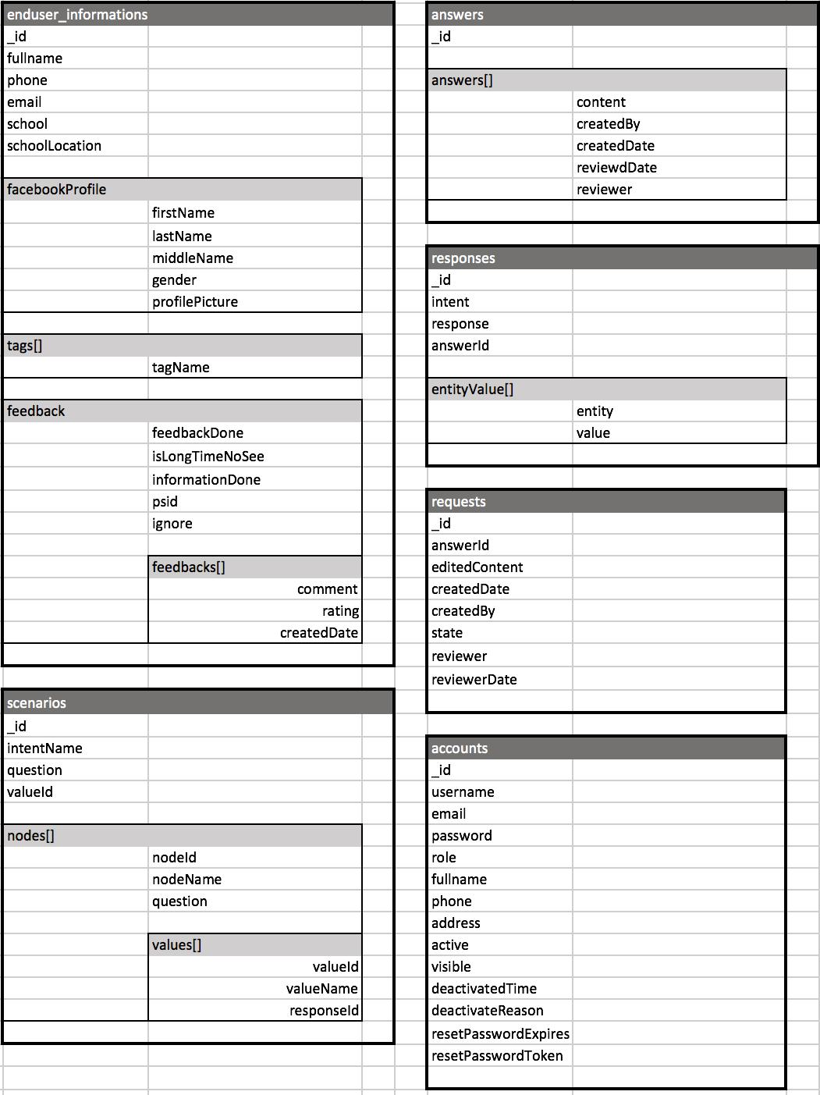

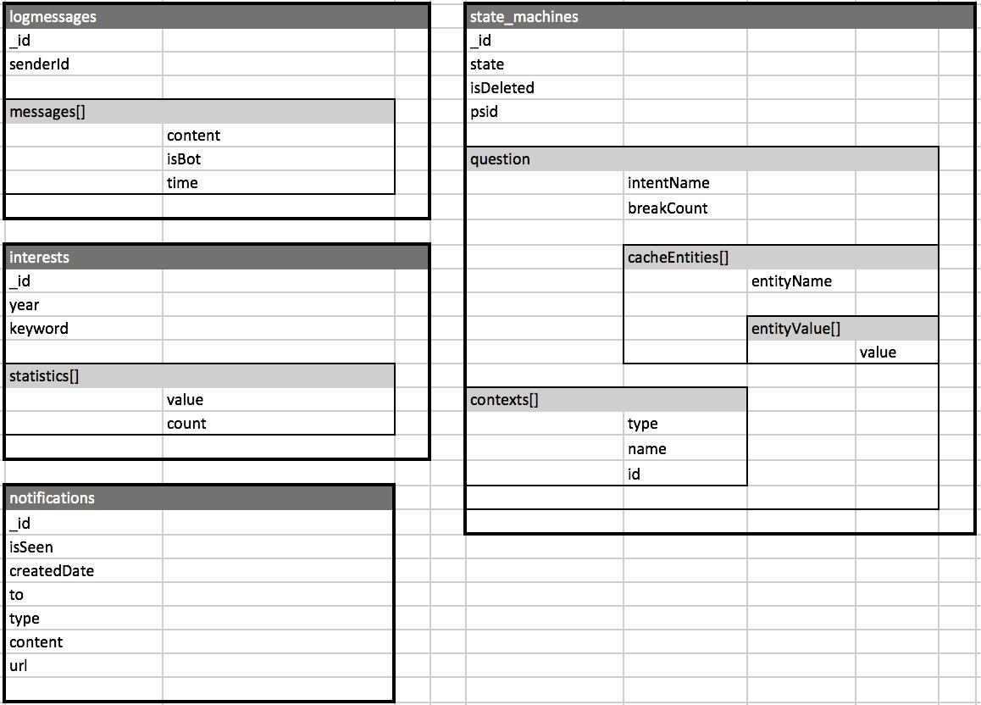

*Figure 4-12: ASC database document diagram*

**4.3.2.3** **Data Dictionary**

|  |  |  |  |  |
| --- | --- | --- | --- | --- |
| **Collection** | **Field** | **Type** | **Description** | |
|  |  |  |  | |
| accounts | _id | ObjectId | MongoDB | |
|  |  |  | ObjectId, | Unique |
|  |  |  | for each document | |
|  |  |  |  | |
|  | username | String | User’s name | |
|  |  |  |  | |
|  | email | String | User’s email | |
|  |  |  |  | |
|  | password | String | User’s password | |
|  |  |  |  | |
|  | role | String | Role of user | |
|  |  |  |  | |
|  | fullname | String | Fullname of user | |
|  |  |  |  |  |
|  | phone | String | Contact | phone of |
|  |  |  | user |  |
|  |  |  |  | |
|  | address | String | Address of user | |
|  |  |  |  |  |
|  | active | Boolean | Status | of user: |
|  |  |  | active or not | |
|  |  |  |  |  |

|  |  |  |  |  |  |  |  |
| --- | --- | --- | --- | --- | --- | --- | --- |
|  | visible | | Boolean | Status | of | user: | |
|  |  |  |  | visible or not | | |  |
|  |  |  |  |  |  |  |  |
|  | deactivatedTime | | Date | Time | that | user | is |
|  |  |  |  | deactivated | |  |  |
|  |  |  |  |  | |  |  |
|  | deactivatedReason | | String | Reason if | | user | is |
|  |  |  |  | deactivated | |  |  |
|  |  |  |  |  | | | |
|  | resetPasswordExpires | | Date | Time that mark all | | | |
|  |  |  |  | token | create after | | |
|  |  |  |  | this time is valid | | |  |
|  |  |  |  |  | |  | |
|  | resetPasswordToken | | String | Password | | reset | |
|  |  |  |  | token |  |  |  |
|  |  |  |  |  | |  |  |
| requests | _id | | ObjectId | MongoDB | |  |  |
|  |  |  |  | ObjectId, | | Unique | |
|  |  |  |  | for each document | | | |
|  |  |  |  |  |  | | |
|  | answerId | | String | Id of | answer that | | |
|  |  |  |  | user edited | |  |  |
|  |  |  |  |  | | | |
|  | editedContent | | String | Content of answer | | | |
|  |  |  |  | that user edited | | |  |
|  |  |  |  |  | | | |
|  | createdDate | | Date | Time when request | | | |
|  |  |  |  | is created | |  |  |
|  |  |  |  |  |  |  | |
|  | createdBy | | String | User |  | created | |
|  |  |  |  | request | |  |  |
|  |  |  |  |  |  |  | |
|  | state | | String | State | of | request: | |
|  |  |  |  | pending, | | rejected | |
|  |  |  |  | or approved | | |  |
|  |  |  |  |  | | | |
|  | reviewer | | String | User that reviewed | | | |
|  |  |  |  | request | |  |  |
|  |  |  |  |  | | | |
|  | reviewedDate | | Date | Time when request | | | |
|  |  |  |  | is reviewed | |  |  |
|  |  |  |  |  | |  |  |
| answers | _id | | ObjectId | MongoDB | |  |  |
|  |  |  |  | ObjectId, | | Unique | |
|  |  |  |  | for each document | | | |
|  |  |  |  |  | | |  |
|  | answers |  | ArrayString | List of answers | | |  |
|  |  |  |  |  | | | |
|  |  | content | String | Content of answer | | | |
|  |  |  |  |  | | | |
|  |  | createdBy | String | User when created | | | |
|  |  |  |  | answer | |  |  |
|  |  |  |  |  |  |  |  |

|  |  |  |  |  |  |  |  |
| --- | --- | --- | --- | --- | --- | --- | --- |
|  |  | createdDate | Date | Time when created | | | |
|  |  |  |  | answer |  |  |  |
|  |  |  |  |  |  |  | |
|  |  | reviewedDate | Date | Time |  | when | |
|  |  |  |  | reviewed answer | | | |
|  |  |  |  |  |  |  | |
|  |  | reviewer | String | User |  | when | |
|  |  |  |  | reviewed answer | | | |
|  |  |  |  |  | |  |  |
| logmessages | _id | | ObjectId | MongoDB | |  |  |
|  |  |  |  | ObjectId, | | Unique | |
|  |  |  |  | for each document | | | |
|  |  | |  |  |  |  |  |
|  | senderId | | String | psid | of |  | user |
|  |  |  |  | sending messages | | | |
|  |  | |  |  | | | |
|  | messages |  | BsonArray | List of messages | | | |
|  |  |  |  |  |  | |  |
|  |  | content | String | Text | content | | in |
|  |  |  |  | message | |  |  |
|  |  |  |  |  | | | |
|  |  | isBot | Boolean | Whether or not the | | | |
|  |  |  |  | message is sent by | | | |
|  |  |  |  | bot. |  |  |  |
|  |  |  |  |  |  | |  |
|  |  | time | Date | Time | when | | sent |
|  |  |  |  | message | |  |  |
|  |  |  |  |  | |  |  |
| responses | _id | | ObjectId | MongoDB | |  |  |
|  |  |  |  | ObjectId, | | Unique | |
|  |  |  |  | for each document | | | |
|  |  | |  |  | | | |
|  | intent | | String | Intent of end user’s | | | |
|  |  |  |  | message | |  |  |
|  |  | |  |  | |  |  |
|  | response | | String | Response | |  | of |
|  |  |  |  | chatbot |  |  |  |
|  |  | |  |  | | | |
|  | entityValue |  | BsonArray | List of entities and | | | |
|  |  |  |  | values |  |  |  |
|  |  |  |  |  |  |  |  |
|  |  | entity | String | Entity |  |  | that |
|  |  |  |  | extracted | |  | in |
|  |  |  |  | message | |  |  |
|  |  |  |  |  |  |  |  |
|  |  | value | String | Value | of |  | each |
|  |  |  |  | entity |  |  |  |
|  |  |  |  |  | |  |  |
|  | _id | | ObjectId | MongoDB | |  |  |
|  |  |  |  | ObjectId, | | Unique | |
|  |  |  |  | for each document | | | |
|  |  |  |  |  |  |  |  |

enduser_infor

mations

|  |  |  |  |  |  |  |  |  |
| --- | --- | --- | --- | --- | --- | --- | --- | --- |
| fullname | | | String | Fullname | | | of | end |
|  |  |  |  | user | |  |  |  |
|  |  |  |  |  | | | | |
| phone | | | String | Phone of end user | | | | |
|  |  |  |  |  | | | | |
| email | | | String | Email of end user | | | | |
|  |  |  |  |  | | | | |
| school | | | String | Scholl of end user | | | | |
|  |  |  |  |  | | | | |
| schoolLocation | | | String | Location of school | | | | |
|  |  |  |  |  |  | |  |  |
| facebookProfile | |  | BsonObject | Fb | profile | | of | end |
|  |  |  |  | user | |  |  |  |
|  |  |  |  |  |  | | |  |
|  |  | firstName | String | Fb | first name | | | of |
|  |  |  |  | end user | | |  |  |
|  |  |  |  |  | | | | |
|  |  | lastName | String | Fb last name of end | | | | |
|  |  |  |  | user | |  |  |  |
|  |  |  |  |  | | | | |
|  |  | middleName | String | Fb middle name of | | | | |
|  |  |  |  | end user | | |  |  |
|  |  |  |  |  |  | |  |  |
|  |  | gender | String | Fb | gender | | of | end |
|  |  |  |  | user | |  |  |  |
|  |  |  |  |  |  | |  | |
|  |  | profilePicture | String | Fb | profile | | picture | |
|  |  |  |  | of end user | | |  |  |
|  |  |  |  |  |  |  |  | |
| tags | | | ArrayString | List |  | of | tags | |
|  |  |  |  | attached | |  | to | end |
|  |  |  |  | user’s interest | | | |  |
|  |  | |  |  | | |  |  |
| feedback |  | | BsonObject | Feedback | | | of | end |
|  |  |  |  | user | |  |  |  |
|  |  | |  |  | |  |  | |
|  | feedbackDone | | Boolean | Status | | of | getting | |
|  |  |  |  | feedback: done or | | | | |
|  |  |  |  | not |  |  |  |  |
|  |  | |  |  | | | | |
|  | isLongTimeNoSee | | Boolean | Status of end user | | | | |
|  |  |  |  | that has not seen | | | | |
|  |  | |  |  | |  |  | |
|  | informationDone | | Boolean | Status | | of | getting | |
|  |  |  |  | end |  |  | user’s | |
|  |  |  |  | information | | | |  |
|  |  | |  |  | | | | |
|  | psid | | String | Id of end user’s Fb | | | | |
|  |  |  |  | page | |  |  |  |
|  |  | |  |  | | | | |
|  | ignore | | Boolean | Whether or not the | | | | |
|  |  |  |  | end user is ignored. | | | | |

|  |  |  |  |  |  |  |  |  |  |  |
| --- | --- | --- | --- | --- | --- | --- | --- | --- | --- | --- |
|  |  |  |  |  |  |  | If | set | to | false, |
|  |  |  |  |  |  |  | chatbot is not auto | | | |
|  |  |  |  |  |  |  | reply with them. | | | |
|  |  |  |  |  |  |  |  | | | |
|  |  |  | feedbacks | |  | BsonArray | List of feedbacks | | | |
|  |  |  |  |  |  |  |  | | | |
|  |  |  |  |  | comment | String | Content for report | | | |
|  |  |  |  |  |  |  |  | | | |
|  |  |  |  |  | rating | String | Status of rating: | | | |
|  |  |  |  |  |  |  | Excellent, | | | very |
|  |  |  |  |  |  |  | good, | | good, bad, | |
|  |  |  |  |  |  |  | very bad | | |  |
|  |  |  |  |  |  |  |  | |  |  |
|  |  |  |  |  | createdDate | Date | Time | |  | when |
|  |  |  |  |  |  |  | feedback is created | | | |
|  |  |  |  |  |  |  |  | | |  |
| scenarios | _id | | | | | ObjectId | MongoDB | | |  |
|  |  |  |  |  |  |  | ObjectId, | | | Unique |
|  |  |  |  |  |  |  | for each document | | | |
|  |  |  | |  | |  |  | | | |
|  | intentName | | | | | String | Name of intent | | | |
|  |  |  | |  | |  |  | | | |
|  | question | | | | | String | Question to ask end | | | |
|  |  |  |  |  |  |  | user |  |  |  |
|  |  |  | |  | |  |  |  |  | |
|  | valueId | | | | | String | Id | of | extracted | |
|  |  |  |  |  |  |  | value | |  |  |
|  |  |  | |  | |  |  | | | |
|  | nodes |  | |  | | BsonArray | List of nodes | | | |
|  |  |  | |  | |  |  | | |  |
|  |  | nodeId | | | | String | Id of node | | |  |
|  |  |  | |  | |  |  | | | |
|  |  | nodeName | | | | String | Name of node | | | |
|  |  |  | |  | |  |  | | | |
|  |  | question | | | | String | Question to ask end | | | |
|  |  |  |  |  |  |  | user |  |  |  |
|  |  |  | |  | |  |  | | | |
|  |  | values | |  | | BsonArray | List of values | | | |
|  |  |  |  |  | |  |  | | |  |
|  |  |  |  | valueId | | String | Id of value | | |  |
|  |  |  |  |  | |  |  | | | |
|  |  |  |  | valueName | | String | Name of value | | | |
|  |  |  |  |  | |  |  | | | |
|  |  |  |  | responseId | | String | Id of response | | | |
|  |  |  | |  | |  |  | | |  |
| interests | _id | | | | | ObjectId | MongoDB | | |  |
|  |  |  |  |  |  |  | ObjectId, | | | Unique |
|  |  |  |  |  |  |  | for each document | | | |
|  |  | | | | |  |  | | | |
|  | year | | | | | String | Admission year | | | |
|  |  |  |  |  |  |  |  |  |  |  |

|  |  |  |  |  |  |  |  |  |
| --- | --- | --- | --- | --- | --- | --- | --- | --- |
|  | keyword | | | String | Intent | end | | user |
|  |  |  |  |  | interested in. | | |  |
|  |  |  |  |  |  | | | |
|  | statistics |  |  | BsonArray | List of statistics | | | |
|  |  |  |  |  |  |  | |  |
|  |  | value | | String | Value | end | | user |
|  |  |  |  |  | interested in. | | |  |
|  |  |  |  |  |  | | | |
|  |  | count | | Number | Number of value is | | | |
|  |  |  |  |  | interested in. | | |  |
|  |  |  |  |  |  | |  |  |
| notifications | _id | | | ObjectId | MongoDB | |  |  |
|  |  |  |  |  | ObjectID, | | Unique | |
|  |  |  |  |  | for each document. | | | |
|  |  | |  |  |  | | | |
|  | isSeen | | | Boolean | Notification status: | | | |
|  |  |  |  |  | seen or not. | | |  |
|  |  | |  |  |  |  |  |  |
|  | createdDate | | | Date | Time |  |  | when |
|  |  |  |  |  | notification | | | is |
|  |  |  |  |  | created. |  |  |  |
|  |  | |  |  |  |  |  | |
|  | to | | | String | Person | is | received | |
|  |  |  |  |  | notification. | | |  |
|  |  | |  |  |  |  |  |  |
|  | type | | | String | Type |  |  | of |
|  |  |  |  |  | notification. | | |  |
|  |  | |  |  |  |  |  |  |
|  | content | | | String | Content |  |  | for |
|  |  |  |  |  | notification. | | |  |
|  |  | |  |  |  | |  |  |
|  | url | | | String | Reference | |  | to |
|  |  |  |  |  | specific url. | | |  |
|  |  | |  |  |  | |  |  |
| state_machines | _id | | | ObjectId | MongoDB | |  |  |
|  |  |  |  |  | ObjectID, | | Unique | |
|  |  |  |  |  | for each document. | | | |
|  |  | |  |  |  | | | |
|  | state | | | String | Current state in the | | | |
|  |  |  |  |  | conversation. | | |  |
|  |  | |  |  |  | | | |
|  | psid | | | String | Id of end user’s Fb | | | |
|  |  |  |  |  | page. |  |  |  |
|  |  | |  |  |  | | | |
|  | question | |  | BsonObject | Question to ask end | | | |
|  |  |  |  |  | user. |  |  |  |
|  |  |  |  |  |  | | | |
|  |  |  | intentName | String | Intent of end user. | | | |
|  |  |  |  |  |  |  |  |  |
|  |  |  | breakCount | Number | Count | to |  | break |
|  |  |  |  |  | state. |  |  |  |
|  |  |  |  |  |  |  |  |  |

|  |  |  |  |  |  |
| --- | --- | --- | --- | --- | --- |
|  | contexts |  | BsonObject | Context | of |
|  |  |  |  | utterance. |  |
|  |  |  |  |  |  |
|  |  | type | String | Type of context. |  |
|  |  |  |  |  |  |
|  |  | name | String | Name of context. |  |
|  |  |  |  |  |  |
|  |  | id | String | Id of context. |  |
|  |  |  |  |  |  |

*Table 4.2 ASC’s data dictionary*

**Common Design**



**4.3.3.1** **Natural Language Processing**

Natural language processing (NLP) employs computational techniques for the purpose of **learning, understanding, and producing human language content**.

A more advanced application of NLP is Natural language understanding (NLU), **genuinely** **understanding** what the text says.

Depending on our project demand integrating with Facebook Messenger and supporting the primary Vietnamese language, we find out the 2 most appropriate NLU platforms Wit.AI and FPT.AI.

|  |  |  |
| --- | --- | --- |
| **Description** | **Wit.AI1** | **FPT.AI2** |
| Accuracy3 | 0.83419 | 0.85424 |
|  |  |  |
| Vietnamese Support | Trial version | Version 2.0 |
|  |  |  |
| Integrating tools into | Using built-in NLP easily and quickly | No support for built-in NLP |
| bots for Fb Messenger |  |  |
|  |  |  |
| Service charge | Completely free | Free 25 entities, 25 intents. |
|  |  | Having an upgrade fee. |
|  |  |  |
| Community | Large | Small |
|  |  |  |
| Docs | Full detail | Empty |
|  |  |  |
|  | *Table 4-3:NLP comparison* |  |

After having a comparison of two of these commercial platforms, we chose Wit.ai for applying NLP. With Wit.ai, we simply train my bot with sample utterances that get parsed into intents and entities. Moreover, we can define our own intents and entities, or use those that have already been built into Wit.ai.

The pros and cons of using NLP with Wit.ai:

1. Wit.ai website: <https://wit.ai/>
2. FPT.ai website: <https://fpt.ai/>
3. Accuracy on FTel test data set: <https://www.slideshare.net/minhpqn/cc-bi-ton-x-l-ngn-ng-t-nhin-trong-pht-trin-h-thng-chatbot>

* Lots of built-in intents and entities.
* Easy to use bot creation tool.
* Extensive language support (including Vietnamese).
* An open source model for sharing apps.
* An inbox tool to classify utterances from a running bot.
* Free.
* Multiple ways to parse utterances (**trait, free-text, keywords, free-text and** **keywords**).

No support for bot dialogs - responses are built and maintained outside of Wit.ai. It's unclear how Wit.ai scales.

**4.3.3.1.1** **Data preprocessing**

One example is Stanford CoreNLP, which provides a standard NLP preprocessing pipeline that includes:

POS tagging (with tags such as noun, verb, and preposition).

Identification of named entities, such as people, places, and organizations. Parsing of sentences into their grammatical structures.

Identifying co-references between noun phrase mentions.

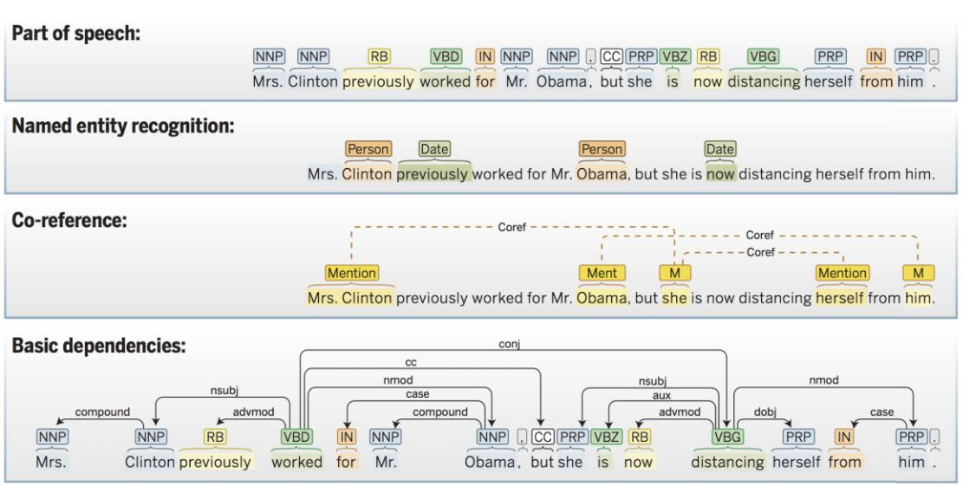

1

*Table 4-4: Many language technology tools start by doing linguistic structure analysis*

As shown from top to bottom, this tool determines the parts of speech of each word, tags various words or phrases as semantic named entities of various sorts, determines which entity mentions co-refer to the same person or organization, and then works out the syntactic structure of each sentence, using a dependency grammar analysis.

With Wit.ai, it uses [duckling](https://github.com/facebookincubator/duckling) library to extract entities. Duckling is a Haskell library that parses text into structured data. Example of text extraction using duckling is provided below.



"the first Tuesday of October"

=> {"value":"2017-10-03T00:00:00.000-07:00","grain":"day"}

1. Advances in natural language processing page: <https://cs224d.stanford.edu/papers/advances.pdf>

**4.3.3.1.2 Extraction process**

Wit.ai has predefined entities developers need to extract temporal expressions, numbers, locations, temperatures, etc. One example Wit.ai auto extracts an entity “wit/amount_of_money” after inputing a sentence.

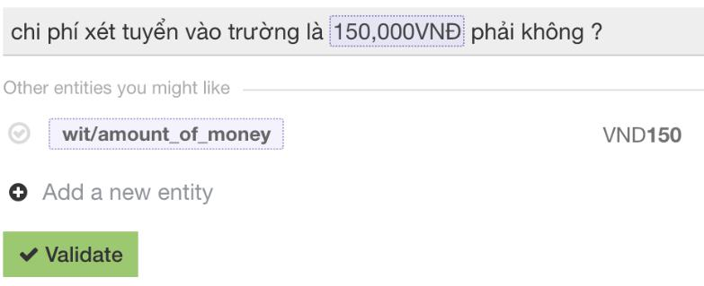

Figure 4-13: Built-In Entity Extraction

If the entity we need is not built-in, we can create our own. We will have to choose a Lookup Strategy for our entity:

|  |  |
| --- | --- |
| **Lookup** | **Use Case** |
| **Strategy** |  |
|  |  |
| Trait | There is no obvious association between certain words in |
|  | the sentence and the value of the entity, but rather need the |
|  | sentence as a whole to determine the value. |
|  |  |
| Free Text | When need to extract a substring of the message, and this |
|  | substring does not belong to a predefined list of possible |
|  | values. |
|  |  |
| Keywords | When the entity value belongs to a predefined list, and just |
|  | need substring matching to look it up in the sentence. |
|  |  |
|  | *Table 4-5: Wit.ai Lookup Strategy* |

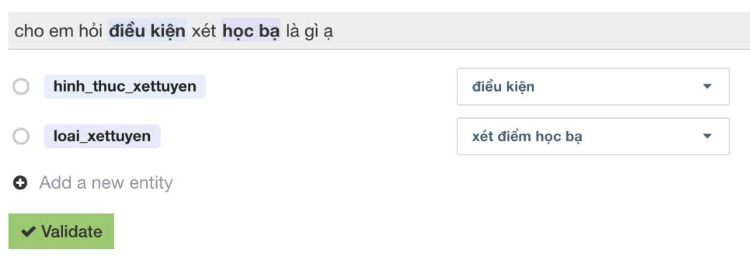

Figure 4-14: Custom Entities Labeling

**4.3.3.1.3 Classification process**

Intent is categorized using text classification methods that are based on Bag of Words or more advanced word embedding methods like Support Vector Machine.

A **bag-of-words (BoW)** is a representation of text that describes the occurrence of words within a document. A simple illustration of bag-of-words model is provided below:

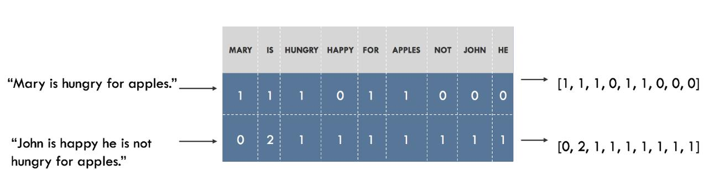

1

*Table 4-6: Bag-of-words model*

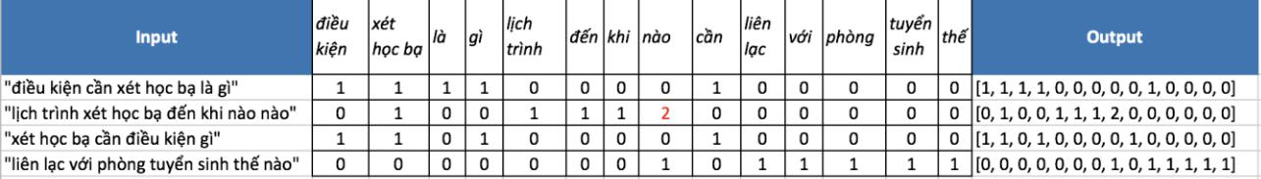

*Figure 4-15: BoW Example*

Once a vocabulary has been chosen, the occurrence of words in documents needs to be scored. A problem with scoring word frequency is that highly frequent words may not contain as much “informational content” to the model as rarer but perhaps domain specific words.

One approach is to rescale the problem called **Term Frequency** **–** **Inverse Document** **Frequency (TF-IDF)2.** The scores have the effect of highlighting words that are distinct (containuseful information) in a given document.

TF-IDF is computed for each term in each document following the formula:



TF(t) = (Number of times term t appears in a document) / (Total number of terms in the document)

IDF(t) = log_e(Total number of documents / Number of documents with term t in it). Value = TF * IDF

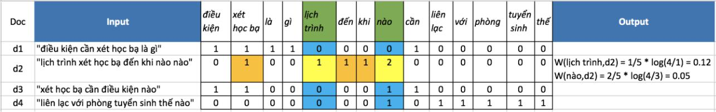

*Figure 4-16: TF-IDF Example*

Furthermore, the other algorithm can be used for classification is **Support Vector Machine** **(SVM).** With given labeled training data (*supervised learning*), the algorithm outputs the hyper-planethat differentiate the two classes very well so the misclassification is reduced when training new data set.

1. Bag-of-words page: <https://machinelearningmastery.com/gentle-introduction-bag-words-model/>
2. TF-IDF page: <http://www.tfidf.com/>

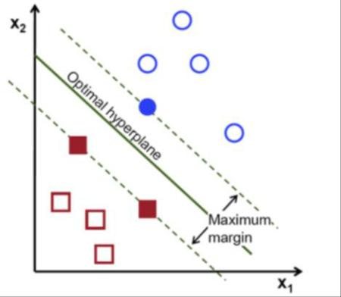

1

*Table 4-7: SVM algorithm*

**4.3.3.2** **Elasticsearch on ASC Backend**

We use Elasticsearch database to support ASC back-end search by full-text search helping backend search for name and school.

1. Initialization

**Implementation:**



var elasticsearch = require(“elasticsearch”)

const ElasticConfig = require (“../config/elasticConfig”)

var client = new elasticsearch.Client

host: ElasticConfi.host

log: ElasticConfig.log

1. Searching with elasticsearch

**Implementation:**



searchName()

body = index: ElasticConfig.index

type: “names”

body: query: match: name: query

**4.3.3.3 Real-time features with Socket.IO**

**Real-time applications**

**Socket.IO** is a JavaScript library for real-time web applications. It enables real-time, bi-directional communication between web clients and servers.

**Socket.IO** has two parts: a client-side library that runs in the browser, and a server-side libraryfor Node.js. Both components have a nearly identical API.

**Socket.IO** primarily uses the WebSocket protocol with polling as a fallback option, whileproviding the same interface.

**4.3.3.4 Socket.IO on ASC Frontend**

1. SVM page: <https://towardsdatascience.com/support-vector-machine-introduction-to-machine-learning-algorithms-934a444fca47>

We use **socket.io-client** library on [NPM](https://www.npmjs.com/package/socket.io-client) to implement it on ASC Frontend.

1. Initialization

**Implementation:**



const socket = socketIOClient (config.SOCKET_URL)

secure = true

1. Receive Socket.IO event from server as actions in Redux using socketIoMiddleware from **socket.io-client**.

**Implementation:**



const store = createStore (myReducer, window._REDUX_DEVTOOLS_EXTENSION_ && window._REDUX_DEVTOOLS_EXTENSION(), applyMiddleware(thunk))

**4.3.3.5** **Socket.IO on ASC Backend**

We use **socket.io** library on [NPM](https://www.npmjs.com/package/socket.io) to implement it on ASC Backend.

1. Initialization

**Implementation:**



var io = require ("socket.io”)(http)

1. Socket.IO connection

**Implementation:**



io.on()

App.request.socketId = socket.id

Socket.on ()

Var socketIds = global.socketIds

If socketIds === null

Return

For each user in socketId list

If socketId of user includes socket.id in socketId list

For each index in socketId of user list

If socketId === socket.id

Break

If socketId of user === null

delete socketId of user

global.socketIds = socketIds

**4.3.3.6 Using MongoDB with Mongoose**

**Mongoose** is a library on[NPM](https://www.npmjs.com/package/mongoose)forMongo, written in Node.js. The document of Mongooseis very clear and well updated. Every model in our project will be wrapped inside Mongoose Model. Thus, every model by default will have a unique _**id.**

**4.3.3.7 Class diagram**

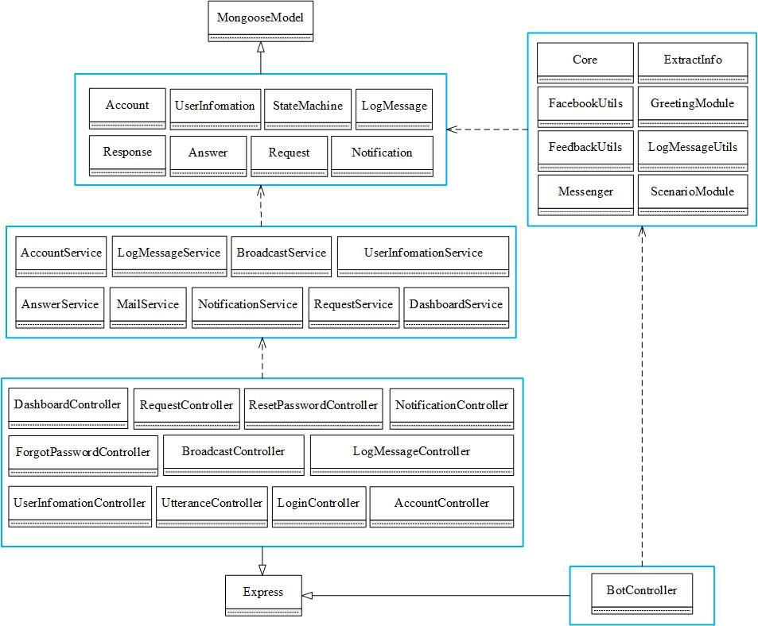

*Figure 4-17: ASC class diagram*

**Detail Design**



**4.3.4.1** **End user chats**

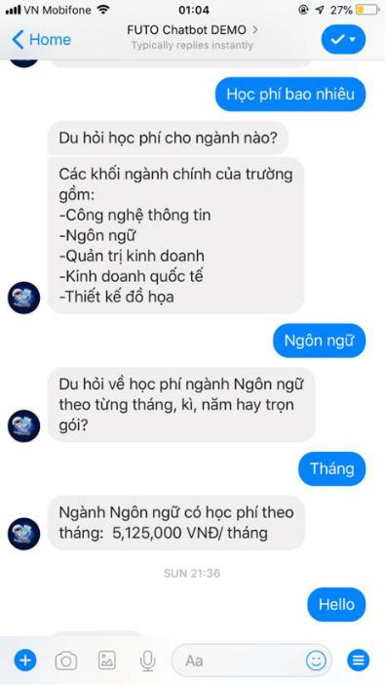

*Figure 4-18: Chat Conversation design*

**4.3.4.1.1** **Training the chatbot using Wit.ai**

**Collect real end user utterances on website**

***Implementation***



var data = request.request(“http://daihoc.fpt.edu.vn/tuyen-sinh/”)

auto_load_more: true

io.writeAsync()

write data into file

path: “./”

file_name: “data.json”

**Define intents and entities**

With my project, we choose 2 types of Lookup Strategy including Trait for intents and Free Text and Keywords for entities.

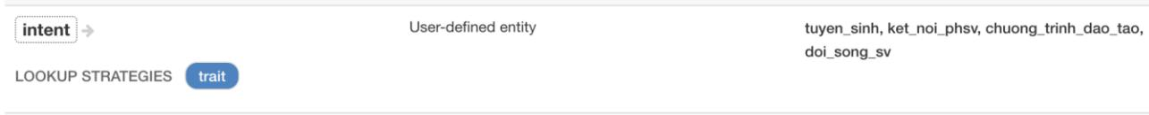

*Figure 4-19: Intent list*

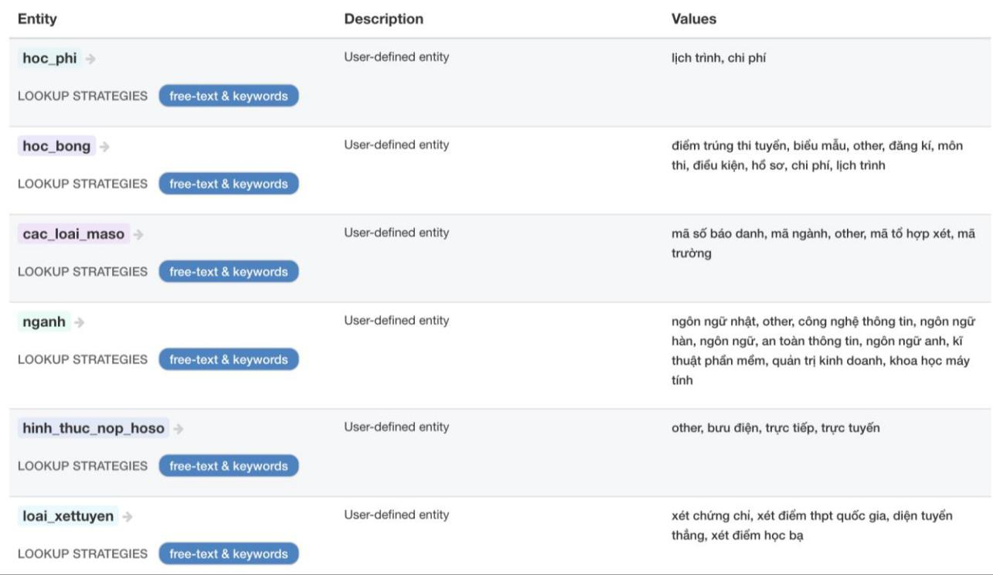

*Figure 4-20: Entity list*

**Categorize the end user intent and extract entities**

Using labelling training data set, we train all questions mapped to the different intent. If a sentence containing one of the keywords or substring of the message, Wit.ai will extract all its. To push all questions into Wit instead of typing manually, we must create a tool to read Excel file.

***Implementation***

******ReadExcel = require(“./ReadExcel”)

Wit = require(“./Wit”)

var Data = readExcel.process

input path

Wit.insertManyAsync(entities)

* OUTPUT:

doc: cho mình hỏi thông tin tuyển sinh của nhà trường với

id: tuyen_sinh

status: success

After importing training data successfully, we check again intent regarding to entities Wit.ai extracted and validate manually to train Wit again.

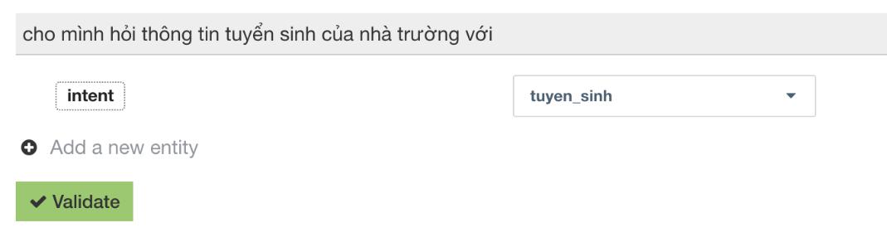

*Figure 4-21: Intent Classification*

**4.3.4.1.2 Conversation Design**

**4.3.4.1.2.1 Dialogues by finite state method**

In order to model dialogues, we made so many states and defined lots of transitions using Wit intent model. When our system initialized, it enters initiation state. A response is selected among the candidate sentences based on the transition triggered by an end user query and by the explicit state which stores context information.

The dialogues managed by finite state method has two types: multi-round and one-round dialogue.

**4.3.4.1.2.1.1 Multi-round dialogues**

We designed 4 multi-round dialogues: Admission, Major, Accommodation and Contact.

These dialogues are triggered when the end user asks about the topics.

1. Admission dialogue provides a general information about the admission that end user asked about and provides about scholarships, costs and fees, entry requirements, how to

apply.

1. Major dialogue provides a general information about degree programs, short courses. o Accommodation dialogue provides information about dormitory, services, sports,

security.

o Contact dialogue provides information about receive counseling indirectly or directly.

To break down a complex end user’s utterance we use decision tree, a map of the possible outcomes of related choices. A decision tree typically starts with a single node, which branches into possible outcomes. Each of those outcomes leads to additional nodes, which branch off into other possibilities. This gives it a treelike shape. We design 4 decision trees corresponding with 4 multi-round dialogues.

Now we describe our decision trees for making state machine transitions in multi-rounds conversations.

**Admission dialogue**

Intent Node: tuyen_sinh

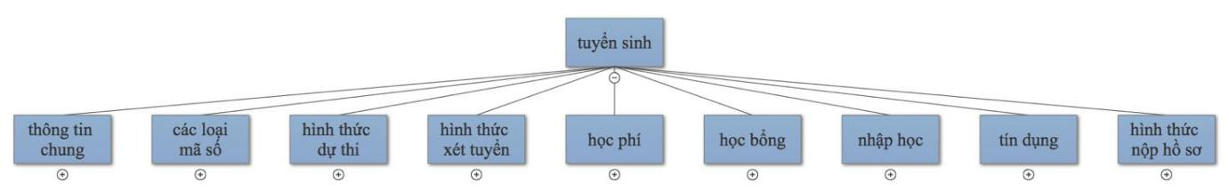

*Figure 4-22: tuyen_sinh node*

Entity Node: thong_tin_chung

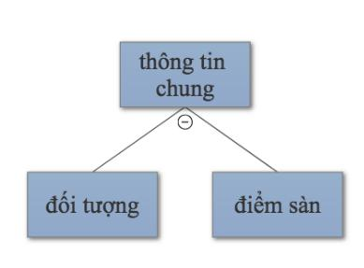

*Figure 4-23: thong_tin_chung node*

Entity Node: cac_loai_maso

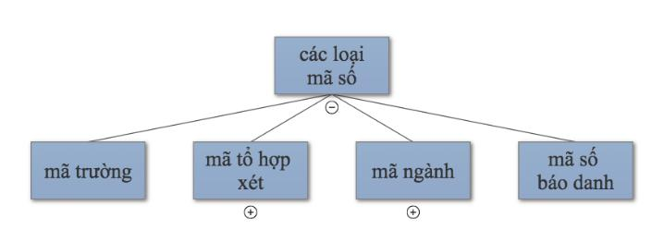

*Figure 4-24: cac_loai_maso node*

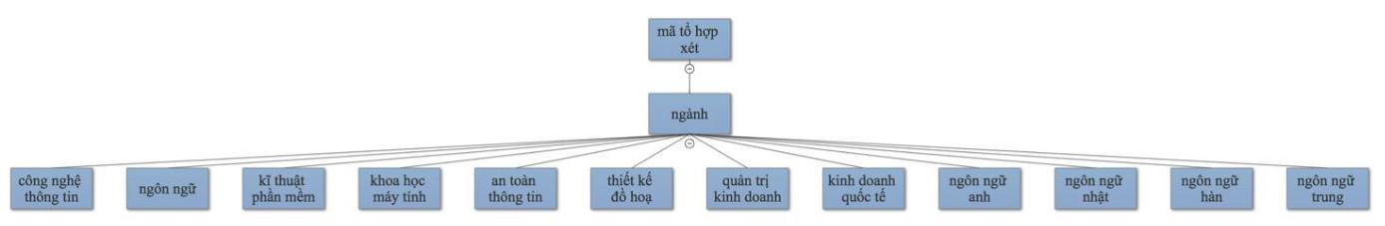

*Figure 4-25: mã tổ hợp xét node*

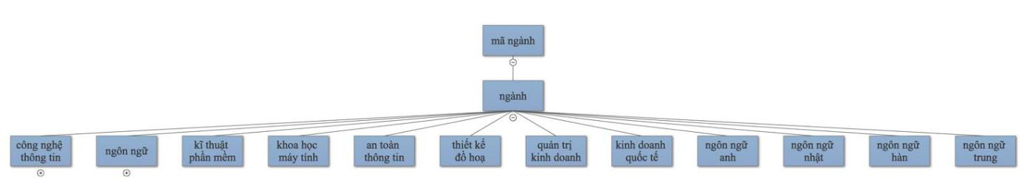

*Figure 4-26: mã ngành node*

Entity Node: hinh_thuc_duthi

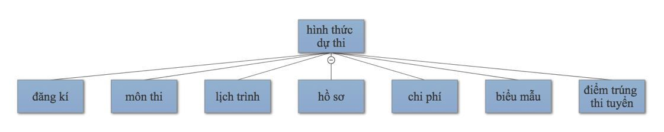

*Figure 4-27: hinh_thuc_duthi node*

Entity Node: hinh_thuc_xettuyen

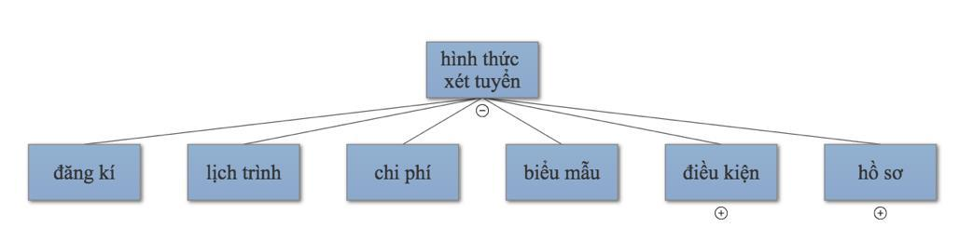

*Figure 4-28: hinh_thuc_xettuyen node*

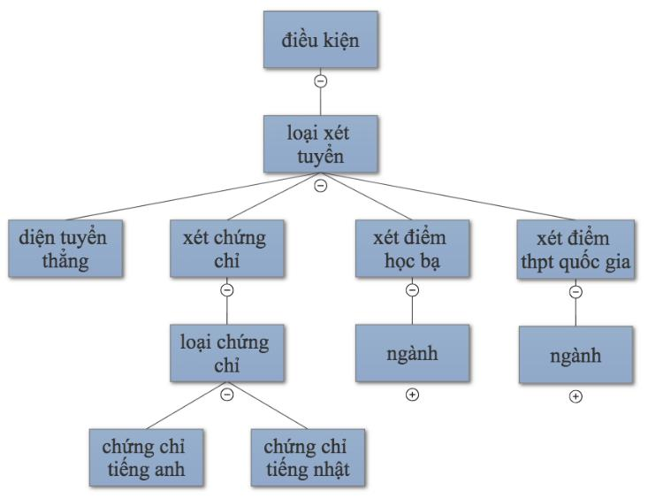

*Figure 4-29: điều kiện node*

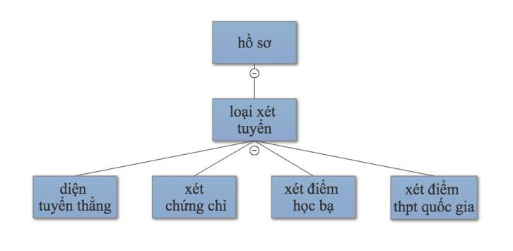

*Figure 4-30: hồ sơ node*

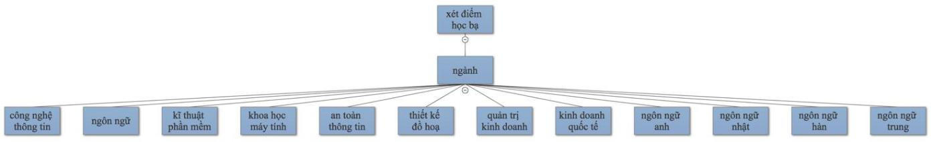

*Figure 4-31: xét điểm học bạ node*

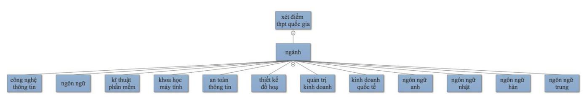

*Figure 4-32: xét điểm thpt quốc gia node*

Entity Node: hoc_phi

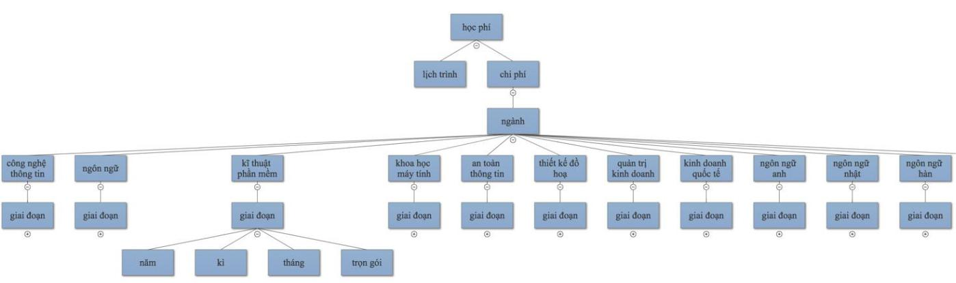

*Figure 4-33: hoc_phi node*

Entity Node: hoc_bong

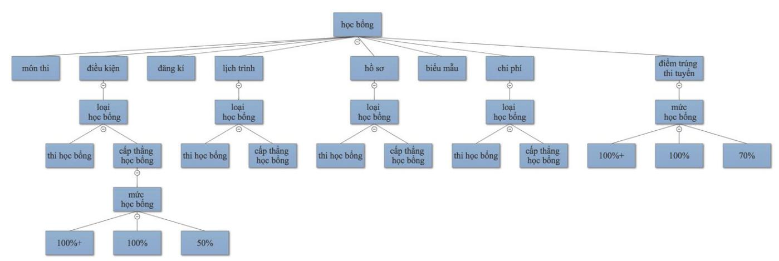

*Figure 4-34: hoc_bong node*

Entity Node: nhap_hoc

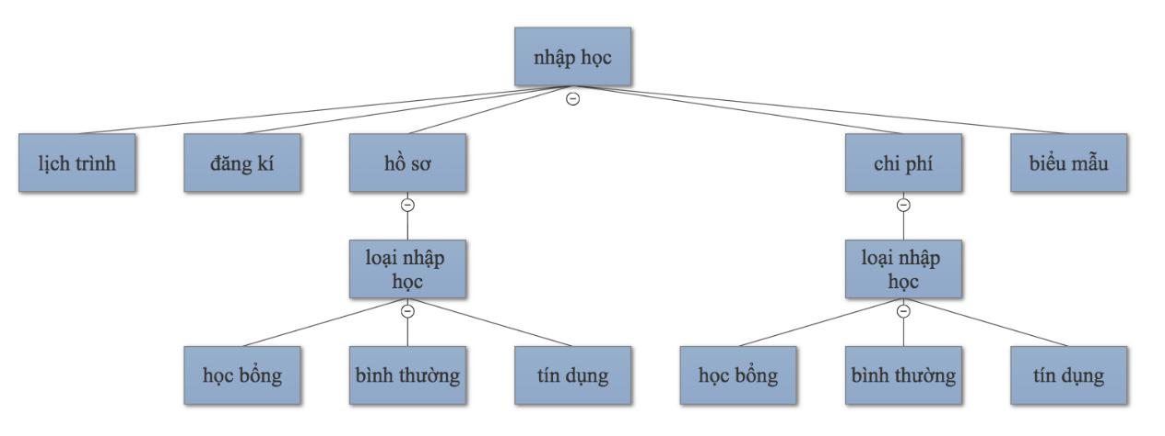

*Figure 4-35: nhap_hoc node*

Entity Node: tin_dung

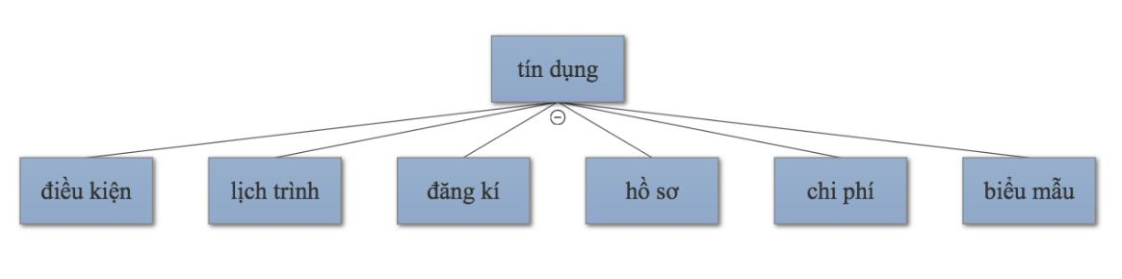

*Figure 4-36: tin_dung node*

Entity Node: hinh_thuc_nop_hoso

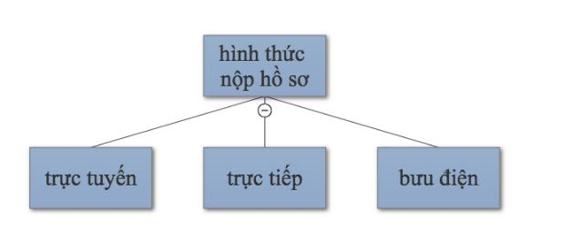

*Figure 4-37: hinh_thuc_nop_hoso node*

**Major Dialogue**

Intent Node: chuong_trinh_dao_tao

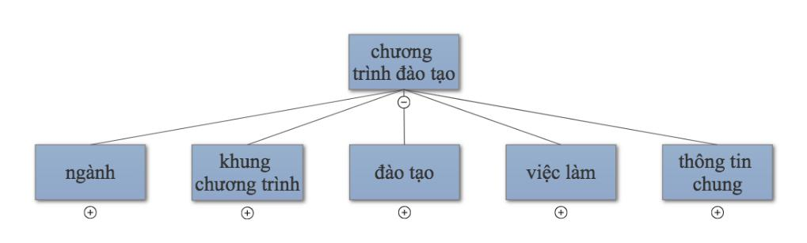

*Figure 4-38: chuong_trinh_dao_tao node*

Entity Node: nganh

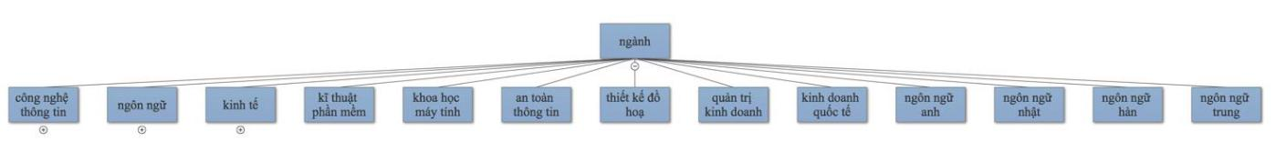

*Figure 4-39: nganh node*

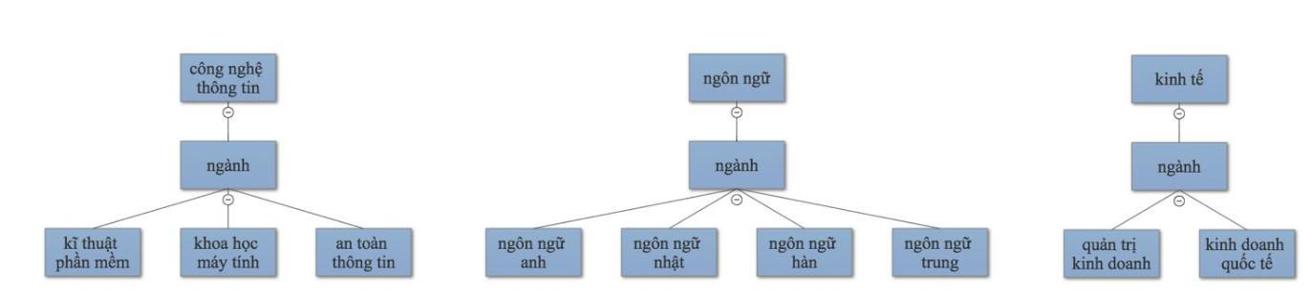

*Figure 4-40: công nghệ thông tin, ngôn ngữ, kinh tế node*

Entity Node: khung_chuong_trinh

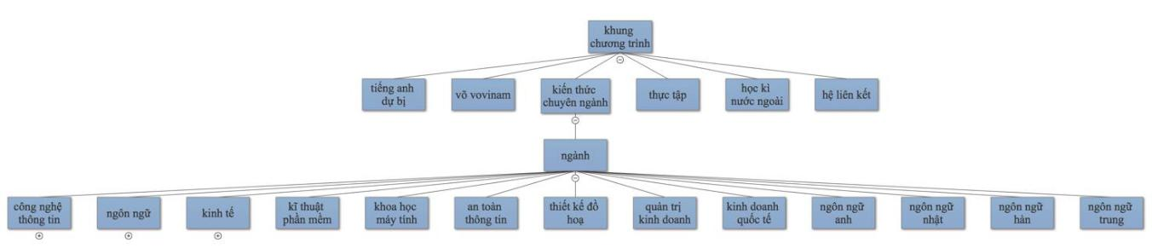

*Figure 4-41: khung_chuong_trinh node*

Entity Node: dao_tao

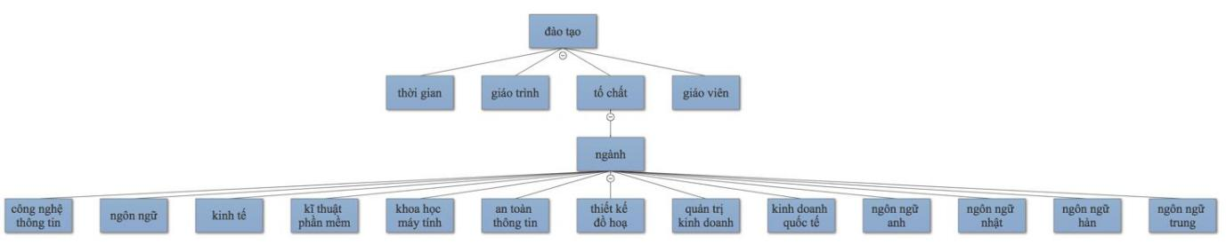

*Figure 4-42: dao_tao node*

Entity Node: viec_lam

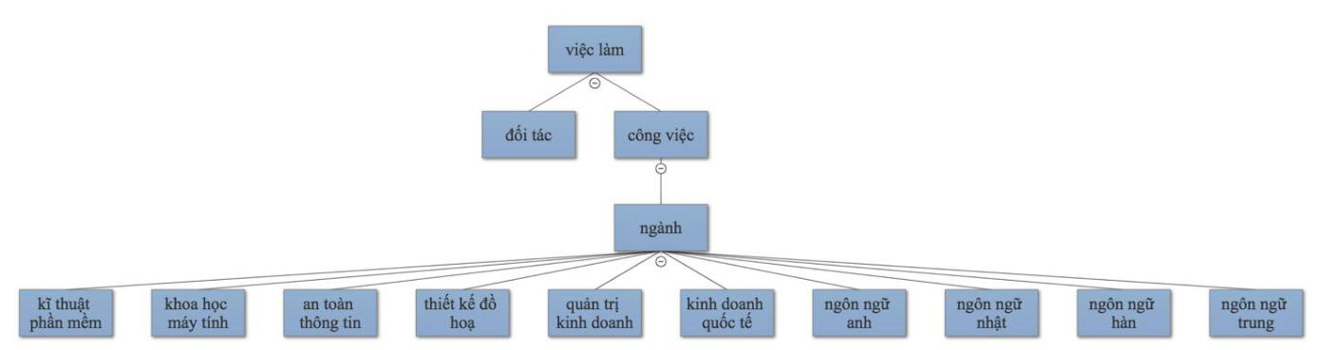

*Figure 4-43: viec_lam node*

Entity Node: thong_tin_chung

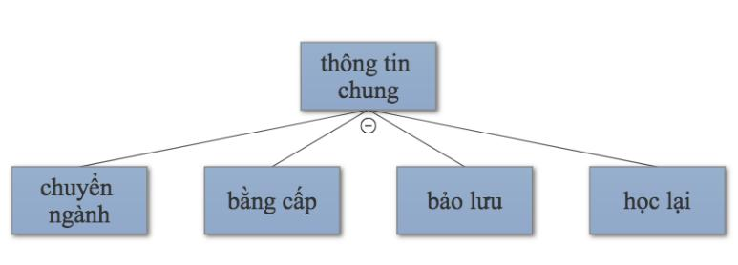

*Figure 4-44: thong_tin_chung node*

**Accommodation Dialogue**

Intent Node: doi_song_sv

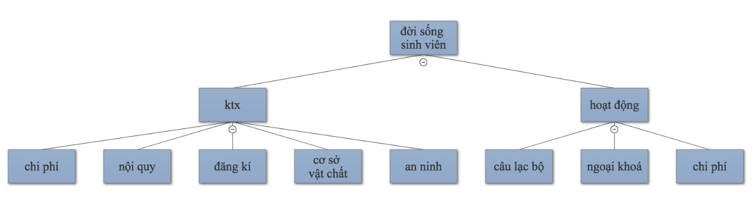

*Figure 4-45: doi_song_sv node*

**Contact Dialogue**

Intent Node: ket_noi_phsv

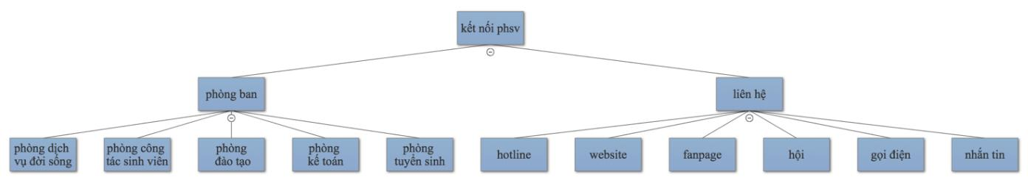

*Figure 4-46: ket_noi_phsv node*

**4.3.4.1.2.1.2 One-round dialogues**

We also defined intents for one-round conversations. These intents return appropriate utterance and change state to Default. First, we made an intent handling greetings from end users. Moreover, to handle end user’s questions about the system’s personal information such as age, name, sex, address, maker we made 5 different intents for each of them. Also we desinged intents to respond to ethical issues using bad words.

**4.3.4.1.3 Integrate Wit.ai with Facebook Messenger**

By choosing a page in <https://developers.facebook.com/apps>, Built-In NLP is automatically integrated on it.

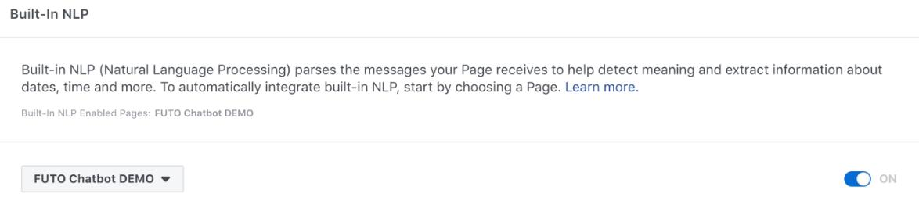

**4.3.4.1.4 Class diagram**

**One-round dialogue**

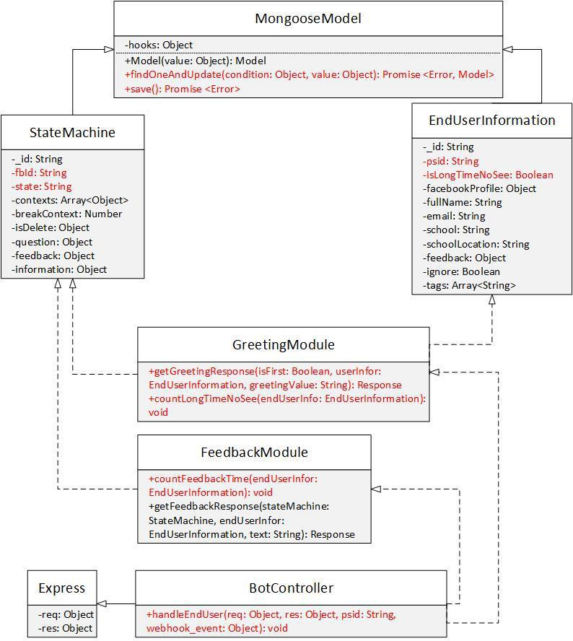

*Figure 4-47: One-round dialogue class diagram*

**Class Specification**

***EndUserInformation***

|  |  |  |  |  |
| --- | --- | --- | --- | --- |
|  | **EndUserInformation** | | | |
| Physical address | Backend/models/EndUserInformation.js | | | |
| Base class | MongooseModel |  |  |  |
|  |  | Attributes | |  |
| No | Name |  | Type | Description |
| 1 | psid |  | String |  |
| 2 | isLongTimeNoSee |  | Boolean |  |
|  |  | Operation | |  |

***StateMachine***



**StateMachine**

|  |  |  |  |  |  |  |  |  |  |  |  |  |  |
| --- | --- | --- | --- | --- | --- | --- | --- | --- | --- | --- | --- | --- | --- |
| Physical address |  | Backend/models/StateMachine.js | | | | | |  |  |  |  |  |  |
| Base class |  | MongooseModel | | |  |  |  |  |  |  |  |  |  |
|  |  |  |  |  | Attributes | | |  |  |  |  |  |  |
| No |  | Name | | |  | Type | |  | Description | |  |  |  |
| 1 |  | fbId | | |  | String | |  |  |  |  |  |  |
| 2 |  | state | | |  | Boolean | |  |  |  |  |  |  |
|  |  |  |  |  | Operation | | |  |  |  |  |  |  |
| ***GreetingModule*** | |  |  |  |  |  |  |  |  |  |  |  |  |
|  |  |  |  | **GreetingModule** | | | | | | |  |  |  |
| Physical address | |  |  | Backend/controllers/GreetingModule.js | | | | | | |  |  |  |
| Base class | |  |  | N/A |  |  |  |  |  |  |  |  |  |
|  |  |  |  |  |  | Attributes | | | | |  |  |  |
| No | |  |  | Name |  |  |  | Type | | |  | Description |  |
| N/A | |  |  | N/A |  |  |  | N/A | | |  | N/A |  |
|  |  |  |  |  |  | Operation | | | | |  |  |  |
| getGreetingResponse | | |  |  |  |  |  |  |  |  |  |  |  |
| Return Type | |  |  | Response |  |  |  |  |  |  |  |  |  |
| Parameters | |  |  | Name |  |  |  | Type | | |  | Description |  |
|  |  |  |  | isFirst |  |  |  | Boolean | | |  |  |  |
|  |  |  |  | userInfor |  |  |  | EndUserInformation | | | |  |  |
|  |  |  |  | greetingValue |  |  |  | String | | |  |  |  |
| countLongTimeNoSee | | |  |  |  |  |  |  |  |  |  |  |  |
| Return Type | |  |  | void |  |  |  |  |  |  |  |  |  |
| Parameters | |  |  | Name |  |  |  | Type | | |  | Description |  |
|  |  |  |  | endUserInfor |  |  |  | EndUserInformation | | | |  |  |
| ***FeedbackModule*** | | | | |  |  |  |  |  |  |  |  |  |
|  |  |  |  | **FeedbackModule** | | | | | | |  |  |  |
| Physical address | |  | Backend/controllers/FeedbackModule.js | | | | | | | |  |  |  |
| Base class | |  | N/A | |  |  |  |  |  |  |  |  |  |
|  |  |  |  |  |  | Attributes | | | | |  |  |  |
| No | |  | Name | |  |  |  | Type | | |  | Description |  |
| N/A | |  | N/A | |  |  |  | N/A | | |  | N/A |  |
|  |  |  |  |  |  | Operation | | | | |  |  |  |
| countFeedbackTime | | |  |  |  |  |  |  |  |  |  |  |  |
| Return Type | |  | void | |  |  |  |  |  |  |  |  |  |
| Parameters | |  | Name | |  |  |  | Type | | |  | Description |  |
|  |  |  | endUserInfor | |  |  |  | EndUserInformation | | | |  |  |
| ***BotController*** | |  |  |  |  |  |  |  |  |  |  |  |  |
|  |  |  |  |  | **BotController** | | | | | |  |  |  |
| Physical address | |  |  | Backend/controllers/BotController.js | | | | | | |  |  |  |
| Base class | |  |  | Express |  |  |  |  |  |  |  |  |  |
|  |  |  |  |  |  | Attributes | | | | |  |  |  |
| No | |  |  | Name |  |  |  |  |  | Type | Description | |  |
| N/A | |  |  | N/A |  |  |  |  |  | N/A | N/A | |  |
|  |  |  |  |  |  | Operation | | | | |  |  |  |
| handleEndUser | |  |  |  |  |  |  |  |  |  |  |  |  |
| Return Type | |  |  | void |  |  |  |  |  |  |  |  |  |

|  |  |  |  |
| --- | --- | --- | --- |
| Parameters | Name | Type | Description |
|  | req | object |  |
|  | res | object |  |
|  | psid | String |  |
|  | webhook_event | object |  |

**Multi-round dialog**

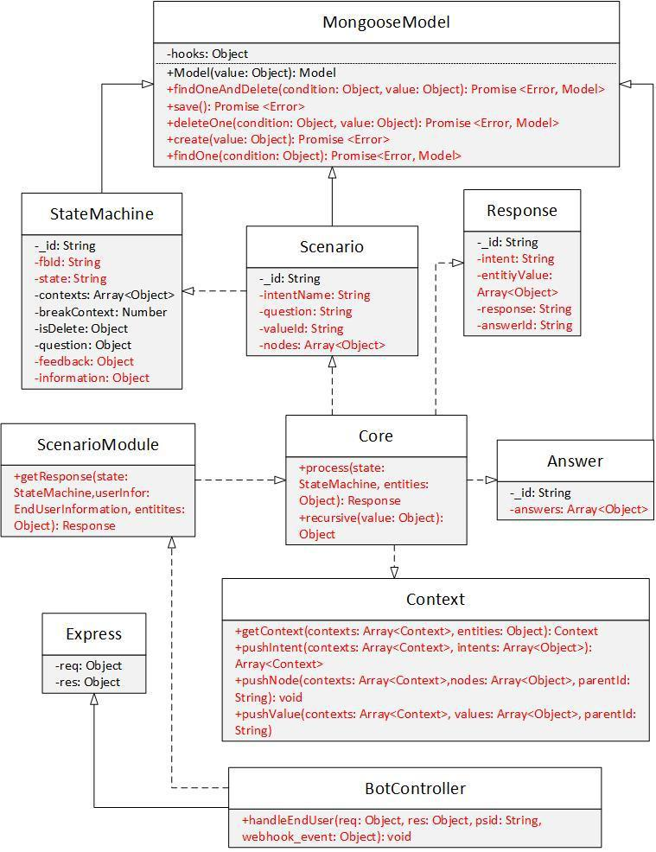

*Figure 4-48: Multi-round dialogue class diagram*

**Class Specification**

***Scenario***

****Scenario**

|  |  |  |  |  |  |  |  |  |  |  |  |  |  |  |
| --- | --- | --- | --- | --- | --- | --- | --- | --- | --- | --- | --- | --- | --- | --- |
|  | Physical address | Backend/models/Scenario.js | | | | | | |  |  |  |  |  |  |
|  | Base class | MongooseModel | |  |  |  |  |  |  |  |  |  |  |  |
|  |  |  |  |  |  | Attributes | | |  |  |  |  |  |  |
|  | No | Name | |  |  | Type | | |  |  | Description | |  |  |
| 1 | | intentName | |  |  | String | | |  |  |  |  |  |  |
| 2 | | question | |  |  | Boolean | | |  |  |  |  |  |  |
| 3 | | valueId | |  |  | String | | |  |  |  |  |  |  |
| 4 | | nodes | |  |  | Array<Object> | | | |  |  |  |  |  |
|  |  |  |  |  |  | Operation | | |  |  |  |  |  |  |
|  | ***StateMachine*** |  |  |  |  |  |  |  |  |  |  |  |  |  |
|  |  |  |  |  | **StateMachine** | | | |  |  |  |  |  |  |
|  | Physical address | Backend/models/StateMachine.js | | | | | | |  |  |  |  |  |  |
|  | Base class | MongooseModel | |  |  |  |  |  |  |  |  |  |  |  |
|  |  |  |  |  |  | Attributes | | |  |  |  |  |  |  |
|  | No | Name | |  |  | Type | |  | Description | | | |  |  |
|  | 1 | fbId | |  |  | String | |  |  |  |  |  |  |  |
|  | 2 | state | |  |  | Boolean | |  |  |  |  |  |  |  |
|  |  |  |  |  |  | Operation | | |  |  |  |  |  |  |
|  | ***Response*** |  |  |  |  |  |  |  |  |  |  |  |  |  |
|  |  |  |  |  |  | **Response** | | |  |  |  |  |  |  |
|  | Physical address | Backend/models/Response.js | | | | | | |  |  |  |  |  |  |
|  | Base class | MongooseModel | |  |  |  |  |  |  |  |  |  |  |  |
|  |  |  |  |  |  | Attributes | | |  |  |  |  |  |  |
|  | No | Name | |  | Type | | | |  | Description | | |  |  |
|  | 1 | intent | |  | String | | | |  |  |  |  |  |  |
|  | 2 | entityValue | |  | Array<Object> | | | |  |  |  |  |  |  |
|  | 3 | response | |  | String | | | |  |  |  |  |  |  |
|  | 4 | answerId | |  | String | | | |  |  |  |  |  |  |
|  |  |  |  |  |  | Operation | | |  |  |  |  |  |  |
|  | ***Answer*** |  |  |  |  |  |  |  |  |  |  |  |  |  |
|  |  |  |  |  |  | **Answer** | | |  |  |  |  |  |  |
|  | Physical address | Backend/models/Answer.js | | | | | | |  |  |  |  |  |  |
|  | Base class | MongooseModel | |  |  |  |  |  |  |  |  |  |  |  |
|  |  |  |  |  |  | Attributes | | |  |  |  |  |  |  |
|  | No | Name | |  | Type | | | |  | Description | | |  |  |
|  | 1 | answers | |  | Array<Object> | | | |  |  |  |  |  |  |
|  |  |  |  |  |  | Operation | | |  |  |  |  |  |  |
|  | ***ScenarioModule*** | | |  |  |  |  |  |  |  |  |  |  |  |
|  |  |  |  | **ScenarioModule** | | | | |  |  |  |  |  |  |
|  | Physical address |  | Backend/controllers/ScenarioModule.js | | | | | | | | | | |  |
|  | Base class |  | N/A |  |  |  |  |  |  |  |  |  |  |  |
|  |  |  |  |  |  | Attributes | | |  |  |  |  |  |  |
|  | No |  | Name |  |  |  | Type | | |  |  | Description |  |  |
|  | N/A |  | N/A |  |  |  | N/A | | |  |  | N/A | |  |

Operation

|  |  |  |  |  |  |
| --- | --- | --- | --- | --- | --- |
| getResonse |  |  |  |  |  |
| Return Type | Response |  |  |  |  |
| Parameters | Name |  | Type | Description |  |
|  | state |  | StateMachine |  |  |
|  | userInfor |  | EndUserInformation |  |  |
|  | entities |  | Object |  |  |
| ***Core*** |  |  |  |  |  |
|  |  | **Core** | |  |  |
| Physical address | Backend/controllers/Core.js | | |  |  |
| Base class | N/A |  |  |  |  |
|  |  | Attributes | |  |  |
| No | Name |  | Type | Description |  |
| N/A | N/A |  | N/A | N/A |  |
|  |  | Operation | |  |  |
| process |  |  |  |  |  |
| Return Type | void |  |  |  |  |
| Parameters | Name |  | Type | Description |  |
|  | state |  | StateMachine |  |  |
|  | entities |  | Object |  |  |
| ***Context*** |  |  |  |  |  |
|  |  | **Context** | |  |  |
| Physical address | Backend/controllers/Context.js | | |  |  |
| Base class | N/A |  |  |  |  |
|  |  | Attributes | |  |  |
| No | Name |  | Type | Description |  |
| N/A | N/A |  | N/A | N/A |  |
|  |  | Operation | |  |  |
| getContext |  |  |  |  |  |
| Return Type | Context |  |  |  |  |
| Parameters | Name |  | Type | Description |  |
|  | contexts |  | Array<Context> |  |  |
|  | entities |  | Object |  |  |
| pushIntent |  |  |  |  |  |
| Return Type | Array<Context> |  |  |  |  |
| Parameters | Name |  | Type | Description |  |
|  | contexts |  | Array<Context> |  |  |
|  | intents |  | Array<Object> |  |  |
| pushNode |  |  |  |  |  |
| Return Type | void |  |  |  |  |
| Parameters | Name |  | Type | Description |  |
|  | contexts |  | Array<Context> |  |  |
|  | nodes |  | Array<Object> |  |  |
|  | parentId |  | String |  |  |
| pushValue |  |  |  |  |  |
| Return Type | void |  |  |  |  |
| Parameters | Name |  | Type | Description |  |
|  | contexts |  | Array<Context> |  |  |

|  |  |  |  |  |  |  |  |
| --- | --- | --- | --- | --- | --- | --- | --- |
|  | values | | Array<Object> | |  |  |  |
|  | parentId | | String | |  |  |  |
| ***BotController*** |  |  |  |  |  |  |  |
|  |  | **BotController** | | |  |  |  |
| Physical address |  | Backend/controllers/BotController.js | | |  |  |  |
| Base class |  | Express |  |  |  |  |  |
|  |  | Attributes | | |  |  |  |
| No |  | Name |  | Type | Description | |  |
| N/A |  | N/A |  | N/A | N/A | | |
|  |  | Operation | | |  |  |  |
| handleEndUser |  |  |  |  |  |  |  |
| Return Type |  | void |  |  |  |  |  |
| Parameters |  | Name |  | Type | Description | | |
|  |  | req |  | object |  |  |  |
|  |  | res |  | object |  |  |  |
|  |  | psid |  | String |  |  |  |
|  |  | webhook_event |  | object |  |  |  |

**4.3.4.1.5 Sequence diagram**

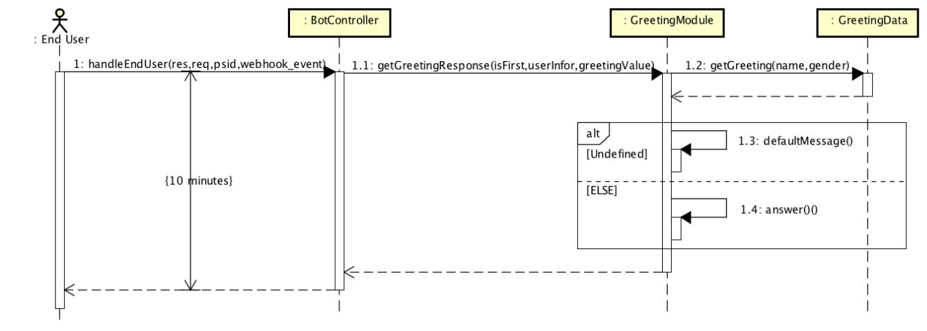

*Figure 4-49: One-round dialog sequence diagram*

**Implementation**

Pseudo code



var getFinalGreetingResponse ()

for each greeting intent list

greeting = greetingData at each index

if greeting.intentName === intentName

if intentName === "bat_dau"

if isFirstInbox

return greeting.firstInboxResponse

else if isLongTimeNoSee

return greeting.responseAfterLongTime return randomResponse(greeting.responses)

return undefined



var randomResponse ()

index = Math.floor(Math.random() * responses.length)

if index < length of responses

return responses at index

return undefined

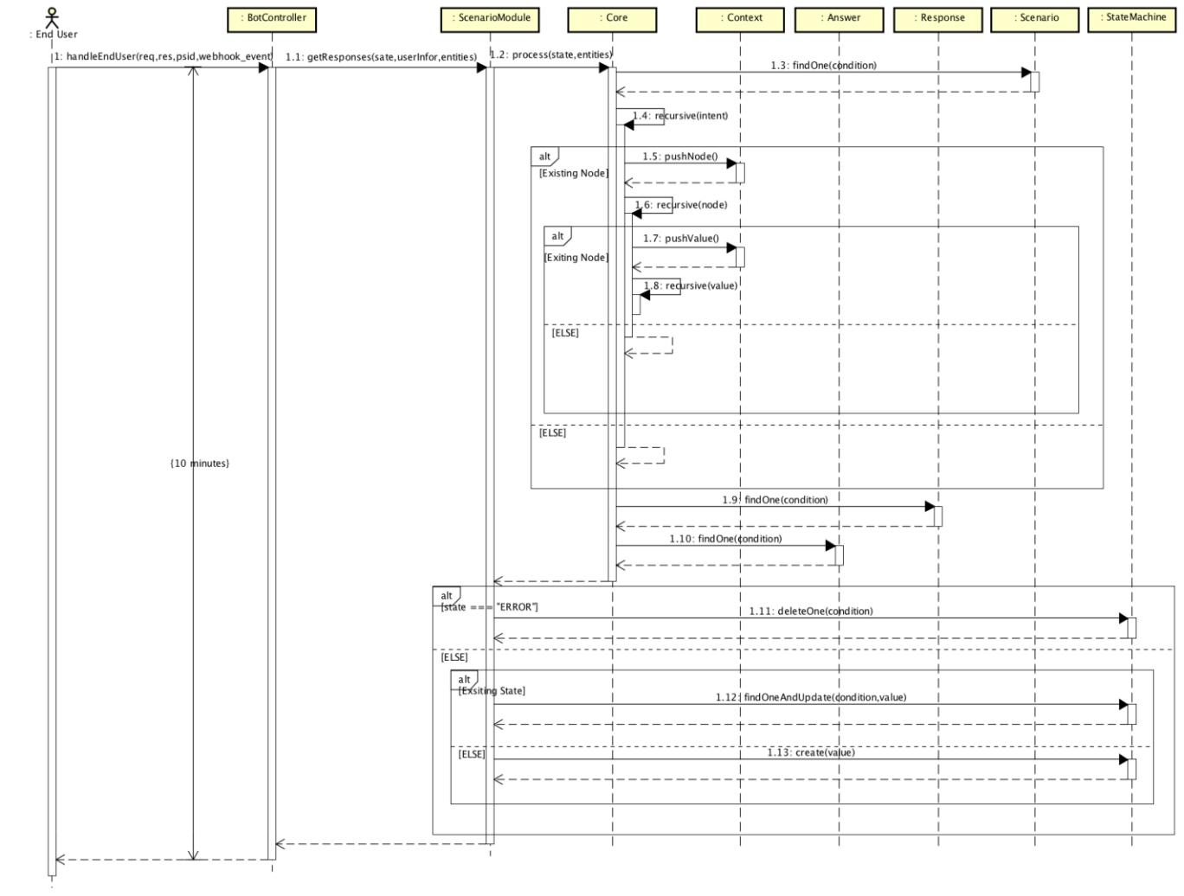

*Figure 4-50: Multi-round dialog sequence diagram*

**Implementation**

Pseudo code



if stateMachine not exist

init stateMachine

if context exist

map entities with context

if entities map with context

if stateMachine is continue but currentNode can go award use context to continue

else

if use context less than 3 time



use context to continue

else

recreate stateMachine and recreate context with intent else if entities do not map with context and stateMachine not continue

recreate stateMachine and recreate context with intent

else

create context with intent

if stateMachine continue

if continue at a value

recursive at this value to find answer else if continue at node

if entities map with a value of this node recursive at this value to find answer

else

return stateMachine with continue true at this node

else

handleError

else

if intent and entities valid

recursive at root to find answer

else

return stateMachine with continue true at root

**4.3.4.2** **End user leaves feedback**

**Conversation Design**

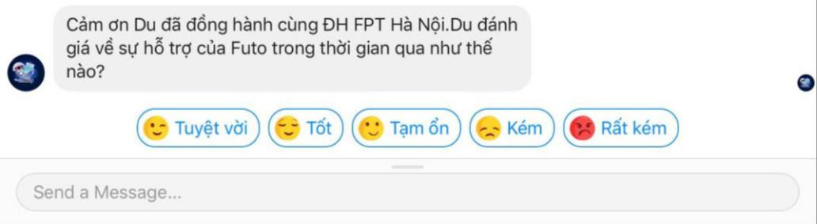

*Figure 4-51: Leave Feedback Conversation Design*

**Class diagram**

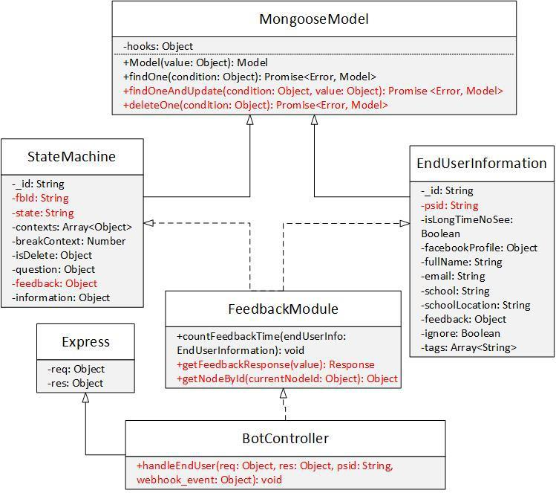

|  |  |  |  |  |  |
| --- | --- | --- | --- | --- | --- |
|  |  |  | *Figure 4-52: Leave feedback class diagram* | | |
| **Class Specification** | |  |  |  |  |
| ***EndUserInformation*** | | |  |  |  |
|  |  |  | **EndUserInformation** | | |
| Physical address |  | Backend/models/EndUserInformation.js | | | |
| Base class |  | MongooseModel | | |  |
|  |  |  | Attributes | |  |
| No |  | Name |  | Type | Description |
| 1 |  | psid |  | String |  |
|  |  |  | Operation | |  |
| ***StateMachine*** | |  |  |  |  |
|  |  |  | **StateMachine** | |  |
| Physical address |  | Backend/models/StateMachine.js | | |  |
| Base class |  | MongooseModel | | |  |
|  |  |  | Attributes | |  |
| No |  | Name |  | Type | Description |
| 1 |  | fbId |  | String |  |
| 2 |  | state |  | Boolean |  |
| 3 |  | feedback |  | Object |  |
|  |  |  | Operation | |  |

***FeedbackModule***



**FeedbackModule**

|  |  |  |  |  |  |  |  |  |  |
| --- | --- | --- | --- | --- | --- | --- | --- | --- | --- |
|  | Physical address | Backend/controllers/FeedbackModule.js | | | |  |  |  |  |
|  | Base class | N/A | |  |  |  |  |  |  |
|  |  |  | Attributes | | |  |  |  |  |
|  | No | Name | | Type | |  | Description |  |  |
|  | N/A | N/A | | N/A | |  | N/A | | |
|  |  |  | Operation | | |  |  |  |  |
|  | getFeedbackResponse |  |  |  |  |  |  |  |  |
|  | Return Type | Response | |  |  |  |  |  |  |
|  | Parameters | Name | | Type | |  | Description | | |
|  |  | value | | Object | |  |  |  |  |
|  | getNodeById |  |  |  |  |  |  |  |  |
|  | Return Type | Object | |  |  |  |  |  |  |
|  | Parameters | Name | | Type | |  | Description | | |
|  |  | currentNodeId | | Object | |  |  |  |  |
|  | ***BotController*** |  |  |  |  |  |  |  |  |
|  |  |  | **BotController** | | |  |  |  |  |
|  | Physical address |  | Backend/controllers/BotController.js | | |  |  |  |  |
|  | Base class |  | Express |  |  |  |  |  |  |
|  |  |  | Attributes | | |  |  |  |  |
|  | No |  | Name |  | Type | Description | |  |  |
|  | N/A |  | N/A |  | N/A | N/A | | |  |
|  |  |  | Operation | | |  |  |  |  |
|  | handleEndUser |  |  |  |  |  |  |  |  |
|  | Return Type |  | void |  |  |  |  |  |  |
|  | Parameters |  | Name |  | Type | Description | | |  |
|  |  |  | req |  | object |  |  |  |  |
|  |  |  | res |  | object |  |  |  |  |
|  |  |  | psid |  | String |  |  |  |  |
|  |  |  | webhook_event |  | object |  |  |  |  |

**Sequence diagram**

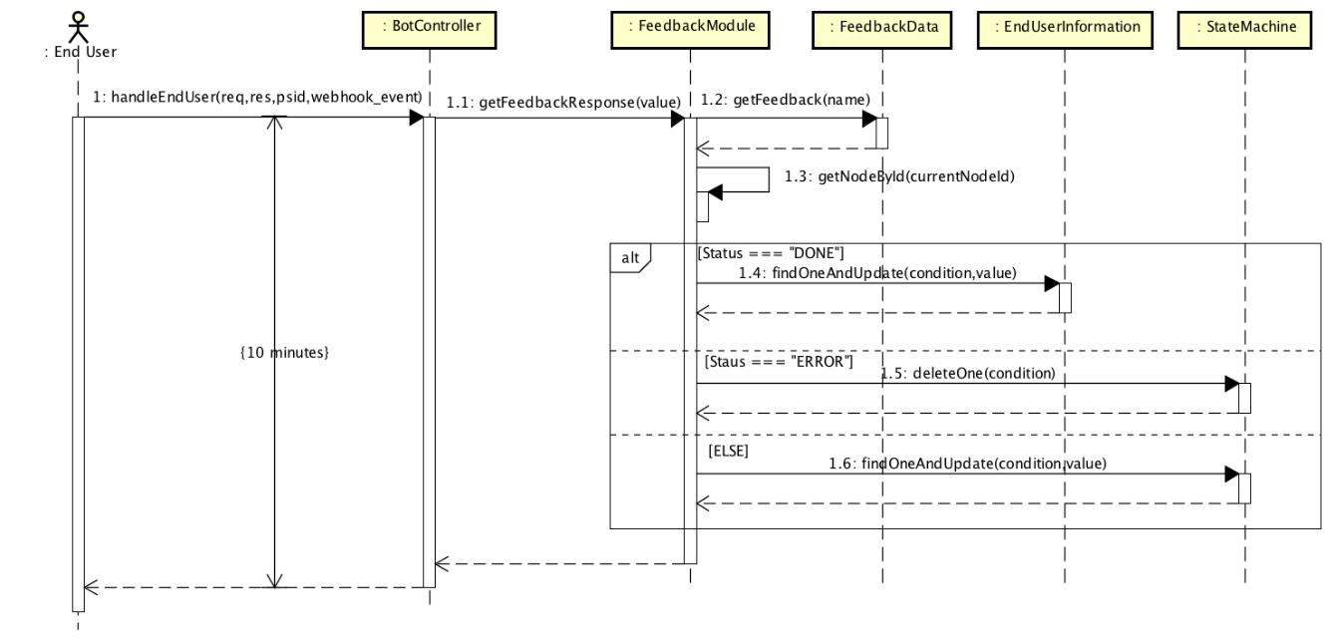

*Figure 4-53: Leave Feedback sequence diagram*

**4.3.4.3 End user leaves personal information Conversation Design**

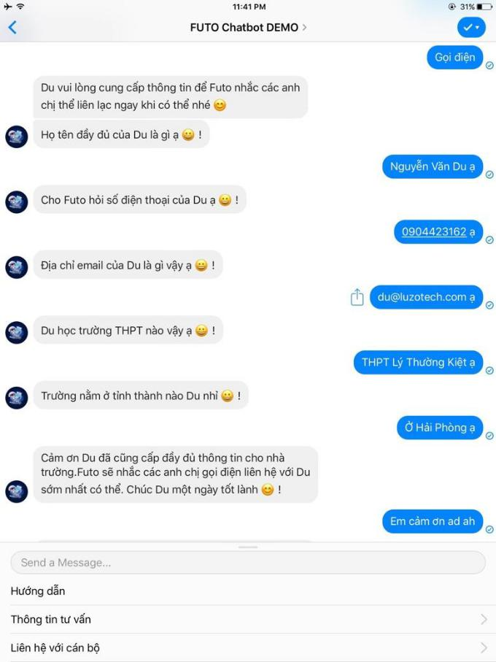

*Figure 4-54: Leave Personal Information Conversation*

**Class Diagram**

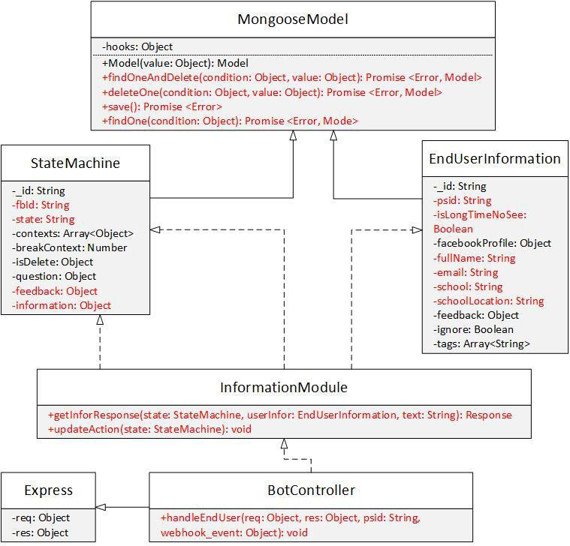

|  |  |  |  |  |  |
| --- | --- | --- | --- | --- | --- |
|  |  | *Figure 4-55: Leave information class diagram* | | | |
| **Class Specification** | |  |  |  |  |
| ***EndUserInformation*** | | |  |  |  |
|  |  | **EndUserInformation** | | | |
| Physical address |  | Backend/models/EndUserInformation.js | | | |
| Base class |  | MongooseModel |  |  |  |
|  |  |  |  | Attributes |  |
| No |  | Name |  | Type | Description |
| 1 |  | psid |  | String |  |
| 2 |  | isLongTimeNoSee |  | Boolean |  |
| 3 |  | fullName |  | String |  |
| 4 |  | email |  | String |  |
| 5 |  | school |  | String |  |
| 6 |  | schoolLocation |  | String |  |
|  |  |  |  | Operation |  |
| ***StateMachine*** | |  |  |  |  |
|  |  |  | **StateMachine** | |  |

|  |  |  |  |  |  |  |  |  |  |  |  |  |  |
| --- | --- | --- | --- | --- | --- | --- | --- | --- | --- | --- | --- | --- | --- |
| Physical address | Backend/models/StateMachine.js | | | | | |  |  |  |  |  |  |  |
| Base class | MongooseModel | | |  |  |  |  |  |  |  |  |  |  |
|  |  |  |  |  | Attributes | | | | |  |  |  |  |
| No | Name | | |  | Type | |  | Description | |  |  |  |  |
| 1 | fbId | | |  | String | |  |  |  |  |  |  |  |
| 2 | state | | |  | Boolean | |  |  |  |  |  |  |  |
| 3 | information | | |  | Object | |  |  |  |  |  |  |  |
|  |  |  |  |  | Operation | | | | |  |  |  |  |
| ***InformationModule*** | | | |  |  |  |  |  |  |  |  |  |  |
|  |  |  |  | **InformationModule** | | | | | |  |  |  |  |
| Physical address |  | Backend/controllers/InformationModule.js | | | | | | | |  |  |  |  |
| Base class |  | N/A | |  |  |  |  |  |  |  |  |  |  |
|  |  |  |  |  | Attributes | | | | |  |  |  |  |
| No |  | Name | |  |  |  | Type | | |  | Description |  |  |
| N/A |  | N/A | |  |  |  | N/A | | |  | N/A | |  |
|  |  |  |  |  | Operation | | | | |  |  |  |  |
| getInforResponse |  |  |  |  |  |  |  |  |  |  |  |  |  |
| Return Type |  | Response | |  |  |  |  |  |  |  |  |  |  |
| Parameters |  | Name | |  |  |  | Type | | |  | Description | |  |
|  |  | state | |  |  |  | StateMachine | | |  |  |  |  |
|  |  | userInfor | |  |  |  | EndUserInformation | | | |  | |  |
|  |  | text | |  |  |  | String | | |  |  |  |  |
| updateAction |  |  |  |  |  |  |  |  |  |  |  |  |  |
| Return Type |  | void | |  |  |  |  |  |  |  |  |  |  |
| Parameters |  | Name | |  |  |  | Type | | |  | Description | |  |
|  |  | state | |  |  |  | StateMachine | | |  |  |  |  |
| ***BotController*** |  |  |  |  |  |  |  |  |  |  |  |  |  |
|  |  |  |  | **BotController** | | | | | |  |  |  |  |
| Physical address |  |  | Backend/controllers/BotController.js | | | | | | |  |  |  |  |
| Base class |  |  | Express |  |  |  |  |  |  |  |  |  |  |
|  |  |  |  |  | Attributes | | | | |  |  |  |  |
| No |  |  | Name |  |  |  |  |  | Type | Description | |  |  |
| N/A |  |  | N/A |  |  |  |  |  | N/A | N/A | | |  |
|  |  |  |  |  | Operation | | | | |  |  |  |  |
| handleEndUser |  |  |  |  |  |  |  |  |  |  |  |  |  |
| Return Type |  |  | void |  |  |  |  |  |  |  |  |  |  |
| Parameters |  |  | Name |  |  |  |  |  | Type | Description | | |  |
|  |  |  | req |  |  |  |  |  | object |  |  |  |  |
|  |  |  | res |  |  |  |  |  | object |  |  |  |  |
|  |  |  | psid |  |  |  |  |  | String |  |  |  |  |
|  |  |  | webhook_event | | | |  |  | object |  |  |  |  |

**Sequence Diagram**

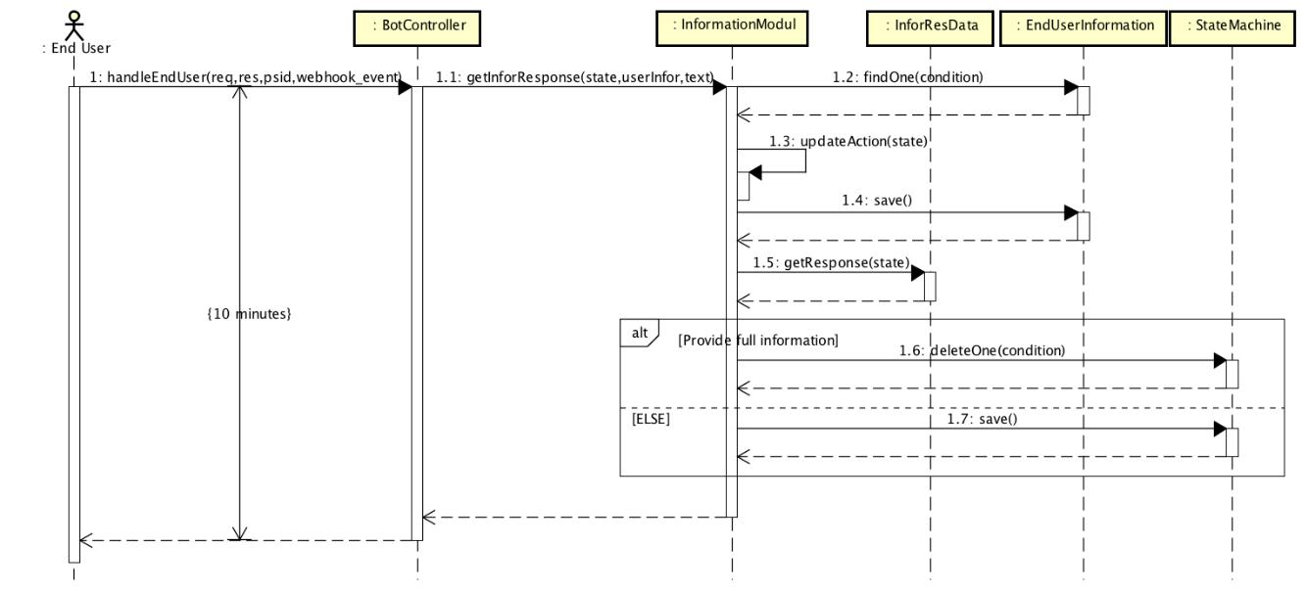

*Figure 4-56: Leave personal information sequence diagram*

**4.3.4.4 Staff resets password**

**Screen Design**

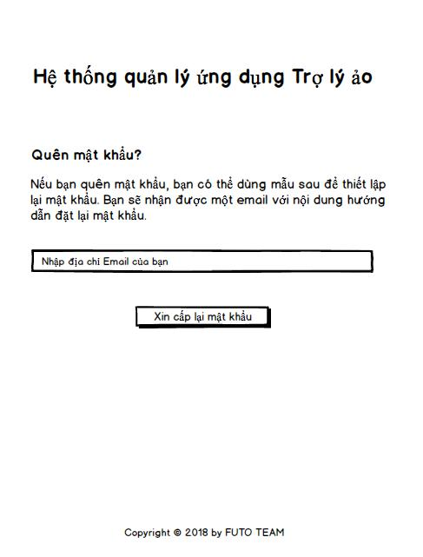

*Figure 4-57: Staff resets password screen design*

**Class Diagram**

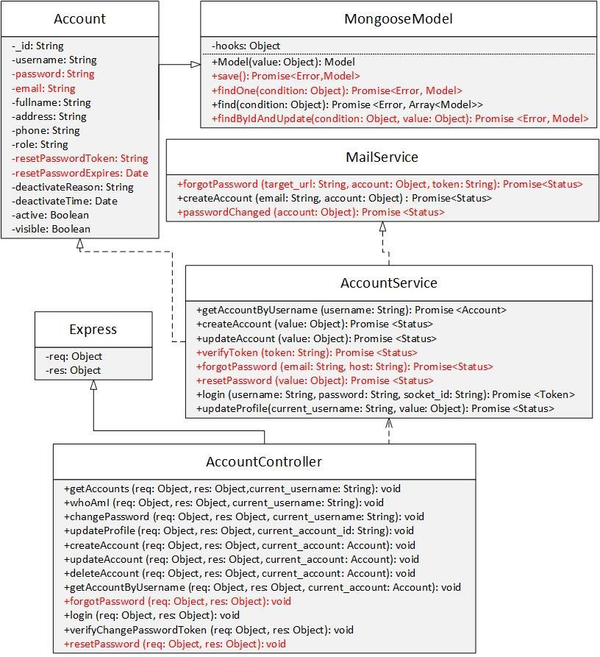

|  |  |  |  |  |  |  |  |
| --- | --- | --- | --- | --- | --- | --- | --- |
|  |  | *Figure 4-58: Staff resets password class diagram* | | | | |  |
| **Class Specification** | |  |  |  |  |  |  |
| ***Account*** | |  |  |  |  |  |  |
|  |  |  |  | **Account** | |  |  |
| Physical address |  | Backend/models/Account.js | | | |  |  |
| Base class |  | MongooseModel |  |  |  |  |  |
|  |  |  | Attributes | | |  |  |
| No |  | Name |  | Type |  | Description |  |
| 1 |  | email |  | String |  |  |  |
| 2 |  | password |  | String |  |  |  |
| 3 |  | resetPasswordToken |  | String |  |  |  |
| 4 |  | resetPasswordExpires |  | Date |  |  |  |
|  |  |  | Operation | | |  |  |
| ***AccountService*** | |  |  |  |  |  |  |
|  |  | **AccountService** | | | |  |  |

|  |  |  |  |  |  |  |  |
| --- | --- | --- | --- | --- | --- | --- | --- |
| Physical address | Backend/controllers/AccountService.js | | | |  |  |  |
| Base class | N/A | | |  |  |  |  |
|  | Attributes | | |  |  |  |  |
| No | Name |  |  | Type | Description |  |  |
| N/A | N/A | |  | N/A | N/A | | |
|  | Operation | | |  |  |  |  |
| forgotPassword |  |  |  |  |  |  |  |
| Return Type | Promise<Status> | | |  |  |  |  |
| Parameters | Name | |  | Type | Description | | |
|  | email | |  | String |  |  |  |
|  | host | |  | String |  |  |  |
| resetPassword |  |  |  |  |  |  |  |
| Return Type | Promise<Status> | | |  |  |  |  |
| Parameters | Name | |  | Type | Description | | |
|  | value | |  | object |  |  |  |
| ***MailService*** |  |  |  |  |  |  |  |
|  | **MailService** | | |  |  |  |  |
| Physical address | Backend/controllers/MailService.js | | | |  |  |  |
| Base class | N/A | | |  |  |  |  |
|  | Attributes | | |  |  |  |  |
| No | Name |  |  | Type | Description |  |  |
| N/A | N/A | |  | N/A | N/A | |  |
|  | Operation | | |  |  |  |  |
| passwordChanged |  |  |  |  |  |  |  |
| Return Type | Promise<Status> | | |  |  |  |  |
| Parameters | Name | |  | Type | Description | |  |
|  | account | |  | object |  |  |  |
| forgotPassword |  |  |  |  |  |  |  |
| Return Type | Promise<Status> | | |  |  |  |  |
| Parameters | Name | |  | Type | Description | |  |
|  | target_url | |  | String |  |  |  |
|  | account | |  | object |  |  |  |
|  | token | |  | String |  |  |  |
| ***AccountController*** |  |  |  |  |  |  |  |
|  | **AccountController** | | |  |  |  |  |
| Physical address | Backend/controllers/AccountController.js | | | |  |  |  |
| Base class | Express | | |  |  |  |  |
|  | Attributes | | |  |  |  |  |
| No | Name |  |  | Type | Description |  | |
| N/A | N/A | |  | N/A | N/A | | |
|  | Operation | | |  |  |  |  |
| resetPassword |  |  |  |  |  |  |  |
| Return Type | void | | |  |  |  |  |
| Parameters | Name | |  | Type | Description | | |
|  | req | |  | object |  |  |  |
|  | res | |  | object |  |  |  |
| forgotPassword |  |  |  |  |  |  |  |
| Return Type | void | | |  |  |  |  |

|  |  |  |  |
| --- | --- | --- | --- |
| Parameters | Name | Type | Description |
|  | req | object |  |
|  | res | object |  |

**Sequence Diagram**

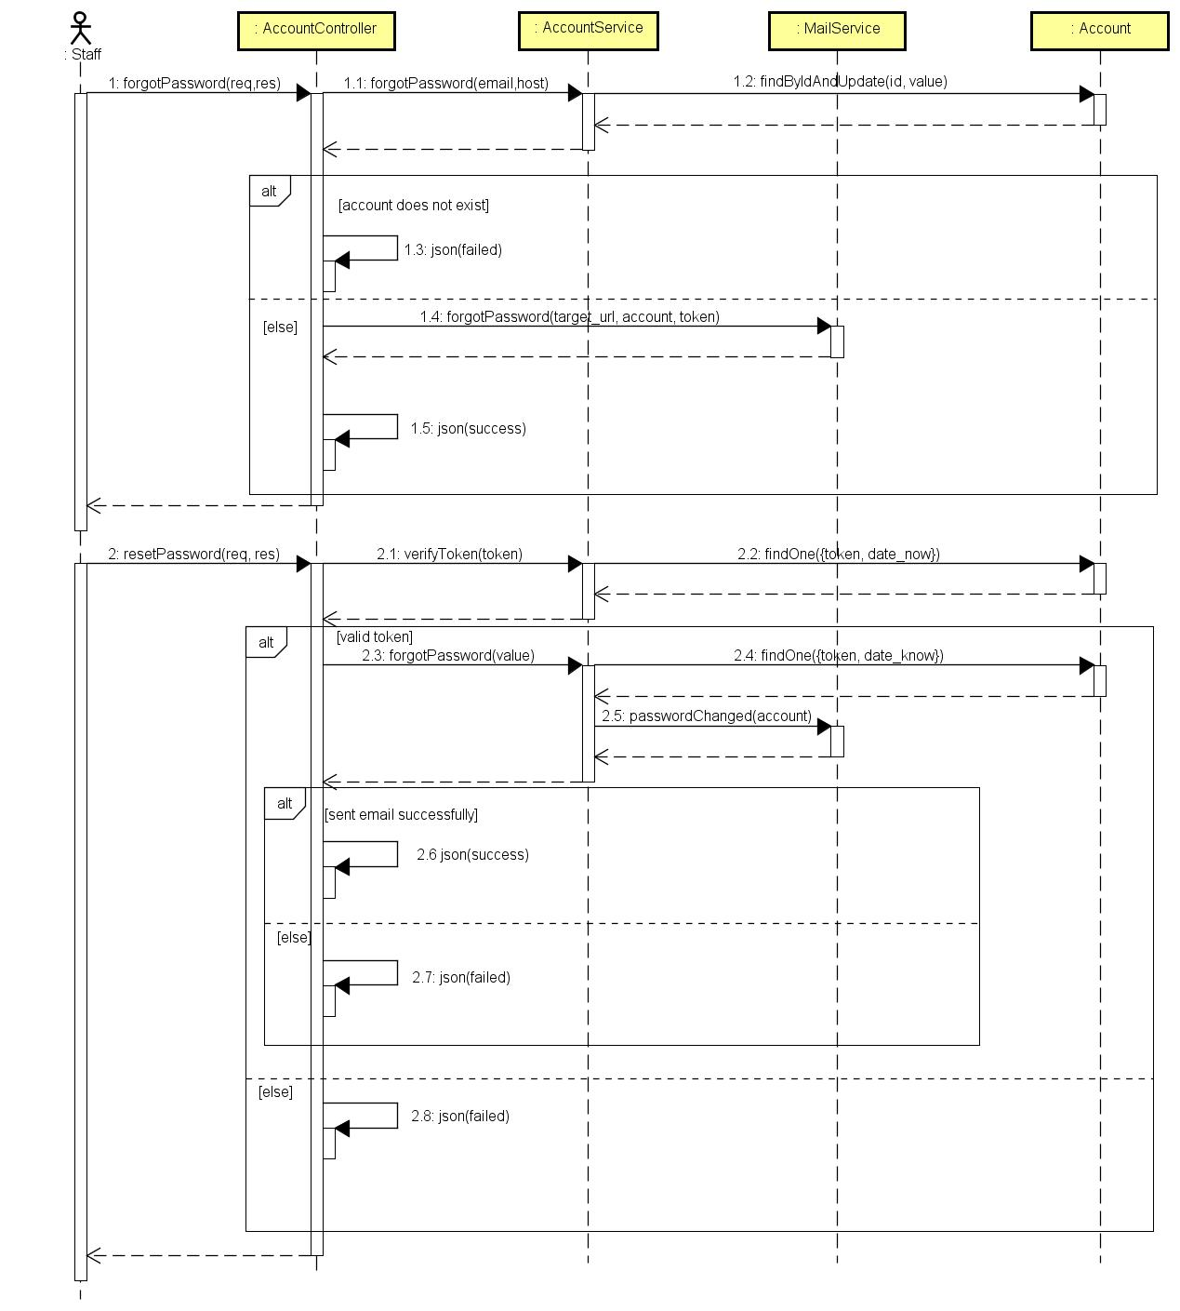

*Figure 4-59: Staff resets password sequence diagram*

**4.3.4.5 Staff logins by ASC account**

**Screen Design**

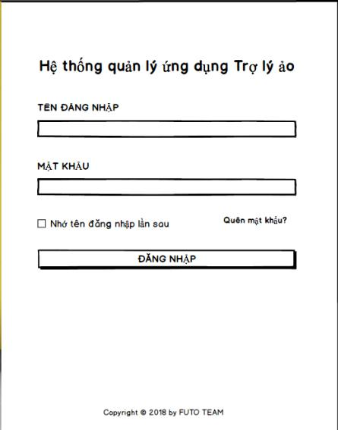

*Figure 4-60: Staff logins by ASC account screen design*

**Class Diagram**

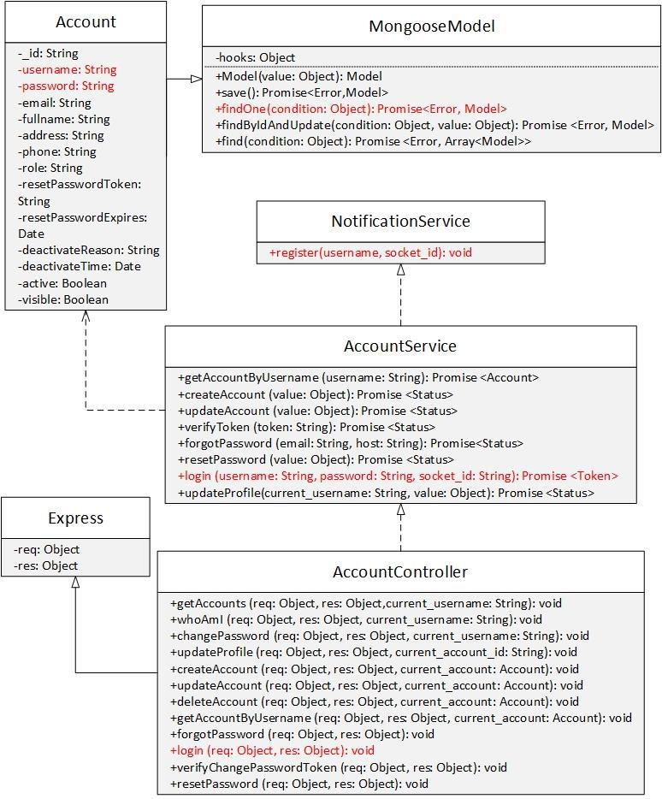

*Figure 4-61: Staff logins by ASC account class diagram.*

**Class Specification**

***Account***



**Account**

|  |  |  |  |  |  |  |
| --- | --- | --- | --- | --- | --- | --- |
| Physical address | | Backend /models/Account.js | |  |  |  |
| Base class | | MongooseModel | |  |  |  |
|  |  | Attributes | |  |  |  |
| No |  | Name |  | Type | Description |  |
| 1 |  | username | | String |  |  |
| 2 |  | password | | String |  |  |
|  |  | Operation | |  |  |  |
| N/A |  | N/A | |  |  |  |
| ***AccountService*** | |  |  |  |  |  |
|  |  | **AccountService** | |  |  |  |
| Physical address |  | Backend/controllers/AccountService.js | | |  |  |
| Base class |  | N/A | |  |  |  |
|  |  | Attributes | |  |  |  |
| No |  | Name |  | Type | Description |  |
| N/A | | N/A | | N/A | N/A | |
|  |  | Operation | |  |  |  |
| login |  |  |  |  |  |  |
| Return Type | | Promise<Token> | |  |  |  |
| Parameters | | Name | | Type | Description | |
|  |  | username | | String |  |  |
|  |  | password | | String |  |  |
|  |  | socket_id | | String |  |  |
| ***AccountController*** | |  |  |  |  |  |
|  |  | **AccountController** | |  |  |  |
| Physical address | | Backend/controllers/AccountController.js | | |  |  |
| Base class | | Express | |  |  |  |
|  |  | Attributes | |  |  |  |
| No |  | Name |  | Type | Description |  |
|  |  | Operation | |  |  |  |
| login |  |  |  |  |  |  |
| Return Type | | void | |  |  |  |
| Parameters | | Name | | Type | Description | |
|  |  | req | | object |  |  |
|  |  | res | | object |  |  |

**Sequence Diagram**

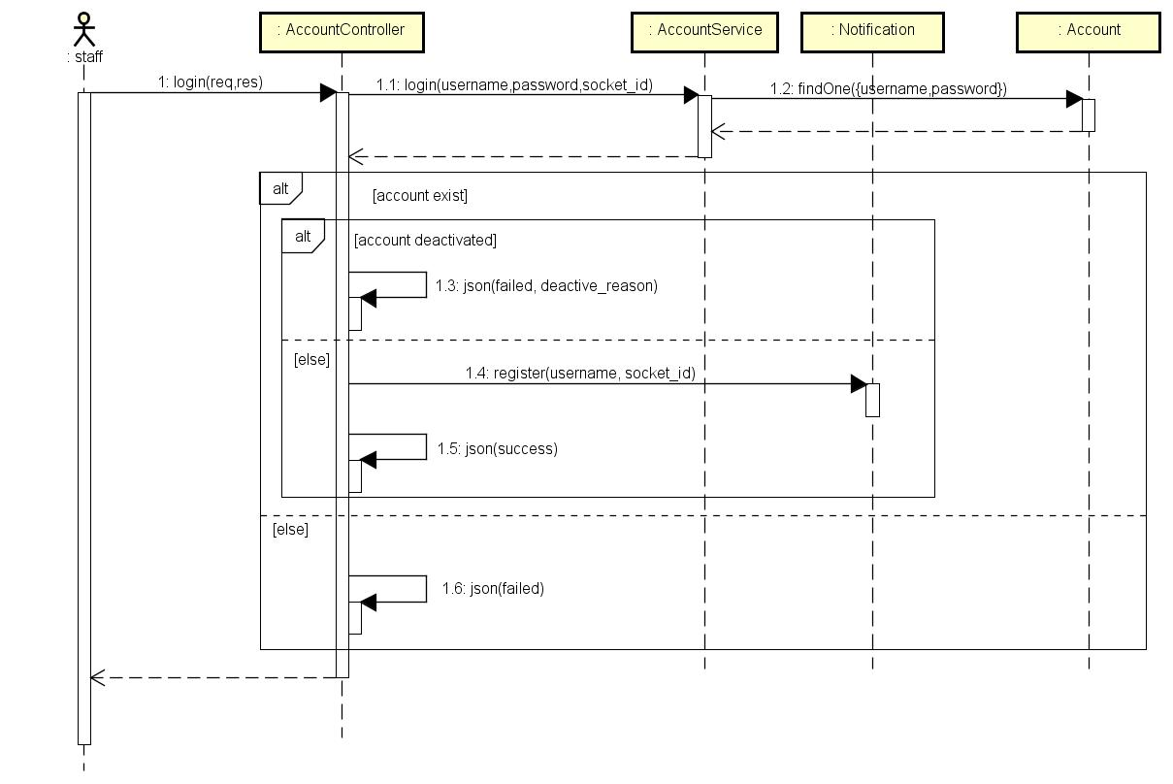

*Figure 4-62: Staff logins by ASC account sequence diagram*

**4.3.4.6 Staff views statistics**

**Screen Design**

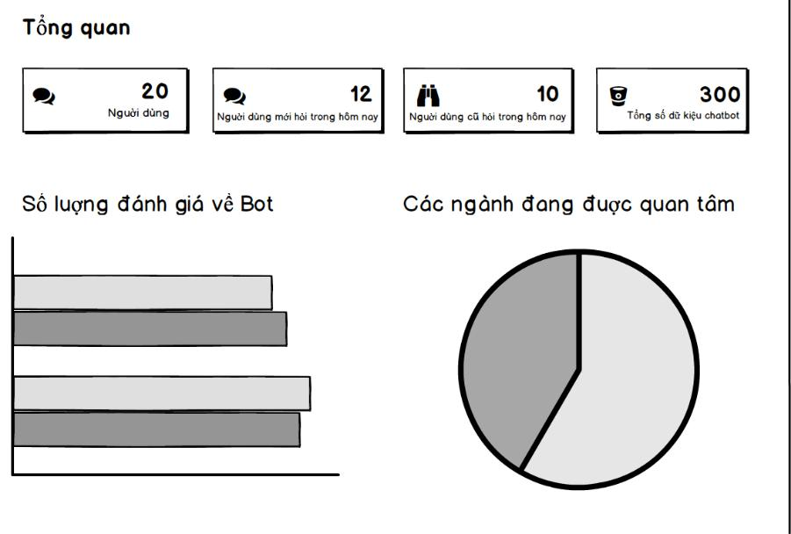

*Figure 4-63: Staff views statistics screen design*

**Class Diagram**

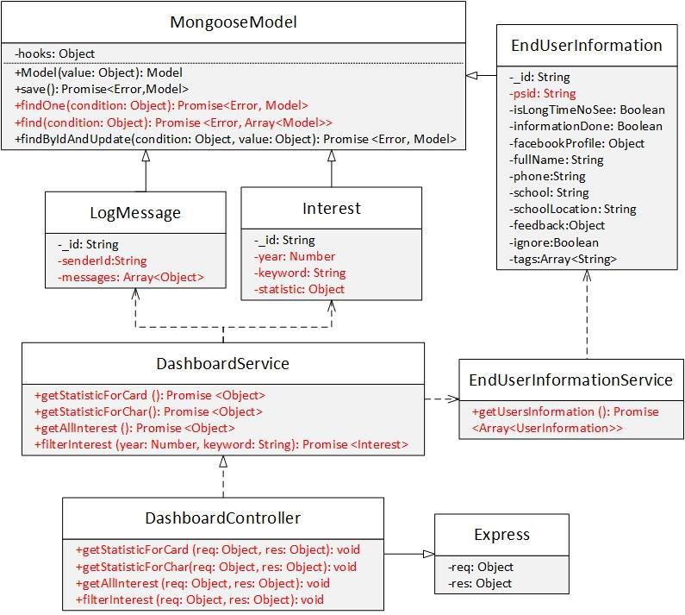

|  |  |  |  |  |  |  |
| --- | --- | --- | --- | --- | --- | --- |
|  |  | *Figure 4-64: View statistics class diagram* | | | | |
| **Class Specification** | |  |  |  |  |  |
| ***EndUserInformation*** | | |  |  |  |  |
|  |  |  | **EndUserInformation** | | | |
| Physical address |  | Backend /models/EndUserInformation.js | | | | |
| Base class |  | MongooseModel |  |  |  |  |
|  |  |  |  | Attributes |  |  |
| No |  | Name |  | Type |  | Description |
| 1 |  | psid |  | String |  |  |
|  |  |  |  | Operation |  |  |
| N/A |  | N/A |  |  |  |  |
| ***LogMessage*** | |  |  |  |  |  |
|  |  |  |  | **LogMessage** |  |  |
| Physical address |  | Backend /models/LogMessage.js | | |  |  |
| Base class |  | MongooseModel |  |  |  |  |
|  |  |  |  | Attributes |  |  |
| No |  | Name |  | Type |  | Description |
| 1 |  | _id |  | object |  |  |
| 2 |  | senderId |  | String |  |  |

|  |  |  |  |  |  |  |  |  |  |  |
| --- | --- | --- | --- | --- | --- | --- | --- | --- | --- | --- |
| 3 |  | messages | | |  | Array<object> |  |  |  |  |
|  |  |  |  |  |  | Operation |  |  |  |  |
| N/A |  | N/A | | |  |  |  |  |  |  |
| ***Interests*** | |  |  |  |  |  |  |  |  |  |
|  |  |  |  |  |  | **Interests** |  |  |  |  |
| Physical address |  | Backend /models/Interests.js | | | | |  |  |  |  |
| Base class |  | MongooseModel | | |  |  |  |  |  |  |
|  |  |  |  |  |  | Attributes |  |  |  |  |
| No |  | Name | | |  | Type | Description | |  |  |
| 1 |  | year | | |  | number |  |  |  |  |
| 2 |  | keyword | | |  | String |  |  |  |  |
| 3 |  | statistics | | |  | object |  |  |  |  |
|  |  |  |  |  |  | Operation |  |  |  |  |
| N/A |  | N/A | | |  |  |  |  |  |  |
| ***DashboardService*** | | | | |  |  |  |  |  |  |
|  |  |  |  |  | **DashboardService** | | | |  |  |
| Physical address | |  |  | Backend /controllers/DashboardService.js | | | | |  |  |
| Base class | |  |  | N/A |  |  |  |  |  |  |
|  |  |  |  |  |  | Attributes |  |  |  |  |
| No | |  |  | Name |  |  |  | Type | Description |  |
|  |  |  |  |  |  | Operation |  |  |  |  |
| getStatisticForCard | |  |  |  |  |  |  |  |  |  |
| Return Type | |  |  | Promise<object> | | |  |  |  |  |
| Parameters | |  |  | Name |  |  |  | Type | Description | |
|  |  |  |  | N/A |  |  |  | N/A | N/A | |
| getStatisticForChart | | | |  |  |  |  |  |  |  |
| Return Type | |  |  | Promise<object> | | |  |  |  |  |
| Parameters | |  |  | Name |  |  |  | Type | Description | |
|  |  |  |  | N/A |  |  |  | N/A | N/A | |
| getAllInterest | |  |  |  |  |  |  |  |  |  |
| Return Type | |  |  | Promise<object> | | |  |  |  |  |
| Parameters | |  |  | Name |  |  |  | Type | Description | |
|  |  |  |  | N/A |  |  |  | N/A | N/A | |
| filterInterest | |  |  |  |  |  |  |  |  |  |
| Return Type | |  |  | Promise<Interest> | | |  |  |  |  |
| Parameters | |  |  | Name |  |  |  | Type | Description | |
|  |  |  |  | year |  |  |  | Number |  |  |
|  |  |  |  | keyword |  |  |  | String |  |  |
| ***EndUserInformationService*** | | | | |  |  |  |  |  |  |
|  |  |  |  | **EndUserInformationService** | | | | |  |  |
| Physical address | |  | Backend /controllers/EndUserInformationService.js | | | | | | | |
| Base class | |  | N/A | |  |  |  |  |  |  |
|  |  |  |  |  |  | Attributes |  |  |  |  |
| No | |  | Name | |  |  |  | Type | Description |  |
|  |  |  |  |  |  | Operation |  |  |  |  |
| getUserInformation | | |  | |  |  |  |  |  |  |
| Return Type | |  | Promise<Array<EndUserInformation>> | | | | | |  |  |

|  |  |  |  |  |  |  |  |  |
| --- | --- | --- | --- | --- | --- | --- | --- | --- |
| Parameters |  | Name | |  | Type | | Description | |
|  |  | N/A | |  | N/A | | N/A | |
| ***DashboardController*** | |  |  |  |  |  |  |  |
|  |  |  |  | **DashboardController** | | |  |  |
| Physical address | |  | Backend /controllers/DashboardController.js | | | | | |
| Base class | |  | Express |  |  |  |  |  |
|  |  |  |  | Attributes | | |  |  |
| No | |  | Name |  | Type |  | Description |  |
|  |  |  |  | Operation | | |  |  |
| getStatisticForCard | |  |  |  |  |  |  |  |
| Return Type | |  | void |  |  |  |  |  |
| Parameters | |  | Name |  | Type |  | Description | |
|  |  |  | req |  | object |  |  |  |
|  |  |  | res |  | object |  |  |  |
| getStatisticForChart | |  |  |  |  |  |  |  |
| Return Type | |  | void |  |  |  |  |  |
| Parameters | |  | Name |  | Type |  | Description | |
|  |  |  | req |  | object |  |  |  |
|  |  |  | res |  | object |  |  |  |
| getAllInterest | |  |  |  |  |  |  |  |
| Return Type | |  | void |  |  |  |  |  |
| Parameters | |  | Name |  | Type |  | Description | |
|  |  |  | req |  | object |  |  |  |
|  |  |  | res |  | object |  |  |  |
| filterInterest | |  |  |  |  |  |  |  |
| Return Type | |  | void |  |  |  |  |  |
| Parameters | |  | Name |  | Type |  | Description | |
|  |  |  | req |  | object |  |  |  |
|  |  |  | res |  | object |  |  |  |

**Sequence Diagram**

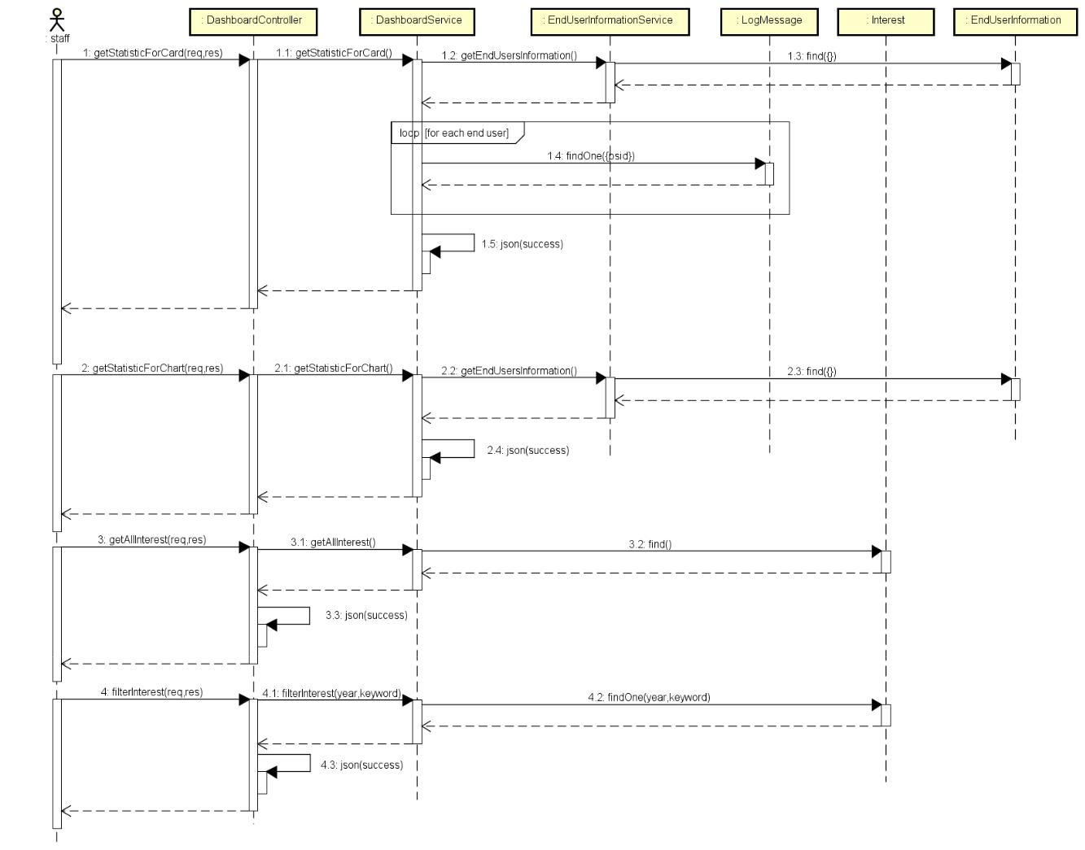

*Figure 4-65: View statistics sequence diagram*

**4.3.4.7 Staff views profile**

**Screen Design**

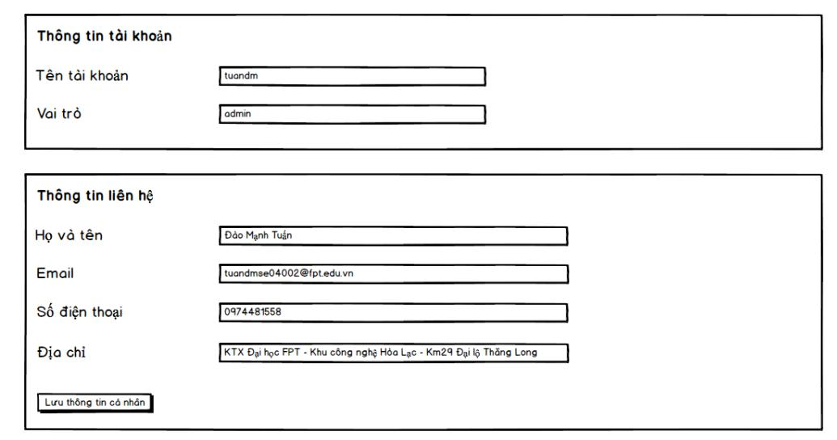

*Figure 4-66: Staff views profile screen design*

**Class Diagram**

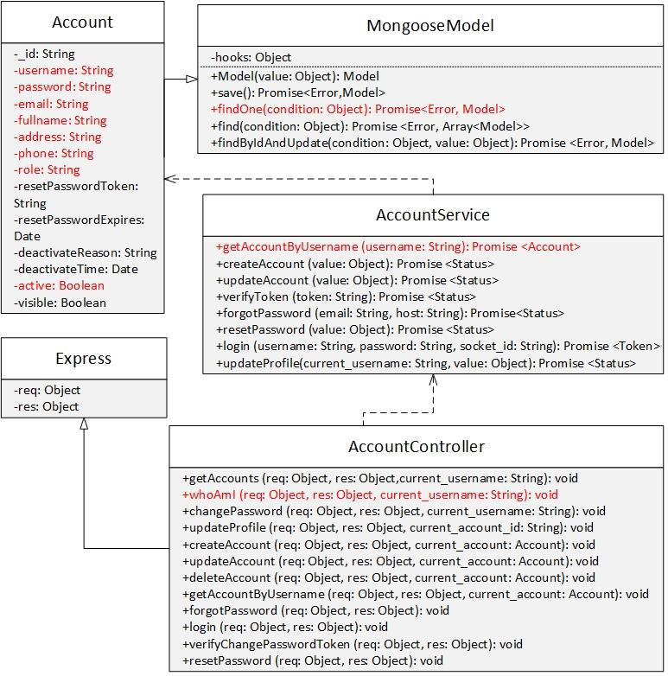

|  |  |  |  |  |  |
| --- | --- | --- | --- | --- | --- |
|  |  | *Figure 4-67: Staff views profile class diagram* | | | |
| **Class Specification** | |  |  |  |  |
| ***Account*** | |  |  |  |  |
|  |  |  | **Account** | |  |
| Physical address |  | Backend /models/Account.js | | |  |
| Base class |  | MongooseModel |  |  |  |
|  |  |  | Attributes | |  |
| No |  | Name | Type |  | Description |
| 1 |  | username | String |  |  |
| 2 |  | email | String |  |  |
| 3 |  | fullname | String |  |  |
| 4 |  | address | String |  |  |
| 5 |  | phone | String |  |  |
| 6 |  | role | String |  |  |
|  |  |  | Operation | |  |
| N/A |  | N/A |  |  |  |

***AccountService***

|  |  |  |  |  |  |
| --- | --- | --- | --- | --- | --- |
|  | **AccountService** | | |  |  |
| Physical address | Backend /controllers/AccountService.js | | | |  |
| Base class | N/A | | |  |  |
|  | Attributes | | |  |  |
| No | Name |  |  | Type | Description |
|  | Operation | | |  |  |
| getAccountByUsername |  |  |  |  |  |
| Return Type | Promise<Account> | | |  |  |
| Parameters | Name | |  | Type | Description |
|  | username | |  | String |  |
| ***AccountController*** |  |  |  |  |  |
|  | **AccountController** | | |  |  |
| Physical address | Backend /controllers/AccountController.js | | | |  |
| Base class | Express | | |  |  |
|  | Attributes | | |  |  |
| No | Name |  |  | Type | Description |
|  | Operation | | |  |  |
| whoAmI |  |  |  |  |  |
| Return Type | void | | |  |  |
| Parameters | Name | |  | Type | Description |
|  | req | |  | object |  |
|  | res | |  | object |  |
|  | current_username | |  | String |  |

**Sequence Diagram**

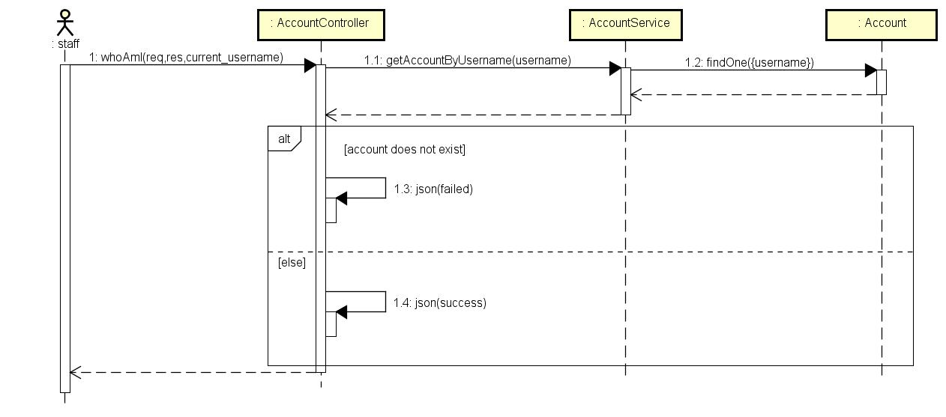

*Figure 4-68: Staff views profile sequence diagram*

**4.3.4.8 Staff updates profile**

**Screen Design**



*Figure 4-69: Staff updates profile screen design*

**Class Diagram**

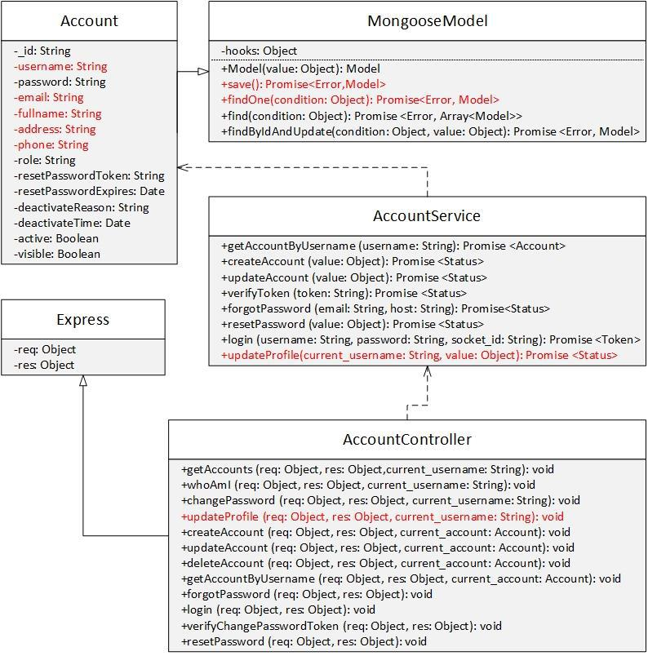

|  |  |  |  |  |  |  |  |
| --- | --- | --- | --- | --- | --- | --- | --- |
|  |  | *Figure 4-70: Staff updates profile class diagram* | | | | | |
| **Class Specification** | |  |  |  |  |  |  |
| ***Account*** | |  |  |  |  |  |  |
|  |  |  |  | **Account** | |  |  |
| Physical address |  | Backend /models/Account.js | | | |  |  |
| Base class |  | MongooseModel | |  |  |  |  |
|  |  |  |  | Attributes | |  |  |
| No |  | Name | | Type |  | Description |  |
| 1 |  | fullname | | String |  |  |  |
| 2 |  | email | | String |  |  |  |
| 3 |  | phone | | String |  |  |  |
| 4 |  | address | | String |  |  |  |
|  |  |  |  | Operation | |  |  |
| ***AccountService*** | |  |  |  |  |  |  |
|  |  |  |  | **AccountService** | | |  |
| Physical address | |  | Backend /controllers/AccountService.js | | | | |

|  |  |  |  |  |  |  |  |
| --- | --- | --- | --- | --- | --- | --- | --- |
| Base class | N/A | | |  |  |  |  |
|  | Attributes | | |  |  |  |  |
| No | Name |  |  | Type | Description |  |  |
|  | Operation | | |  |  |  |  |
| getAccountByUsername |  |  |  |  |  |  |  |
| Return Type | Promise<Account> | | |  |  |  |  |
| Parameters | Name | |  | Type | Description | | |
|  | username | |  | String |  |  |  |
| updateProfile |  |  |  |  |  |  |  |
| Return Type | Promise<Status> | | |  |  |  |  |
| Parameters | Name | |  | Type | Description | | |
|  | current_username | |  | String |  |  |  |
|  | value | |  | object |  |  |  |
| ***AccountController*** |  |  |  |  |  |  |  |
|  | **AccountController** | | |  |  |  |  |
| Physical address | Backend /controllers/AccountController.js | | | |  |  |  |
| Base class | Express | | |  |  |  |  |
|  | Attributes | | |  |  |  |  |
| No | Name |  |  | Type | Description |  |  |
|  | Operation | | |  |  |  |  |
| updateProfile |  |  |  |  |  |  |  |
| Return Type | void | | |  |  |  |  |
| Parameters | Name | |  | Type | Description | |  |
|  | req | |  | object |  |  |  |
|  | res | |  | object |  |  |  |
|  | current_account_id | |  | String |  |  |  |

**Sequence Diagram**

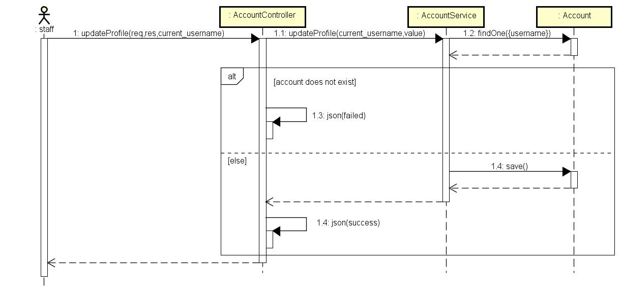

*Figure 4-71: Staff updates profile sequence diagram*

**4.3.4.9** **Staff changes password**

**Screen Design**

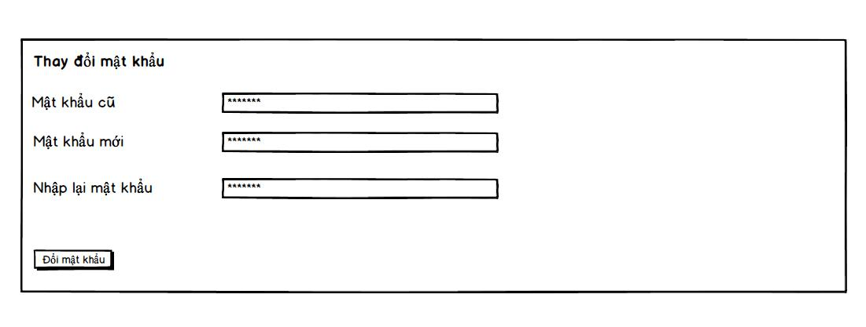

*Figure 4-72: Staff changes password screen design*

**Class Diagram**

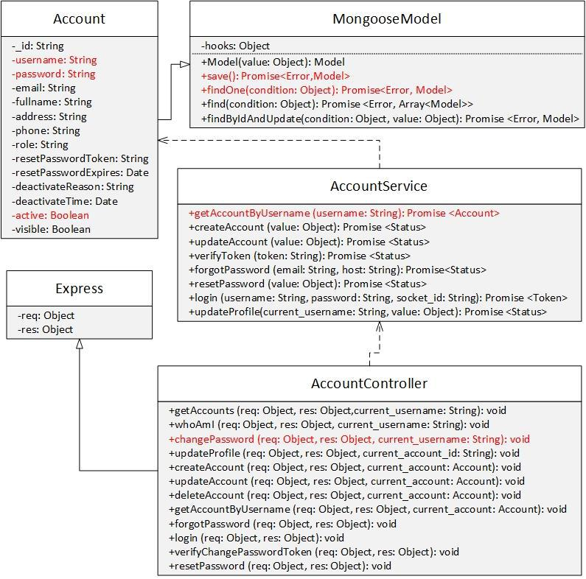

*Figure 4-73: Staff changes password class diagram*

**Class Specification**

***Account***



**Account**

|  |  |  |  |  |  |  |  |  |  |  |
| --- | --- | --- | --- | --- | --- | --- | --- | --- | --- | --- |
| Physical address |  | Backend /models/Account.js | | | | |  |  |  |  |
| Base class |  | MongooseModel | |  |  |  |  |  |  |  |
|  |  |  |  |  | Attributes | |  |  |  |  |
| No |  | Name | |  | Type |  | Description | |  |  |
| 1 |  | username | |  | String |  |  |  |  |  |
| 2 |  | password | |  | String |  |  |  |  |  |
|  |  |  |  |  | Operation | |  |  |  |  |
| N/A |  | N/A | |  |  |  |  |  |  |  |
| ***AccountService*** | |  |  |  |  |  |  |  |  |  |
|  |  |  |  |  | **AccountService** | | | |  |  |
| Physical address | |  | Backend /controllers/AccountService.js | | | | | |  |  |
| Base class | |  | N/A |  |  |  |  |  |  |  |
|  |  |  |  |  | Attributes | |  |  |  |  |
| No | |  | Name |  |  |  |  | Type | Description |  |
|  |  |  |  |  | Operation | |  |  |  |  |
| getAccountByUsername | | |  |  |  |  |  |  |  |  |
| Return Type | |  | Promise<Account> | | | |  |  |  |  |
| Parameters | |  | Name |  |  |  |  | Type | Description | |
|  |  |  | username |  |  |  |  | String |  |  |
| ***AccountController*** | | | |  |  |  |  |  |  |  |
|  |  |  |  | **AccountController** | | | | |  |  |
| Physical address | |  | Backend /controllers/AccountController.js | | | | | |  |  |
| Base class | |  | Express |  |  |  |  |  |  |  |
|  |  |  |  |  | Attributes | |  |  |  |  |
| No | |  | Name |  |  |  |  | Type | Description |  |
|  |  |  |  |  | Operation | |  |  |  |  |
| changePassword | |  |  |  |  |  |  |  |  |  |
| Return Type | |  | void |  |  |  |  |  |  |  |
| Parameters | |  | Name |  |  |  |  | Type | Description | |
|  |  |  | req |  |  |  |  | object |  |  |
|  |  |  | res |  |  |  |  | object |  |  |
|  |  |  | current_username | | | |  | String |  |  |

**Sequence Diagram**

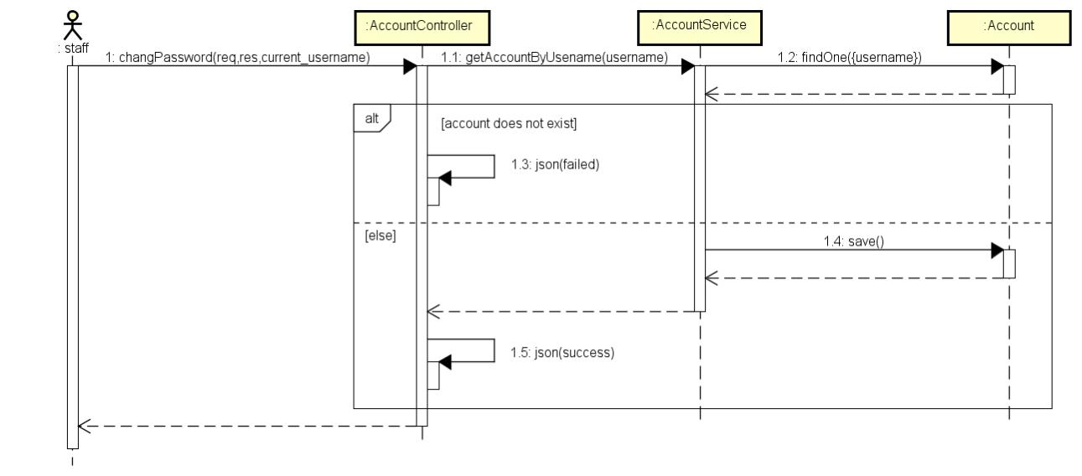

*Figure 4-74: Staff changes password sequence diagram*

**4.3.4.10 Staff views account list**

**Screen Design**

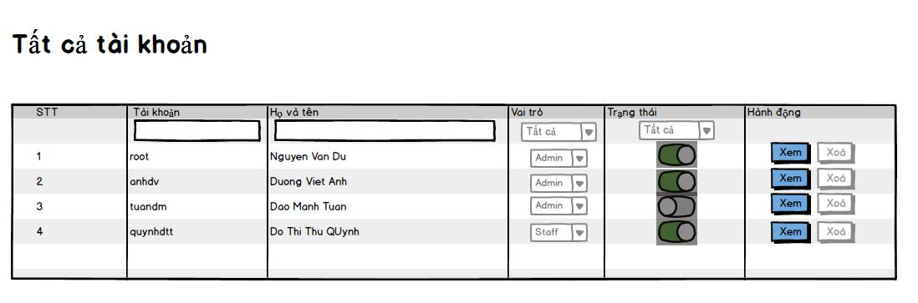

*Figure 4-75: Staff views account list*

**Class Diagram**

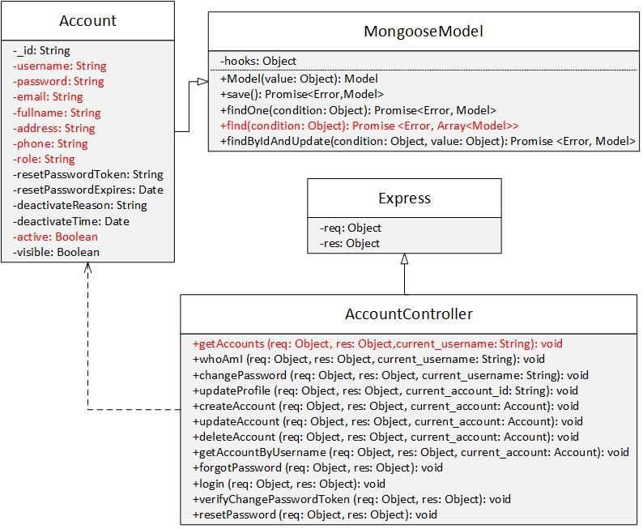

*Figure 4-76: Staff views account list class diagram*

**Class Specification**

***Account***

|  |  |  |  |  |  |  |  |
| --- | --- | --- | --- | --- | --- | --- | --- |
|  |  |  |  | **Account** | |  |  |
| Physical address | Backend /models/Account.js | | | | |  |  |
| Base class | MongooseModel | |  |  |  |  |  |
|  |  |  |  | Attributes | |  |  |
| No | Name | |  | Type |  | Description |  |
| 1 | username | |  | String |  |  |  |
| 2 | email | |  | String |  |  |  |
| 3 | fullname | |  | String |  |  |  |
| 4 | address | |  | String |  |  |  |
| 5 | phone | |  | String |  |  |  |
| 6 | role | |  | String |  |  |  |
| 7 | active | |  | Boolean |  |  |  |
|  |  |  |  | Operation | |  |  |
| N/A | N/A | |  |  |  |  |  |
| ***AccountController*** | | |  |  |  |  |  |
|  |  |  | **AccountController** | | | |  |
| Physical address |  | Backend /controllers/AccountController.js | | | | | |

|  |  |  |  |  |
| --- | --- | --- | --- | --- |
| Base class | Express |  |  |  |
|  | Attributes |  |  |  |
| No | Name | Type | Description |  |
|  | Operation |  |  |  |
| getAccounts |  |  |  |  |
| Return Type | void |  |  |  |
| Parameters | Name | Type | Description | |
|  | req | object |  |  |
|  | res | object |  |  |
|  | current_username | String |  |  |

**Sequence Diagram**

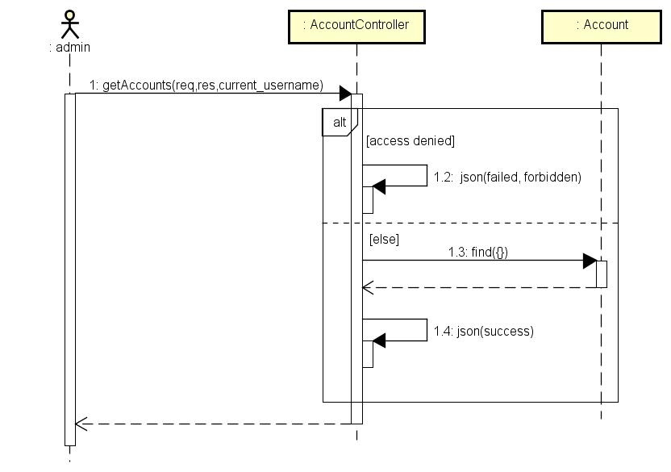

*Figure 4-77: Staff views account list sequence diagram*

**4.3.4.11 Staff views account information detail**

**Screen Design**

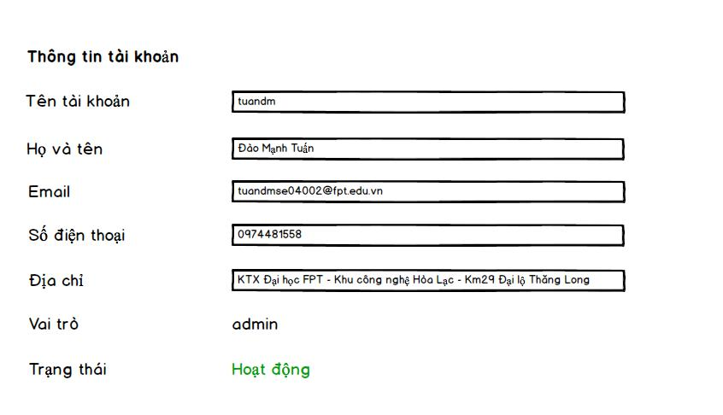

*Figure 4-78: Staff views account information detail screen design*

**Class Diagram**

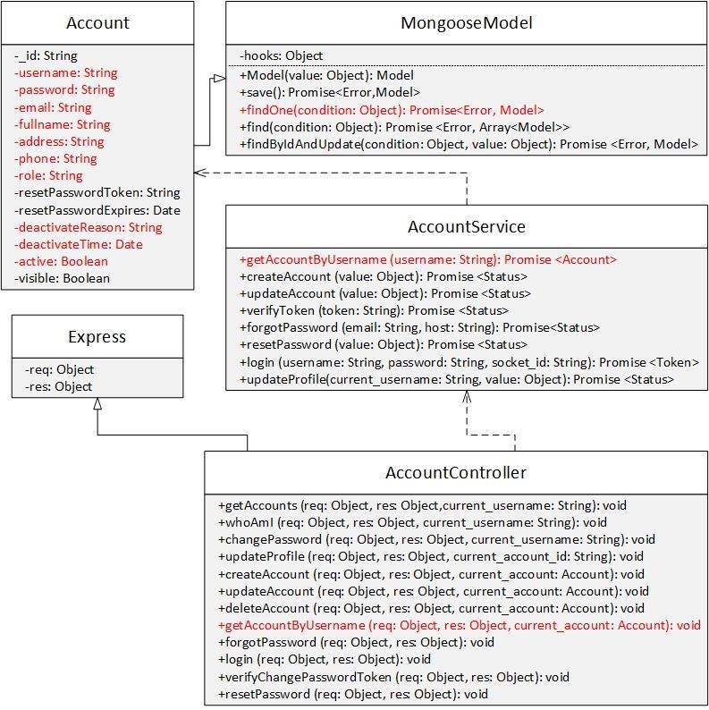

*Figure 4-57: Staff view account information detail class diagram*

**Class Specification**

***Account***



**Account**

|  |  |  |  |  |  |  |  |  |  |  |  |  |
| --- | --- | --- | --- | --- | --- | --- | --- | --- | --- | --- | --- | --- |
| Physical address |  | Backend /models/Account.js | | | |  |  |  |  |  |  |  |
| Base class |  | MongooseModel | |  |  |  |  |  |  |  |  |  |
|  |  |  |  | Attributes | |  |  |  |  |  |  |  |
| No |  | Name | | Type |  | Description | | | |  |  |  |
| 1 |  | username | | String |  |  |  |  |  |  |  |  |
| 2 |  | email | | String |  |  |  |  |  |  |  |  |
| 3 |  | fullname | | String |  |  |  |  |  |  |  |  |
| 4 |  | address | | String |  |  |  |  |  |  |  |  |
| 5 |  | phone | | String |  |  |  |  |  |  |  |  |
| 6 |  | role | | String |  |  |  |  |  |  |  |  |
| 7 |  | active | | Boolean |  |  |  |  |  |  |  |  |
| 8 |  | deactivatedReason | | String |  |  |  |  |  |  |  |  |
| 9 |  | deactiveTime | | Date |  |  |  |  |  |  |  |  |
|  |  |  |  | Operation | |  |  |  |  |  |  |  |
| N/A |  | N/A | |  |  |  |  |  |  |  |  |  |
| ***AccountService*** | |  |  |  |  |  |  |  |  |  |  |  |
|  |  |  |  | **AccountService** | | | | | |  |  |  |
| Physical address | |  | Backend /controllers/AccountService.js | | | | | | |  |  |  |
| Base class | |  |  |  |  |  |  |  |  |  |  |  |
|  |  |  |  | Attributes | |  |  |  |  |  |  |  |
| No | |  | Name |  |  |  | Type |  |  | Description |  |  |
| N/A | |  | N/A |  |  |  | N/A |  | | N/A | |  |
|  |  |  |  | Operation | |  |  |  |  |  |  |  |
| getAccountByUsername | | |  |  |  |  |  |  |  |  |  |  |
| Return Type | |  | Promise<Account> | | |  |  |  |  |  |  |  |
| Parameters | |  | Name |  |  |  | Type |  |  | Description | |  |
|  |  |  | username | | |  | String |  |  |  |  |  |

***AccountController***



**AccountController**

|  |  |  |  |  |  |
| --- | --- | --- | --- | --- | --- |
| Physical address | | Backend /controllers/AccountController.js | | | |
| Base class | | Express |  |  |  |
|  |  |  |  |  |  |
|  |  | Attributes |  |  |  |
| No |  | Name | Type | Description |  |
|  |  | Operation |  |  |  |
| getAccountByUsername |  |  |  |  |  |
| Return Type | | void |  |  |  |
| Parameters | | Name | Type | Description | |
|  |  | req | object |  |  |
|  |  | res | object |  |  |
|  |  | current_account | Account |  |  |

**Sequence Diagram**

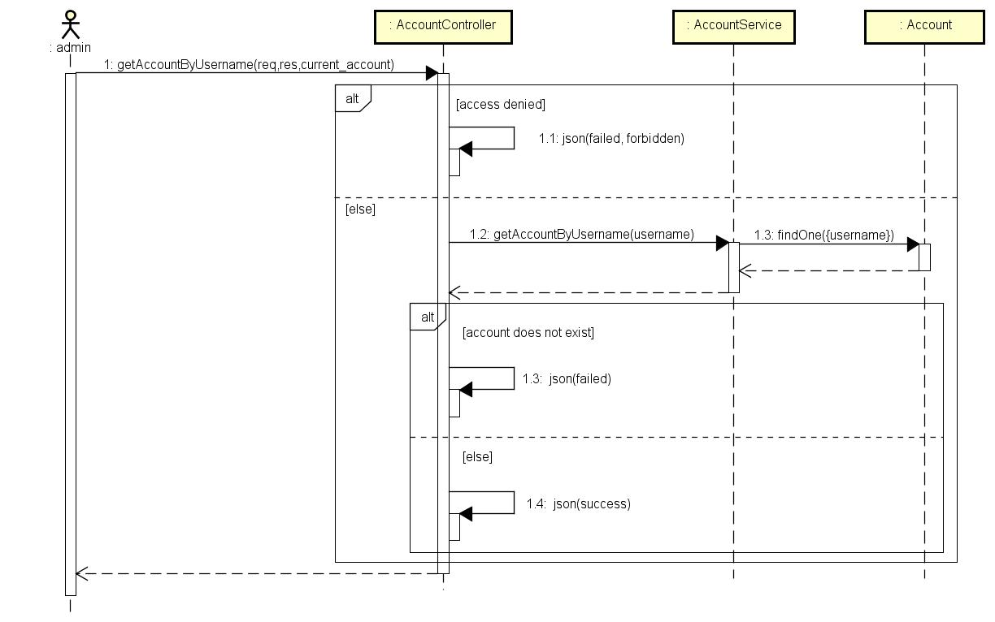

*Figure 4-79: Staff views account information detail sequence diagram*

**4.3.4.12 Staff searches account**

**Screen Design**

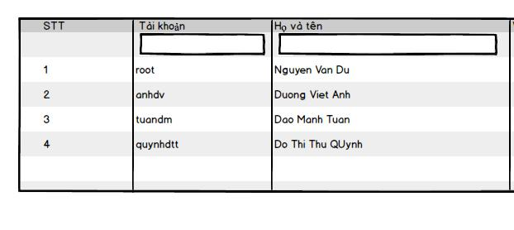

*Figure 4-80: Staff searches account screen design*

**Class Diagram**

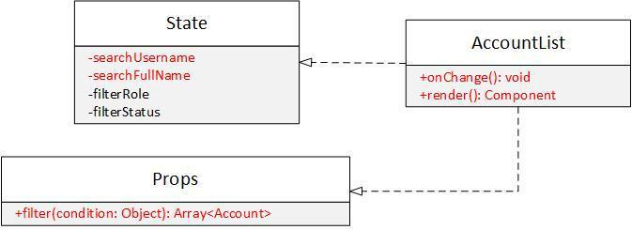

|  |  |  |  |  |  |  |  |
| --- | --- | --- | --- | --- | --- | --- | --- |
|  | *Figure 4-81: Staff searches account class diagram* | | | | | |  |
| **Class Specification** |  |  |  |  |  |  |  |
| ***State*** |  |  |  |  |  |  |  |
|  |  | **State** | | |  |  |  |
| Physical address |  | N/A | | |  |  |  |
| Base class |  | N/A | | |  |  |  |
|  |  | Attributes | | |  |  |  |
| No |  | Name |  |  | Type |  | Description |
| 1 |  | searchUsername | |  | String |  |  |
| 2 |  | searchFullName | |  | String |  |  |
|  |  | Operation | | |  |  |  |
| N/A |  | N/A | | |  |  |  |
| ***AccountList*** |  |  |  |  |  |  |  |
|  |  | **AccountList** | | |  |  |  |
| Physical address |  | src/components/AccountList.js | | |  |  |  |
| Base class |  | N/A | | |  |  |  |
|  |  | Attributes | | |  |  |  |
| No |  | Name |  |  | Type |  | Description |
|  |  | Operation | | |  |  |  |
| onChange |  |  |  |  |  |  |  |
| Return Type |  | void | | |  |  |  |
| Parameters |  | Name | |  | Type |  | Description |
|  |  | N/A | |  | N/A |  | N/A |
| render |  |  |  |  |  |  |  |
| Return Type |  | Component | | |  |  |  |
| Parameters |  | Name | |  | Type |  | Description |
|  |  | N/A | |  | N/A |  | N/A |
| ***Props*** |  |  |  |  |  |  |  |
|  |  | **Props** | | |  |  |  |
| Physical address |  | N/A | | |  |  |  |
| Base class |  | N/A | | |  |  |  |
|  |  | Attributes | | |  |  |  |
| No |  | Name |  |  | Type |  | Description |
|  |  | Operation | | |  |  |  |
| filter |  |  |  |  |  |  |  |
| Return Type |  | Array<Account> | | |  |  |  |

|  |  |  |  |
| --- | --- | --- | --- |
| Parameters | Name | Type | Description |
|  | condition | object |  |

**Sequence Diagram**

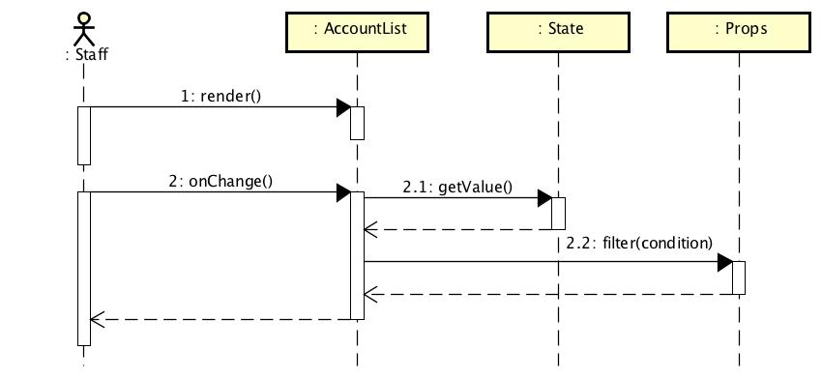

*Figure 4-82: Staff searches account sequence diagram*

**4.3.4.13 Staff filters account**

**Screen Design**

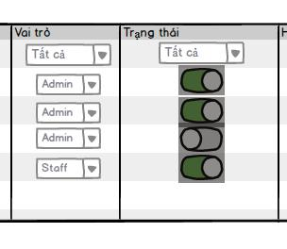

*Figure 4-83: Staff filters account screen design*

**Class Diagram**

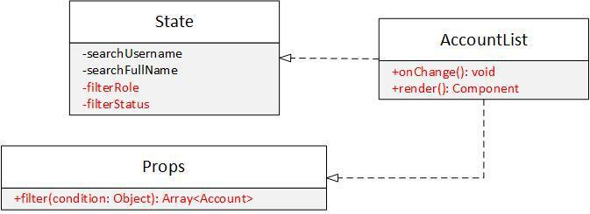

|  |  |  |  |  |  |
| --- | --- | --- | --- | --- | --- |
|  | *Figure 4-84: Staff filters account class diagram* | | | |  |
| **Class Specification** |  |  |  |  |  |
| ***State*** |  |  |  |  |  |
|  |  | **State** | |  |  |
| Physical address |  | N/A | |  |  |
| Base class |  | N/A | |  |  |
|  |  | Attributes | |  |  |
| No |  | Name |  | Type | Description |
| 1 |  | filterRole | | String |  |
| 2 |  | filterStatus | | String |  |
|  |  | Operation | |  |  |
| N/A |  | N/A | |  |  |
| ***AccountList*** |  |  |  |  |  |
|  |  | **AccountList** | |  |  |
| Physical address |  | src/component/AccountList.js | |  |  |
| Base class |  | N/A | |  |  |
|  |  | Attributes | |  |  |
| No |  | Name |  | Type | Description |
|  |  | Operation | |  |  |
| onChange |  |  |  |  |  |
| Return Type |  | void | |  |  |
| Parameters |  | Name | | Type | Description |
|  |  | N/A | | N/A | N/A |
| render |  |  |  |  |  |
| Return Type |  | Component | |  |  |
| Parameters |  | Name | | Type | Description |
|  |  | N/A | | N/A | N/A |
| ***Props*** |  |  |  |  |  |
|  |  | **Props** | |  |  |
| Physical address |  | N/A | |  |  |
| Base class |  | N/A | |  |  |
|  |  | Attributes | |  |  |
| No |  | Name |  | Type | Description |
|  |  | Operation | |  |  |
| filter |  |  |  |  |  |

|  |  |  |  |
| --- | --- | --- | --- |
| Return Type | Array<Account> |  |  |
| Parameters | Name | Type | Description |
|  | condition | object |  |

**Sequence Diagram**



*Figure 4-85: Staff filters account sequence diagram*

**4.3.4.14 Staff views response & answer list**

**Screen Design**

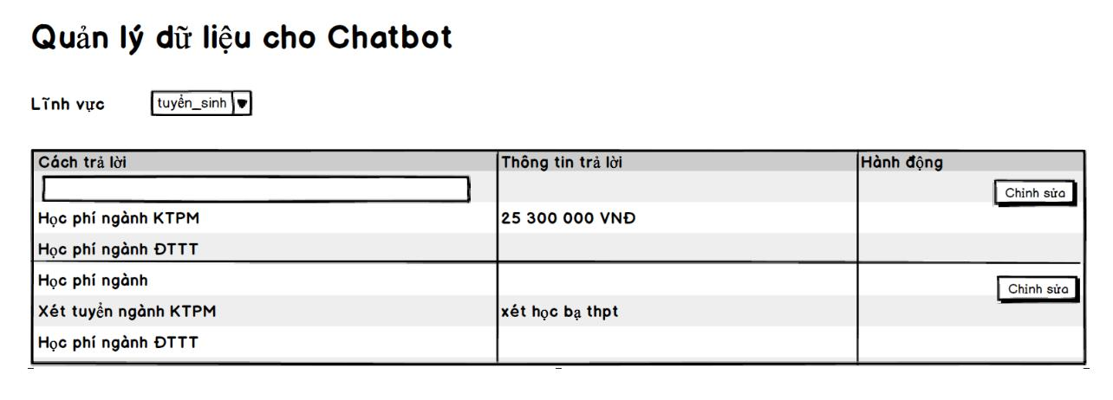

*Figure 4-65: Staff views response & answer list screen design*

**Class Diagram**

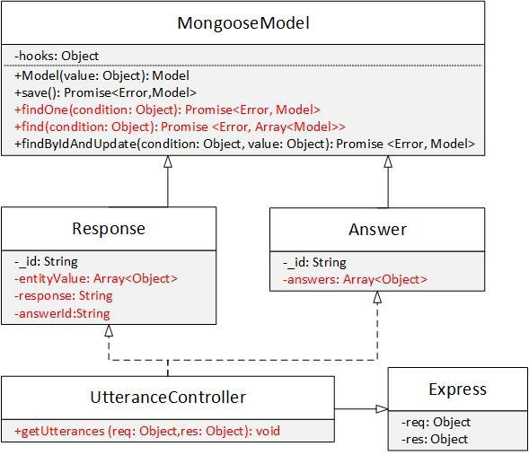

|  |  |  |  |  |  |  |  |  |  |
| --- | --- | --- | --- | --- | --- | --- | --- | --- | --- |
|  |  |  | *Figure 4-66: Staff views response & answer list class diagram* | | | | | | |
| **Class Specification** | | |  |  |  |  |  |  |  |
| ***Response*** | | |  |  |  |  |  |  |  |
|  |  |  |  |  |  | **Response** | |  |  |
| Physical address |  |  | Backend /models/Response.js | | | | |  |  |
| Base class |  |  | MongooseModel | |  |  |  |  |  |
|  |  |  |  |  |  | Attributes | |  |  |
| No |  |  | Name | |  | Type |  | Description |  |
| 1 |  |  | entityValue | |  | Array<object> |  |  |  |
| 2 |  |  | response | |  | String |  |  |  |
| 3 |  |  | answerId | |  | String |  |  |  |
|  |  |  |  |  |  | Operation | |  |  |
| ***Answer*** | | |  |  |  |  |  |  |  |
|  |  |  |  |  |  | **Answer** | |  |  |
| Physical address |  | | Backend /models/Answer.js | | | | |  |  |
| Base class |  | | MongooseModel | |  |  |  |  |  |
|  |  |  |  |  |  | Attributes | |  |  |
| No |  |  | Name | |  | Type |  | Description |  |
| 1 |  |  | answers | |  | Array<object> |  |  |  |
|  |  |  |  |  |  | Operation | |  |  |
| ***UtteranceController*** | | | | |  |  |  |  |  |
|  |  |  |  |  | **UtteranceController** | | |  |  |
| Physical address | | |  | Backend /controllers/UtteranceController.js | | | | | |
| Base class | | |  | Express |  |  |  |  |  |
|  |  |  |  |  |  | Attributes | |  |  |

|  |  |  |  |  |
| --- | --- | --- | --- | --- |
| No | Name |  | Type | Description |
|  |  | Operation | |  |
| getUtterances |  |  |  |  |
| Return Type | void |  |  |  |
| Parameters | Name |  | Type | Description |
|  | req |  | object |  |
|  | res |  | object |  |

**Sequence Diagram**

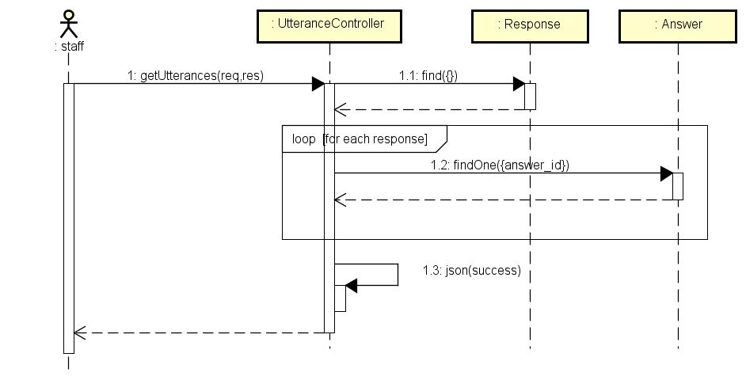

*Figure 4-67: Staff views response & answer list sequence diagram*

**4.3.4.15 Staff filters response & answer**

**Screen Design**

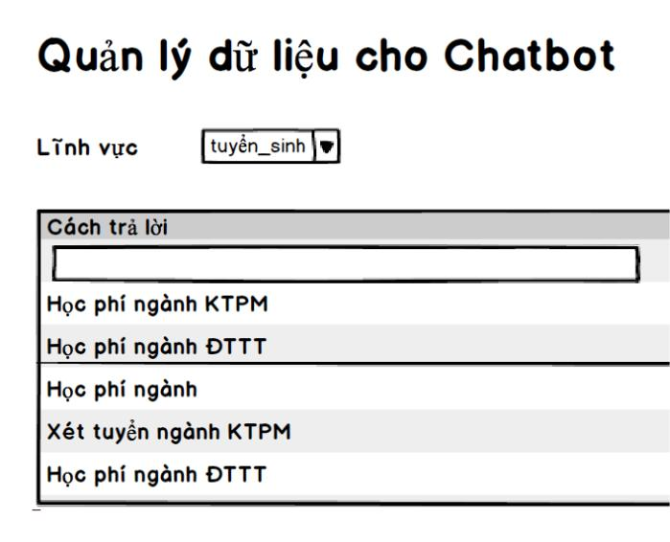

*Figure 4-68: Staff filters response & answer screen design*

**Class Diagram**

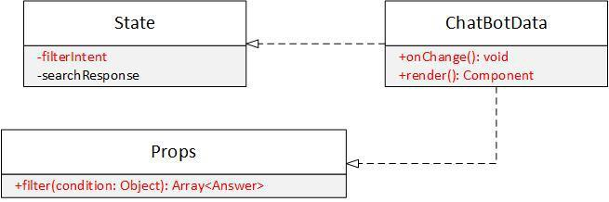

|  |  |  |  |  |  |  |
| --- | --- | --- | --- | --- | --- | --- |
|  | *Figure 4-69: Staff filters response & answer class diagram* | | | | | |
| **Class Specification** |  |  |  |  |  |  |
| ***State*** |  |  |  |  |  |  |
|  |  | **State** | | |  |  |
| Physical address |  | N/A | | |  |  |
| Base class |  | N/A | | |  |  |
|  |  | Attributes | | |  |  |
| No |  | Name |  |  | Type | Description |
| 1 |  | filterIntent | |  | String |  |
|  |  | Operation | | |  |  |
| N/A |  | N/A | | |  |  |
| ***ChaBotData*** |  |  |  |  |  |  |
|  |  | **ChatBotData** | | |  |  |
| Physical address |  | src/component/ChatbotData.js | | |  |  |
| Base class |  | N/A | | |  |  |
|  |  | Attributes | | |  |  |
| No |  | Name |  |  | Type | Description |
|  |  | Operation | | |  |  |
| onChange |  |  |  |  |  |  |
| Return Type |  | void | | |  |  |
| Parameters |  | Name | |  | Type | Description |
|  |  | N/A | |  | N/A | N/A |
| render |  |  |  |  |  |  |
| Return Type |  | Component | | |  |  |
| Parameters |  | Name | |  | Type | Description |
|  |  | N/A | |  | N/A | N/A |
| ***Props*** |  |  |  |  |  |  |
|  |  | **Props** | | |  |  |
| Physical address |  | N/A | | |  |  |
| Base class |  | N/A | | |  |  |
|  |  | Attributes | | |  |  |
| No |  | Name |  |  | Type | Description |
|  |  | Operation | | |  |  |
| filter |  |  |  |  |  |  |
| Return Type |  | Array<Answer> | | |  |  |

|  |  |  |  |
| --- | --- | --- | --- |
| Parameters | Name | Type | Description |
|  | condition | object |  |

**Sequence Diagram**

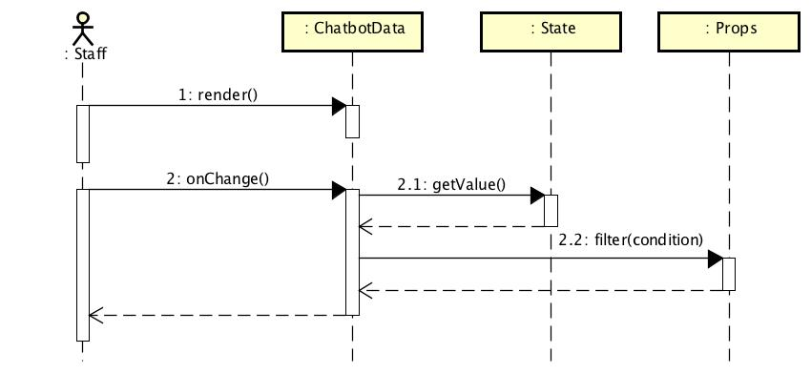

*Figure 4-70: Staff filters response & answer sequence diagram*

**4.3.4.16 Staff searches response**

**Screen Design**

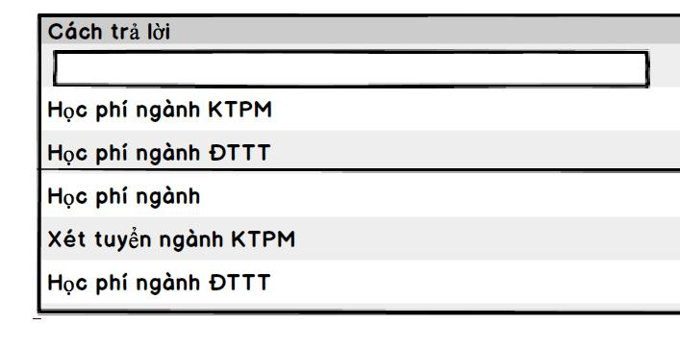

*Figure 4-71: Staff searches response screen design*

**Class Diagram**

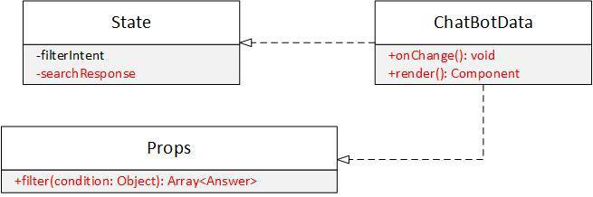

*Figure 4-72: Staff searches response screen class diagram*

**Class Specification**

***State***



**State**

|  |  |  |  |  |  |  |  |
| --- | --- | --- | --- | --- | --- | --- | --- |
| Physical address | N/A | | |  |  |  |  |
| Base class | N/A | | |  |  |  |  |
|  | Attributes | | |  |  |  |  |
| No | Name |  |  | Type | Description |  |  |
| 1 | filterResponse | |  | String |  |  |  |
|  | Operation | | |  |  |  |  |
| N/A | N/A | | |  |  |  |  |
| ***ChaBotData*** |  |  |  |  |  |  |  |
|  | **ChatBotData** | | |  |  |  |  |
| Physical address | src/component/ChatBotData.js | | |  |  |  |  |
| Base class | N/A | | |  |  |  |  |
|  | Attributes | | |  |  |  |  |
| No | Name |  |  | Type | Description |  |  |
|  | Operation | | |  |  |  |  |
| onChange |  |  |  |  |  |  |  |
| Return Type | void | | |  |  |  |  |
| Parameters | Name | |  | Type | Description | |  |
|  | N/A | |  | N/A | N/A | |  |
| render |  |  |  |  |  |  |  |
| Return Type | Component | | |  |  |  |  |
| Parameters | Name | |  | Type | Description | |  |
|  | N/A | |  | N/A | N/A | |  |
| ***Props*** |  |  |  |  |  |  |  |
|  | **Props** | | |  |  |  |  |
| Physical address | N/A | | |  |  |  |  |
| Base class | N/A | | |  |  |  |  |
|  | Attributes | | |  |  |  |  |
| No | Name |  |  | Type | Description |  |  |
|  | Operation | | |  |  |  |  |
| filter |  |  |  |  |  |  |  |
| Return Type | Array<Answer> | | |  |  |  |  |
| Parameters | Name | |  | Type | Description | |  |
|  | condition | |  | object |  |  |  |

**Sequence Diagram**



*Figure 4-73: Staff searches response sequence diagram*

**4.3.4.17 Staff requests to edit answer**

**Screen Design**

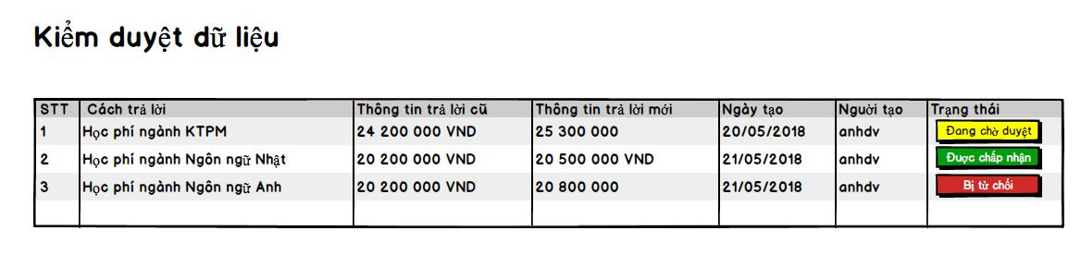

*Figure 4-86: Staff requests to edit answer screen design*

**Class Diagram**

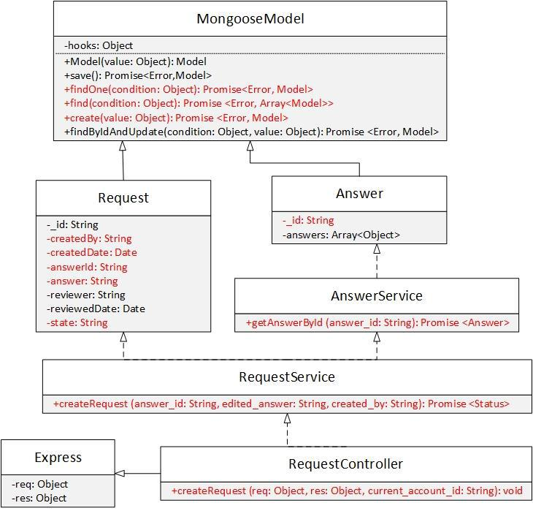

|  |  |  |  |  |  |  |  |  |  |
| --- | --- | --- | --- | --- | --- | --- | --- | --- | --- |
|  |  | *Figure 4-87: Staff requests to edit answer class diagram* | | | | | | |  |
| **Class Specification** | |  |  |  |  |  |  |  |  |
| ***Request*** | |  |  |  |  |  |  |  |  |
|  |  |  |  | **Request** | |  |  |  |  |
| Physical address |  | Backend /models/Request.js | | | |  |  |  |  |
| Base class |  | MongooseModel | |  |  |  |  |  |  |
|  |  |  |  | Attributes | |  |  |  |  |
| No |  | Name | | Type |  | Description | |  |  |
| 1 |  | createdBy | | String |  |  |  |  |  |
| 2 |  | createdDate | | String |  |  |  |  |  |
| 3 |  | answerId | | String |  |  |  |  |  |
| 4 |  | answer | | String |  |  |  |  |  |
| 5 |  | state | | String |  |  |  |  |  |
|  |  |  |  | Operation | |  |  |  |  |
| ***Answer*** | |  |  |  |  |  |  |  |  |
|  |  |  |  | **Answer** | |  |  |  |  |
| Physical address | |  | Backend /models/Answer.js | | |  |  |  |  |
| Base class | |  | Mongoose Model | | |  |  |  |  |
|  |  |  |  | Attributes | |  |  |  |  |
| No | |  | Name |  |  |  | Type | Description |  |
| 1 |  |  | _id |  |  |  | String |  |  |

|  |  |  |  |  |  |
| --- | --- | --- | --- | --- | --- |
|  | Operation | | |  |  |
| N/A | N/A | | |  |  |
| ***AnswerService*** |  |  |  |  |  |
|  | **AnswerService** | | |  |  |
| Physical address | Backend /services/AnswerService.js | | | |  |
| Base class | N/A | | |  |  |
|  | Attributes | | |  |  |
| No | Name |  |  | Type | Description |
| N/A | N/A | |  | N/A | N/A |
|  | Operation | | |  |  |
| getAnswerById |  |  |  |  |  |
| Return Type | Promise<Answer> | | |  |  |
| Parameters | Name | |  | Type | Description |
|  | answer_id | |  | String |  |
| ***RequestService*** |  |  |  |  |  |
|  | **RequestService** | | |  |  |
| Physical address | Backend /services/RequestService.js | | | |  |
| Base class | N/A | | |  |  |
|  | Attributes | | |  |  |
| No | Name |  |  | Type | Description |
| N/A | N/A | |  | N/A | N/A |
|  | Operation | | |  |  |
| createRequest |  |  |  |  |  |
| Return Type | Promise<Status> | | |  |  |
| Parameters | Name | |  | Type | Description |
|  | answer_id | |  | String |  |
|  | edited_answer | |  | String |  |
|  | created_by | |  | String |  |
| ***RequestController*** |  |  |  |  |  |
|  | **RequestController** | | |  |  |
| Physical address | Backend /controllers/RequestController.js | | | |  |
| Base class | Express | | |  |  |
|  | Attributes | | |  |  |
| No | Name |  |  | Type | Description |
| N/A | N/A | |  | N/A | N/A |
|  | Operation | | |  |  |
| createRequest |  |  |  |  |  |
| Return Type | void | | |  |  |
| Parameters | Name | |  | Type | Description |
|  | req | |  | object | The object contains |
|  |  |  |  |  | request information. |
|  | res | |  | object | The object contains |
|  |  |  |  |  | response information. |
|  | current_account_id | |  | String |  |

**Sequence Diagram**

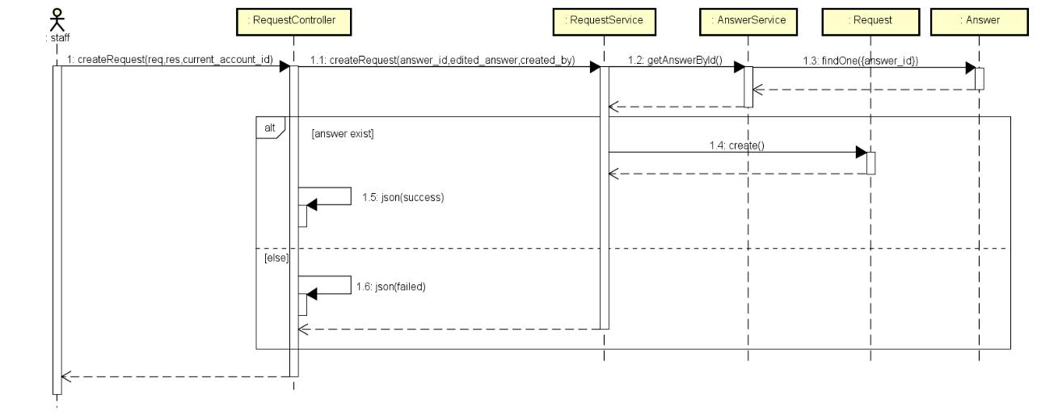

*Figure 4-88: Staff request to edit answer sequence diagram*

**4.3.4.18 Staff receives notification**

**Screen Design**



*Figure 4-89: Staff receives notification screen design*

**Class Diagram**

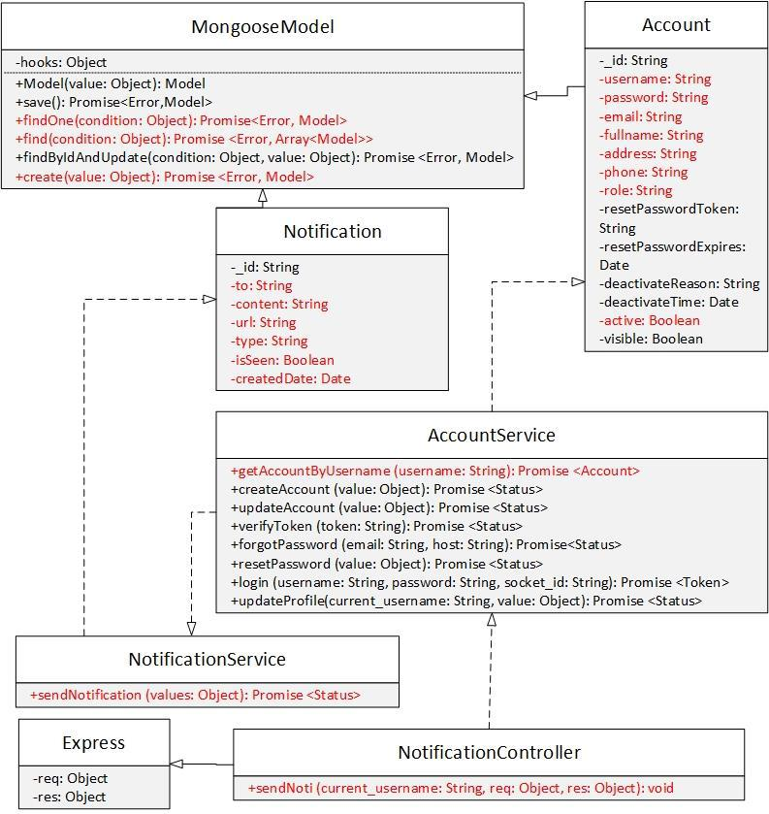

|  |  |  |  |  |  |
| --- | --- | --- | --- | --- | --- |
|  |  | *Figure 4-90: Staff receives notification class diagram* | | | |
| **Class Specification** | |  |  |  |  |
| ***Notification*** | |  |  |  |  |
|  |  |  | **Notification** | |  |
| Physical address |  | Backend /models/Notification.js | | |  |
| Base class |  | MongooseModel |  |  |  |
|  |  |  | Attributes | |  |
| No |  | Name | Type |  | Description |
| 1 |  | to | String |  |  |
| 2 |  | content | String |  |  |
| 3 |  | url | String |  |  |
| 4 |  | type | String |  |  |
| 5 |  | isSeen | Boolean |  |  |
| 6 |  | createdDate | Date |  |  |
|  |  |  | Operation | |  |

|  |  |  |  |  |  |  |  |  |  |  |  |  |
| --- | --- | --- | --- | --- | --- | --- | --- | --- | --- | --- | --- | --- |
| N/A | |  |  | N/A | |  |  |  |  |  |  |  |
| ***Account*** | |  |  |  |  |  |  |  |  |  |  |  |
|  |  |  |  |  |  |  | **Account** | |  |  |  |  |
| Physical address |  | Backend /models/Account.js | | | | | | |  |  |  |  |
| Base class |  | MongooseModel | | | |  |  |  |  |  |  |  |
|  |  |  |  |  |  |  | Attributes | |  |  |  |  |
| No |  | Name | | | |  | Type |  | Description | |  |  |
| 1 |  | username | | | |  | String | |  |  |  |  |
| 2 |  | email | | | |  | String | |  |  |  |  |
| 3 |  | fullname | | | |  | String | |  |  |  |  |
| 4 |  | password | | | |  | String | |  |  |  |  |
| 5 |  | address | | | |  | String | |  |  |  |  |
| 6 |  | phone | | | |  | String | |  |  |  |  |
| 7 |  | role | | | |  | String | |  |  |  |  |
| 8 |  | active | | | |  | Boolean | |  |  |  |  |
|  |  |  |  |  |  |  | Operation | |  |  |  |  |
| N/A | |  |  | N/A | |  |  |  |  |  |  |  |
| ***NotificationService*** | | | | | |  |  |  |  |  |  |  |
|  |  |  |  |  |  | **NotificationService** | | | | |  |  |
| Physical address | |  |  |  | Backend /services/NotificationService.js | | | | | |  |  |
| Base class | |  |  |  | N/A |  |  |  |  |  |  |  |
|  |  |  |  |  |  |  | Attributes | |  |  |  |  |
| No | |  |  |  | Name |  |  |  | Type |  | Description |  |
|  |  |  |  |  |  |  | Operation | |  |  |  |  |
| sendNotification | |  |  |  |  |  |  |  |  |  |  |  |
| Return Type | |  |  |  | Promise<Status> | | | |  |  |  |  |
| Parameters | |  |  |  | Name |  |  |  | Type |  | Description |  |
|  |  |  |  |  | value |  |  |  | Object |  |  |  |
| ***AccountService*** | |  |  |  |  |  |  |  |  |  |  |  |
|  |  |  |  |  |  | **AccountService** | | |  |  |  |  |
| Physical address | |  |  |  | Backend /controllers/AccountService.js | | | | | |  |  |
| Base class | |  |  |  | N/A |  |  |  |  |  |  |  |
|  |  |  |  |  |  |  | Attributes | |  |  |  |  |
| No | |  |  |  | Name |  |  |  | Type |  | Description |  |
|  |  |  |  |  |  |  | Operation | |  |  |  |  |
| getAccountByUsername | | | |  |  |  |  |  |  |  |  |  |
| Return Type | |  |  |  | Promise<Account> | | | |  |  |  |  |
| Parameters | |  |  |  | Name |  |  |  | Type |  | Description |  |
|  |  |  |  |  | username |  |  |  | String |  |  |  |

***NotificationController***



**NotificationController**

|  |  |  |  |  |  |
| --- | --- | --- | --- | --- | --- |
| Physical address | Backend /controllers/NotificationController.js | | | | |
| Base class | Express |  |  |  |  |
|  |  | Attributes | |  |  |
| No | Name |  | Type | Description |  |
|  |  | Operation | |  |  |

|  |  |  |  |
| --- | --- | --- | --- |
| sendNoti |  |  |  |
| Return Type | void |  |  |
| Parameters | Name | Type | Description |
|  | current_username | String |  |
|  | req | object |  |
|  | res | object |  |

**Sequence Diagram**

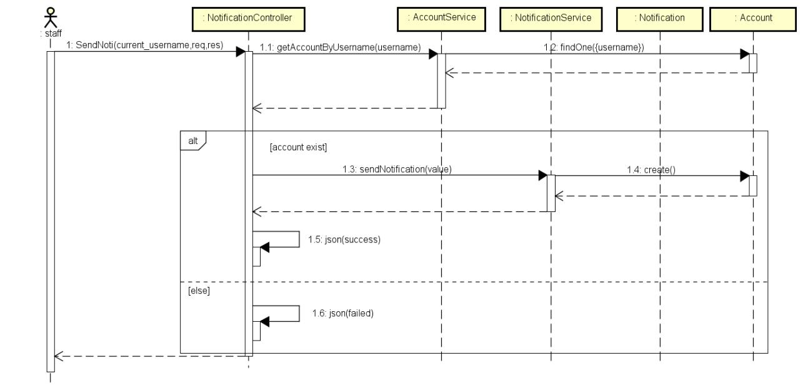

*Figure 4-91: Staff receives notification sequence diagram*

**4.3.4.19 Staff views notification list**

**Screen Design**

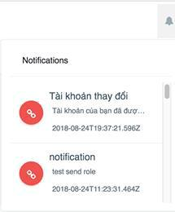

*Figure 4-92: Staff views notification list screen design*

**Class Diagram**

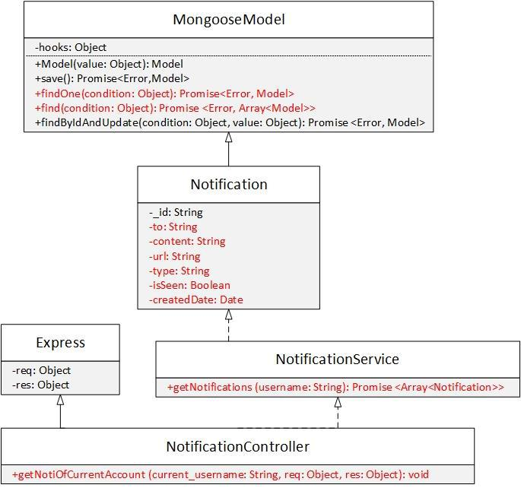

|  |  |  |  |  |  |  |  |  |  |
| --- | --- | --- | --- | --- | --- | --- | --- | --- | --- |
|  |  | *Figure 4-93: Staff views notification list class diagram* | | | | | | |  |
| **Class Specification** | |  |  |  |  |  |  |  |  |
| ***Notification*** | |  |  |  |  |  |  |  |  |
|  |  |  |  |  |  | **Notification** | |  |  |
| Physical address |  | Backend /models/Notification.js | | | | | |  |  |
| Base class |  | MongooseModel | | |  |  |  |  |  |
|  |  |  |  |  |  | Attributes | |  |  |
| No |  | Name | | |  | Type |  | Description |  |
| 1 |  | to | | |  | String |  |  |  |
| 2 |  | content | | |  | String |  |  |  |
| 3 |  | url | | |  | String |  |  |  |
| 4 |  | type | | |  | String |  |  |  |
| 5 |  | isSeen | | |  | Boolean |  |  |  |
| 6 |  | createdDate | | |  | Date |  |  |  |
|  |  |  |  |  |  | Operation | |  |  |
| N/A | |  | N/A | |  |  |  |  |  |
| ***NotificationService*** | | | | |  |  |  |  |  |
|  |  |  |  |  | **NotificationService** | | | |  |
| Physical address | |  |  | Backend /services/NotificationService.js | | | | |  |
| Base class | |  |  | N/A |  |  |  |  |  |

|  |  |  |  |
| --- | --- | --- | --- |
|  | Attributes |  |  |
| No | Name | Type | Description |
|  | Operation |  |  |
| getNotifications |  |  |  |
| Return Type | Promise<Array<Notification>> | |  |
| Parameters | Name | Type | Description |
|  | username | String |  |
| ***NotificationController*** |  |  |  |
|  | **NotificationController** | |  |
| Physical address | Backend /controllers/NotificationController.js | | |
| Base class | Express |  |  |
|  | Attributes |  |  |
| No | Name | Type | Description |
|  | Operation |  |  |
| getNotiOfCurrentAccount |  |  |  |
| Return Type | void |  |  |
| Parameters | Name | Type | Description |
|  | req | Object |  |
|  | res | Object |  |
|  | current_username | String |  |

**Sequence Diagram**

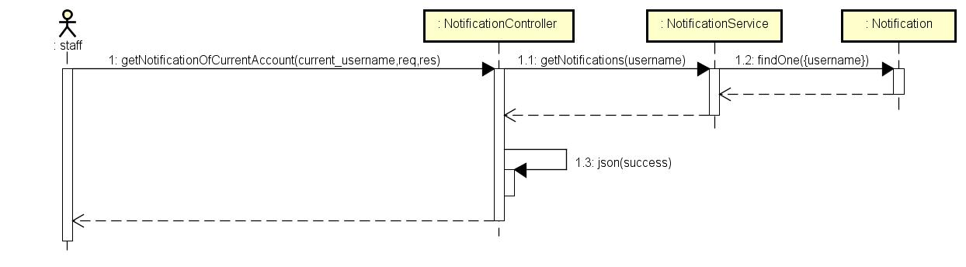

*Figure 4-94: Staff views notification list sequence diagram*

**4.3.4.20 Staff views notification detail**

**Screen Design**

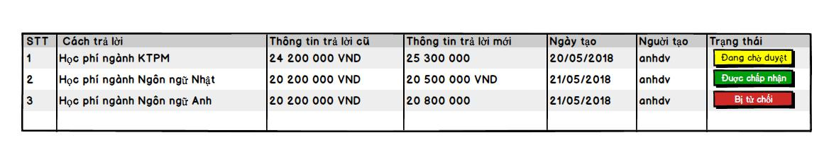

*Figure 4- 86: Staff views notification detail screen design*

**Class Diagram**

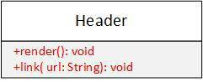

|  |  |  |  |  |
| --- | --- | --- | --- | --- |
|  | *Figure 4-87: Staff views notification detail class diagram* | | | |
| **Class Specification** |  |  |  |  |
| ***Header*** |  |  |  |  |
|  |  | **Header** |  |  |
| Physical address |  | src/component/Header.js |  |  |
| Base class |  | N/A |  |  |
|  |  | Attributes |  |  |
| No |  | Name | Type | Description |
|  |  | Operation |  |  |
| render |  |  |  |  |
| Return Type |  | Component |  |  |
| Parameters |  | Name | Type | Description |
|  |  | N/A | N/A | N/A |
| link |  |  |  |  |
| Return Type |  | Component |  |  |
| Parameters |  | Name | Type | Description |
|  |  | url | String |  |

**Sequence Diagram**

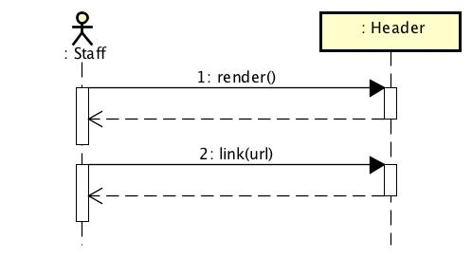

*Figure 4-88: Staff views notification detail sequence diagram*

**4.3.4.21 Staff views Fb Count Page**

**Screen Design**

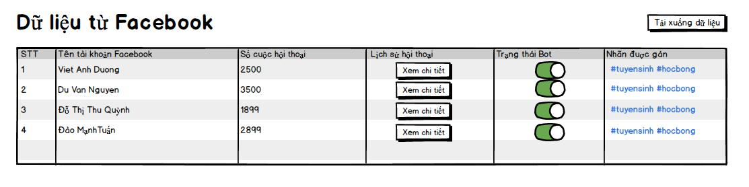

*Figure 4-95: Staff views Fb Count Page screen design*

**Class Diagram**

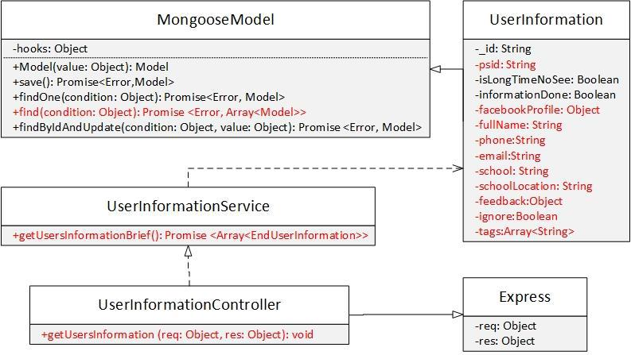

|  |  |  |  |  |
| --- | --- | --- | --- | --- |
|  | *Figure 4-96: Staff views Fb Count Page class diagram* | | | |
| **Class Specification** |  |  |  |  |
| ***UserInformation*** |  |  |  |  |
|  |  | **UserInformation** | |  |
| Physical address |  | Backend /models/UserInformation.js | | |
| Base class |  | MongooseModel |  |  |
|  |  |  | Attributes |  |
| No |  | Name | Type | Description |
| 1 |  | psid | String |  |
| 2 |  | facebookProfile | Object |  |
| 3 |  | fullName | String |  |
| 4 |  | phone | String |  |
| 5 |  | email | String |  |
| 6 |  | school | String |  |
| 7 |  | schoolLocation | String |  |
| 8 |  | feedback | Object |  |
| 9 |  | ignore | Boolean |  |
| 10 |  | tags | Array<String> |  |
|  |  |  | Operation |  |



***UserInformationService***

|  |  |  |  |  |  |  |  |
| --- | --- | --- | --- | --- | --- | --- | --- |
|  |  | **UserInformationService** | | | |  |  |
| Physical address | Backend /services/UserInformationService.js | | | | | | |
| Base class | N/A |  |  |  |  |  |  |
|  |  | Attributes | | | |  |  |
| No | Name |  |  | Type | |  | Description |
|  |  | Operation | | | |  |  |
| getUserInformationBrief |  |  |  |  |  |  |  |
| Return Type | Promise<Array<UserInformation>> | | | | |  |  |
| Parameters | Name |  |  | Type | |  | Description |
|  | N/A |  |  | N/A | |  | N/A |
| ***UserInformationController*** | |  |  |  |  |  |  |
|  |  | **UserInformationController** | | | |  |  |
| Physical address | Backend /controllers/UserInformationController.js | | | | | | |
| Base class | Express | | | | |  |  |
|  |  | Attributes | | | |  |  |
| No | Name |  | Type | |  | Description | |
|  |  | Operation | | | |  |  |
| getUsersInformation |  |  |  |  |  |  |  |
| Return Type | void |  |  |  |  |  |  |
| Parameters | Name |  | Type | |  | Description | |
|  | req |  | Object | |  |  |  |
|  | res |  | Object | |  |  |  |

**Sequence Diagram**

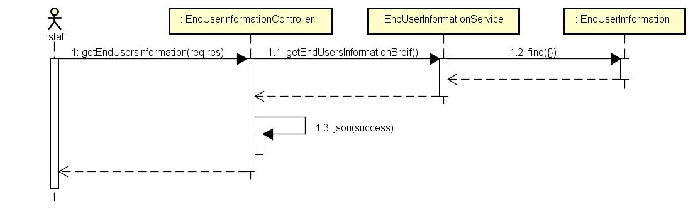

*Figure 4-97: Staff views Fb Count Page sequence diagram*

**4.3.4.22 Staff views chat logs**

**Screen Design**

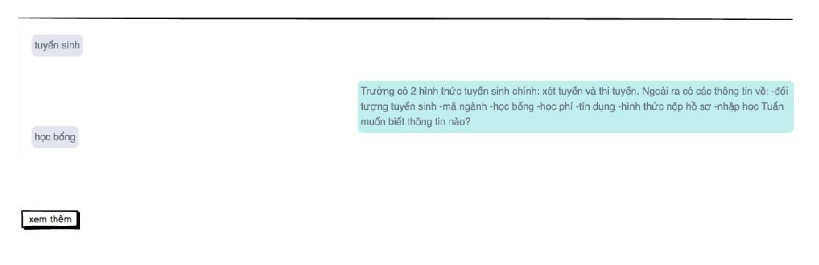

*Figure 4-98: Staff views chat logs screen design*

**Class Diagram**

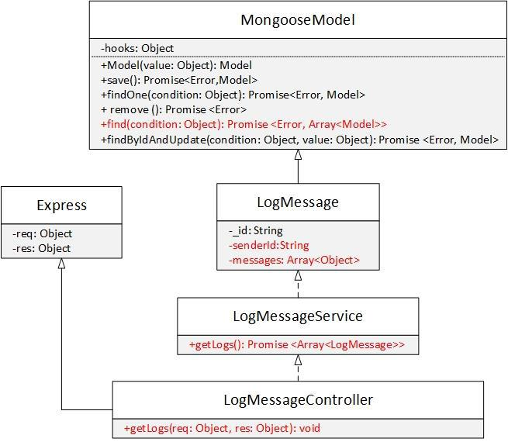

|  |  |  |  |  |  |
| --- | --- | --- | --- | --- | --- |
|  | *Figure 4-99: Staff views chat logs class diagram* | | | |  |
| **Class Specification** |  |  |  |  |  |
| ***LogMessage*** |  |  |  |  |  |
|  |  | **LogMessage** | | |  |
| Physical address | Backend /models/LogMessage.js | | | |  |
| Base class | MongooseModel | | | |  |
|  |  | Attributes | | |  |
| No | Name |  | Type |  | Description |
| 1 | senderId |  | String |  |  |

|  |  |  |  |  |  |  |  |  |  |  |
| --- | --- | --- | --- | --- | --- | --- | --- | --- | --- | --- |
| 2 | messages | |  | Array<object> | | |  |  |  |  |
|  |  |  | Operation | | | | |  |  |  |
| N/A | N/A | |  |  |  |  |  |  |  |  |
| ***LogMessageService*** |  |  |  |  |  |  |  |  |  |  |
|  |  |  | **LogMessageService** | | | | |  |  |  |
| Physical address | Backend /controllers/LogMessageService.js | | | | | | |  |  |  |
| Base class | N/A | |  |  |  |  |  |  |  |  |
|  |  |  | Attributes | | | | |  |  |  |
| No | Name | |  |  |  | Type | |  | Description |  |
|  |  |  | Operation | | | | |  |  |  |
| getLogs |  |  |  |  |  |  |  |  |  |  |
| Return Type | Promise<Array<LogMessage>> | | | | |  |  |  |  |  |
| Parameters | Name | |  |  |  | Type | |  | Description | |
|  | N/A | |  |  |  | N/A | |  | N/A | |
| ***LogMessageController*** | | |  |  |  |  |  |  |  |  |
|  |  |  | **LogMessageController** | | | | |  |  |  |
| Physical address |  | Backend /controllers/LogMessageController.js | | | | | | | | |
| Base class |  | Express |  |  |  |  |  |  |  |  |
|  |  |  | Attributes | | | | |  |  |  |
| No |  | Name |  |  | Type | |  | Description | |  |
|  |  |  | Operation | | | | |  |  |  |
| getLogs |  |  |  |  |  |  |  |  |  |  |
| Return Type |  | void |  |  |  |  |  |  |  |  |
| Parameters |  | Name |  |  | Type | | | Description | | |
|  |  | req |  |  | object | | |  |  |  |
|  |  | res |  |  | object | | |  |  |  |

**Sequence Diagram**

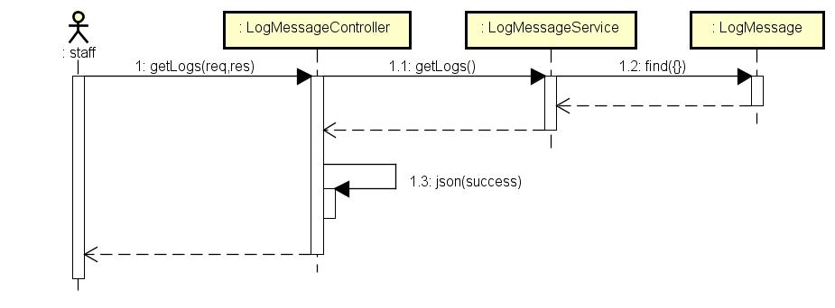

*Figure 4-100: Staff views chat logs sequence diagram*

**4.3.4.23 Staff views Fb account infor**

**Screen Design**

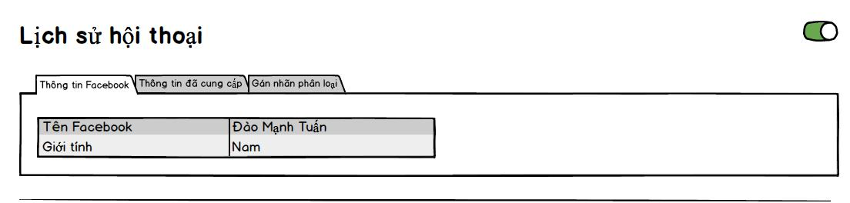

*Figure 4-101: Staff views Fb account infor screen desgin*

**Class Diagram**

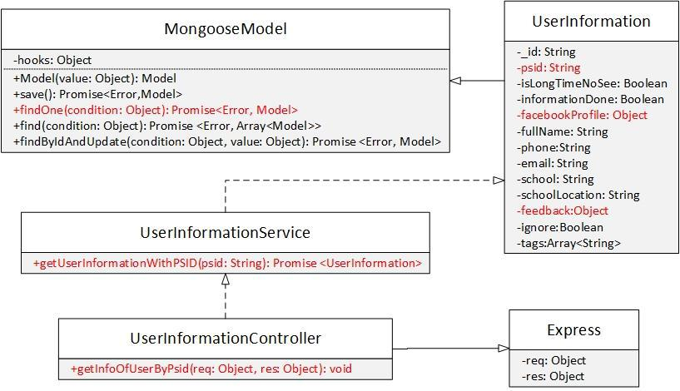

|  |  |  |  |  |  |  |  |  |  |
| --- | --- | --- | --- | --- | --- | --- | --- | --- | --- |
|  | *Figure 4-102: Staff views Fb account infor class diagram* | | | | | | | |  |
| **Class Specification** |  |  |  |  |  |  |  |  |  |
| ***UserInformation*** |  |  |  |  |  |  |  |  |  |
|  |  |  | **UserInformation** | | | |  |  |  |
| Physical address |  | Backend /models/UserInformation.js | | | | |  |  |  |
| Base class |  | MongooseModel | | |  |  |  |  |  |
|  |  |  | Attributes | |  |  |  |  |  |
| No |  | Name | |  | Type | | Description | |  |
| 1 |  | psid | |  | String | |  |  |  |
| 2 |  | facebookProfile | |  | Object | |  |  |  |
| 3 |  | feedback | |  | Object | |  |  |  |
|  |  |  | Operation | |  |  |  |  |  |
|  |  |  |  | |  |  |  |  |  |
| ***UserInformationService*** | | | | |  |  |  |  |  |
|  |  |  | **UserInformationService** | | | |  |  |  |
| Physical address |  |  | Backend /services/UserInformationService.js | | | | | |  |
| Base class |  |  | N/A | |  |  |  |  |  |
|  |  |  | Attributes | |  |  |  |  |  |
| No |  |  | Name | |  | Type |  | Description |  |

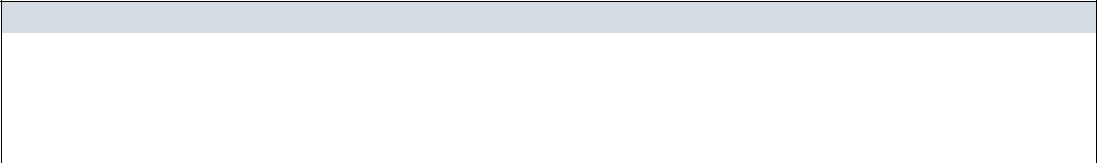Operation

|  |  |  |  |  |
| --- | --- | --- | --- | --- |
| getUserInformationWithPSID |  |  |  |  |
| Return Type | Promise<UserInformation> |  |  |  |
| Parameters | Name | Type | Description |  |
|  | psid | String |  |  |

***UserInformationController***

|  |  |  |  |  |
| --- | --- | --- | --- | --- |
|  |  | **UserInformationController** | |  |
| Physical address | Backend /controllers/UserInformationController.js | | | |
| Base class | Express | | |  |
|  |  | Attributes | |  |
| No | Name |  | Type | Description |
|  |  | Operation | |  |
| getInforOfUserByPsid |  |  |  |  |
| Return Type | void |  |  |  |
| Parameters | Name |  | Type | Description |
|  | req |  | object |  |
|  | res |  | object |  |

**Sequence Diagram**

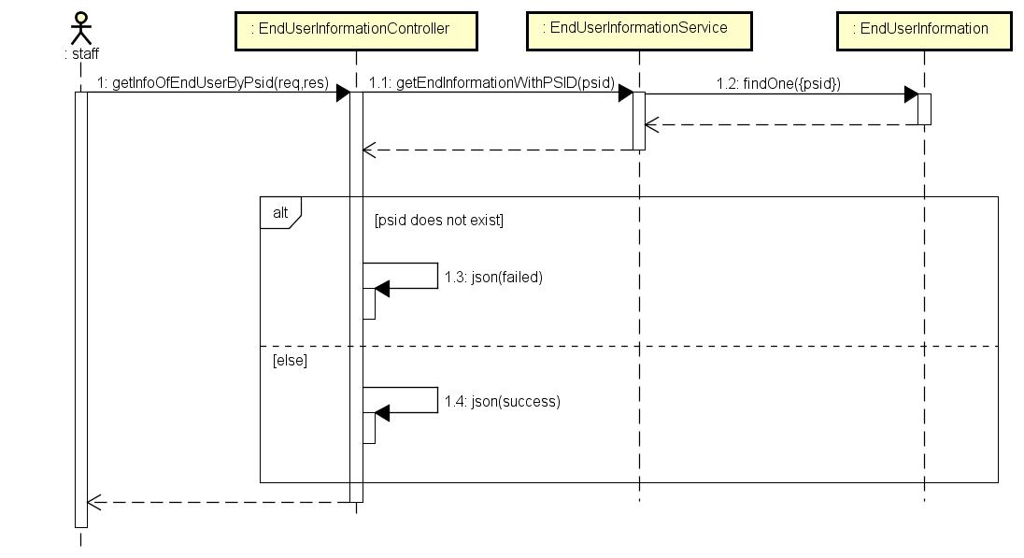

*Figure 4-103: Staff views Fb account infor sequence diagram*

**4.3.4.24 Staff views providing infor**

**Screen Design**

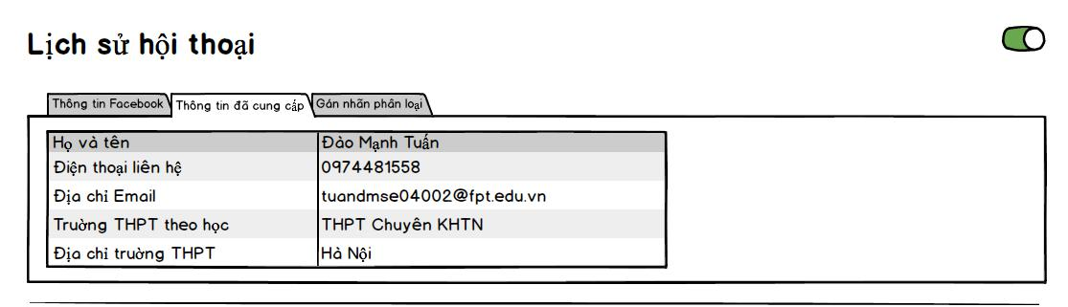

*Figure 4-104: Staff views providing infor screen design*

**Class Diagram**

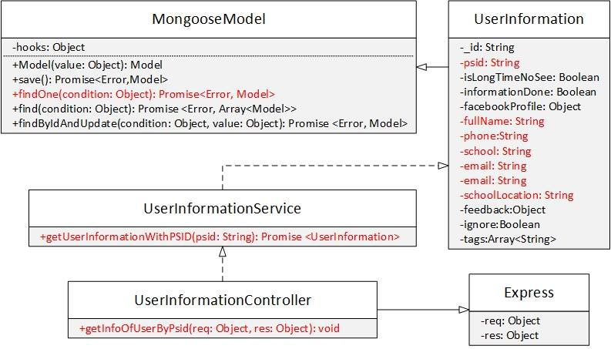

|  |  |  |  |  |  |
| --- | --- | --- | --- | --- | --- |
|  | *Figure 4-105: Staff views providing infor class diagram* | | | | |
| **Class Specification** |  |  |  |  |  |
| ***EndUserInformation*** | | |  |  |  |
|  |  | **EndUserformation** | | |  |
| Physical address |  | Backend /models/EndUserInformation.js | | |  |
| Base class |  | MongooseModel |  |  |  |
|  |  |  | Attributes | |  |
| No |  | Name |  | Type | Description |
| 1 |  | psid |  | String |  |
| 2 |  | fullname |  | String |  |
| 3 |  | phone |  | String |  |
| 4 |  | school |  | String |  |
| 5 |  | schoolLocation |  | String |  |
| 6 |  | email |  | String |  |
|  |  |  | Operation | |  |
| N/A |  | N/A |  |  |  |

***EndUserInformationService***

****EndUserInformationService**

|  |  |  |  |  |  |
| --- | --- | --- | --- | --- | --- |
| Physical address | Backend /services/EndUserInformationService.js | | | | |
| Base class | N/A |  |  |  |  |
|  |  | Attributes | |  |  |
| No | Name |  | Type | Description |  |
|  |  | Operation | |  |  |
| getUserInformationWithPSID |  |  |  |  |  |
| Return Type | Promise<EndUserInformation> | | |  |  |
| Parameters | Name |  | Type | Description | |
|  | psid |  | String |  |  |

***EndUserInformationController***

|  |  |  |  |  |
| --- | --- | --- | --- | --- |
|  | **EndUserInformationController** | | |  |
| Physical address | Backend /controllers/EndUserInformationController.js | | | |
| Base class | Express |  |  |  |
|  |  | Attributes | |  |
| No | Name |  | Type | Description |
|  |  | Operation | |  |
| getInforOfUserByPsid |  |  |  |  |
| Return Type | void |  |  |  |
| Parameters | Name |  | Type | Description |
|  | req |  | object |  |
|  | res |  | object |  |

**Sequence Diagram**



*Figure 4-106: Staff views providing infor sequence diagram*

**4.3.4.25 Staff adds tag**

**Screen Design**

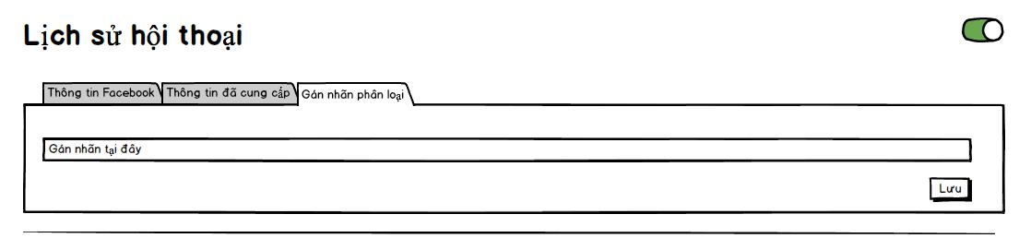

*Figure 4-107: Staff adds tag screen design*

**Class Diagram**

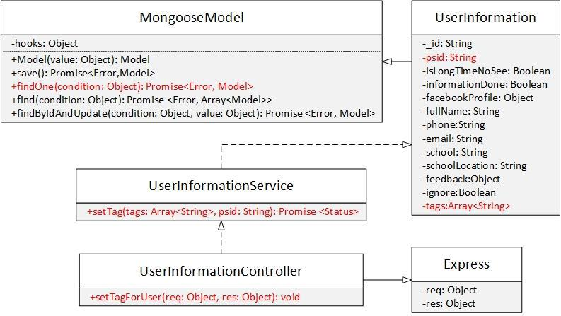

|  |  |  |  |  |  |  |
| --- | --- | --- | --- | --- | --- | --- |
|  |  | *Figure 4-108: Staff adds tag class diagram* | | |  |  |
| **Class Specification** | |  |  |  |  |  |
| ***EndUserInformation*** | |  |  |  |  |  |
|  |  |  | **EndUserInformation** | |  |  |
| Physical address | | Backend /models/EndUserInformation.js | | |  |  |
| Base class | | MongooseModel | | |  |  |
|  |  |  | Attributes | |  |  |
| No |  | Name |  | Type | Description |  |
| 1 |  | psid |  | String |  |  |
| 2 |  | tags |  | Array<String> |  |  |
|  |  |  | Operation | |  |  |
| N/A |  | N/A |  |  |  |  |
| ***EndUserInformationService*** | | |  |  |  |  |
|  |  |  | **EndUserInformationService** | |  |  |
| Physical address | | Backend /controllers/EndUserInformationService.js | | | |  |

|  |  |  |  |  |  |  |
| --- | --- | --- | --- | --- | --- | --- |
| Base class | N/A |  |  |  |  |  |
|  |  | Attributes | |  |  |  |
| No | Name |  | Type | Description |  |  |
|  |  | Operation | |  |  |  |
| setTag |  |  |  |  |  |  |
| Return Type | Promise<Status> |  |  |  |  |  |
| Parameters | Name |  | Type | Description | |  |
|  | tags |  | Array<String> |  |  |  |
|  | psid |  | String |  |  |  |
| ***EndUserInformationController*** | |  |  |  |  |  |
|  | **EndUserInformationController** | | |  |  |  |
| Physical address | Backend /controllers/EndUserInformationController.js | | | | | |
| Base class | Express |  |  |  |  |  |
|  |  | Attributes | |  |  |  |
| No | Name |  | Type | Description |  | |
|  |  | Operation | |  |  |  |
| setTagForUser |  |  |  |  |  |  |
| Return Type | void |  |  |  |  |  |
| Parameters | Name |  | Type | Description | | |
|  | req |  | object |  |  |  |
|  | res |  | object |  |  |  |

**Sequence Diagram**

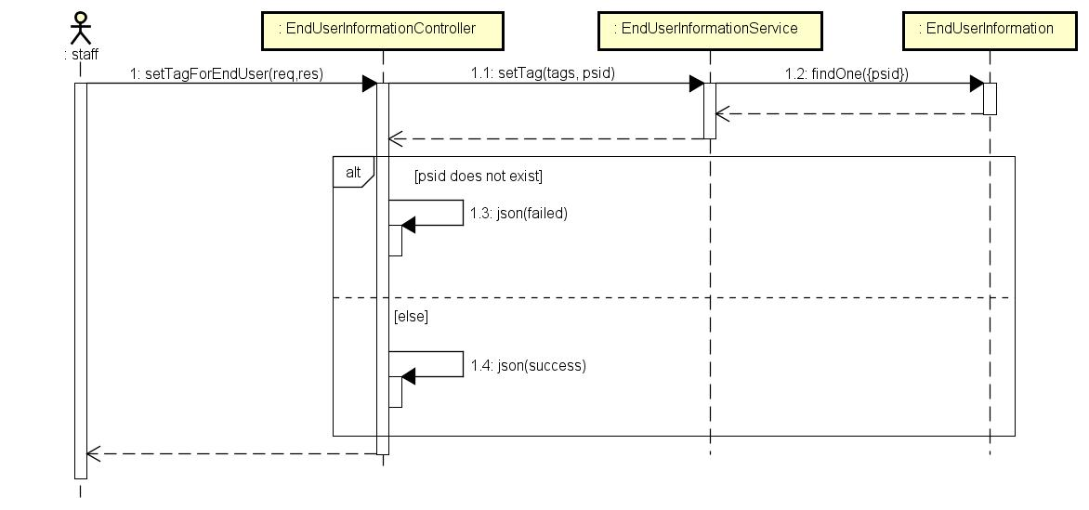

*Figure 4-109: Staff adds tag sequence diagram*

**4.3.4.26 Staff removes tag**

**Screen Design**



*Figure 4-110: Staff removes tag screen design*

**Class Diagram**

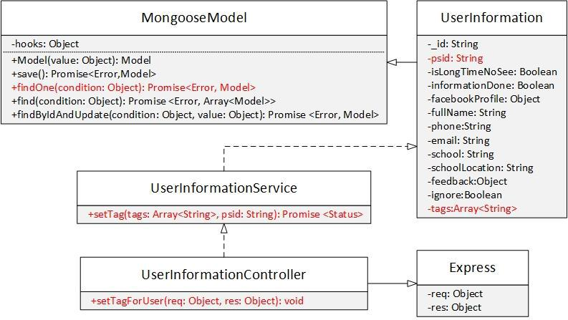

|  |  |  |  |  |  |  |  |  |  |
| --- | --- | --- | --- | --- | --- | --- | --- | --- | --- |
|  |  | *Figure 4-111: Staff removes tag class diagram* | | | | |  |  |  |
| **Class Specification** | |  |  |  |  |  |  |  |  |
| ***EndUserInformation*** | |  |  |  |  |  |  |  |  |
|  |  |  | **EndUserInformation** | | | |  |  |  |
| Physical address | | Backend /models/EndUserInformation.js | | | | |  |  |  |
| Base class | | MongooseModel | | | | |  |  |  |
|  |  |  | Attributes | | | |  |  |  |
| No |  | Name |  | Type | |  | Description | |  |
| 1 |  | psid |  | String | |  |  |  |  |
| 2 |  | tags |  | Array<String> | |  |  |  |  |
|  |  |  | Operation | | | |  |  |  |
| N/A |  | N/A |  |  |  |  |  |  |  |
| ***EndUserInformationService*** | | |  |  |  |  |  |  |  |
|  |  |  | **EndUserInformationService** | | | |  |  |  |
| Physical address | | Backend /controllers/EndUserInformationService.js | | | | | | |  |
| Base class | | N/A |  |  |  |  |  |  |  |
|  |  |  | Attributes | | | |  |  |  |
| No |  | Name |  |  | Type | |  | Description |  |
|  |  |  | Operation | | | |  |  |  |
| setTag |  |  |  |  |  |  |  |  |  |

|  |  |  |  |
| --- | --- | --- | --- |
| Return Type | Promise<Status> |  |  |
| Parameters | Name | Type | Description |
|  | tags | Array<String> |  |
|  | psid | String |  |

***EndUserInformationController***

|  |  |  |  |  |
| --- | --- | --- | --- | --- |
|  | **EndUserInformationController** | | |  |
| Physical address | Backend /controllers/EndUserInformationController.js | | | |
| Base class | Express |  |  |  |
|  |  | Attributes | |  |
| No | Name |  | Type | Description |
|  |  | Operation | |  |
| setTagForUser |  |  |  |  |
| Return Type | void |  |  |  |
| Parameters | Name |  | Type | Description |
|  | req |  | object |  |
|  | res |  | object |  |

**Sequence Diagram**



*Figure 4-112: Staff removes tag sequence diagram*

**4.3.4.27 Staff exports end user list**

**Screen Design**



*Figure 4-113: Staff exports end user list screen design*

**Class Diagram**

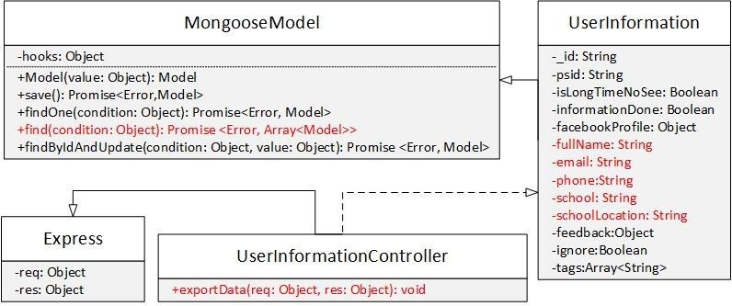

|  |  |  |  |  |  |  |  |  |  |
| --- | --- | --- | --- | --- | --- | --- | --- | --- | --- |
|  | *Figure 4-114: Staff exports end user list class diagram* | | | | | | | | |
| **Class Specification** |  |  |  |  |  |  |  |  |  |
| ***EndUserInformation*** | | | |  |  |  |  |  |  |
|  |  |  | **EndUserInformation** | | | | |  |  |
| Physical address |  | Backend /models/EndUserInformation.js | | | | | |  |  |
| Base class |  | MongooseModel | |  |  |  |  |  |  |
|  |  |  |  | Attributes | | | |  |  |
| No |  | Name | |  | Type | | |  | Description |
| 1 |  | fullName | |  | String | | |  |  |
| 2 |  | email | |  | String | | |  |  |
| 3 |  | phone | |  | String | | |  |  |
| 4 |  | school | |  | String | | |  |  |
| 5 |  | schoolLocation | |  | String | | |  |  |
|  |  |  |  | Operation | | | |  |  |
| N/A |  | N/A | |  |  |  |  |  |  |
| ***EndUserInformationController*** | | | |  |  |  |  |  |  |
|  |  |  | **EndUserInformationController** | | | | |  |  |
| Physical address |  |  | Backend /controllers/EndUserInformationController.js | | | | | | |
| Base class |  |  | Express |  |  |  |  |  |  |
|  |  |  |  | Attributes | | | |  |  |
| No |  |  | Name |  |  | Type |  | Description | |
|  |  |  |  | Operation | | | |  |  |
| exportData |  |  |  |  |  |  |  |  |  |
| Return Type |  |  | void |  |  |  |  |  |  |
| Parameters |  |  | Name |  |  | Type |  | Description | |
|  |  |  | req |  |  | object |  |  |  |
|  |  |  | res |  |  | object |  |  |  |

**Sequence Diagram**

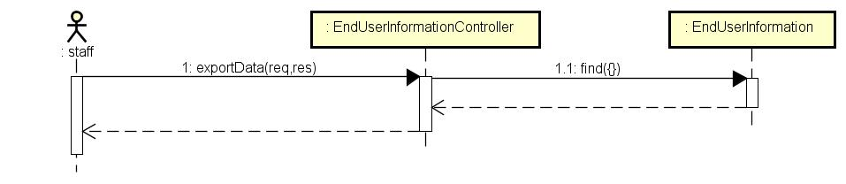

*Figure 4-115: Staff exports end user list sequence diagram*

**4.3.4.28 Staff changes bot status**

**Screen Design**

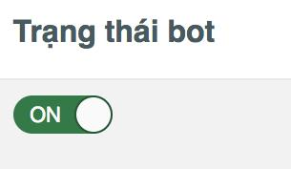

*Figure 4-116: Staff changes bot status screen design*

**Class Diagram**

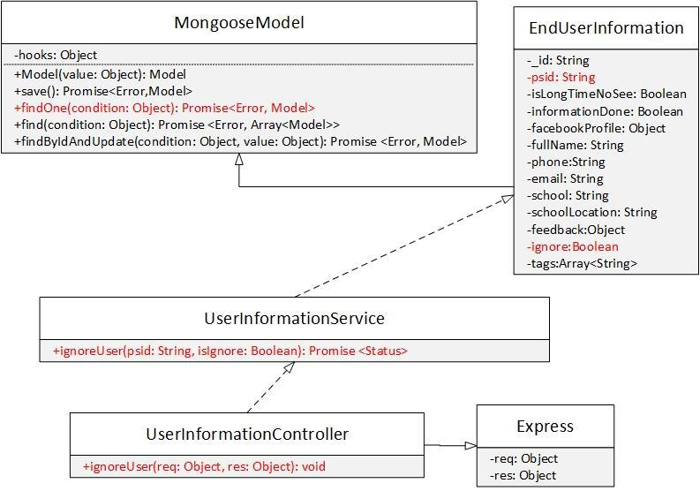

*Figure 4-117: Staff changes bot status class diagram*

**Class Specification**

***EndUserInformation***

|  |  |
| --- | --- |
|  | **EndUserInformation** |
| Physical address | Backend /models/EndUserInformation.js |
| Base class | MongooseModel |

|  |  |  |  |  |  |  |  |  |
| --- | --- | --- | --- | --- | --- | --- | --- | --- |
|  |  | Attributes | |  |  |  |  |  |
| No | Name | |  | Type | | Description | |  |
| 1 | psid | |  | String | |  |  |  |
| 2 | ignore | |  | Boolean | |  |  |  |
|  |  | Operation | |  |  |  |  |  |
| N/A | N/A | | |  |  |  |  |  |
| ***EndUserInformationService*** | | | |  |  |  |  |  |
|  |  | **EndUserInformationService** | | | |  |  |  |
| Physical address |  | Backend /controllers/EndUserInformationService.js | | | | | |  |
| Base class |  | N/A | |  |  |  |  |  |
|  |  | Attributes | |  |  |  |  |  |
| No |  | Name | |  | Type |  | Description |  |
|  |  | Operation | |  |  |  |  |  |
| ignoreUser |  |  |  |  |  |  |  |  |
| Return Type |  | Promise<Status> | |  |  |  |  |  |
| Parameters |  | Name | |  | Type |  | Description |  |
|  |  | psid | |  | String |  |  |  |
|  |  | isIgnore | |  | Boolean | |  |  |
| ***EndUserInformationController*** | | | |  |  |  |  |  |
|  |  | **EndUserInformationController** | | | |  |  |  |
| Physical address |  | Backend /controllers/EndUserInformationController.js | | | | | |  |
| Base class |  | Express | |  |  |  |  |  |
|  |  | Attributes | |  |  |  |  |  |
| No |  | Name | |  | Type |  | Description |  |
|  |  | Operation | |  |  |  |  |  |
| ignoreUser |  |  |  |  |  |  |  |  |
| Return Type |  | void | |  |  |  |  |  |
| Parameters |  | Name | |  | Type |  | Description |  |
|  |  | req | |  | object |  |  |  |
|  |  | res | |  | object |  |  |  |

**Sequence Diagram**

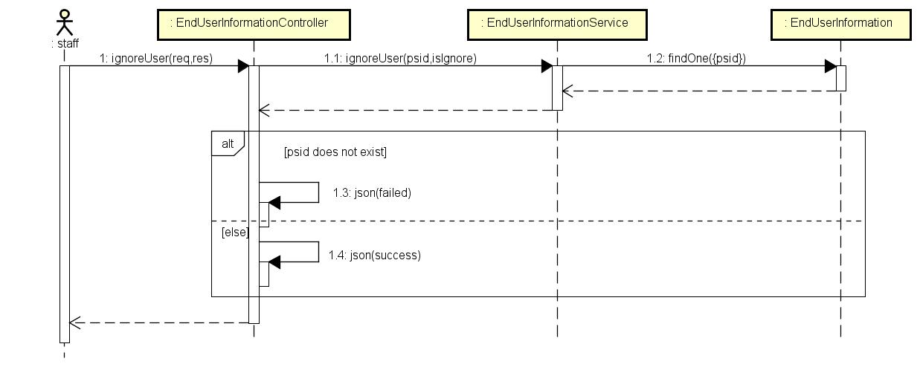

*Figure 4-118: Staff changes bot status sequence diagram*

**4.3.4.29 Staff logouts**

**Screen Design**

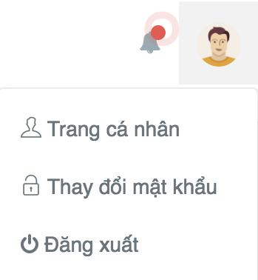

*Figure 4-119: Staff logouts screen design*

**Class diagram**

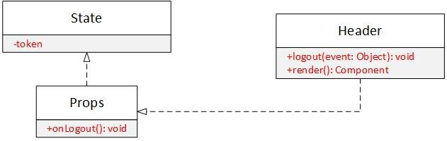

|  |  |  |  |  |  |  |  |  |
| --- | --- | --- | --- | --- | --- | --- | --- | --- |
|  |  | *Figure 4-120: Staff logouts class diagram* | | | | |  |  |
| **Class Specification** |  |  |  |  |  |  |  |  |
| ***State*** |  |  |  |  |  |  |  |  |
|  |  |  | **State** | | | |  |  |
| Physical address | N/A | |  |  |  |  |  |  |
| Base class | N/A | |  |  |  |  |  |  |
|  |  |  | Attributes | | | |  |  |
| No | Name | |  | Type | | |  | Description |
| 1 | token | |  | String | | |  |  |
|  |  |  | Operation | | | |  |  |
| N/A | N/A | |  |  |  |  |  |  |
| ***Props*** |  |  |  |  |  |  |  |  |
|  |  |  | **Props** | | | |  |  |
| Physical address |  | N/A |  |  |  |  |  |  |
| Base class |  | N/A |  |  |  |  |  |  |
|  |  |  | Attributes | | | |  |  |
| No |  | Name |  |  | Type |  | Description | |
|  |  |  | Operation | | | |  |  |
| onLogout |  |  |  |  |  |  |  |  |
| Return Type |  | void |  |  |  |  |  |  |
| Parameters |  | Name |  |  | Type |  | Description | |
|  |  | N/A |  |  | N/A |  | N/A | |

***Header***

|  |  |  |  |
| --- | --- | --- | --- |
|  | **Header** |  |  |
| Physical address | Src/components/Header.js |  |  |
| Base class | N/A |  |  |
|  | Attributes |  |  |
| No | Name | Type | Description |
|  | Operation |  |  |
| logout |  |  |  |
| Return Type | void |  |  |
| Parameters | Name | Type | Description |
|  | event | object |  |
| render |  |  |  |
| Return Type | Component |  |  |
| Parameters | Name | Type | Description |
|  | N/A | N/A | N/A |

**Sequence Diagram**

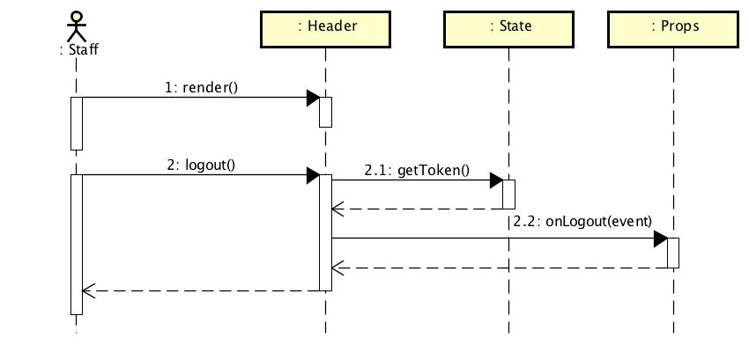

*Figure 4-115: Staff logouts sequence diagram*

**4.3.4.30 Admin views answer editing requests**

**Screen Design**

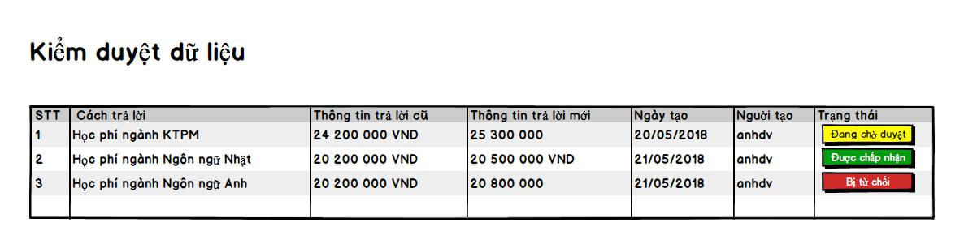

*Figure 4-121: Admin views answer editing requests screen design*

**Class Diagram**

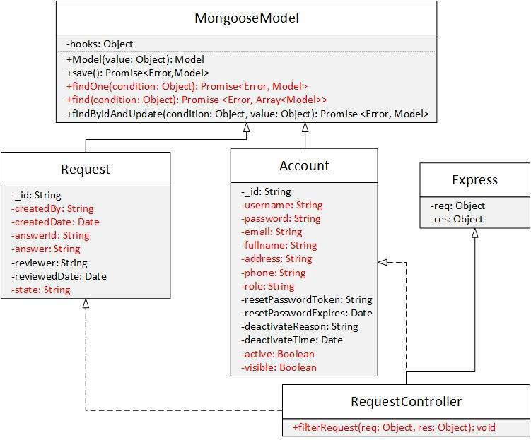

*Figure 4-122: Admin views answer editing requests class diagram*

**Class Specification**

***Request***

|  |  |  |  |
| --- | --- | --- | --- |
|  |  | **Request** |  |
| Physical address | Backend /models/Request.js | |  |
| Base class | MongooseModel |  |  |
|  |  | Attributes |  |
| No | Name | Type | Description |
| 1 | createdBy | String |  |
| 2 | createdDate | Date |  |
| 3 | answerId | String |  |
| 4 | answer | String |  |
| 5 | state | String |  |
|  |  | Operation |  |
| ***Account*** |  |  |  |
|  |  | **Account** |  |
| Physical address | Backend /models/Account.js | |  |
| Base class | MongooseModel |  |  |
|  |  | Attributes |  |
| No | Name | Type | Description |
| 1 | username | String |  |
|  |  | Operation |  |

***RequestController***

|  |  |  |  |  |
| --- | --- | --- | --- | --- |
|  |  | **RequestController** | |  |
| Physical address | Backend /controllers/RequestController.js | | |  |
| Base class | Express |  |  |  |
|  |  | Attributes | |  |
| No | Name |  | Type | Description |
|  |  | Operation | |  |
| filterRequest |  |  |  |  |
| Return Type | void |  |  |  |
| Parameters | Name |  | Type | Description |
|  | req |  | Object |  |
|  | res |  | Object |  |

**Sequence Diagram**

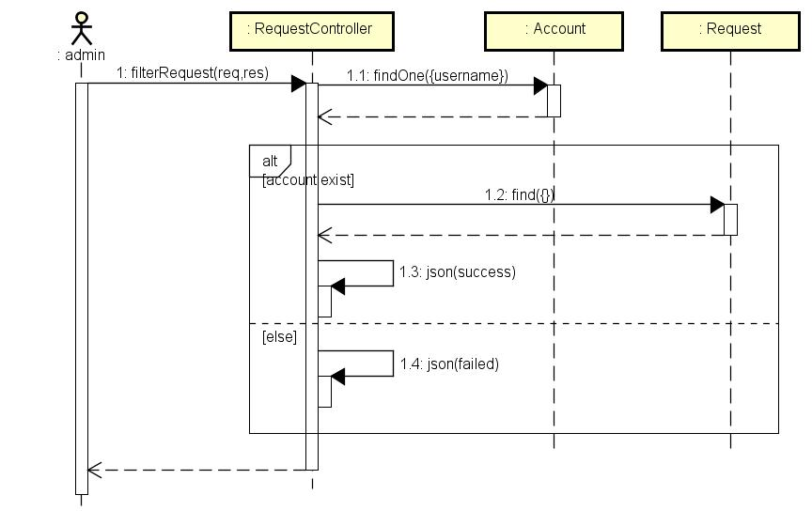

*Figure 4-123: Admin views answer editing requests sequence diagram*

**4.3.4.31 Admin accepts an answer editing request Screen Design**

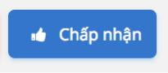

*Figure 4-124: Admin accepts an answer editing request screen design*

**Class Diagram**

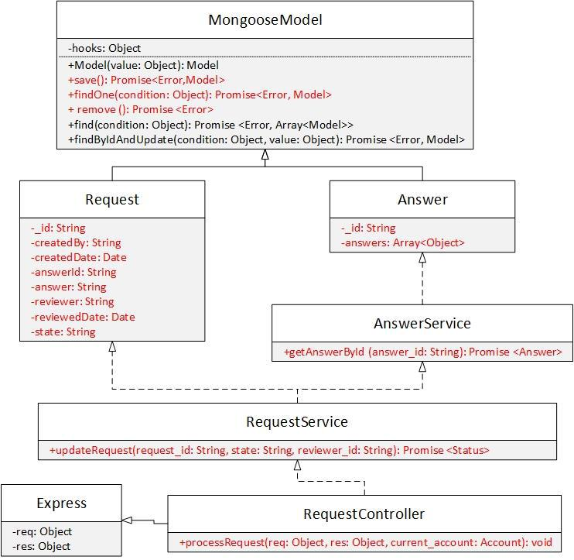

|  |  |  |  |
| --- | --- | --- | --- |
| *Figure 4-125: Admin accepts an answer editing request class diagram* | | | |
| **Class Specification** |  |  |  |
| ***Request*** |  |  |  |
|  | **Request** |  |  |
| Physical address | Backend /models/Request.js |  |  |
| Base class | Mongoose Model |  |  |
|  | Attributes |  |  |
| No | Name | Type | Description |
| 1 | _id | String |  |
| 2 | createdBy | String |  |
| 3 | createdDate | String |  |
| 4 | answerId | String |  |
| 5 | answer | String |  |
| 6 | reviewer | String |  |
| 7 | reviewedDate | Date |  |
| 8 | state | String |  |

|  |  |  |  |  |  |
| --- | --- | --- | --- | --- | --- |
|  |  | Operation |  |  |  |
| N/A | | N/A |  |  |  |
| ***Answer*** | |  |  |  |  |
|  |  | **Answer** |  |  |  |
| Physical address |  | Backend /models/Answer.js |  |  |  |
| Base class |  | Mongoose Model |  |  |  |
|  |  | Attributes |  |  |  |
| No |  | Name | Type | | Description |
| 1 |  | _id | String | |  |
| 2 |  | answers | Array<Object> | |  |
|  |  | Operation |  |  |  |
| N/A |  | N/A |  |  |  |
| ***AnswerService*** | |  |  |  |  |
|  |  | **AnswerService** | | |  |
| Physical address | | Backend /services/AnswerService.js | | |  |
| Base class | | N/A |  |  |  |
|  |  | Attributes |  |  |  |
| No | | Name |  | Type | Description |
| N/A | | N/A |  | N/A | N/A |
|  |  | Operation |  |  |  |
| getAnswerById | |  |  |  |  |
| Return Type | | Promise<Answer> |  |  |  |
| Parameters | | Name |  | Type | Description |
|  |  | answer_id |  | String |  |
| ***RequestService*** | |  |  |  |  |
|  |  | **RequestService** | | |  |
| Physical address | | Backend /services/RequestService.js | | |  |
| Base class | | N/A |  |  |  |
|  |  | Attributes |  |  |  |
| No | | Name |  | Type | Description |
| N/A | | N/A |  | N/A | N/A |
|  |  | Operation |  |  |  |
| updateRequest | |  |  |  |  |
| Return Type | | Promise<Status> |  |  |  |
| Parameters | | Name |  | Type | Description |
|  |  | request_id |  | String |  |
|  |  | reviewer_id |  | String |  |
| ***RequestController*** | |  |  |  |  |
|  |  | **RequestController** | | |  |
| Physical address | | Backend /controllers/RequestController.js | | |  |
| Base class | | Express |  |  |  |
|  |  | Attributes |  |  |  |
| No | | Name |  | Type | Description |
| N/A | | N/A |  | N/A | N/A |
|  |  | Operation |  |  |  |
| processRequest | |  |  |  |  |

|  |  |  |  |
| --- | --- | --- | --- |
| Return Type | void |  |  |
| Parameters | Name | Type | Description |
|  | req | object | The object contains |
|  |  |  | request information. |
|  | res | object | The object contains |
|  |  |  | response information. |
|  | current_accoun | Account |  |

**Sequence Diagram**

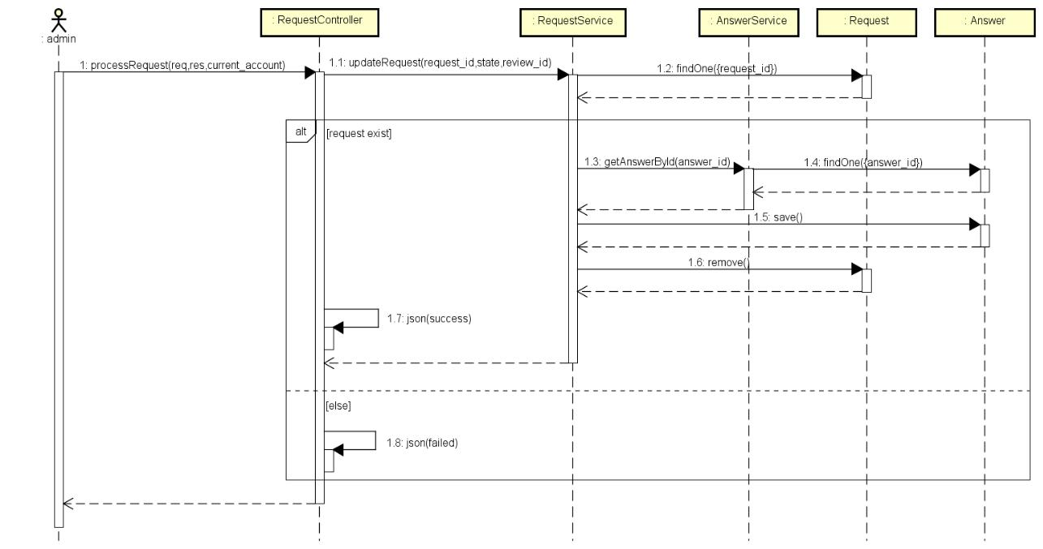

*Figure 4-126: Admin accepts answer editing request sequence diagram*

**4.3.4.32 Admin rejects an answer editing request Screen Design**

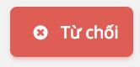

*Figure 4-127: Admin rejects an answer editing request screen design*

**Class Diagram**

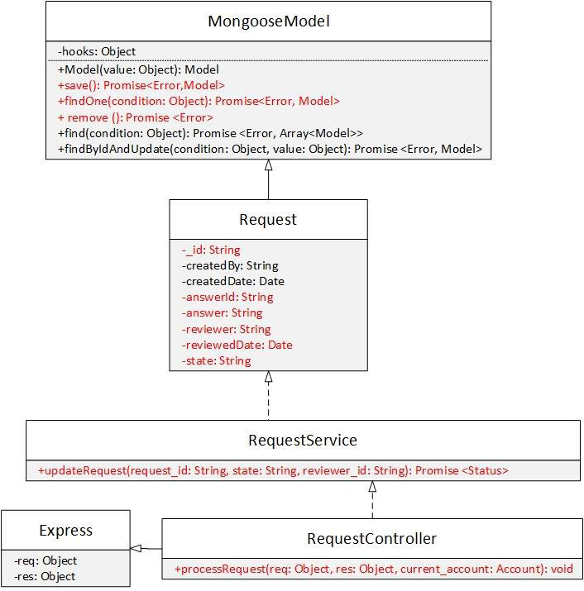

*Figure 4-128: Admin rejects an answer editing request class diagram*

**Class Specification**

***Request***



**Request**

|  |  |  |  |  |
| --- | --- | --- | --- | --- |
| Physical address | Backend /models/Request.js |  |  |  |
| Base class | Mongoose Model |  |  |  |
|  | Attributes |  |  |  |
| No | Name | Type | Description |  |
| 1 | _id | String |  |  |
| 2 | reviewer | String |  |  |
| 3 | answerId | String |  |  |
| 4 | answer | String |  |  |
| 5 | state | String |  |  |
| 6 | reviewedDate | Date |  |  |
|  | Operation |  |  |  |
| N/A | N/A |  |  |  |
| ***RequestService*** |  |  |  |  |
|  | **RequestService** |  |  |  |
| Physical address | Backend /services/RequestService.js | |  |  |
| Base class | N/A |  |  |  |
|  | Attributes |  |  |  |
| No | Name | Type | Description |  |
| N/A | N/A | N/A | N/A | |
|  | Operation |  |  |  |

|  |  |  |  |  |  |
| --- | --- | --- | --- | --- | --- |
| updateRequest |  |  |  |  |  |
| Return Type | Promise<Status> | | |  |  |
| Parameters | Name | |  | Type | Description |
|  | request_id | |  | String |  |
|  | reviewer_id | |  | String |  |
| ***RequestController*** |  |  |  |  |  |
|  | **RequestController** | | |  |  |
| Physical address | Backend /controllers/RequestController.js | | | |  |
| Base class | Express | | |  |  |
|  | Attributes | | |  |  |
| No | Name |  |  | Type | Description |
| N/A | N/A | |  | N/A | N/A |
|  | Operation | | |  |  |
| processRequest |  |  |  |  |  |
| Return Type | void | | |  |  |
| Parameters | Name | |  | Type | Description |
|  | req | |  | object | The object contains |
|  |  |  |  |  | request information. |
|  | res | |  | object | The object contains |
|  |  |  |  |  | response information. |
|  | current_accoun | |  | Account |  |

**Sequence Diagram**

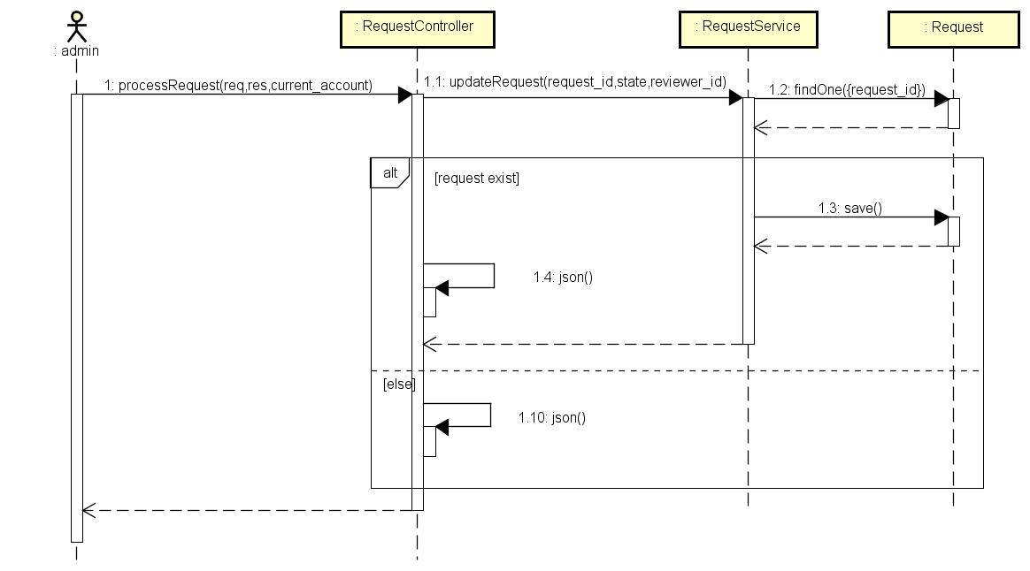

*Figure 4-129: Admin rejects an answer editing request sequence diagram*

**4.3.4.33 Admin creates account**

**Screen Design**

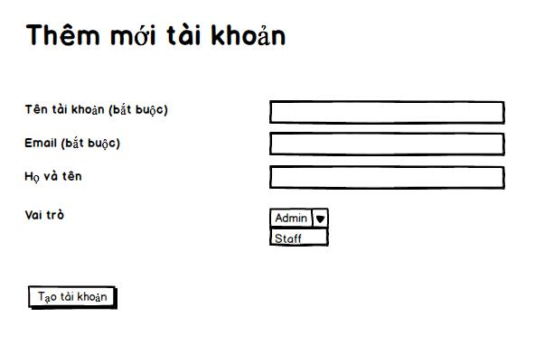

*Figure 4-130: Admin creates account screen design*

**Class Diagram**

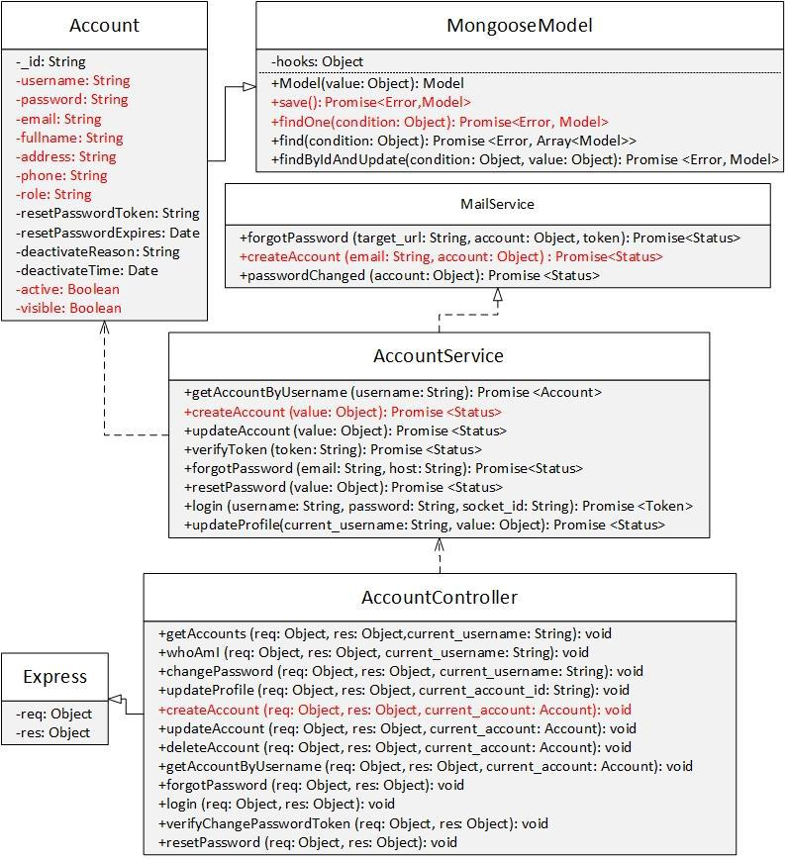

*Figure 4-131: Admin creates account class diagram*

**Class Specification**

***Account***



**Account**

|  |  |  |  |  |  |  |  |  |  |  |  |
| --- | --- | --- | --- | --- | --- | --- | --- | --- | --- | --- | --- |
| Physical address | Backend /models/Account.js | | | | | |  |  |  |  |  |
| Base class | Mongoose Model | | | | | |  |  |  |  |  |
|  |  |  |  | Attributes | | |  |  |  |  |  |
| No | Name | | |  | Type | |  | Description | |  |  |
| 1 | username | | |  | String | |  |  |  |  |  |
| 2 | password | | |  | String | |  |  |  |  |  |
| 3 | fullname | | |  | String | |  |  |  |  |  |
| 4 | email | | |  | String | |  |  |  |  |  |
| 5 | address | | |  | String | |  |  |  |  |  |
| 6 | role | | |  | String | |  |  |  |  |  |
| 7 | active | | |  | Boolean | |  |  |  |  |  |
| 8 | visible | | |  | Boolean | |  |  |  |  |  |
|  |  |  |  | Operation | | |  |  |  |  |  |
| N/A | N/A | | |  |  |  |  |  |  |  |  |
| ***AccountService*** |  |  |  |  |  |  |  |  |  |  |  |
|  |  |  |  | **AccountService** | | |  |  |  |  |  |
| Physical address |  |  | Backend /controllers/AccountService.js | | | | | |  |  |  |
| Base class |  |  | N/A |  |  |  |  |  |  |  |  |
|  |  |  |  | Attributes | | |  |  |  |  |  |
| No |  |  | Name |  |  |  | Type | | Description |  |  |
| N/A |  |  | N/A |  |  |  | N/A | | N/A | |  |
|  |  |  |  | Operation | | |  |  |  |  |  |
| createAccount |  |  |  |  |  |  |  |  |  |  |  |
| Return Type |  |  | Promise<Status> | | | |  |  |  |  |  |
| Parameters |  |  | Name |  |  |  | Type | | Description | |  |
|  |  |  | value |  |  |  | object | | The object contains | |  |
|  |  |  |  |  |  |  |  |  | account information | |  |
| ***MailService*** |  |  |  |  |  |  |  |  |  |  |  |
|  |  |  |  | **MailService** | | |  |  |  |  |  |
| Physical address |  |  | Backend /controllers/MailService.js | | | |  |  |  |  |  |
| Base class |  |  | N/A |  |  |  |  |  |  |  |  |
|  |  |  |  | Attributes | | |  |  |  |  |  |
| No |  |  | Name |  |  |  | Type | | Description |  |  |
| N/A |  |  | N/A |  |  |  | N/A | | N/A | | |
|  |  |  |  | Operation | | |  |  |  |  |  |
| createAccount |  |  |  |  |  |  |  |  |  |  |  |
| Return Type |  |  | Promise<Status> | | | |  |  |  |  |  |
| Parameters |  |  | Name |  |  |  | Type | | Description | | |
|  |  |  | email |  |  |  | String | |  |  |  |
|  |  |  | account |  |  |  | object | |  |  |  |
| ***AccountController*** |  |  |  |  |  |  |  |  |  |  |  |
|  |  |  |  | **AccountController** | | |  |  |  |  |  |
| Physical address |  |  | Backend /controllers/AccountController.js | | | | | |  |  |  |

|  |  |  |  |  |
| --- | --- | --- | --- | --- |
| Base class | Express |  |  |  |
|  | Attributes |  |  |  |
| No | Name | Type | Description |  |
| N/A | N/A | N/A | N/A | |
|  | Operation |  |  |  |
| createAccount |  |  |  |  |
| Return Type | void |  |  |  |
| Parameters | Name | Type | Description | |
|  | req | object | The object contains | |
|  |  |  | request information. | |
|  | res | object | The object contains | |
|  |  |  | response information. | |
|  | current_account | Account |  |  |

**Sequence Diagram**

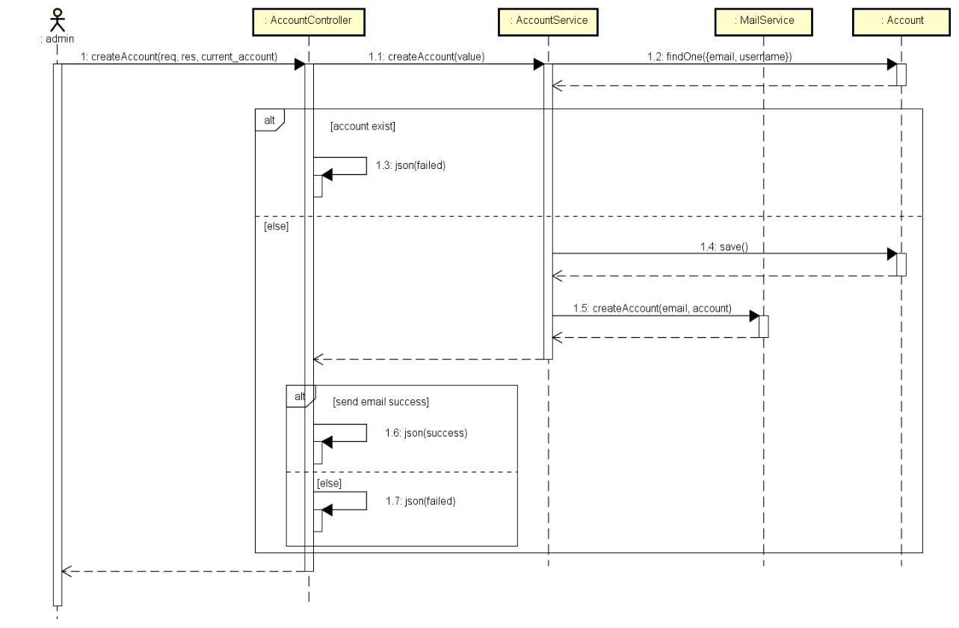

*Figure 4-132: Admin creates account sequence diagram*

**4.3.4.34 Admin deletes account**

**Screen Design**

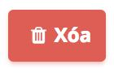

*Figure 4-133: Admin deletes account screen design*

**Class Diagram**

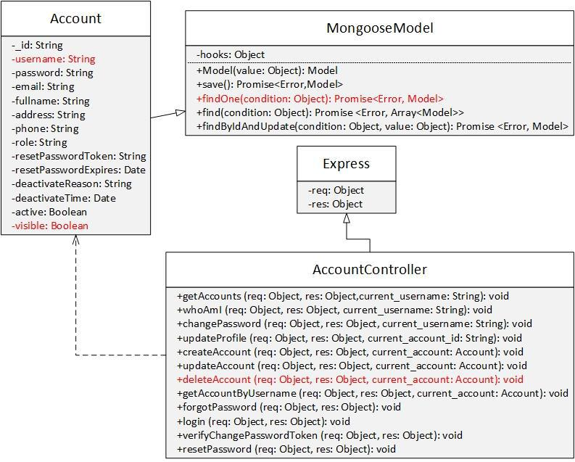

|  |  |  |  |  |  |  |
| --- | --- | --- | --- | --- | --- | --- |
|  | *Figure 4-134: Admin deletes account class diagram* | | | | | |
| **Class Specification** |  |  |  |  |  |  |
| ***Account*** |  |  |  |  |  |  |
|  |  | **Account** | |  |  |  |
| Physical address |  | Backend /models/Account.js | |  |  |  |
| Base class |  | Mongoose Model | |  |  |  |
|  |  | Attributes | |  |  |  |
| No |  | Name |  | Type | Description |  |
| 1 |  | username | | String |  |  |
| 2 |  | visible | | String |  |  |
|  |  | Operation | |  |  |  |
| N/A |  | N/A | |  |  |  |
| ***AccountController*** |  |  |  |  |  |  |
|  |  | **AccountController** | |  |  |  |
| Physical address |  | Backend /controllers/AccountController.js | | |  |  |
| Base class |  | Express | |  |  |  |
|  |  | Attributes | |  |  |  |
| No |  | Name |  | Type | Description |  |
| N/A |  | N/A | | N/A | N/A | |
|  |  | Operation | |  |  |  |
| deleteAccount |  |  |  |  |  |  |
| Return Type |  | void | |  |  |  |
| Parameters |  | Name | | Type | Description | |
|  |  | req | | object | The object contains | |
|  |  |  |  |  | request information. | |

|  |  |  |  |
| --- | --- | --- | --- |
|  | res | object | The object contains |
|  |  |  | response information. |
|  | current_account | Account |  |

**Sequence Diagram**

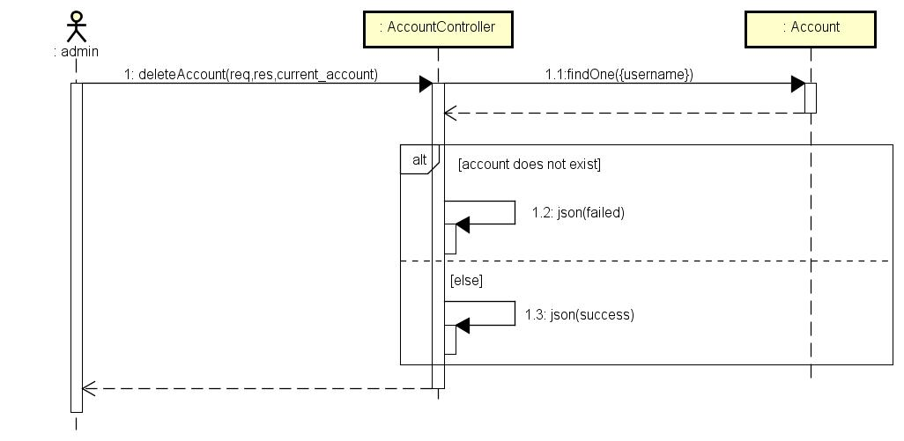

*Figure 4-135: Admin deletes account sequence diagram*

**4.3.4.35 Admin changes account role**

**Screen Design**

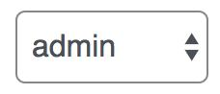

*Figure 4-136: Admin changes account role screen design*

**Class Diagram**

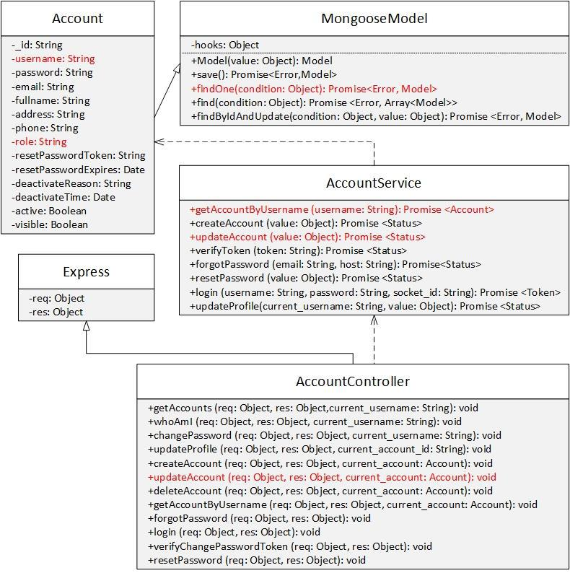

|  |  |  |  |  |  |
| --- | --- | --- | --- | --- | --- |
|  | *Figure 4-137: Admin changes account role class diagram* | | | | |
| **Class Specification** |  |  |  |  |  |
| ***Account*** |  |  |  |  |  |
|  |  | **Account** |  |  |  |
| Physical address |  | Backend /models/Account.js |  |  |  |
| Base class |  | Mongoose Model |  |  |  |
|  |  | Attributes |  |  |  |
| No |  | Name | Type | Description |  |
| 1 |  | username | String |  |  |
| 2 |  | role | String |  |  |
|  |  | Operation |  |  |  |
| ***AccountService*** |  |  |  |  |  |
|  |  | **AccountService** |  |  |  |
| Physical address |  | Backend /controllers/AccountService.js | |  |  |
| Base class |  | N/A |  |  |  |
|  |  | Attributes |  |  |  |
| No |  | Name | Type | Description |  |
| N/A |  | N/A | N/A | N/A | |
|  |  | Operation |  |  |  |
| getAccountByUsername | |  |  |  |  |

|  |  |  |  |  |  |  |  |
| --- | --- | --- | --- | --- | --- | --- | --- |
| Return Type | Promise<Account> | | |  |  |  |  |
| Parameters | Name | |  | Type | Description | |  |
|  | username | |  | String |  |  |  |
| updateAccount |  |  |  |  |  |  |  |
| Return Type | Promise<Status> | | |  |  |  |  |
| Parameters | Name | |  | Type | Description | |  |
|  | value | |  | object | The object contains | |  |
|  |  |  |  |  | account information. | |  |
| ***AccountController*** |  |  |  |  |  |  |  |
|  | **AccountController** | | |  |  |  |  |
| Physical address | Backend /controllers/AccountController.js | | | |  |  |  |
| Base class | Express | | |  |  |  |  |
|  | Attributes | | |  |  |  |  |
| No | Name |  |  | Type | Description |  | |
|  | Operation | | |  |  |  |  |
| updateAccount |  |  |  |  |  |  |  |
| Return Type | void | | |  |  |  |  |
| Parameters | Name | |  | Type | Description | | |
|  | req | |  | object | The object contains | | |
|  |  |  |  |  | request information. | | |
|  | res | |  | object | The object contains | | |
|  |  |  |  |  | response information. | | |
|  | current_account | |  | Account |  |  |  |

**Sequence Diagram**

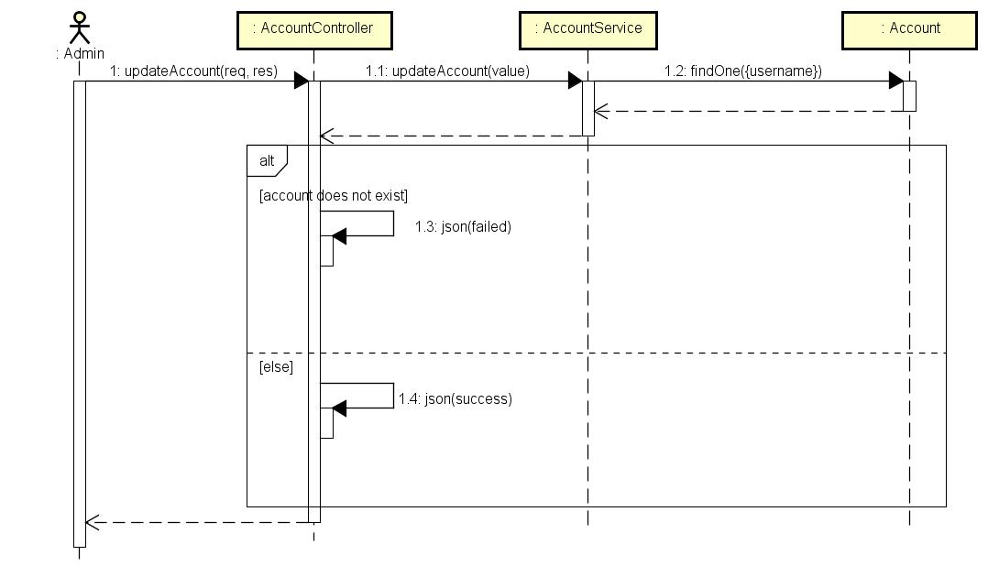

*Figure 4-138: Admin changes account role sequence diagram*

**4.3.4.36 Admin changes account status**

**Screen Design**

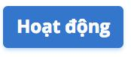

*Figure 4-139: Admin changes account status screen design*

**Class Diagram**

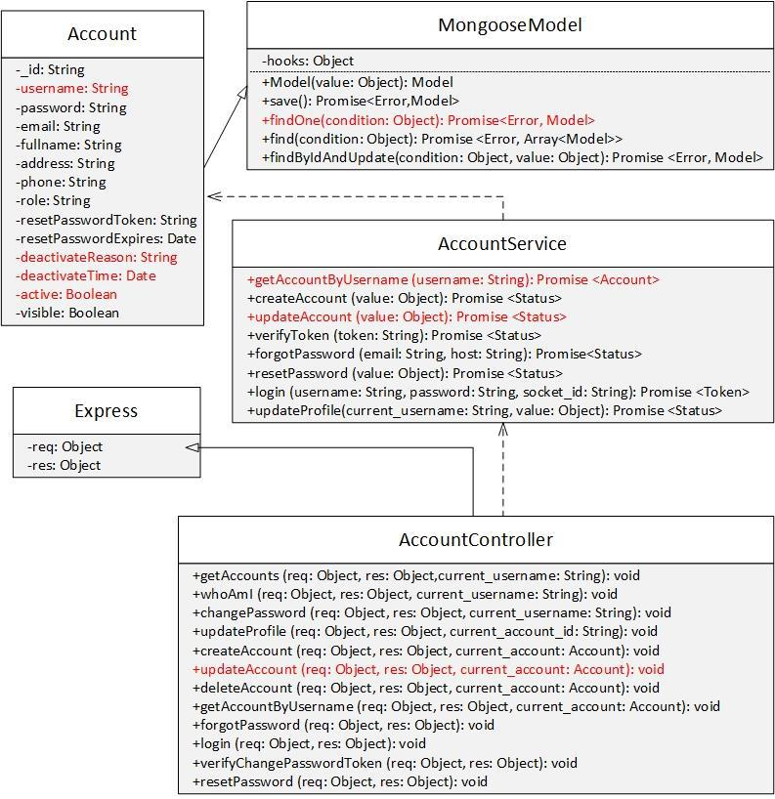

|  |  |  |  |  |
| --- | --- | --- | --- | --- |
|  | *Figure 4-140: Admin changes account status class diagram* | | | |
| **Class Specification** |  |  |  |  |
| ***Account*** |  |  |  |  |
|  |  | **Account** |  |  |
| Physical address |  | Backend /models/Account.js |  |  |
| Base class |  | Mongoose Model |  |  |
|  |  | Attributes |  |  |
| No |  | Name | Type | Description |
| 1 |  | username | String |  |
| 2 |  | active | String |  |
| 3 |  | deactivateReason | String |  |
| 4 |  | deactiveTime | Date |  |
|  |  | Operation |  |  |
| ***AccountService*** |  |  |  |  |
|  |  | **AccountService** |  |  |

|  |  |  |  |  |  |  |
| --- | --- | --- | --- | --- | --- | --- |
| Physical address | Backend /controllers/AccountService.js | | | |  |  |
| Base class | N/A | | |  |  |  |
|  | Attributes | | |  |  |  |
| No | Name |  |  | Type | Description |  |
| N/A | N/A | |  | N/A | N/A | |
|  | Operation | | |  |  |  |
| getAccountByUsername |  |  |  |  |  |  |
| Return Type | Promise<Account> | | |  |  |  |
| Parameters | Name | |  | Type | Description | |
|  | username | |  | String |  |  |
| updateAccount |  |  |  |  |  |  |
| Return Type | Promise<Status> | | |  |  |  |
| Parameters | Name | |  | Type | Description | |
|  | value | |  | object | The object contains | |
|  |  |  |  |  | account information. | |
| ***AccountController*** |  |  |  |  |  |  |
|  | **AccountController** | | |  |  |  |
| Physical address | Backend /controllers/AccountController.js | | | |  |  |
| Base class | Express | | |  |  |  |
|  | Attributes | | |  |  |  |
| No | Name |  |  | Type | Description |  |
| N/A | N/A | |  | N/A | N/A | |
|  | Operation | | |  |  |  |
| updateAccount |  |  |  |  |  |  |
| Return Type | void | | |  |  |  |
| Parameters | Name | |  | Type | Description | |
|  | req | |  | object | The object contains | |
|  |  |  |  |  | request information. | |
|  | res | |  | object | The object contains | |
|  |  |  |  |  | response information. | |
|  | current_account | |  | Account |  |  |

**4.3.4.37 Admin broadcasts**

**Screen Design**

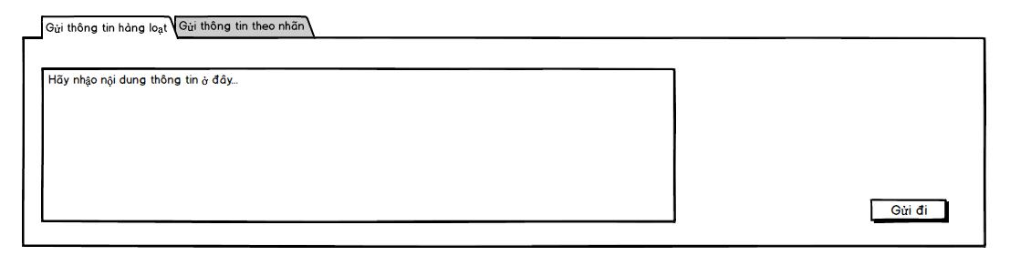

*Figure 4-141: Broadcast screen design*

**Class Diagram**

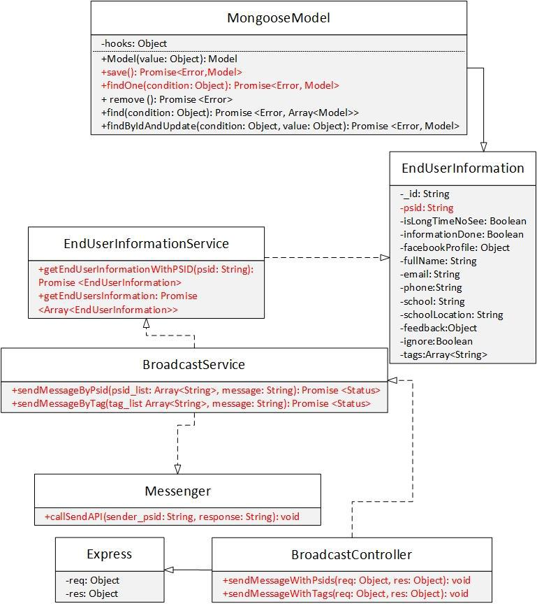

|  |  |  |  |  |
| --- | --- | --- | --- | --- |
|  | *Figure 4-142: Admin broadcasts* | | |  |
| **Class Specification** |  |  |  |  |
| ***EndUserInformation*** |  |  |  |  |
|  |  | **EndUserInformation** | |  |
| Physical address | Backend /models/EndUserInformation.js | | |  |
| Base class | MongooseModel | | |  |
|  |  | Attributes | |  |
| No | Name |  | Type | Description |
| 1 | psid |  | String |  |
|  |  | Operation | |  |

***EndUserInformationtService***



**EndUserInformationService**

|  |  |  |  |  |  |  |  |  |  |  |  |  |  |
| --- | --- | --- | --- | --- | --- | --- | --- | --- | --- | --- | --- | --- | --- |
| Physical address | |  |  |  | Backend /controllers/EndUserInformationService.js | | | | | | | | |
| Base class | |  |  |  | N/A |  |  |  |  |  |  |  |  |
|  |  |  |  |  | Attributes |  |  |  |  |  |  |  |  |
| No | |  |  |  | Name |  | Type | |  | Description | |  |  |
| N/A | |  |  |  | N/A |  | N/A | |  | N/A | | | |
|  |  |  |  |  | Operation |  |  |  |  |  |  |  |  |
| getEndUserInformationWithPSID | | | |  |  |  |  |  |  |  |  |  |  |
| Return Type | |  |  |  | Promise<EndUserInformation> | | | |  |  |  |  |  |
| Parameters | |  |  |  | Name |  | Type | |  | Description | | | |
|  |  |  |  |  | psid |  | String | |  |  |  |  |  |
| getEndUserInformation | |  |  |  |  |  |  |  |  |  |  |  |  |
| Return Type | |  |  |  | Promise<Array<EndUserInformation>> | | | | | | | | |
| Parameters | |  |  |  | Name |  | Type | |  | Description | | | |
|  |  |  |  |  | N/A |  | N/A | |  | N/A | | | |
| ***BroadcastService*** | |  |  |  |  |  |  |  |  |  |  |  |  |
|  |  |  |  |  | **BroadcastService** |  |  |  |  |  |  |  |  |
| Physical address | |  |  | Backend /controllers/BroadcastService.js | | | | | | | | |  |
| Base class | |  |  | N/A | |  |  |  |  |  |  |  |  |
|  |  |  |  |  | Attributes |  |  |  |  |  |  |  |  |
| No | |  |  | Name | | Type | | |  |  | Description |  |  |
| N/A | |  |  | N/A | | N/A | | |  |  | N/A | |  |
|  |  |  |  |  | Operation |  |  |  |  |  |  |  |  |
| sendMessageByPsid | |  |  |  |  |  |  |  |  |  |  |  |  |
| Return Type | |  |  | Promise<Status> | |  |  |  |  |  |  |  |  |
| Parameters | |  |  | Name | | Type | | |  |  | Description | |  |
|  |  |  |  | psid_list | | Array<String> | | | | |  | |  |
| sendMessageByTag | |  |  |  |  |  |  |  |  |  |  |  |  |
| Return Type | |  |  | Promise<Array<Status>> | | | | |  |  |  |  |  |
| Parameters | |  |  | Name | | Type | | |  |  | Description | |  |
|  |  |  |  | tag_list | | Array<String> | | | | |  | |  |
|  |  |  |  | message | | String | | |  |  |  |  |  |
| ***BroadcastController*** | |  |  |  |  |  |  |  |  |  |  |  |  |
|  |  |  |  |  | **BroadcastController** | | | |  |  |  |  |  |
| Physical address | | Backend /controllers/BroadcastController.js | | | | | | |  |  |  |  |  |
| Base class | | Express | | | |  |  |  |  |  |  |  |  |
|  |  |  |  |  | Attributes |  |  |  |  |  |  |  |  |
| No |  | Name | | | | Type | |  | Description | | |  |  |
| N/A |  | N/A | | | | N/A | |  | N/A | | | |  |
|  |  |  |  |  | Operation |  |  |  |  |  |  |  |  |
| sendMessageWithPsids |  |  |  |  |  |  |  |  |  |  |  |  |  |
| Return Type | | void | | | |  |  |  |  |  |  |  |  |
| Parameters | | Name | | | | Type | |  | Description | | | |  |
|  |  | req | | | | object | |  | The object contains | | | |  |
|  |  |  |  |  |  |  |  |  | request information. | | | |  |
|  |  | res | | | | object | |  | The object contains | | | |  |
|  |  |  |  |  |  |  |  |  | response information. | | | |  |

|  |  |  |  |
| --- | --- | --- | --- |
| sendMessageWithTags |  |  |  |
| Return Type | void |  |  |
| Parameters | Name | Type | Description |
|  | req | object | The object contains |
|  |  |  | request information. |
|  | res | object | The object contains |
|  |  |  | response information. |
| **Sequence diagram** |  |  |  |

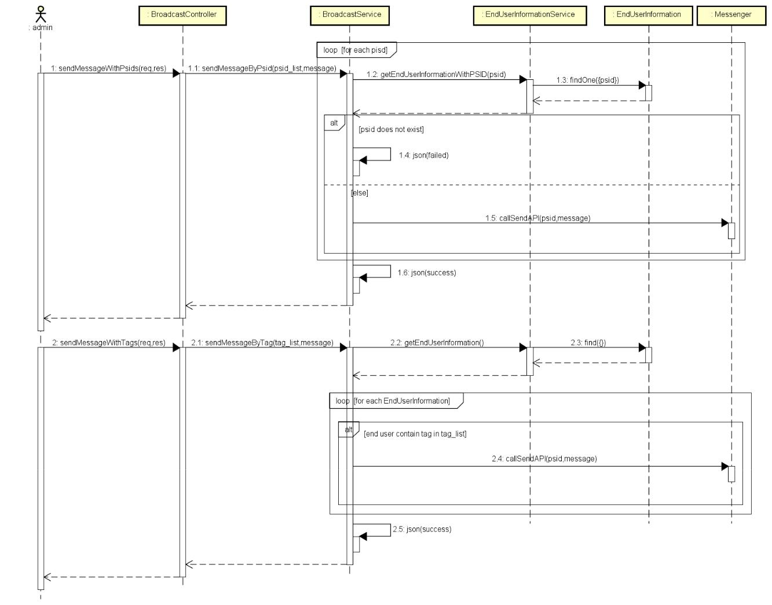

*Figure 4-143: Broadcast sequence diagram*

**Chapter 5 : Software Testing Documentation**

**5.1 Purpose**

The primary purpose of this chapter is to detect and prevent defects which may be created by developers while developing the software and this may lead to software failures. On the other hand, another objective of this chapter is to provide information about the level of quality and to make sure that the end result meets the business and user requirements. It contains the following sections:

Scope of Testing.

Testing Tool and Environment. Resources and responsibilities.

Test strategy: Test approach, test stages. Test schedule.

Feature to be tested.

Feature not to be tested. Defect Log.

Test report.

**Scope of testing**



Testing phases

There are 4 phases in Testing Process: Unit testing, Integration testing, System testing and Acceptance testing.

|  |  |  |  |  |
| --- | --- | --- | --- | --- |
| **ID** | **Testing Phase** | **Description** |  |  |
|  |  |  | |  |
| 1 | **Unit testing** | The main aim of this endeavor is to determine whether the application | | |
|  |  | functions as designed. In this phase, a unit can refer to a function, | | |
|  |  | individual program or even a procedure, and | | a [White-box](http://stackoverflow.com/questions/402161/black-box-vs-white-box-testing) |
|  |  | [Testing](http://stackoverflow.com/questions/402161/black-box-vs-white-box-testing) method is usually used to get the job done. | |  |
|  |  |  | | |
| 2 | **Integration testing** | Integration testing allows individuals the opportunity to combine all | | |
|  |  | of the units within a program and test them as a group. This testing | | |
|  |  | level is designed to find interface | defects | between the |
|  |  | modules/functions. This is particularly beneficial because it | | |
|  |  | determines how efficiently the units are running together. | | |
|  |  |  | | |
| 3 | **System testing** | System testing is the first level in which the complete application is | | |
|  |  | tested as a whole. The goal at this level is to evaluate whether the | | |
|  |  | system has complied with all of the outlined requirements and to see | | |
|  |  | that it meets Quality Standards. |  |  |
|  |  |  |  |  |
| 4 | **Acceptance testing** | Acceptance testing (or User Acceptance | Testing), | is conducted |
|  |  | to determine whether the system is ready for release. During this | | |
|  |  | phase, the tester and some alpha test user will test the system to find | | |
|  |  | out whether the application meets their business’ needs. | | |
|  |  |  |  |  |

**Testing types**

1. GUI testing
2. Function testing
   1. Performance testing o Regression testing

o Acceptance testing including alpha testing o Unit testing

o Load testing

**Testing range**

Team performs all functions defined in the SRS based on the approved version.

**5.2** **Test plan**

**Testing tools and environment**

**5.2.1.1 Testing tools**

***5.2.1.1.1*** ***ASC Front-end and Project testing***

* **Chrome DevTools:** To view logs, inspect elements.



*Figure 5-1: Chrome Developer Tools*

* **Redux DevTools:** To view Redux action and state tree.
* **Backlog:** To manage bugs: Show all bugs and life cycle of process to resolve bug.



*Figure 5-2: Backlog*

* **Microsoft Excel:** To manage test cases



*Figure 5-3: Microsoft Excel*

* **Postman:** to manage the list of all APIs and manually test API



*Figure 5-4: Postman*

***5.2.1.1.2 ASC API testing***

* **Mocha 1:** a feature-rich JavaScript test framework running on Node.js and in the browser,using to make asynchronous testing simple.



*Figure 5-5: MochaJS*

* **Chaijs 2:** Chai is a BDD / TDD assertion library for node, to help assertion result in a test.



*Figure 5-6: ChaiJS*

* **Chai as Promised 3:** Chai as Promised extends Chai with a fluent language for assertingfacts about promises, to assert result with Promises.
* **SuperTest 4:** A Super-agent5driven library for testing Node.js HTTP servers using a fluentAPI, use to make a test with from high-level abstraction to the low-level API.
* **Nyc6**: command-line-client for Istanbul works well with most JavaScript testing

frameworks: tap, mocha, AVA, …

**5.2.1.2 Testing environment**

1. Mocha main page: [https://mochajs.org](https://mochajs.org/)
2. Chai assertion library main page: [http://chaijs.com](http://chaijs.com/)
3. Chai as promised project: <https://github.com/domenic/chai-as-promised>
4. SuperTest project: <https://github.com/visionmedia/supertest>
5. SuperAgent main page: <http://visionmedia.github.io/superagent>
6. Nyc project: <https://github.com/istanbuljs/nyc>

|  |  |  |  |  |  |  |
| --- | --- | --- | --- | --- | --- | --- |
| **Type of testing** | | **Software** | |  | **Hardware** | |
|  |  |  |  |  |  | |
| System test | and | - | Microsoft Office Excel | | Personal computer for developing with the | |
| Acceptance test | | minimum configuration: | |
|  |  |  | 2016. |  | - | Windows 10 Professional 64-bit |
|  |  | - | Microsoft Office Word | |
|  |  | - | Intel® Core™ i3 |
|  |  |  | 2016 |  |
|  |  |  |  | - | Installed memory (RAM): 8.00GB |
|  |  | - | Chrome Version | |
|  |  | - | or |
|  |  |  | 68.0.3071.115 |  |
|  |  |  |  | - | Ubuntu 16.04 64-bit |
|  |  |  |  |  |
|  |  |  |  |  | - | Intel® Core™ i3 |
|  |  |  |  |  | - Installed memory (RAM): 8.00GB | |
|  |  |  |  |  |  | |
| Unit testing | and | - | Chaijs v4.1.2 | | Personal computer for developing with the | |
| API testing |  | minimum configuration: | |
|  |  | - Chai as promised v4.1.2 | | | - | Windows 10 Professional 64-bit |
|  |  | - | Mocha v5.2.0 | |
|  |  | - | Intel® Core™ i3 |
|  |  | - | SuperTest v3.1.0 | |
|  |  | - | Installed memory (RAM): 8.00GB |
|  |  | - | Nyc v12.0.2 | |
|  |  | - | or |
|  |  |  |  |  |
|  |  |  |  |  | - | Ubuntu 16.04 64-bit |
|  |  |  |  |  | - | Intel® Core™ i3 |
|  |  |  |  |  | - Installed memory (RAM): 8.00GB | |
|  |  |  |  |  |  |  |

**Resources and responsibilities**



|  |  |  |  |
| --- | --- | --- | --- |
| **ID** | **Resources** | **Responsibilities** | |
|  |  |  |  |
| 1 | Project Manager |  | Responsible for Project Schedules and overall success of the |
|  |  |  | project. |
|  |  | Review Test-case and report. | |
|  |  |  |  |
| 2 | Tester |  | Preforming the actual system testing. |
|  |  | Manage test resource and assign test tasks. | |
|  |  |  | Create Test Plan. |
|  |  |  | Create Test Cases. |
|  |  |  | Create Test Report. |
|  |  |  | Execute Test. |
|  |  |  | Test Log report. |
|  |  |  |  |
| 3 | Developer |  | Create unit test and integration test scripts. |
|  |  |  | Fix bugs. |
|  |  |  |  |

**Test strategy**



**5.2.3.1 Testing model**

Overall, ASC project uses the Iterative and Incremental Software Process Model, ASC is divided into 2 sub-systems: ASC API and ASC Frontend. In each phase of process, we use specific process for each sub-system team to fit the requirement, the characteristic and the human resource of each team.

Since APIs lack [GUI](https://en.wikipedia.org/wiki/Graphical_user_interface) and need to change source code rapidly as ASC Frontend requires, so that ASC API applies Test-driven development (TDD) and Behavior Driven Development (BDD) process, which covers source code by Unit testing and API testing at the message layer. In the development time, whenever we add a new feature or change the old features, we will add/modify the tests first, then write code to make the test pass then refactor the code and refactor the test at the last.

ASC API has 2 levels of test:

Unit testing: Automation tests that cover logic of XXXService.js files.

API testing: Automation tests that involve testing APIs directly (in isolation) to determine whether APIs return the correct response (in the expected format) for a broad range of feasible requests, react properly to edge cases such as failures and unexpected/extreme inputs.

ASC Frontend works mostly with GUI instead of logic and it depends on ASC API, so that ASC Frontend applies System testing which covers the whole ASC system.

**5.2.3.2 Testing types**

Testing ASC Project will be carried out in each release package as defined in project plan and will depend on internal delivery by development side. Critical tests will be defined as any new or modified tests for the ASC system. Project Manager will decide which closed defects the test team cannot determine.

Each type of ASC Project Testing will be designated to cover a level of project, from each model level, API level, ASC API sub-system level and ASC Project level with Unit testing combined with Database testing, API testing, System testing and Acceptance testing. On the other hand, ASC will use several of testing type to prevent defects from code modifications and latent bugs.

The different types of testing that will be carried out this project are:

Unit testing:

1. Testing all individual implemented methods, functions of XXXService.js files.
2. Unit test also includes database testing to verify constraint, transaction, default value, data types, data format which are mentioned in database design and software requirement.
3. Test case will have to cover all logic branch that function or method could execute with difference data input. Another alternative logic branch should be covered if not, that logic branch should be detected at API testing level.
   1. Implemented function’s error message and database error message will be included in this test.

API testing:

* 1. Involves testing APIs directly to determine if they meet expectations for functionality, reliability, performance, and security. API testing will test all of individual implemented API of ASC API.

1. Testing will mock all possible datasets and call to corresponding API with separate testing database by using Chaijs, SuperTest and Mocha.
2. Test case will verify constraint of data which be mention in Business rule.
   1. Basically, almost all API test cases are executed as automation test. After that all API with standard sample datasets will be saved and confirmation tests will be executed by using Postman with developer’s local database.

UI testing

* 1. User Interface testing verifies a user’s interaction with the software. The goal of GUI testing is to ensure that the GUI provides the user with an appropriate access and navigation through the functions of the target-of-test. In addition, GUI testing ensures that the objects within the GUI function as expected and conform to requirement.

1. This testing type targets to cover the verification of the overall look and feel of the ASC system including initial position, font, text size, color, focus, initial button, tab order, label, screen sizes and sentences width.
   1. Check all the GUI elements for size, position, width, length and acceptance of characters or numbers. For instance, it must be able to provide inputs to the input fields.
2. Check if Error Messages are displayed correctly.
3. Check if Font used in application is readable.
4. Check if the alignment of the text is proper.
5. Check if the Color of the font and warning messages is aesthetically pleasing.
6. Check if images have good clarity.
7. Check if images are properly aligned.
8. Check the positioning of GUI elements for different screen resolution.

Performance testing

* 1. The testing is to confirm to cover for response time for ASC System with different network conditions with the throttling tool of Google Chrome

Regression testing

* 1. The testing is to confirm that the bug was removed including the extent of the impact, when developers fix bug, developers and testers will confirm with each other what is the impacts of fix bug modification, after that all impact unit or function will be retested by developers then testers after that.

Acceptance testing

* 1. This test type will be executed by tester with designed test cases, acceptance test is a test type conducted to determine if the requirements of a specification or contract are met.
  2. It also includes alpha testing alpha testing takes place at close relation user’s site and are free test to detect bug and strange behavior. By that, development team will improve UX and UI of system

Load testing

1. The testing is executed by developers to estimate a web server performance in order to find if the server can serve sufficiently high workload by using Artillery1

**5.2.3.3 Testing phases**

Table below are the stages in which common tests are executed:

|  |  |  |  |  |  |  |
| --- | --- | --- | --- | --- | --- | --- |
| **Testing type** |  |  | **Testing phase** | | |  |
|  | **Unit testing** |  | **Integration** |  | **System testing** | **Acceptance** |
|  |  | **testing** |  | **testing** |
|  |  |  |  |  |
| Unit Testing | x |  | x |  | x |  |
| API Testing | x |  | x |  |  |  |
| UI Testing |  |  |  |  |  | x |
| Regression Testing | x |  | x |  | x | x |
| Performance Testing |  |  |  |  | x | x |
| Acceptance Testing |  |  |  |  | x |  |
| Load Testing |  |  |  |  | x | x |
|  |  | *Table 5-1: Testing phase* | | |  |  |

**5.2.3.4 Test schedule**

Table below is the Test Schedule for ASC Project:

|  |  |  |  |
| --- | --- | --- | --- |
| **Test Schedule** |  | **Start Date** | **End Date** |
| *Phase 1: Authentication and Bot’s* |  |  |  |
| *related features* |  | 6/19/2018 | 7/9/2018 |
| Unit Testing and API Testing |  | 6/19/2018 | 7/8/2018 |
| User Interface Testing |  | 7/1/2018 | 7/2/2018 |
| System Testing |  | 6/30/2018 | 7/9/2018 |
| Performance Tests |  | 7/8/2018 | 7/8/2018 |
| Regression Tests |  | 7/9/2018 | 7/9/2018 |
| *Phase 2: Dashboard related features* |  |  |  |
| *and optimization* |  | 7/13/2018 | 8/9/2018 |
| Unit Testing and API Testing |  | 7/13/2018 | 8/8/2018 |
| User Interface Testing |  | 1/8/2018 | 8/2/2018 |
| System Testing |  | 7/30/2018 | 8/9/2018 |
| Performance Tests |  | 8/7/2018 | 8/7/2018 |
| Regression Tests |  | 8/8/2018 | 8/8/2018 |
| Acceptance testing |  | 8/9/2018 | 8/9/2018 |
|  | *Table 5-2: Test schedule* | |  |

**5.2.3.5 Deliverables**

Table below is the Deliverables for ASC Project:

|  |  |  |
| --- | --- | --- |
| **Deliverables** | **Responsibilities** | **Complete date** |
| *Phase 1* |  |  |
| Test Plan | Tester | 6/21/2018 |
| Test Cases | Tester | 6/29/2018 |
| Test case review | Tester + PM | 6/30/2018 |
| Defect report | All members | 7/8/2018 |

1. https://artillery.io

|  |  |  |  |  |
| --- | --- | --- | --- | --- |
| *Phase 2* | |  |  |  |
| Test Plan | | Tester |  | 7/16/2018 |
| Test Cases | | Tester |  | 7/26/2018 |
| Test case review | | Tester + PM |  | 8/27/2018 |
| Defect report | | All members |  | 8/7/2018 |
| Final test Summary report | | PM |  | 8/10/2018 |
|  |  | *Table 5-3: Deliverables schedule* | |  |
| **Features to be tested** | |  |  |  |
|  |  |  | | |
| **Actor** |  | **Name** | | |
|  |  | Chat | |  |
| End User |  | Leave feedback | |  |
|  |  | Leave personal information | |  |
|  |  | Reset Password | |  |
|  |  | Login | |  |
|  |  | View statistics | |  |
|  |  | View profile | |  |
|  |  | Update profile | |  |
|  |  | Change password | |  |
|  |  | View account list | |  |
|  |  | View account information detail | |  |
|  |  | Search account | |  |
|  |  | Filter account | |  |
|  |  | View response & answer list | |  |
|  |  | Search response | |  |
|  |  | Filter response & answer | |  |
|  |  | Request to edit answer | |  |
| Staff |  | Receive notification | |  |
|  |  | View notification list | |  |
|  |  | View notification detail | |  |
|  |  | View Fb count page | |  |
|  |  | View chat logs | |  |
|  |  | View Fb account infor | |  |
|  |  | View providing infor | |  |
|  |  | Add tag | |  |
|  |  | Remove tag | |  |
|  |  | Export end user list | |  |
|  |  | Change bot status | |  |
|  |  | Logout | |  |
|  |  | View answer editing requests | |  |
|  |  | Accept answer editing request | |  |
|  |  | Reject answer editing request | |  |
|  |  | Create account | |  |
|  |  | Delete account | |  |
| Admin |  | Change account role | |  |
|  |  | Change account status | |  |
|  |  | Broadcast | |  |
|  |  | *Table 5-4: Features to be tested* | |  |



**5.3** **Test Case**

**Automation testing with API testing and Unit testing**



Unit testing and API testing will be done by the developers and approved by team leader.

The ASC development team embrace this feature to gain the following advantages:

Reduce the level of bugs in production code. Save development time.

Automation tests can be run as frequently as required.

Make it easier to change and refactor code by improving the design of code especially with Test-Driven Development.

Can easily form a document from the tests.

Easier to maintain than [GUI tests](https://en.wikipedia.org/wiki/Graphical_user_interface_testing) which are difficult to maintain with the short release cycles and frequent changes and with a complex system

Reduce cost of resource to corresponding GUI testing

**5.3.1.1 Automation testing framework**

For API testing and Unit testing, we use Mocha testing framework combined with Chai assertion library and Istanbul for code coverage observation.

All testing frameworks and libraries will be installed to ASC APIs project automatically by using npm package manager:

All automation test scripts will be created manually and saved to **tests** directory of ASC API. Unit tests are stored in **api** and **service** folder, API tests will be storage in **api** folder.

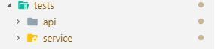

*Figure 5-7: Test directory structure*

Unit tests focus on individual functions in class and will be created simply as below

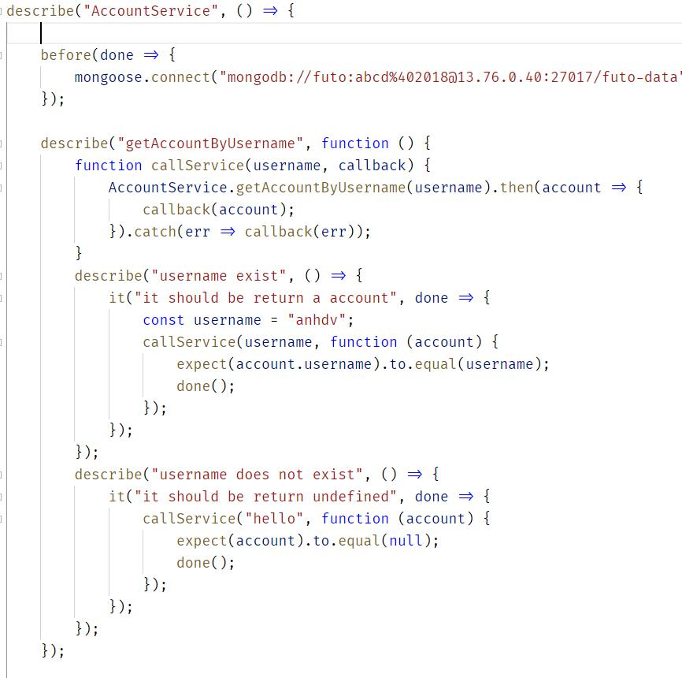

*Figure 5-8: Unit test case sample*

*This getAccountByUsername function is used to retrieve an account info.*

*Test case will check if the getAccountByUsername handles the case that user does not exist.*

API tests focus on individual API and use SuperTest to test these API based on the business rule.

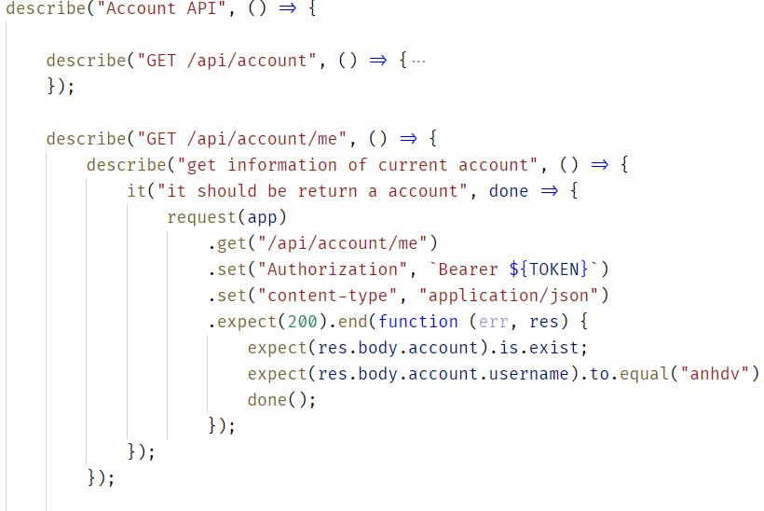

*Figure 5-9: API test case sample*

*Test behavior of HTTP method which is used to get account information with correct token*

Test case are executed automatically by using Nyc (in command line).

*Figure 5-10: Configure script in* ***package.json*** *file*

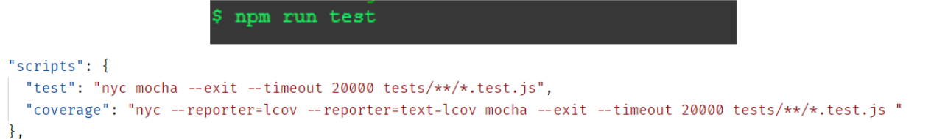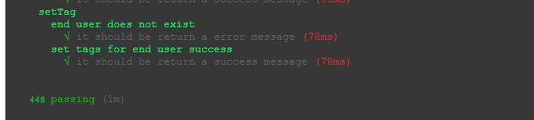

*Figure 5-11: Run test by npm command*

By using Nyc combining with Istanbul, test report can be exported in 2 formats: static html and console table.

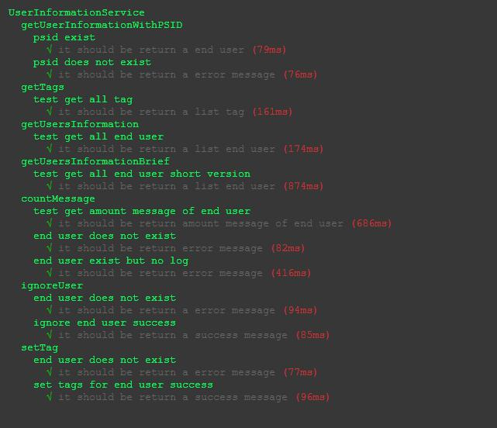

*Figure 5-12:Sample Unit test report*

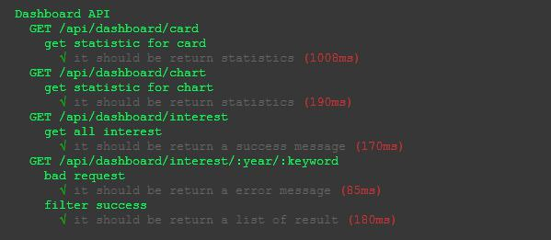

*Figure 5-13: Sample API test report*

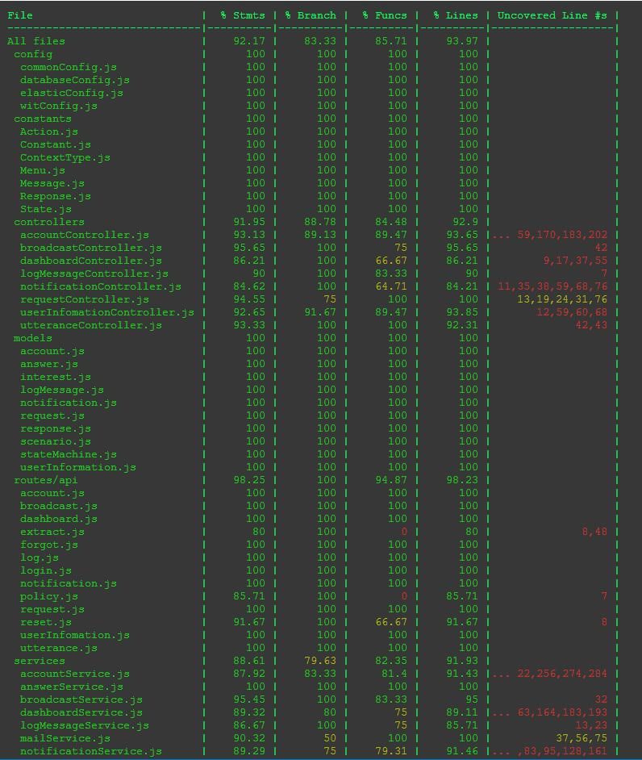

*Figure 5-14: Istanbul console test coverage report*

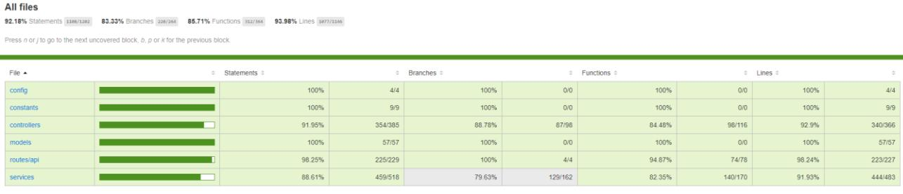

*Figure 5-15: Istanbul static html test coverage report*

**System testing**



Detailed Test cases will be described in ***ASC_TestCase.xlsx*** file.

As a standard definition, ASC Project defines that a test case is:

A set of test data and test programs (test scripts) and their expected results. A test case validates one or more system requirements and generates a pass or fail.

A good test case should follow two basic aspects, the Contents and the Style. Test cases for

functional testing are derived from the target of test's use cases Test cases should be developed for each use case scenario. The use case scenarios are identified by describing the paths through the use case that traverse the basic flow and alternate flows start to finish through the use case.

By using good automation test, ASC Project System testing will not focus on common logic of system like length of text but focus on behavior of website and aims to validate that all software module dependencies are functionally correct and that data integrity is maintained between separate modules for the entire solution.

**Acceptance testing**



Acceptance Testing is a level of the software testing process where a system is tested for acceptability. The purpose of this test is to evaluate the system’s compliance with the business requirements and assess whether it is acceptable for delivery. But our project will use the Checklists as a substitute for Acceptance testing.

The content of the Checklist is shown in the table below

|  |  |  |  |
| --- | --- | --- | --- |
| **ID** | **Checklists** | **Yes** | **No** |
|  | **General** |  |  |
| CL-001 | Text on all pages for spelling and grammatical errors. | √ |  |
| CL-002 | Functionality of buttons available on all pages. | √ |  |
| CL-003 | All mandatory fields are validated. | √ |  |
| CL-004 | Validation error messages are displayed properly below the field. | √ |  |
| CL-005 | All error messages are displayed in red color. | √ |  |
| CL-006 | Delete functionality for any record on page are asked for confirmation. | √ |  |
| CL-007 | All numeric values are formatted properly. | √ |  |
| CL-008 | Unavailable pages are redirected to not found page. | √ |  |

**GUI and Usability**

|  |  |  |  |
| --- | --- | --- | --- |
| CL-009 | Screens are designed follow project standards. | √ |  |
| CL-010 | The screen is well organized. | √ |  |
| CL-011 | All fields on page (e.g. text box, radio options, dropdown lists) should | √ |  |
| be aligned properly. |  |
|  |  |  |
| CL-012 | Information is arranged symmetrically with adequate spacing between | √ |  |
| components. |  |
|  |  |  |
| CL-013 | The most important fields are located where they are easy to see. | √ |  |
| CL-014 | Information is presented in the order that the user needs it. | √ |  |
| CL-015 | Do not use slang, acronyms, and abbreviations. | √ |  |
| CL-016 | Icons and images are designed impression and copyright. | √ |  |
| CL-017 | Font size, style and color for headline, description test, labels, infield | √ |  |
| data, and grid information standard as specified in SRS. |  |
|  |  |  |
| CL-018 | The static text is clear, concise, and meaningful. | √ |  |
| CL-019 | A list view is used to allow a collection of items that are on a single | √ |  |
| hierarchical level. |  |
|  |  |  |
| CL-020 | A tree view is used to allow a collection of items to be displayed and | √ |  |
| manipulated within varying hierarchical levels. |  |
|  |  |  |
| CL-021 | Pop-up menus are provided for the user to access information about an | √ |  |
| object's properties or perform specific tasks on the object. |  |
|  |  |  |
| CL-022 | Command buttons are used to trigger application processes. | √ |  |

|  |  |  |  |
| --- | --- | --- | --- |
| CL-023 | Toggle buttons are used to show independent on/off choices. | √ |  |
| CL-024 | System displays notification message when trouble or error occurs. | √ |  |
| CL-025 | Quick reply is used to show choices. | √ |  |
| CL-026 | Bubble splitting in a long message. | √ |  |
| CL-027 | Typing indicator is used to make real. | √ |  |
|  | **Database** |  |  |
| CL-028 | Correct data is saved in database upon successful page submit. | √ |  |
| CL-029 | Columns does not accept null values. | √ |  |
| CL-030 | Data should be stored in single or multiple collections based on design. | √ |  |
| CL-031 | Input data is not truncated. | √ |  |
| CL-032 | Input numeric fields with minimum, maximum, and float values. | √ |  |
| CL-033 | Drop down list are saved correctly in database. | √ |  |
| CL-034 | Database fields are designed with correct data type and data length. | √ |  |
|  | **Performance** |  |  |
| CL-035 | Real time connection | √ |  |
| CL-036 | Page load time is within acceptable range. | √ |  |
| CL-037 | Page load on slow connections. | √ |  |
| CL-038 | Response time for any action under light, normal, moderate and heavy | √ |  |
| load conditions. |  |
|  |  |  |
| CL-039 | Database query execution time. | √ |  |
| CL-040 | Load testing of application. | √ |  |
|  | **Security** |  |  |
| CL-041 | Test password security and password policy enforcement. | √ |  |
|  | *Table 5-3: Check list table* |  |  |

**Defect Log**



ASC project used to manager tasks and defects.

PM created ASC project in Backlog and add other members’ email to allow the team take part in activities: control bugs, fix bugs, re-test bugs and close bug. Bug will be logged by tester or developer in develop progress.

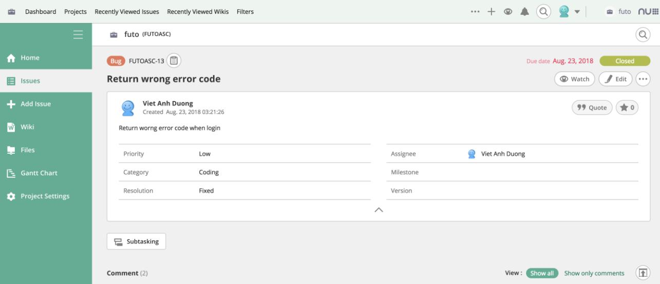

*Figure 5-16: Control task and bug with Backlog*

**5.4** **Test Report**

**Automation test case report**



The contents of the Automation Test Case Report are shown in the table below:

|  |  |  |  |  |  |
| --- | --- | --- | --- | --- | --- |
| **Type of** | **Test Case** | **Pass** | **Fail** | **Not** | **Number** |
| **test case** |  |  |  | **available** | **of Test** |
|  |  |  |  |  | **Case** |
| API Test - | Get all account | 2 | 0 | 0 | 2 |
| Account |  |  |  |  |  |
| Get information of current | 3 | 0 | 0 | 3 |
|  |
|  | account |  |  |  |  |
|  | Change password | 4 | 0 | 0 | 4 |
|  |  |  |  |  |  |
|  | Update profile | 3 | 0 | 0 | 3 |
|  |  |  |  |  |  |
|  | Create account | 4 | 0 | 0 | 4 |
|  |  |  |  |  |  |
|  | Update account | 5 | 0 | 0 | 5 |
|  |  |  |  |  |  |
|  | Delete account | 5 | 0 | 0 | 5 |
|  |  |  |  |  |  |
|  | Total | 26 | 0 | 0 | 26 |
|  |  |  |  |  |  |
| API Test - | Send message with psids | 3 | 0 | 0 | 3 |
| Broadcast |  |  |  |  |  |
| Send message with tags | 3 | 0 | 0 | 3 |
|  |
|  |  |  |  |  |  |
|  | Total | 6 | 0 | 0 | 6 |
|  |  |  |  |  |  |
| API Test - | Get statistic for card | 1 | 0 | 0 | 1 |
| Dashboard |  |  |  |  |  |
| Get statistic for chart | 1 | 0 | 0 | 1 |
|  |
|  |  |  |  |  |  |
|  | Get all interest | 1 | 0 | 0 | 1 |
|  |  |  |  |  |  |
|  | Filter interest | 2 | 0 | 0 | 2 |
|  |  |  |  |  |  |
|  | Total | 5 | 0 | 0 | 5 |
|  |  |  |  |  |  |
| API Test – | Forgot password | 3 | 0 | 0 | 3 |
| Forgot |  |  |  |  |  |
| Total | 3 | 0 | 0 | 3 |
| password |
|  |  |  |  |  |
|  |  |  |  |  |  |
|  | Get all log message | 1 | 0 | 0 | 1 |
|  |  |  |  |  |  |
| API Test – | Get log message by id | 2 | 0 | 0 | 2 |
|  |  |  |  |  |
| Log |  |  |  |  |  |
| Total | 3 | 0 | 0 | 3 |
| message |
|  |  |  |  |  |
| API Test - | Login | 5 | 0 | 0 | 5 |
| Login |  |  |  |  |  |
| Total | 5 | 0 | 0 | 5 |
|  |
|  |  |  |  |  |  |
| API Test – | Get all notification of current | 1 | 0 | 0 | 1 |
| Notification | account |  |  |  |  |
|  | Seen all notification | 1 | 0 | 0 | 1 |
|  |  |  |  |  |  |
|  | Seen a notification | 1 | 0 | 0 | 1 |
|  |  |  |  |  |  |
|  | Send a notification | 4 | 0 | 0 | 4 |
|  |  |  |  |  |  |
|  | Send a notification with role | 2 | 0 | 0 | 2 |
|  |  |  |  |  |  |

|  |  |  |  |  |  |
| --- | --- | --- | --- | --- | --- |
|  | Total | 9 | 0 | 0 | 9 |
|  |  |  |  |  |  |
| API Test – | Filter request | 2 | 0 | 0 | 2 |
| Request |  |  |  |  |  |
| Get all request answer | 1 | 0 | 0 | 1 |
|  |
|  |  |  |  |  |  |
|  | Create request answer | 3 | 0 | 0 | 3 |
|  |  |  |  |  |  |
|  | Process request answer | 4 | 0 | 0 | 4 |
|  |  |  |  |  |  |
|  | Cancel request answer | 2 | 0 | 0 | 2 |
|  |  |  |  |  |  |
|  | Total | 12 | 0 | 0 | 12 |
|  |  |  |  |  |  |
| API Test – | Verify token | 3 | 0 | 0 | 3 |
| Reset |  |  |  |  |  |
| Reset password | 2 | 0 | 0 | 2 |
| password |
|  |  |  |  |  |
|  |  |  |  |  |  |
|  | Total | 5 | 0 | 0 | 5 |
|  |  |  |  |  |  |
| API Test – | Get all end user information | 1 | 0 | 0 | 1 |
| User |  |  |  |  |  |
| Export all end user information | 1 | 0 | 0 | 1 |
| information |
|  |  |  |  |  |
|  |  |  |  |  |  |
|  | Get information of end user by | 2 | 0 | 0 | 2 |
|  | id |  |  |  |  |
|  | Get all tags | 1 | 0 | 0 | 1 |
|  |  |  |  |  |  |
|  | Amount message of end user | 2 | 0 | 0 | 2 |
|  |  |  |  |  |  |
|  | Ignore end user | 3 | 0 | 0 | 3 |
|  |  |  |  |  |  |
|  | Add tag for end user | 3 | 0 | 0 | 3 |
|  |  |  |  |  |  |
|  | Total | 13 | 0 | 0 | 13 |
|  |  |  |  |  |  |
| API Test – | Get all utterance | 1 | 0 | 0 | 1 |
| Utterance |  |  |  |  |  |
| Get answer by id | 2 | 0 | 0 | 2 |
|  |
|  |  |  |  |  |  |
|  | Total | 3 | 0 | 0 | 3 |
|  |  |  |  |  |  |
| API Test - | Chat | 9 | 0 | 0 | 9 |
| Bot |  |  |  |  |  |
|  | Get account by username | 2 | 0 | 0 | 2 |
|  |  |  |  |  |  |
| Unit Test - | Create account | 3 | 0 | 0 | 3 |
|  |  |  |  |  |
| Account |  |  |  |  |  |
| Update account | 5 | 0 | 0 | 5 |
|  |
|  |  |  |  |  |  |
|  | Update profile | 4 | 0 | 0 | 4 |
|  |  |  |  |  |  |
|  | Login | 4 | 0 | 0 | 4 |
|  |  |  |  |  |  |
|  | Forgot password | 3 | 0 | 0 | 3 |
|  |  |  |  |  |  |
|  | Verify token | 2 | 0 | 0 | 2 |
|  |  |  |  |  |  |
|  | Reset password | 3 | 0 | 0 | 3 |
|  |  |  |  |  |  |

|  |  |  |  |  |  |
| --- | --- | --- | --- | --- | --- |
|  | Total | 23 | 0 | 0 | 23 |
|  |  |  |  |  |  |
| Unit Test – | Get answer by id | 3 | 0 | 0 | 3 |
| Answer |  |  |  |  |  |
| Total | 3 | 0 | 0 | 3 |
|  |
|  |  |  |  |  |  |
| Unit Test – | Send message with psids | 1 | 0 | 0 | 1 |
| Broadcast |  |  |  |  |  |
| Send message with tags | 2 | 0 | 0 | 2 |
|  |
|  |  |  |  |  |  |
|  | Total | 3 | 0 | 0 | 3 |
|  |  |  |  |  |  |
| Unit Test – | Get statistic for card | 1 | 0 | 0 | 1 |
| Dashboard |  |  |  |  |  |
| Get statistic for chart | 1 | 0 | 0 | 1 |
|  |
|  |  |  |  |  |  |
|  | Process entities | 2 | 0 | 0 | 2 |
|  |  |  |  |  |  |
|  | Get all interest | 1 | 0 | 0 | 1 |
|  |  |  |  |  |  |
|  | Filter interest | 2 | 0 | 0 | 2 |
|  |  |  |  |  |  |
|  | Total | 7 | 0 | 0 | 7 |
|  |  |  |  |  |  |
| Unit Test – | Get log message by psid | 2 | 0 | 0 | 2 |
| Log |  |  |  |  |  |
| Get logs | 1 | 0 | 0 | 1 |
| message |
|  |  |  |  |  |
|  |  |  |  |  |  |
|  | Total | 3 | 0 | 0 | 3 |
|  |  |  |  |  |  |
| Unit Test – | Send a notification | 2 | 0 | 0 | 2 |
| Notification |  |  |  |  |  |
| Seen a notification | 1 | 0 | 0 | 1 |
|  |
|  |  |  |  |  |  |
|  | Seen all notification | 1 | 0 | 0 | 1 |
|  |  |  |  |  |  |
|  | Get notifications | 1 | 0 | 0 | 1 |
|  |  |  |  |  |  |
|  | Send notification with Role | 1 | 0 | 0 | 1 |
|  |  |  |  |  |  |
|  | Send notification for all account | 1 | 0 | 0 | 1 |
|  |  |  |  |  |  |
|  | Total | 7 | 0 | 0 | 7 |
|  |  |  |  |  |  |
| Unit Test – | Create request | 2 | 0 | 0 | 2 |
| Request |  |  |  |  |  |
| Update request | 5 | 0 | 0 | 5 |
|  |
|  |  |  |  |  |  |
|  | Total | 7 | 0 | 0 | 7 |
|  |  |  |  |  |  |
| Unit Test – | Get end user information by | 5 | 0 | 0 | 5 |
| User | Psid |  |  |  |  |
| information | Get tags | 1 | 0 | 0 | 1 |
|  |  |  |  |  |  |
|  | Get end users information | 1 | 0 | 0 | 1 |
|  |  |  |  |  |  |
|  | Get end users information brief | 1 | 0 | 0 | 1 |
|  |  |  |  |  |  |
|  | Count message | 3 | 0 | 0 | 3 |
|  |  |  |  |  |  |
|  | Ignore end user | 2 | 0 | 0 | 2 |
|  |  |  |  |  |  |

|  |  |  |  |  |  |
| --- | --- | --- | --- | --- | --- |
|  | Set tag | 2 | 0 | 0 | 2 |
|  |  |  |  |  |  |
|  | Total | 15 | 0 | 0 | 15 |
|  |  |  |  |  |  |
| Unit Test - | Chat | 265 | 13 | 0 | 278 |
| Bot |  |  |  |  |  |
| Total of Test Case | | 428 | 13 | 0 | 441 |
|  |  |  |  |  |  |

*Table 5-4: Automation test case report*

**Automation test report**



Automation test is an integral part of development process. So that, there are 2 phases as 2 phases of Iterative and Incremental Software Process Model.

|  |  |  |  |  |  |
| --- | --- | --- | --- | --- | --- |
| **Test case** | **Phase 1** | | **Phase 2** | | **Final** |
| Pass | Fail | Pass | Fail |
|  |  |
| API Test – Account | 11 | 0 | 15 | 0 | 26 |
| API Test – Broadcast | 2 | 0 | 4 | 0 | 6 |
| API Test – Dashboard | 0 | 0 | 4 | 0 | 5 |
| API Test – Forgot Password | 1 | 0 | 2 | 0 | 3 |
| API Test – Log message | 1 | 0 | 2 | 0 | 3 |
| API Test – Login | 2 | 0 | 3 | 0 | 5 |
| API Test – Notification | 3 | 0 | 6 | 0 | 9 |
| API Test – Request | 5 | 0 | 7 | 0 | 12 |
| API Test – Reset password | 2 | 0 | 3 | 0 | 5 |
| API Test – User information | 6 | 0 | 7 | 0 | 13 |
| API Test – Utterance | 1 | 0 | 2 | 0 | 3 |
| API Test - Bot | 1 | 0 | 8 | 0 | 9 |
| Unit Test – Account | 10 | 0 | 13 | 0 | 23 |
| Unit Test – Answer | 1 | 0 | 2 | 0 | 3 |
| Unit Test – Broadcast | 1 | 0 | 2 | 0 | 3 |
| Unit Test – Dashboard | 2 | 0 | 5 | 0 | 7 |
| Unit Test – Log message | 1 | 0 | 2 | 0 | 3 |
| Unit Test – Notification | 2 | 0 | 5 | 0 | 7 |
| Unit Test – Request | 1 | 0 | 6 | 0 | 7 |
| Unit Test – User Information | 3 | 0 | 12 | 0 | 15 |
| Unit Test - Bot | 73 | 13 | 192 | 0 | 278 |
| Total all test case | 131 | 13 | 297 | 0 | 441 |

*Table 5-5: Automation test report*

|  |  |  |  |  |  |  |
| --- | --- | --- | --- | --- | --- | --- |
|  | **Phase** |  |  | **Coverage** | |  |
|  |  | Statements | Branches | Functions | Lines |
|  |  |  |
| **Phase 1** |  |  | 89.01% | 80.23% | 86.31% | 92.07% |
| **Phase 2** |  |  | 92.18% | 83.33% | 85.71% | 93.98% |
|  |  | *Table 5-6: Automation test coverage report* | | | |  |

**System test case report**



The contents of the System Test Case Report are shown in the table below:

|  |  |  |  |  |  |
| --- | --- | --- | --- | --- | --- |
| **Module** | **Test Case** | **Pass** | **Fail** | **Not** | **Number** |
|  |  |  |  | **available** | **of Test** |
|  |  |  |  |  | **Case** |
| Authorization | View Login form | 1 | 1 | 0 | 2 |
|  |  |  |  |  |
|  |  |  |  |  |  |
|  | Login by ASC account | 3 | 1 | 0 | 4 |
|  |  |  |  |  |
|  |  |  |  |  |  |
|  | Logout | 1 | 0 | 0 | 1 |
|  |  |  |  |  |
|  |  |  |  |  |  |
|  | Reset password | 4 | 1 | 0 | 5 |
|  |  |  |  |  |
|  |  |  |  |  |  |
|  | Deactivated user logins | 1 | 0 | 0 | 1 |
|  |  |  |  |  |
|  |  |  |  |  |  |
|  | **Total** | **10** | **3** | **0** | **13** |
|  |  |  |  |  |  |
| Broadcast | Send message | 3 | 1 | 0 | 4 |
|  |  |  |  |  |  |
|  | Send message with tags | 3 | 1 | 0 | 4 |
|  |  |  |  |  |  |
|  | **Total** | **6** | **2** | **0** | **8** |
|  |  |  |  |  |  |
| Staff | View statistics | 6 | 3 | 0 | 9 |
|  |  |  |  |  |
|  |  |  |  |  |  |
|  | View profile | 1 | 0 | 0 | 1 |
|  |  |  |  |  |
|  |  |  |  |  |  |
|  | Update profile | 3 | 0 | 0 | 3 |
|  |  |  |  |  |
|  |  |  |  |  |  |
|  | View account list | 1 | 0 | 0 | 1 |
|  |  |  |  |  |
|  |  |  |  |  |  |
|  | Change password | 3 | 1 | 0 | 4 |
|  |  |  |  |  |
|  |  |  |  |  |  |
|  | Edit answer | 3 | 1 | 0 | 4 |
|  |  |  |  |  |
|  |  |  |  |  |  |
|  | View editing answer request | 1 | 0 | 0 | 1 |
|  |  |  |  |  |
|  |  |  |  |  |  |
|  | View account detail | 1 | 0 | 0 | 1 |
|  |  |  |  |  |
|  |  |  |  |  |  |
|  | **Total** | **19** | **5** | **0** | **24** |
|  |  |  |  |  |  |
|  | View Facebook count | 1 | 0 | 0 | 1 |
|  |  |  |  |  |
|  |  |  |  |  |  |
| Log message | View chat logs | 3 | 0 | 0 | 3 |
|  |  |  |  |  |
|  |  |  |  |  |  |
|  | View Fb account infor | 1 | 0 | 0 | 1 |
|  |  |  |  |  |
|  |  |  |  |  |  |
|  | View providing infor | 1 | 0 | 0 | 1 |
|  |  |  |  |  |
|  |  |  |  |  |  |
|  | Add tags | 2 | 1 | 0 | 3 |
|  |  |  |  |  |
|  |  |  |  |  |  |
|  | Remove tags | 1 | 1 | 0 | 2 |
|  |  |  |  |  |
|  |  |  |  |  |  |
|  | Export end user list | 3 | 1 | 0 | 4 |
|  |  |  |  |  |
|  |  |  |  |  |  |
|  | Load more message | 1 | 0 | 0 | 1 |
|  |  |  |  |  |
|  |  |  |  |  |  |
|  | **Total** | **13** | **3** | **0** | **16** |
|  |  |  |  |  |  |
| Notification | Receive notification | 5 | 2 | 0 | 7 |
|  |  |  |  |  |
|  |  |  |  |  |  |
|  | Open event on notification | 1 | 0 | 0 | 1 |
|  |  |  |  |  |
|  |  |  |  |  |  |

|  |  |  |  |  |  |
| --- | --- | --- | --- | --- | --- |
|  | Load more notification | 1 | 0 | 0 | 1 |
|  |  |  |  |  |
|  |  |  |  |  |  |
|  | View notification in details | 6 | 2 | 0 | 8 |
|  |  |  |  |  |
|  |  |  |  |  |  |
|  | **Total** | **13** | **4** | **0** | **17** |
|  |  |  |  |  |  |
| Request | Filter request | 1 | 0 | 0 | 1 |
|  |  |  |  |  |  |
|  | View request | 1 | 0 | 0 | 1 |
|  |  |  |  |  |  |
|  | Create request | 3 | 1 | 0 | 4 |
|  |  |  |  |  |  |
|  | Reject request | 1 | 1 | 0 | 2 |
|  |  |  |  |  |  |
|  | Accept request | 1 | 1 | 0 | 2 |
|  |  |  |  |  |  |
|  | **Total** | **7** | **3** | **0** | **10** |
|  |  |  |  |  |  |
| Search | Search account by full name | 2 | 0 | 0 | 2 |
|  |  |
|  |  |  |  |  |  |
|  | Search account by username | 2 | 0 | 0 | 2 |
|  |  |
|  |  |  |  |  |  |
|  | Search response | 2 | 1 | 0 | 3 |
|  |  |
|  |  |  |  |  |  |
|  | Filter account by role | 1 | 0 | 0 | 1 |
|  |  |
|  |  |  |  |  |  |
|  | Filter account by status | 1 | 0 | 0 | 1 |
|  |  |
|  |  |  |  |  |  |
|  | Filter response | 1 | 1 | 0 | 3 |
|  |  |
|  |  |  |  |  |  |
|  | Total | **9** | **3** | **0** | **12** |
|  |  |  |  |  |  |
| Admin | Create account | 3 | 1 | 0 | 4 |
|  |  |  |  |  |
|  |  |  |  |  |  |
|  | Delete account | 1 | 1 | 0 | 2 |
|  |  |  |  |  |
|  |  |  |  |  |  |
|  | Staff view | 2 | 0 | 0 | 2 |
|  |  |  |  |  |
|  |  |  |  |  |  |
|  | Change account status | 1 | 0 | 0 | 1 |
|  |  |  |  |  |
|  |  |  |  |  |  |
|  | Logout | 1 | 0 | 0 | 1 |
|  |  |  |  |  |
|  |  |  |  |  |  |
|  | **Total** | **8** | **2** | **0** | **10** |
|  |  |  |  |  |  |
| Bot | **Training** | **702** | **126** | **0** | **828** |
|  |  |  |  |  |  |
| **Total of Test Case** | | **800** | **141** | **0** | **941** |
|  |  |  |  |  |  |

*Table 5-7: System test case report*

Test case list:



|  |  |  |  |  |  |  |  |  |  |  |  |  |  |  |  |
| --- | --- | --- | --- | --- | --- | --- | --- | --- | --- | --- | --- | --- | --- | --- | --- |
|  | **ID** |  |  | **Test Case** |  |  | **Test Case Procedure** |  |  | **Expected Output** |  |  | **Status** |  |  |
|  |  |  | **Description** |  |  |  |  |  |  |  |  |
|  |  |  |  |  |  |  |  |  |  |  |  |  |  |  |
|  |  |  |  |  |  |  |  |  |  |  |  |  |  |  |  |

**View Login & Forget Password Form**

|  |  |  |  |  |  |  |  |
| --- | --- | --- | --- | --- | --- | --- | --- |
|  |  |  |  | 1. | Homepage is displayed |  |  |
|  |  |  |  | 2. | System displays with the |  |  |
|  |  |  |  | following information: | |  |  |
|  |  |  |  | - Title: "Hệ thống quản lý ứng | |  |  |
|  |  | 1. | Access https://futo- | dụng Trợ lý ảo" | |  |  |
|  |  | - Account name field: "TÊN | |  |  |
| [Staff- |  | dashboard.luzotech.com | |  |  |
| View Login | ĐĂNG NHẬP" | | Pass | |
| 1] | 2. | On Screen HomePage, |
|  | - Password field: "MẬT KHẨU" | |  |  |
|  |  | click "Đăng nhập" button | |  |  |
|  |  | - Checkbox: "Nhớ tên đăng nhập | |  |  |
|  |  |  |  |  |  |
|  |  |  |  | lần sau" | |  |  |
|  |  |  |  | - Forget Password: "Quên mật | |  |  |
|  |  |  |  | khẩu?" | |  |  |
|  |  |  |  | - Login button: "Đăng nhập" | |  |  |
|  |  |  |  | 1. | Forget Password Page is |  |  |
|  |  | 1. | On Screen HomePage, | displayed. | |  |  |
|  |  | click to access "Quên mật | | 2. | System displays with the |  |  |
| [Staff- | View Forget | khẩu?" | | following information: | | Pass | |
| 2] | Password | 2. | On Screen | - Title: "Quên mật khẩu?" | |
|  |  |
|  |  | ForgetPassPage, click "Xin | | - Description field. | |  |  |
|  |  | cấp lại mật khẩu" button | | - Email field | |  |  |
|  |  |  |  | - Button: "Xin cấp lại mật khẩu" | |  |  |
|  |  |  | |  |  |  |  |
| **Login & Forget Pasword by ASC account** | | | |  |  |  |  |
|  |  |  |  |  |  |  |  |
| [Staff- | Login by | 1. | Enter invalid account | 1. | Login Page is displayed. |  |  |
| invalid | 2. | Enter valid pasword | 2. | System display an error alert | Pass | |
| 3] |
| account | 3. | Click "Đăng nhập" button | message: "Đăng nhập thất bại". | |  |  |
|  |  |  |
|  |  |  |  |  |  |  |  |
| [Staff- | Login by | 1. | Do not fill account | 1. | Login Page is displayed. |  |  |
| blank | 2. | Enter valid pasword | 2. | System display an error alert | Pass | |
| 4] |
| account | 3. | Click "Đăng nhập" button | message: "Đăng nhập thất bại". | |  |  |
|  |  |  |
|  |  |  |  |  |  |  |  |
| [Staff- | Login by | 1. | Enter valid account | 1. | Login Page is displayed. |  |  |
| invalid | 2. | Enter invalid pasword | 2. | System display an error alert | Pass | |
| 5] |
| password | 3. | Click "Đăng nhập" button | message: "Đăng nhập thất bại". | |  |  |
|  |  |  |
|  |  |  |  |  |  |  |  |
| [Staff- | Login by | 1. | Enter valid account | 1. | Login Page is displayed. |  |  |
| blank | 2. | Do not fill pasword | 2. | System display an error alert | Pass | |
| 6] |
| password | 3. | Click "Đăng nhập" button | message: "Đăng nhập thất bại". | |  |  |
|  |  |  |
|  |  |  |  |  |  |  |  |
|  | Login by | 1. | Enter valid account | 1. | Login Page is displayed. |  |  |
| [Staff- | valid email | 2. | No error alert message is |  |  |
| 2. | Enter valid pasword | Pass | |
| 7] | and | displayed. | |
| 3. | Click "Đăng nhập" button |  |  |
|  | password | 3. | Login successfully |  |  |
|  |  |  |  |  |
|  |  |  |  |  |  |  |  |

|  |  |  |  |  |  |
| --- | --- | --- | --- | --- | --- |
|  |  |  |  | 1. Forget Password Page is |  |
|  | Forget | 1. | Enter invalid email | displayed. |  |
| [Staff- | 2. System display an error alert |  |
| password by | 2. | Click "Xin cấp lại mật | Pass |
| 8] | message: "Please input an '@' in |
| invalid email | khẩu" button | |  |
|  | the email address. Invalid email |  |
|  |  |  |  |  |
|  |  |  |  | is missing an '@'. |  |
|  |  |  |  |  |  |
| [Staff- | Forget | 1. | Enter valid email | 1. Forget Password Page is |  |
| password by | 2. | Click "Xin cấp lại mật | displayed. | Pass |
| 9] |
| valid email | khẩu" button | | 2. Successfully |  |
|  |  |
|  |  |  |  |  |  |

**View Dashboard after login**

|  |  |  |  |  |
| --- | --- | --- | --- | --- |
|  |  |  | 1. Statistics Pgae is displayed. |  |
|  |  |  | 2. System displays with the |  |
|  |  |  | following information: |  |
|  |  |  | - 4 blocks information: "Nguời |  |
|  |  | 1. Login Successfully | dùng, Nguời mới hỏi trong hôm |  |
| [Staff- | View | nay, Nguời dùng cũ hỏi trong |  |
| 2. On Screen "Bảng tin" is | Pass |
| 10] | Statistics | hôm nay, Nguời đã cung cấp |
| statistics. |  |
|  |  | thông tin cá nhân". |  |
|  |  |  |  |
|  |  |  | - 2 charts information: "Số luợng |  |
|  |  |  | nguời đánh giá Bot (bar chart), |  |
|  |  |  | Các ngành đang đuợc quan tâm |  |
|  |  |  | (pie chart)". |  |
|  |  |  | 1. Personal Page is displayed. |  |
|  |  |  | 2. System displays with the |  |
|  |  |  | following information: |  |
|  |  | 1. On the right navigation | - Thông tin tài khoản card: "Tên |  |
| [Staff- |  | tài khoản, Vai trò". |  |
| View Profile | bar, click to avatar. | Pass |
| 11] | - Thông tin liên hệ card: "Họ và |
|  | 2. Click to "Trang cá nhân" |  |
|  |  | tên, Email, Số điện thoại, Địa |  |
|  |  |  |  |
|  |  |  | chỉ". |  |
|  |  |  | 3. "Lưu thông tin cá nhân" |  |
|  |  |  | button |  |
|  |  |  | 1. Personal Page is displayed. |  |
|  |  | 1. On the right navigation | 2. System displays with the |  |
|  | Update | bar, click to avatar. | following information: |  |
| [Staff- | 2. Click to "Trang cá nhân" | - Can be change information in |  |
| Profile by | Pass |
| 12] | 3. Edit/ change valid | "Thông tin liên hệ" card. |
| valid info |  |
|  | information for "Thông tin | 43. System display an alert |  |
|  |  |  |
|  |  | liên hệ" card. | message: "Cập nhật hồ sơ thành |  |
|  |  |  | công". |  |
|  |  |  |  |  |

|  |  |  |  |  |  |
| --- | --- | --- | --- | --- | --- |
|  |  |  |  | 1. Personal Page is displayed. |  |
|  |  | 1. | On the right navigation | 2. System displays with the |  |
|  |  | bar, click to avatar. | | following information: |  |
|  | Update | 2. | Click to "Trang cá nhân" | - Can be change information in |  |
| [Staff- | 3. | Edit/ change invalid | "Thông tin liên hệ" card. |  |
| Profile by | Fail |
| 12] | information for "Thông tin | | 3. No error message for field |
| invalid info |  |
|  | liên hệ" card. | | information |  |
|  |  |  |
|  |  | 4. | Click "Lưu thông tin cá | 3. System display an alert |  |
|  |  | nhân button. | | message: "Cập nhật hồ sơ |  |
|  |  |  |  | Không thành công". |  |
|  |  |  |  |  |  |
|  |  |  |  | 1. Change Password Page is |  |
|  |  |  |  | displayed. |  |
|  |  |  |  | 2. System display with the |  |
|  |  | 1. | On the right navigation | following information: |  |
|  |  | - Title page |  |
| [Staff- | Change | bar, click to avatar. | |  |
| - Password field: "Mật khẩu cũ". | Pass |
| 13] | password | 2. | Click to "Thay đổi mật |
| - Password field: "Mật khẩu |  |
|  |  | khẩu" | |  |
|  |  | mới". |  |
|  |  |  |  |  |
|  |  |  |  | - Password field: "Nhập lại mật |  |
|  |  |  |  | khẩu". |  |
|  |  |  |  | 3. "Đổi mật khẩu" button |  |
|  | Change | 1. | On the right navigation |  |  |
|  | bar, click to avatar. | |  |  |
|  | password by |  |  |
|  | 2. | Click to "Thay đổi mật |  |  |
|  | invalid old |  |  |
|  | khẩu" | | 1. Change Password Page is |  |
|  | password, |  |
| [Staff- | 3. | Enter invalid old | displayed. |  |
| valid new | Pass |
| 14] | password | | 2. System display an alert |
| password, |  |
|  | 4. | Enter valid new password | message: "Mật khẩu chưa khớp". |  |
|  | valid |  |
|  | 5. | Enter valid confirm |  |  |
|  | confirm new |  |  |
|  | password | |  |  |
|  | password |  |  |
|  | 6. | Click to "Đổi mật khẩu". |  |  |
|  |  |  |  |
|  | Change | 1. | On the right navigation |  |  |
|  | bar, click to avatar. | |  |  |
|  | password by |  |  |
|  | 2. | Click to "Thay đổi mật |  |  |
|  | valid old |  |  |
|  | khẩu" | | 1. Change Password Page is |  |
|  | password, |  |
| [Staff- | 3. | Enter valid old password | displayed. |  |
| invalid new | Pass |
| 16] | 4. | Enter invalid new | 2. System display an error alert |
| password, |  |
|  | password | | message: "Mật khẩu chưa khớp". |  |
|  | invalid |  |
|  | 5. | Enter invalid confirm |  |  |
|  | confirm new |  |  |
|  | new password | |  |  |
|  | password |  |  |
|  | 6. | Click to "Đổi mật khẩu". |  |  |
|  |  |  |  |
|  | Change | 1. | On the right navigation |  |  |
|  | password by | bar, click to avatar. | |  |  |
|  | valid old | 2. | Click to "Thay đổi mật | 1. Change Password Page is |  |
| [Staff- | password, | khẩu" | | displayed. |  |
| valid new | 3. | Enter valid old password | 2. System display an error alert | Fail |
| 17] |
| password, | 4. | Enter valid new password | message: "Thay đổi mật khẩu |  |
|  |  |
|  | valid | 5. | Enter valid confirm new | Thất bại". |  |
|  | confirm new | password | |  |  |
|  | password | 6. | Click to "Đổi mật khẩu". |  |  |

|  |  |  |  |  |  |  |
| --- | --- | --- | --- | --- | --- | --- |
|  | Change | 1. | On the right navigation |  |  |  |
|  | password by | bar, click to avatar. | |  |  |  |
|  | blank old | 2. | Click to "Thay đổi mật | 1. | Change Password Page is |  |
| [Staff- | pasword, | khẩu" | | displayed. | |  |
| blank new | 3. | Do not fill old password | 2. | System display an error | Pass |
| 18] |
| password, | 4. | Do not fill new password | message on field: "Please fill out | |  |
|  |  |
|  | blank | 5. | Do not fill confirm new | this field". | |  |
|  | confirm new | password | |  |  |  |
|  | password | 6. | Click to "Đổi mật khẩu". |  |  |  |
|  |  |  |  | 1. | Show all account list on the |  |
|  |  |  |  | system. | |  |
|  |  |  |  | 2. | System display with the |  |
|  |  |  |  | following information: | |  |
|  |  |  |  | - Table account list: "STT, Tài | |  |
|  |  |  |  | khoản, Họ và Tên, Vai trò, | |  |
| [Staff- | View | On the side bar, click to | | Trạng thái, Hành động". | |  |
| 3. | Dropdown list "Vai trò" is | Pass |
| 19] | Account list | "Tất cả tài khoản" | |
| displayed. | |  |
|  |  |  |  |  |
|  |  |  |  | 4. Dropdown list "Trạng thái" is | |  |
|  |  |  |  | displayed. | |  |
|  |  |  |  | 5. | "Hoạt động" button |  |
|  |  |  |  | 6. | "Ngừng hoạt động" button |  |
|  |  |  |  | 7. | "Xem" button |  |
|  |  |  |  | 8. | "Xoá" button |  |
|  |  | 1. | On the side bar, click to |  |  |  |
|  |  | "Tất cả tài khoản" | | 1. | Show all account list on the |  |
| [Staff- | Search | 2. | On the table, click to | system. | | Pass |
| 20] | Account | seach input into table. | | 2. | Table display result for |
|  |
|  |  | 3. | Enter username, "họ và | search. | |  |
|  |  | tên" to search. | |  |  |  |
|  |  |  |  |  |  |  |
|  |  |  |  | 1. | "Thông tin tài khoản" Page is |  |
|  |  |  |  | displayed. | |  |
|  |  | 1. | On the side bar, click to | 2. | System display with the |  |
|  | View | following information: | |  |
| [View | "Tất cả tài khoản" | |  |
| Account | - "Tên tài khoản" field. | |  |
| Login- | 2. | On the table, click to | Pass |
| Information | - "Họ và tên" field. | |
| 21] | "Xem" button, redirect to | |  |
| Detail | - Email field. | |  |
|  | "Thông tin tài khoản" Page. | |  |
|  |  | - "Số điện thoại" field. | |  |
|  |  |  |  |  |
|  |  |  |  | - "Vai trò" field. | |  |
|  |  |  |  | - "Trạng thái" field. | |  |
|  |  |  |  |  |  |  |
|  |  | 1. | On the side bar, click to |  |  |  |
|  |  | "Tất cả tài khoản" | | 1. | Show account when filter |  |
|  |  | 2. | On the table, click to |  |
|  |  | account by click to "Vai trò" | |  |
|  |  | Dropdown list into table. | |  |
| [Staff- | Filter | dropdown list. | |  |
| 3. | Dropdown list can be | Pass |
| 22] | Account | 2. | Show account when filter |
| filter account: | |  |
|  |  | account by click to "Trạng thái" | |  |
|  |  | - "Vai trò" dropdown list | |  |
|  |  | dropdown list. | |  |
|  |  | - "Trạng thái" dropdown | |  |
|  |  |  |  |  |
|  |  | list. | |  |  |  |
|  |  |  | *Table 5-8: Test case* | |  |  |

For more details about all test suites, please look at file “**ASC_TestCase.xlsx”**

**System test report**



We execute test in 2 phases of process model, to finish project. With 2nd phase, we test with

2 small tasks:

The first one: re-test phase 1 and implemented function of phase 2

The last one: test all test case and re-test to confirm bug

The contents of the Test Report are shown in the table below

|  |  |  |  |  |  |  |  |  |  |  |  |  |  |  |  |  |  |  |  |  |  |  |  |
| --- | --- | --- | --- | --- | --- | --- | --- | --- | --- | --- | --- | --- | --- | --- | --- | --- | --- | --- | --- | --- | --- | --- | --- |
|  | Module |  |  | **Phase 1** | | | |  |  | **Phase 2-1** | | | |  |  | **Phase 2-2** | | | |  |  | **Final** |  |
|  |  |  | Pass |  |  | Fail |  |  | Pass |  |  | Fail |  |  | Pass |  |  | Fail |  |  |  |
|  |  |  |  |  |  |  |  |  |  |  |  |  |  |  |  |  |  |
|  | Authorization |  |  | 2 |  |  | 1 |  |  | 2 |  |  | 2 |  |  | 8 |  |  | 0 |  |  | 13 |  |
|  |  |  |  |  |  |  |  |  |  |  |  |  |  |  |  |  |  |  |  |  |  |  |  |
|  | Broadcast |  | 1 | |  | 0 | |  | 2 | |  | 1 | |  |  | 4 |  | 0 | |  | 8 | |  |
|  |  |  |  |  |  |  |  |  |  |  |  |  |  |  |  |  |  |  |  |  |  |  |  |
|  | Staff |  | 4 | |  | 2 | |  | 4 | |  | 2 | |  |  | 12 |  | 0 | |  | 24 | |  |
|  | Log message |  |  | 3 |  |  | 1 |  |  | 5 |  |  | 1 |  |  | 6 |  |  | 0 |  |  | 16 |  |
|  |  |  |  |  |  |  |  |  |  |  |  |  |  |  |  |  |  |  |  |  |  |  |  |
|  | Notification |  |  | 4 |  |  | 1 |  |  | 2 |  |  | 1 |  |  | 9 |  |  | 0 |  |  | 17 |  |
|  |  |  |  |  |  |  |  |  |  |  |  |  |  |  |  |  |  |  |  |  |  |  |  |
|  | Request |  |  | 1 |  |  | 1 |  |  | 3 |  |  | 2 |  |  | 3 |  |  | 0 |  |  | 10 |  |
|  | Search |  |  | 3 |  |  | 0 |  |  | 2 |  |  | 1 |  |  | 9 |  |  | 0 |  |  | 15 |  |
|  | Admin |  |  | 2 |  |  | 0 |  |  | 2 |  |  | 1 |  |  | 5 |  |  | 0 |  |  | 10 |  |
|  | Bot |  |  | 201 |  |  | 72 |  |  | 250 |  |  | 54 |  |  | 251 |  |  | 0 |  |  | 828 |  |
|  | **Total all** |  |  | **221** |  |  | **78** |  |  | **272** |  |  | **63** |  |  | **307** |  |  | **0** |  |  | **941** |  |
|  | **Test Case** |  |  |  |  |  |  |  |  |  |  |  |  |  |  |  |
|  |  |  |  |  |  |  |  |  |  |  |  |  |  |  |  |  |  |  |  |  |  |  |
|  |  |  |  |  |  |  |  |  |  |  |  |  |  |  |  |  |  |  |  |  |  |  |  |
|  |  |  |  |  |  |  | *Table 5-9: System test report* | | | | | | | | |  |  |  |  |  |  |  |  |

**Benchmarks**



***5.4.5.1.1 Requirements***

We did some benchmarks to see if we have any issues with performance of the system. Because of limited resource, out target is that the system should be able to serve **0.5 user can do the**

**search request per second with the response time less than 500ms.**

***5.4.5.1.2 Benchmark Tool***



*Figure 5-17: Artillery*

We use **Artillery** to do our benchmark. **Artillery** is a modern load-testing framework. It offers rich functionality, has a strong focus on developer happiness, and is open-source. It supports:

**HTTPS, WebSockets, Scriptable, HTML reports.**

***5.4.5.1.3 Benchmark implementation***

With **Artillery** we can write a benchmark script that simulates realistic user behavior with scenarios.

We will configure the **Artillery** as following:

1. Run on address: <https://futo.luzotech.com/> o We include a valid token to every request.

o There will be 150 virtual users created and lasts for 300 seconds, so the arrival rate is 0.5 user/second

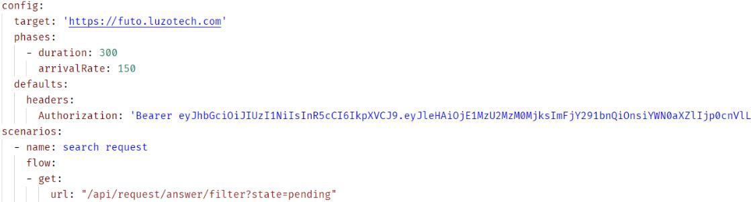

*Figure 5-18: Artillery configuration for REST API*

Then we run the benchmark with commands:



***5.4.5.1.4*** ***Benchmark result***

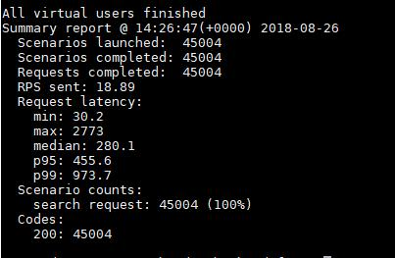

*Figure 5-19: REST API benchmark result*

**The benchmark shows that our system works as expected** as we defined in the first place:

At request latency, the maximum response time is 2773 ms for REST API The median response time is 280.1ms for REST API.

The p99 latency is 973.7 ms for REST API (p99 means that 99% of the requests should be faster than given latency)

**Chapter 6 : User manual**

**6.1** **Deployment guidelines**

**Environment for development**



Apple Macbook Pro with OS High Sierra 10.13.5 Asus Laptop with Microsoft Windows 10

Integrated Development Environment: Visual Studio Code 1.25.0

MongoDB Management Tool: Robomongo 1.2.1 Git extension for Visual Code

**6.1.1.1 Setup development environment**

***6.1.1.1.1 Install Visual Studio Code***

Go to[https://code.visualstudio.com/,](https://code.visualstudio.com/) click on “Download” button to start download the installation file and follow the instruction to install.

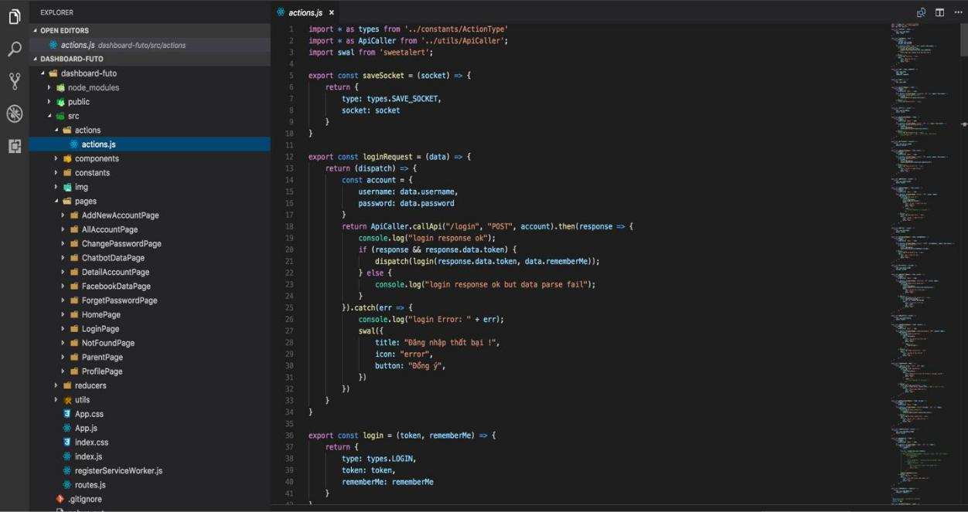

*Figure 6-1: Visual Code*

***6.1.1.1.2*** ***Install Robomongo***

Go to https://robomongo.org/download click on “Download” button to start download the installation file and follow the instruction to install.

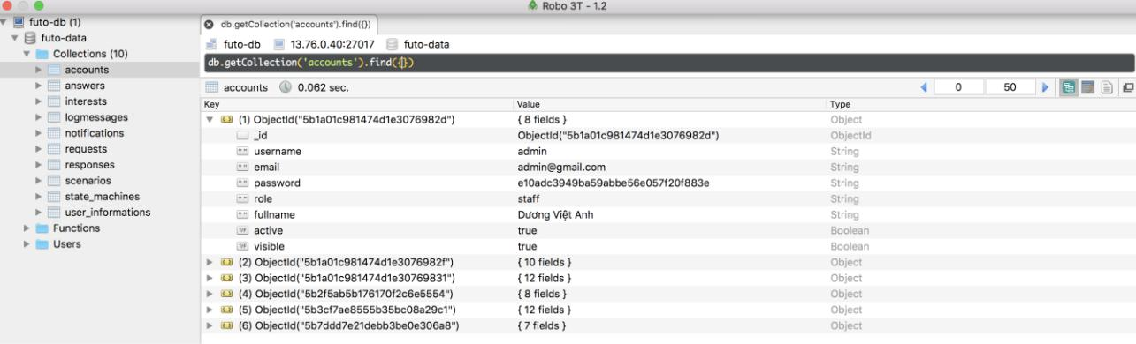

*Figure 62: -Robomongo*

***6.1.1.1.3 Install Git extension***

Integrated on Visual Studio Code

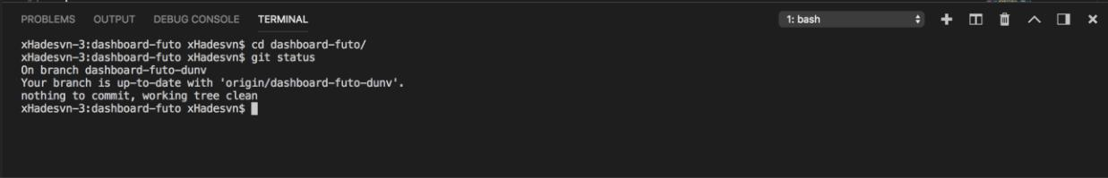

*Figure 6-3: Git on Visual Studio Code*

**6.1.1.2 Run tests in development environment**

To run all test suites, run the follow command in the source code directory:



**Environment for deployment**



Ubuntu 16.04 (provided by Azure Virtual Machine) **(ASC System Architecture)** o ASC System Architecture

o MongoDB

Elasticsearch **(for full-text search feature)** Memcached **(a distributed memory)**

Nginx **(a web server)**

**6.1.2.1 Setup deployment environment for ASC Backend**

***6.1.2.1.1 Create new Ubuntu 16.04 on Virtual Machine (VM) on Microsoft Azure***

Login an account on Microsft Azure Portal at <http://portal.azure.com/> From the Microsoft Azure Portal, choose **Virtual Machines**

Select Add on menu bar, search **Ubuntu Server**

Next, select **Ubuntu Server 16.04 LTS** on right bar, click to **Create** Setup name, VM disk type, Username, Password, Location of server.

Choose a size of server, in this project we will create 3 B2S (2 vCPUs, 4 GiB memory) instances: each for 2-3 **ASC System Architecture.**

Finally **Review** and **Create**

We will have 3 Virtual Machine like this:

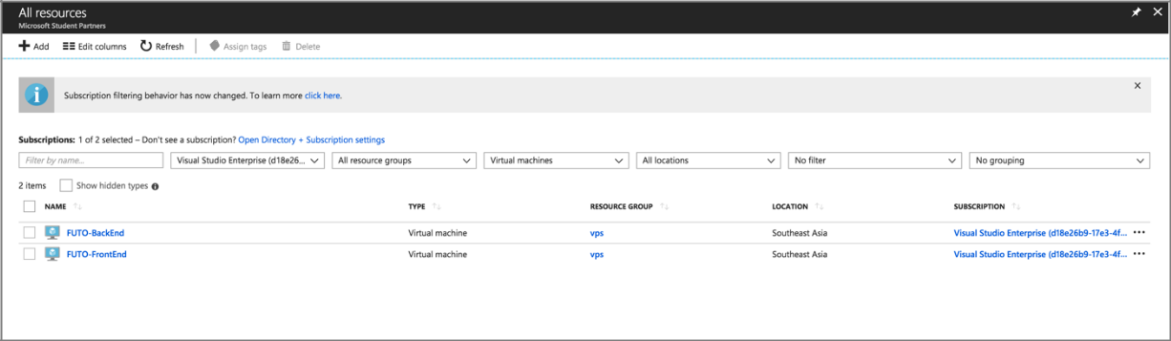

*Figure 6-4: Microsoft Azure Virtual Machine Dashboard*

***6.1.2.1.2 Configure MongoDB***

Go to [https://docs.mongodb.com/manual/tutorial/install-mongodb-on-ubuntu/,](https://docs.mongodb.com/manual/tutorial/install-mongodb-on-ubuntu/) follow the instruction to install and configure MongoDB for Ubuntu 16.04

***6.1.2.1.3 Configure Elasticsearch***

Go to [https://www.digitalocean.com/community/tutorials/how-to-install-and-configure-elasticsearch-on-ubuntu-16-04,](https://www.digitalocean.com/community/tutorials/how-to-install-and-configure-elasticsearch-on-ubuntu-16-04) follow the instruction to install and configure Elasticsearch for Ubuntu 16.04.

***6.1.2.1.4 Configure Memcahed***

Go to [https://www.digitalocean.com/community/tutorials/how-to-install-and-secure-memcached-on-ubuntu-16-04,](https://www.digitalocean.com/community/tutorials/how-to-install-and-secure-memcached-on-ubuntu-16-04) follow the instruction to install and configure Memcached for Ubuntu 16.04

***6.1.2.1.5 Configure Nginx***

Go to [https://www.digitalocean.com/community/tutorials/how-to-install-nginx-on-ubuntu-16-04,](https://www.digitalocean.com/community/tutorials/how-to-install-nginx-on-ubuntu-16-04) follow the instruction to install and configure Nginx for Ubuntu 16.04

**6.2** **User guidelines**

**End User**



**6.2.1.1 Chat**

1. Open Facebook Messenger and click “Get started” for English version or “Bắt đầu” for

Vietnamese version.

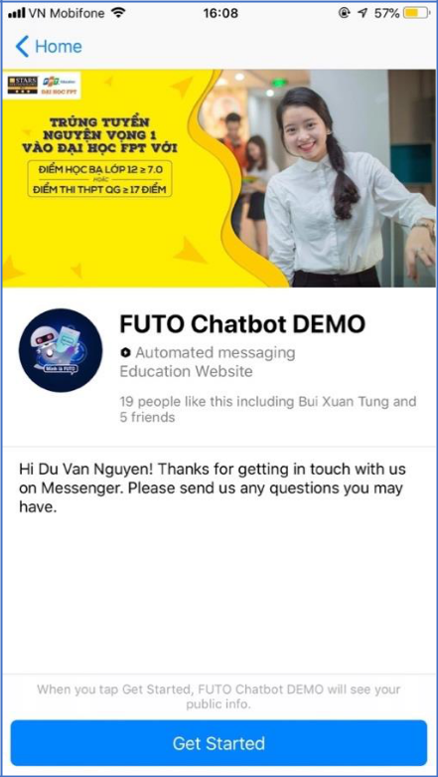

2. Use menu or enter any text directly to send message.

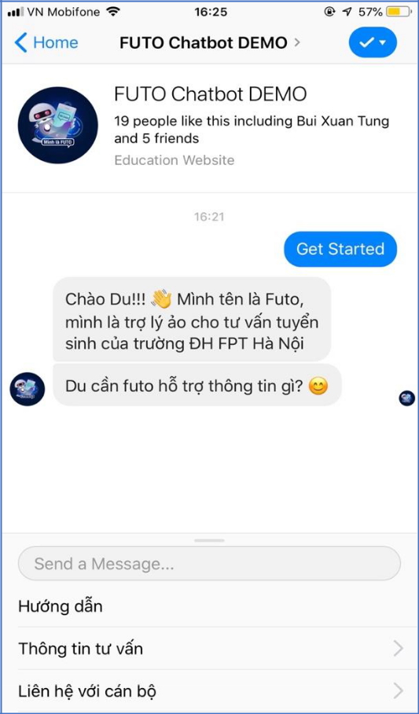

**6.2.1.2 Leave Feedback**

On screen, after 5 minutes if the user does not have any interaction, then Futo Chatbot will give the rating to the user selecting.

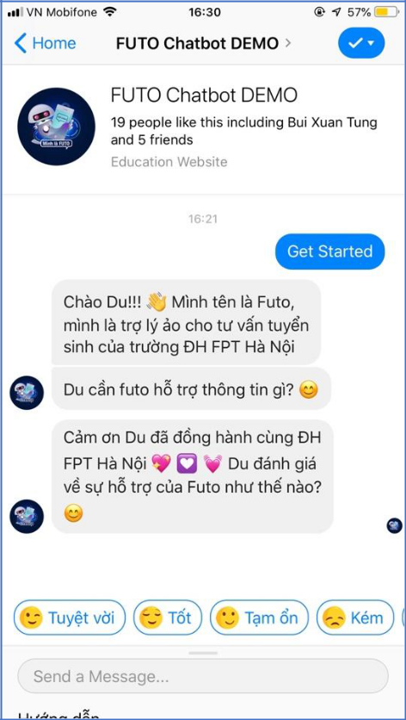

**6.2.1.3 Leave Information**

1. On menu, the end user selects “Liên hệ với cán bộ”

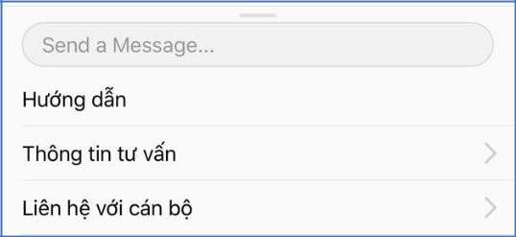

2. Next, the end user selects “Gọi điện”

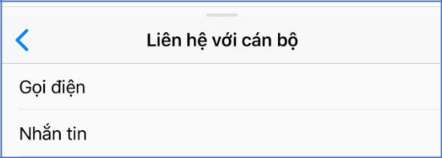

3. FUTO will ask you to provide information.

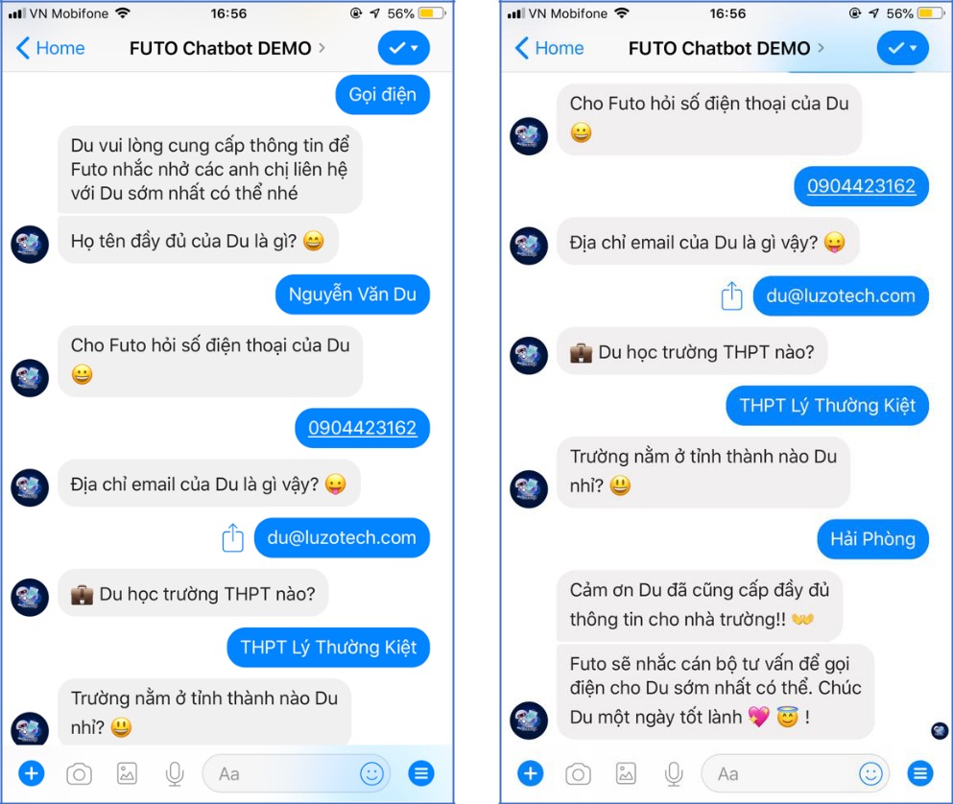

**Staff & Admin**



**6.2.2.1 Login**

Access to [https://futo-dashboard.luzotech.com,](https://futo-dashboard.luzotech.com/) enter “TÊN ĐĂNG NHẬP”, “MẬT KHẨU” and clicks “ĐĂNG NHẬP”.



**6.2.2.2 Reset Password**

1. On screen, user clicks “Quên mật khẩu”

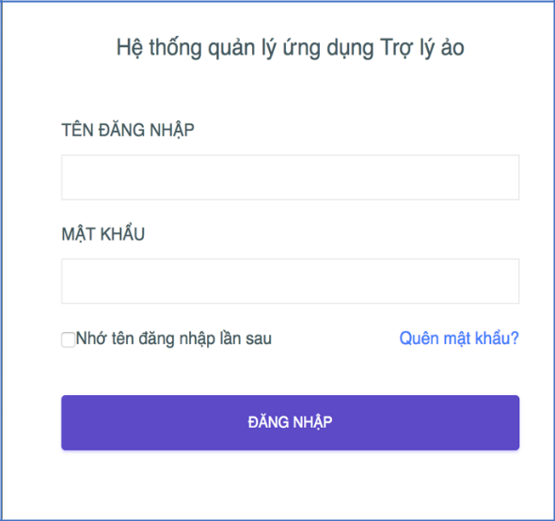

1. On next screen, enter email and clicks “XIN CẤP LẠI MẬT KHẨU”

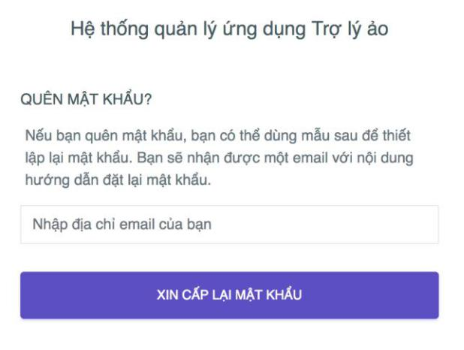

**6.2.2.3 View Statistics**

After login, Statistics will display on the screen.

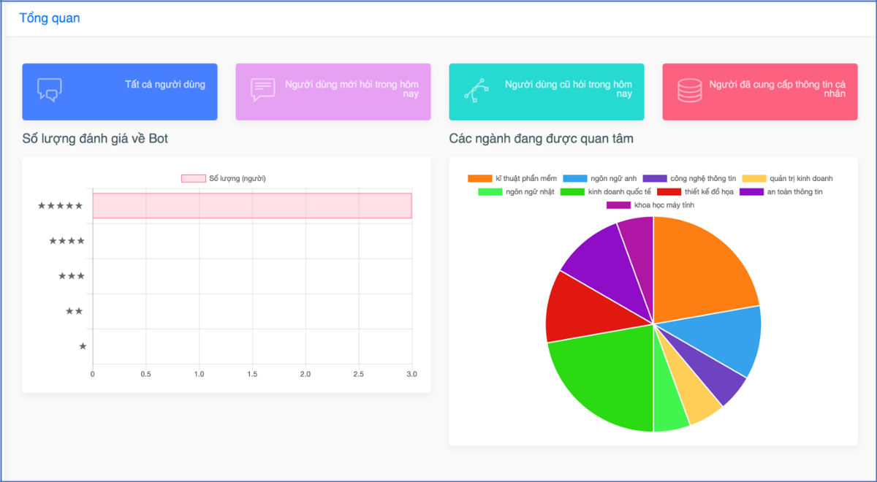

**6.2.2.4 View Profile & Update Profile**

1. On Dashboard, clicks avatar on the right, select “Trang cá nhân”.

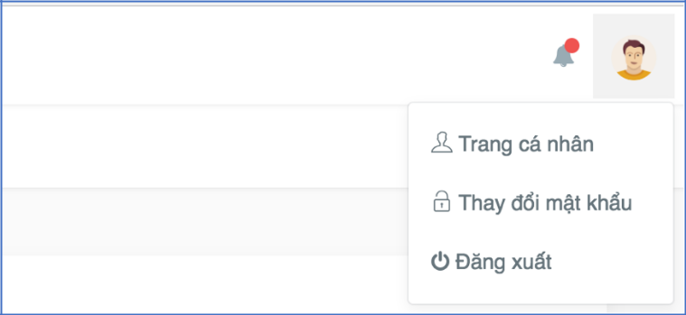

2. View Profile and Update Profile on the screen.

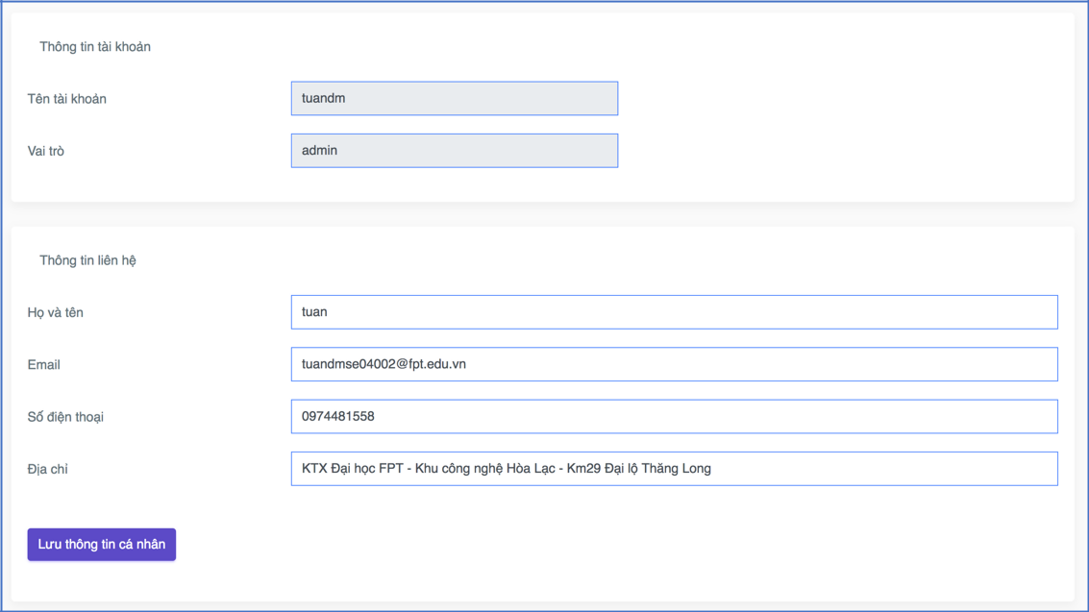

**6.2.2.5 Change Password**

1. On Dashboard, clicks avatar on the right, select “Thay đổi mật khẩu”.

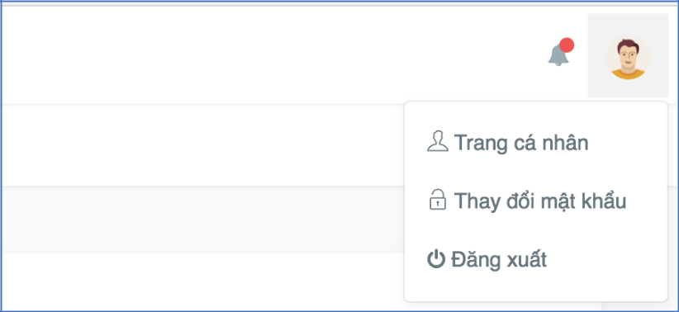

1. Change Password on the screen

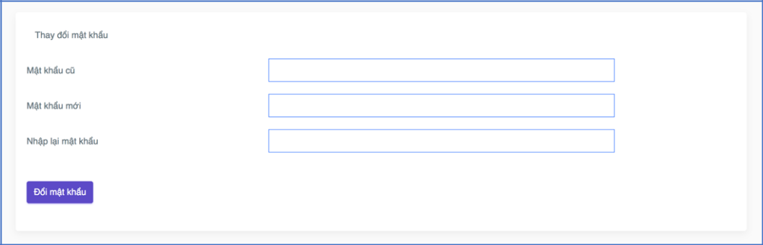

**6.2.2.6 View Account List**

1. On the Sidebar of Dashboard, select “Tất cả tài khoản”.

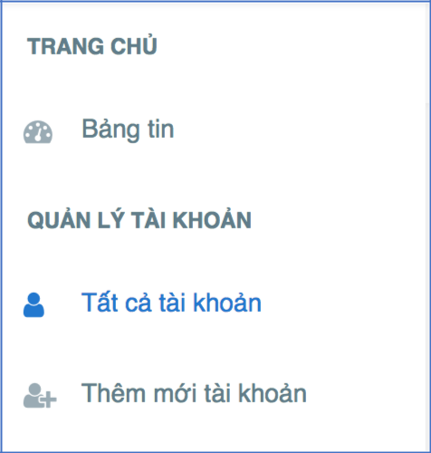

2. All Account List on the screen.

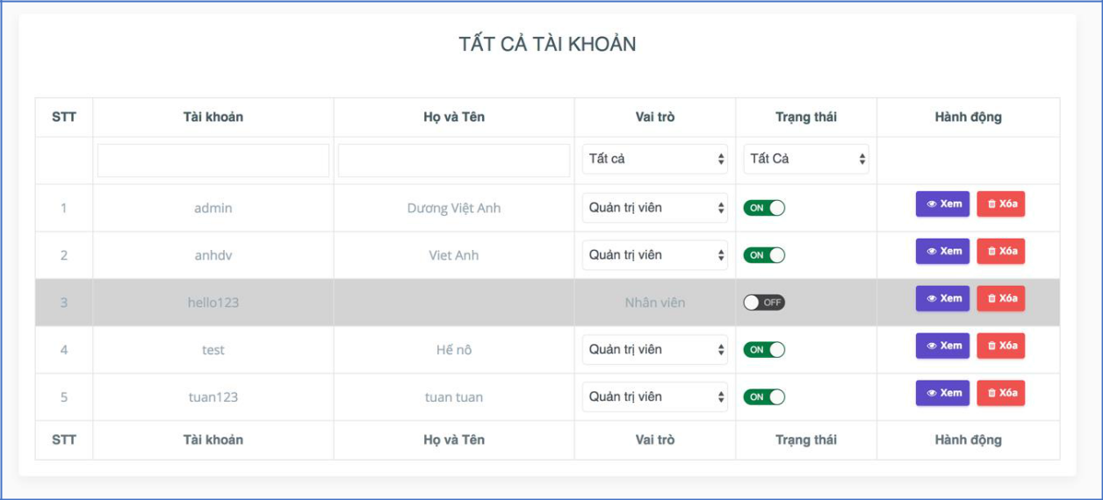

**6.2.2.7 View Account Information Detail**

1. On the table of All Account List, clicks “Xem” on the any user.

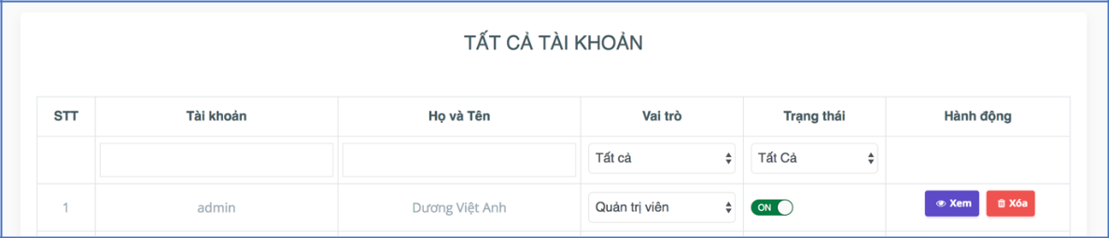

2. View Account Information Detail on the screen

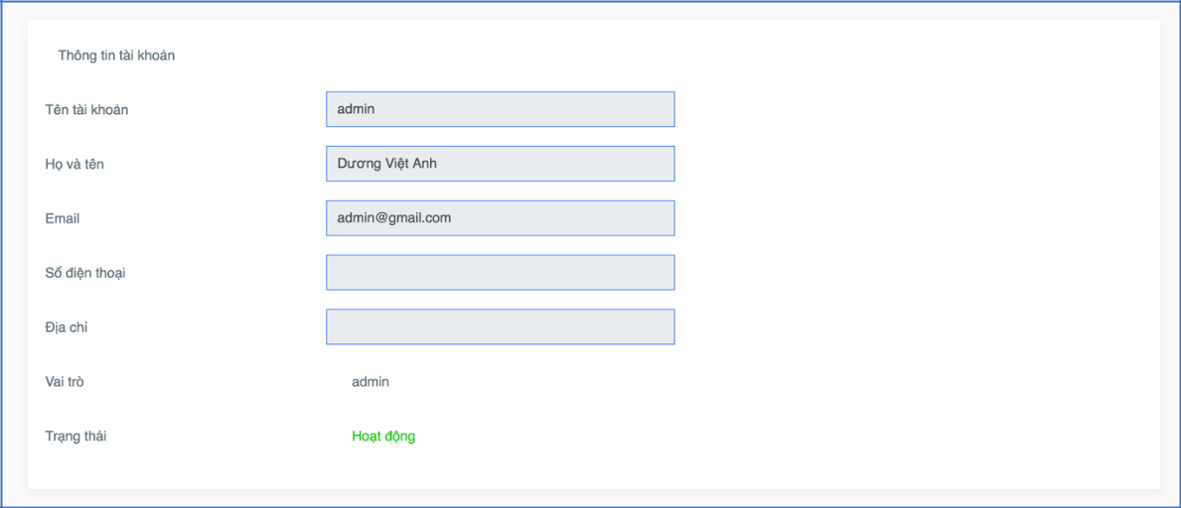

**6.2.2.8 Search Account & Filter Account**

1. On the table of All Account List, clicks on text input below “Tài khoản” or “Họ và tên” to

Search Account.

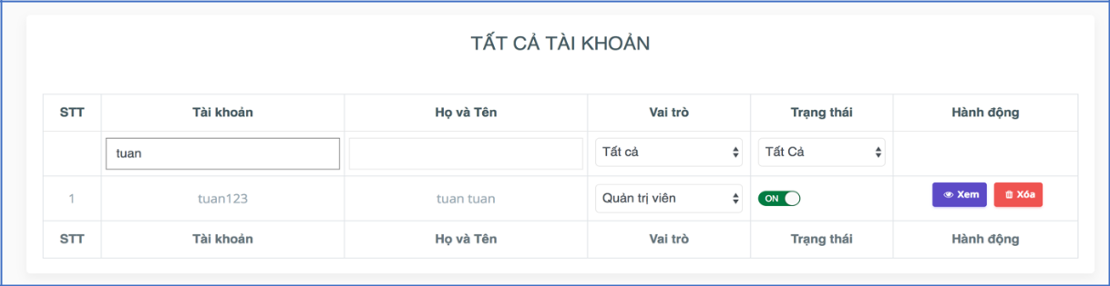

1. On the table of All Account List, clicks on dropdown list below “Vai trò” or “Trạng thái” to

Filter Account.

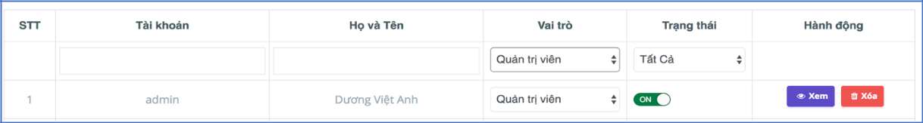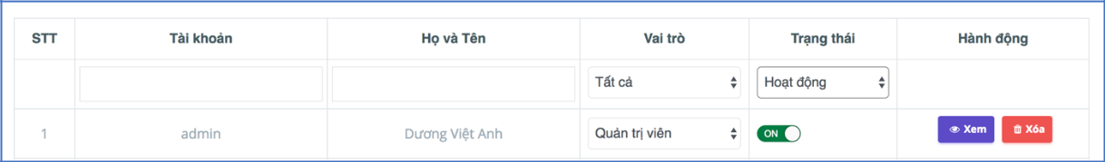

**6.2.2.9** **View Response & Answer List**

1. On the Sidebar of Dashboard, select “Quản lý dữ liệu của Chatbot”.

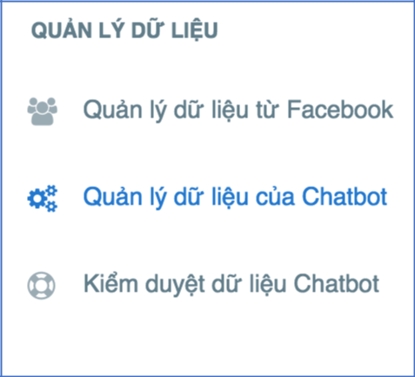

2. View Response & Answer List on the screen.

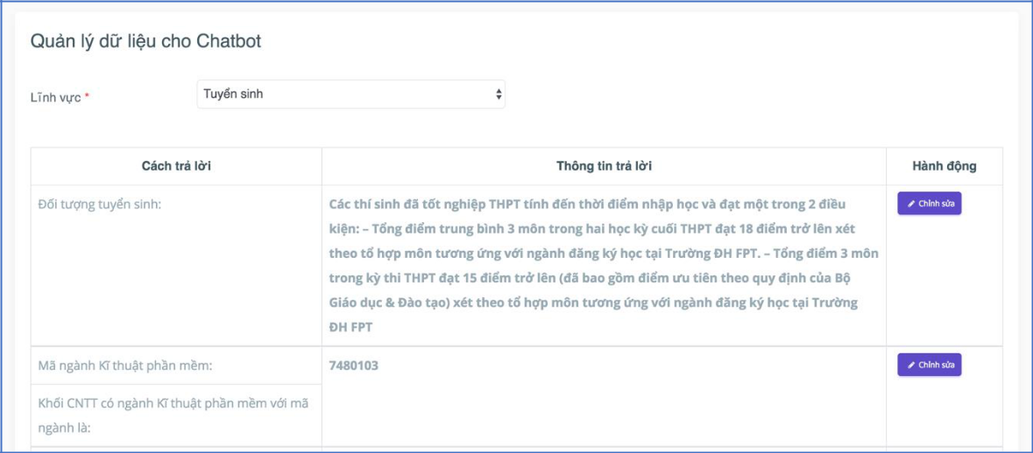

**6.2.2.10 Filter Response & Answer List**

Clicks on dropdown list from “Lĩnh vực” to Filter Search Response & Answer List.

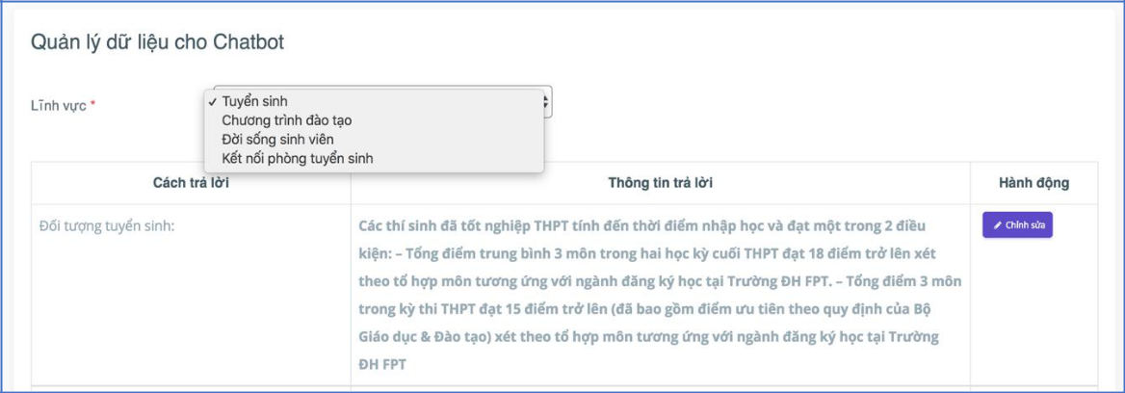

**6.2.2.11 Search Response**

**6.2.2.12 Request to Edit Answer**

On the table of “Quản lý dữ liệu cho Chatbot” page, clicks “Chỉnh sửa”.

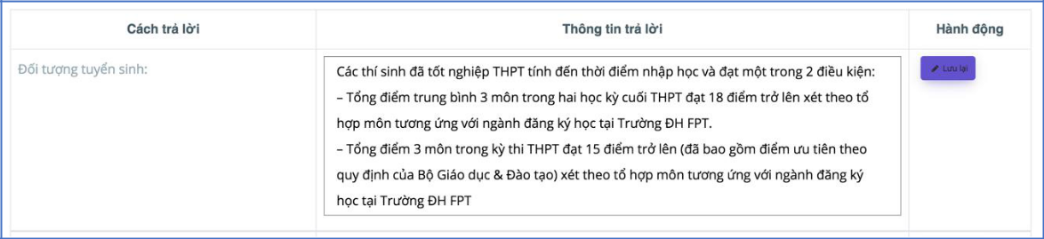

**6.2.2.13 Receive Notification**

On the Dashboard, notice the bell icon on the right.

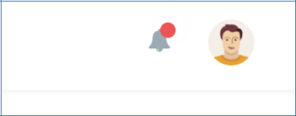

**6.2.2.14 View Notification List & Notification Detail**

On the Dashboard, clicks the bell icon on the right.

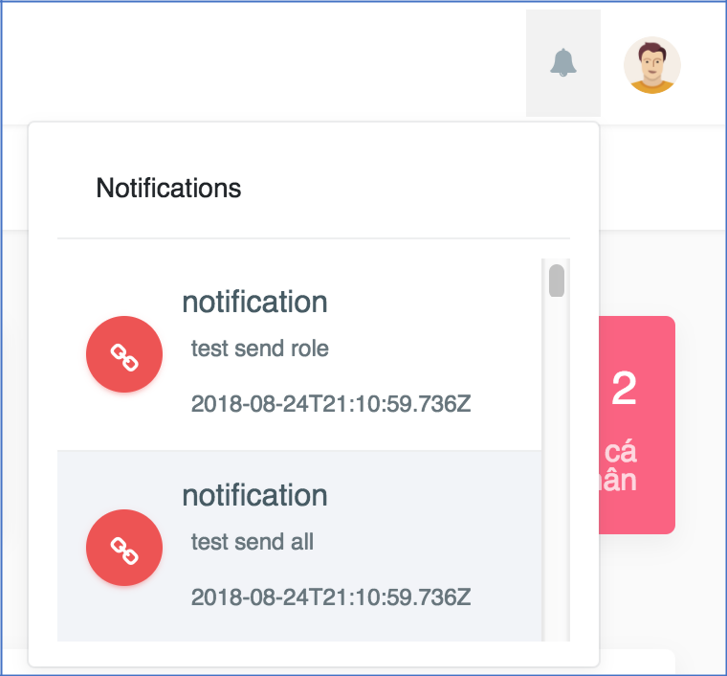

**6.2.2.15 View Facebook Account Page**

1. On the Sidebar of Dashboard, select “Quản lý dữ liệu từ Facebook”.

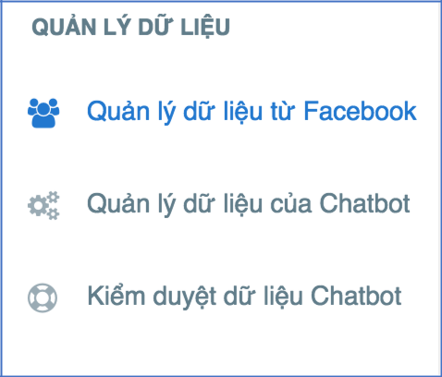

2. View Facebook Account on the screen.

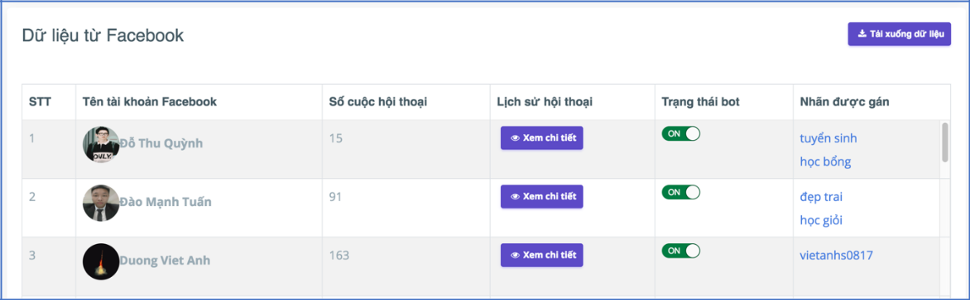

**6.2.2.16 View Chat Logs**

On the table of View Facebook Account page, clicks “Xem chi tiết” on the any user facebook to see view chat logs.

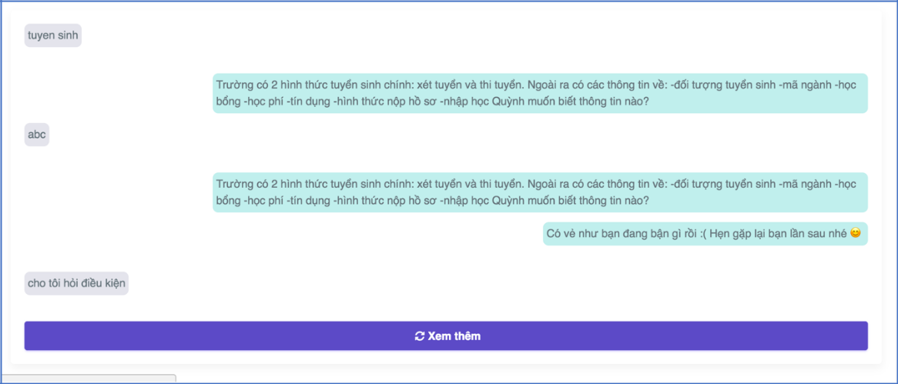

**6.2.2.17 View Facebook Account Information**

On the table of View Facebook Account Page, clicks “Xem chi tiết” on the any user facebook to see view facebook account information of that user.

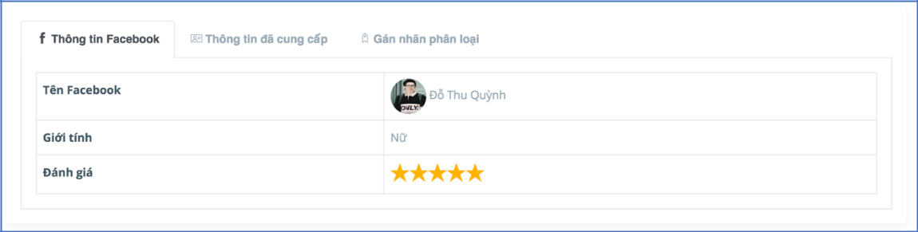

**6.2.2.18 View Providing Information**

On the table of View Facebook Account page, clicks “Xem chi tiết” on the any user facebook to see view providing information from that user facebook.

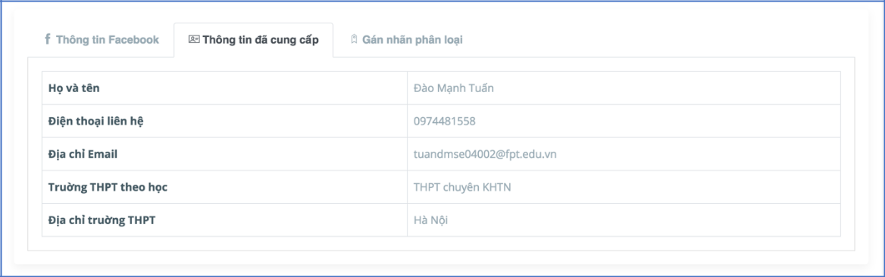

**6.2.2.19 Add tag & Remove tag**

On the table of View Facebook Account page, clicks “Xem chi tiết” on the any user facebook.

Select tab “Gán nhãn phân loại”.

* Clicks text input, enter name tag, press enter and clicks “Lưu” to add tag.
* Clicks “x” beside name tag, and clicks “Lưu” to remove tag.

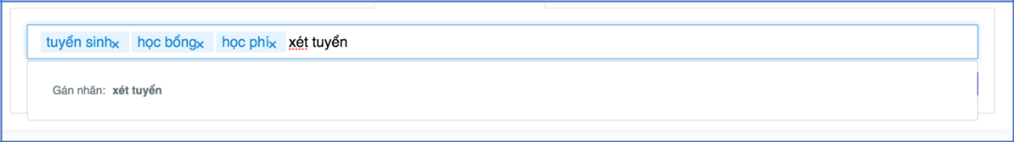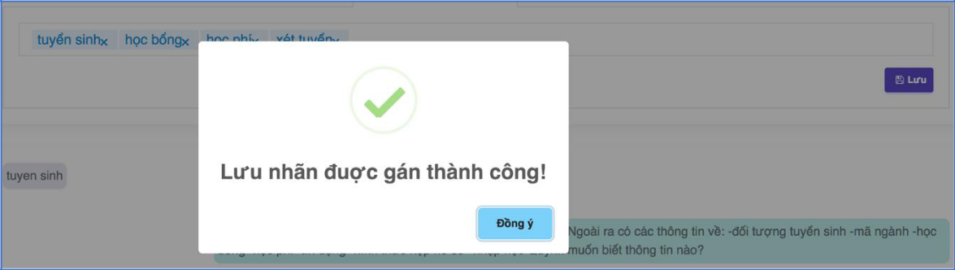

**6.2.2.20 Export End User List**

On the View Facebook Account page, clicks “Tải xuống dữ liệu” on the right, to export end user list.



**6.2.2.21 Change Bot Status**

On the table of View Facebook Account page. At “Trạng thái bot” column, clicks toggle button to On/ Off bot status on the any user. Or clicks “Xem chi tiết” on the any user, clicks toggle button at the right page.

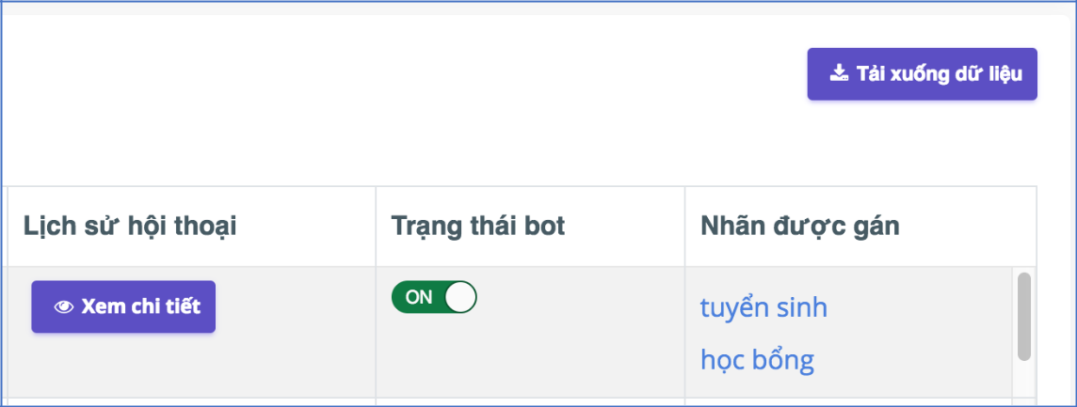

**6.2.2.22 Logout**

On the Dashboard, clicks avatar on the right. Select “Đăng xuất”.

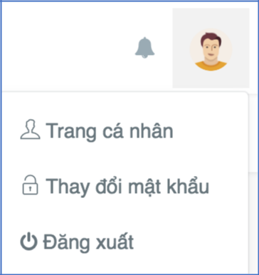

**6.2.2.23 View Answer Editing Requests (Only Admin)**

1. On the Sidebar of Dashboard, select “Kiểm duyệt dữ liệu Chatbot”.

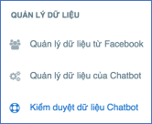

2. View Answer Editing Requests on the screen

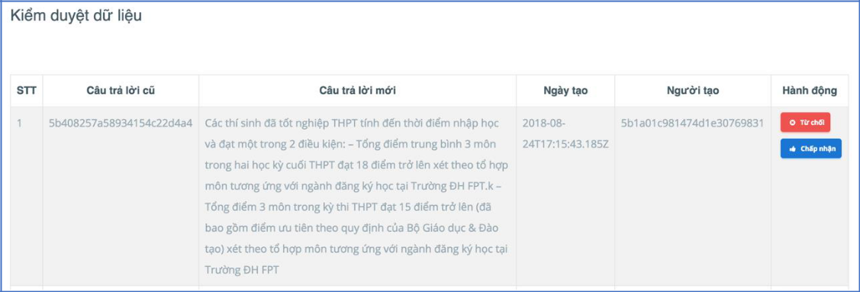

**6.2.2.24 Accept & Reject Answer Editing Requests (Only Admin)**

On the table of View Answer Editing Requests page, at “Hành động” column:

* Clicks “Chấp nhận” to accept answer editing requests.
* Clicks “Từ chối” to reject answer editing requests.

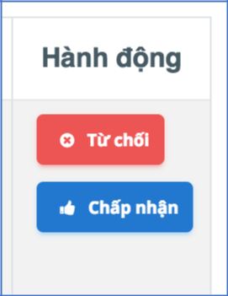

**6.2.2.25 Create Account (Only Admin)**

1. On the Sidebar of Dashboard, select “Thêm mới tài khoản”.

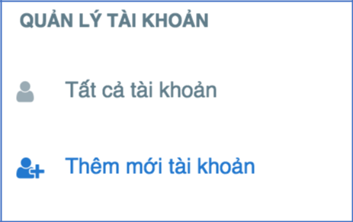

2. Create Account on the screen

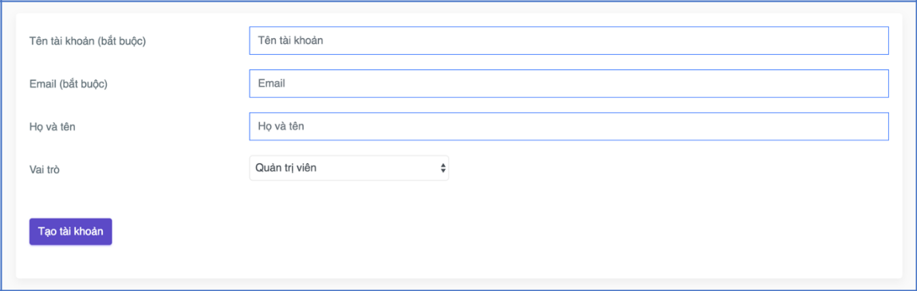

**6.2.2.26 Delete Account (Only Admin)**

On the table of All Account List, clicks “Xoá” on the any user at “Hành động” column, to delete account.

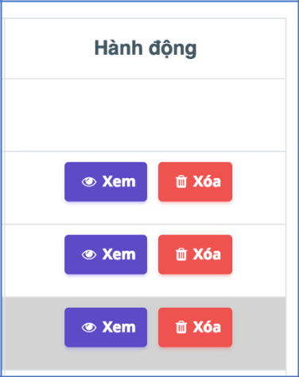

**6.2.2.27 Change Account Role & Account Status (Only Admin)**

On the table of All Account List:

* Clicks on dropdown list at “Vai trò” column on the any user to change account role.

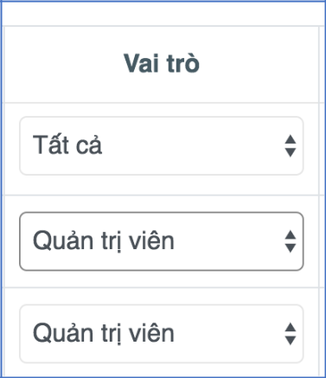

* Clicks on dropdown list at “Trạng thái” column on the any user to change account status.

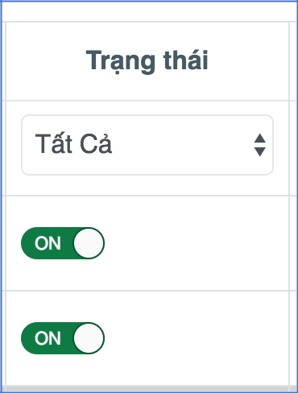

**6.2.2.28 Broadcast (Only Admin)**

On the View Facebook Account page:

* Send a general messages to all

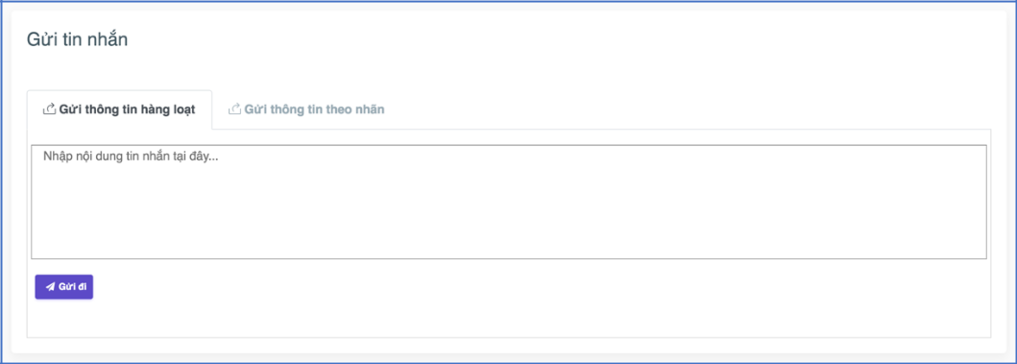

* Send messages follow tag

